Crystal Cove
Crystal Cove Homes each have a private pool, fully-equipped kitchen, dining area and living area. Equipped with clean towels, linen and a basic starter pack for toiletries and laundry.
The resort lies just eight miles and a 14-minute car journey from Walt Disney World Resort gates, the Highway 192 is just a short drive away and Interstate 4 is positioned just ten minutes away, giving access to main attractions.
It's conveniently located minutes away from shopping & restaurants and enjoys a close proximity to some of Florida's top-rated golf courses. Crystal Cove's clubhouse provides guests with a fitness centre, resort-style community pool and beautiful five-acre man-made lake. There is also no resort fee here so no additional charges on arrival.
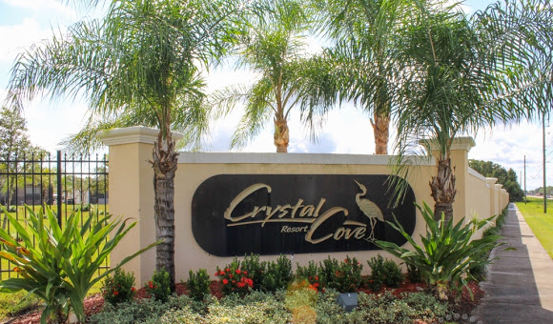

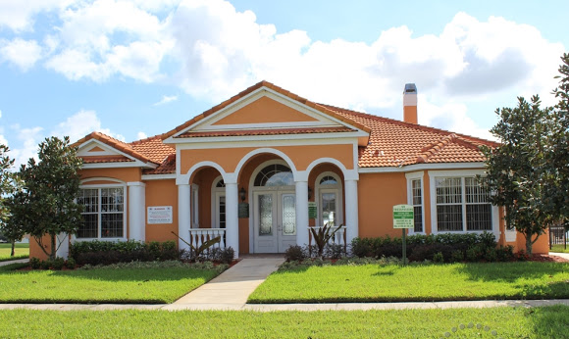

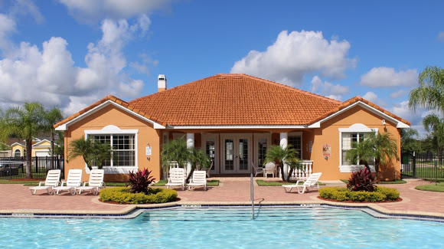

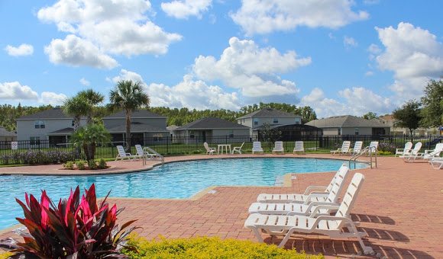

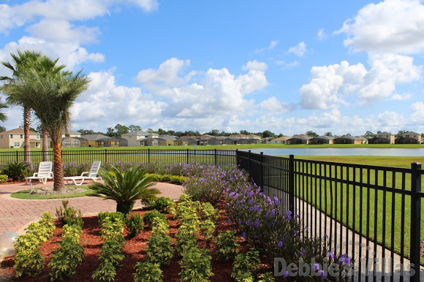

Sandy Ridge and Crystal Cove distance:
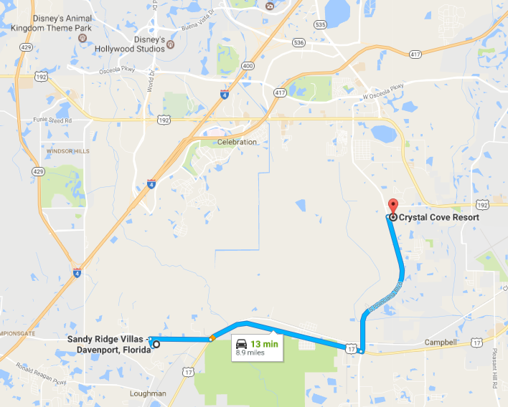
Distance to Walt Disney World:
