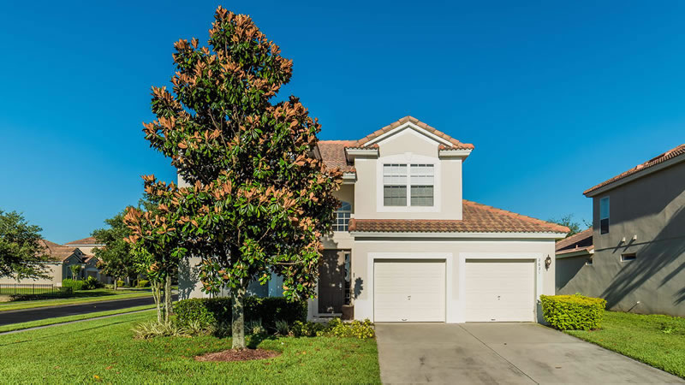
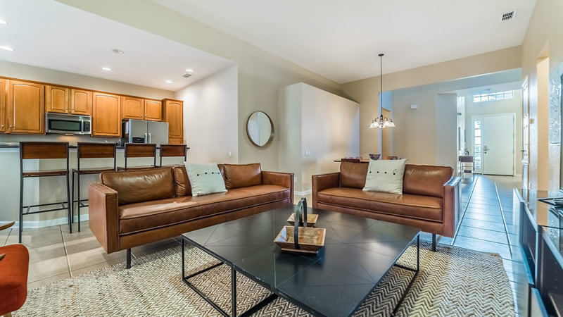
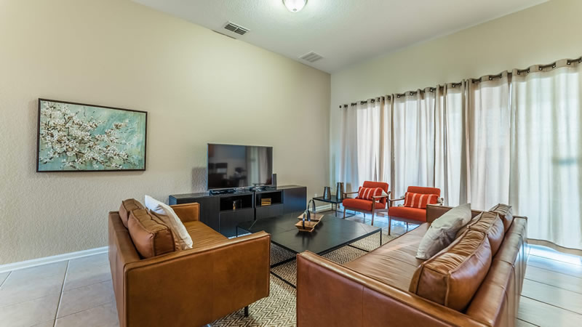
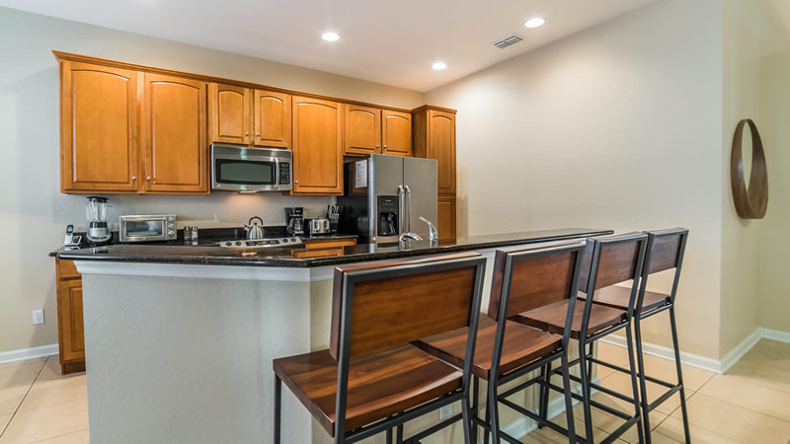
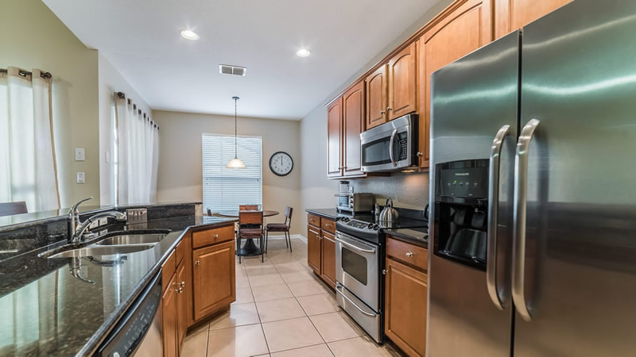
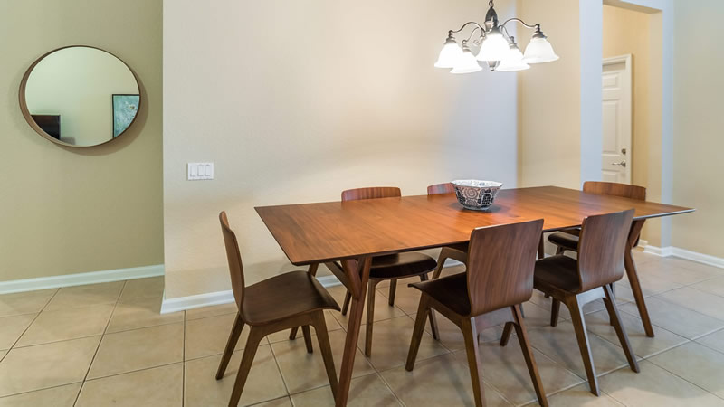
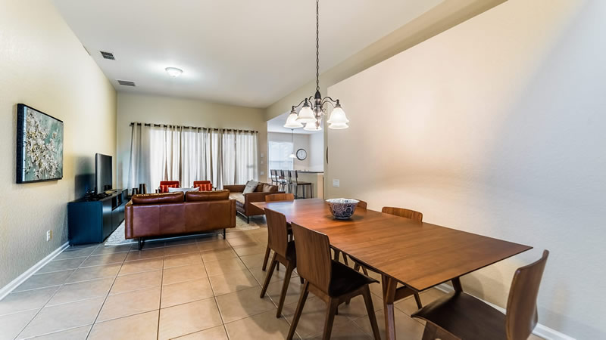
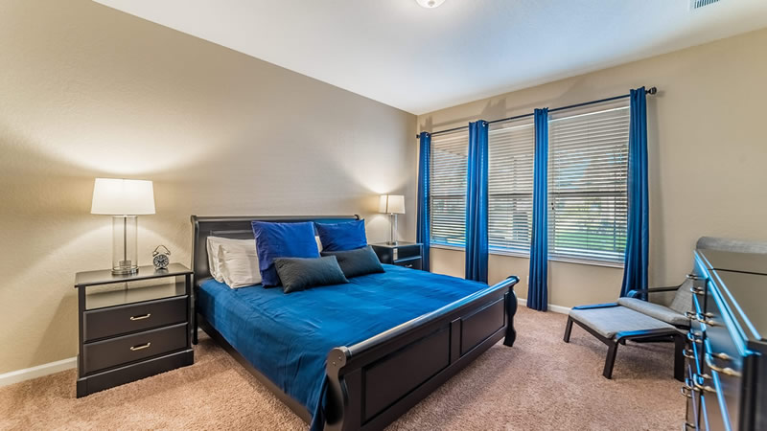
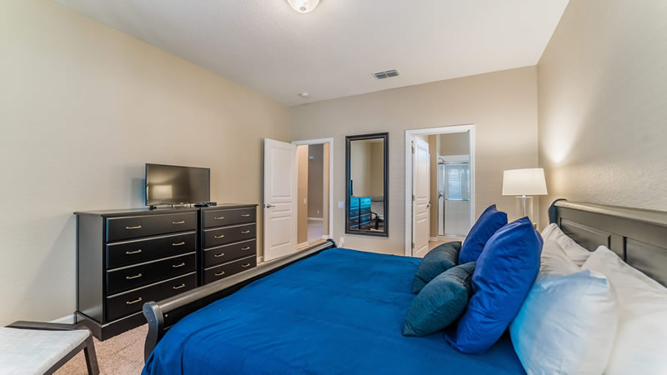
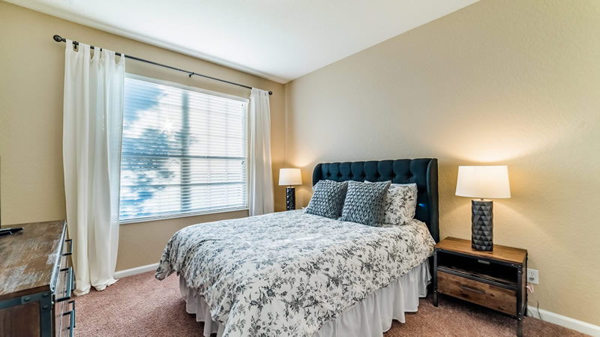
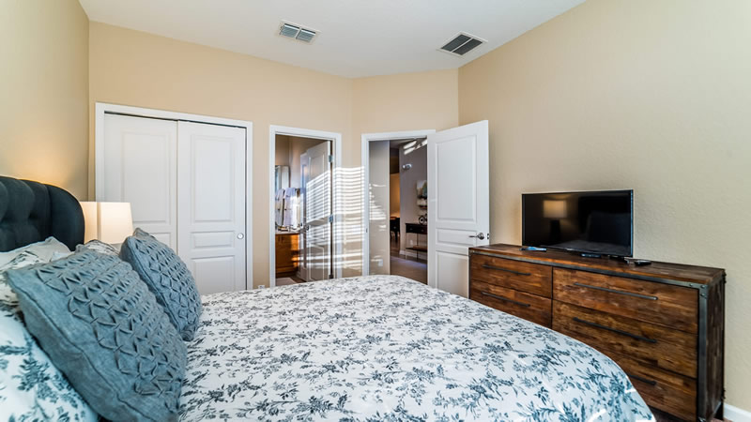
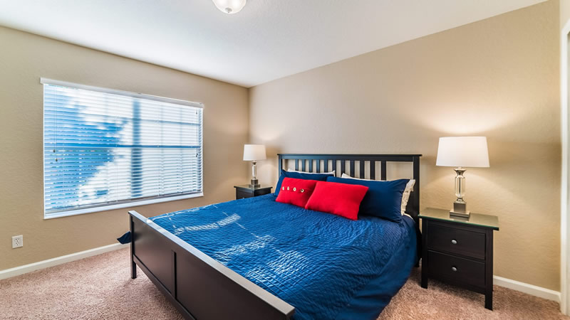
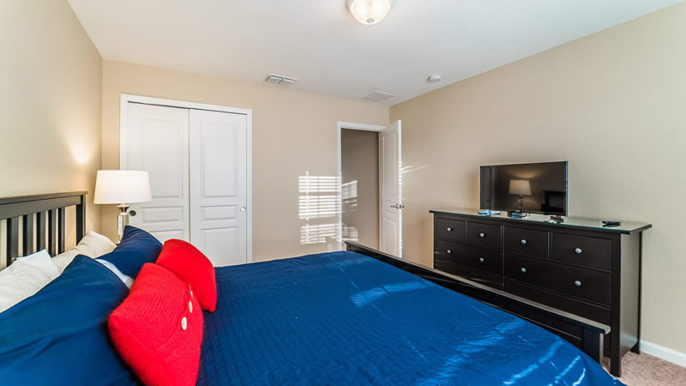
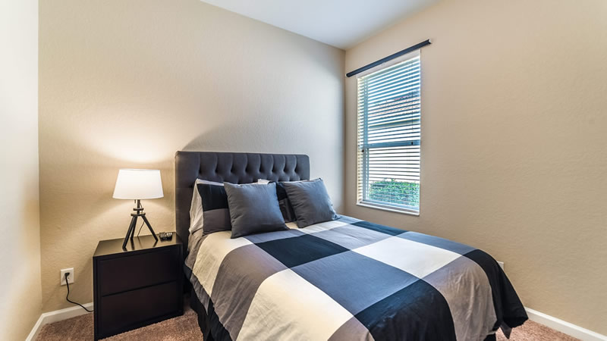
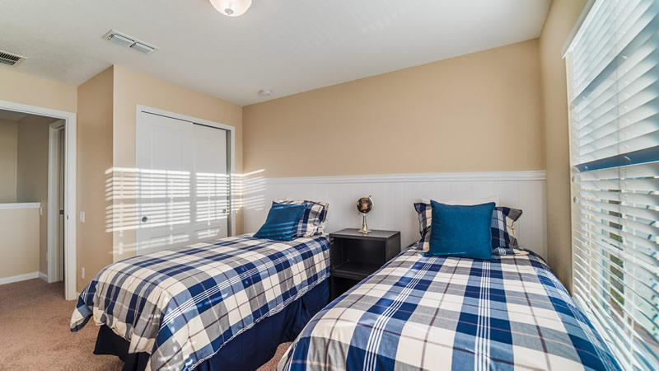
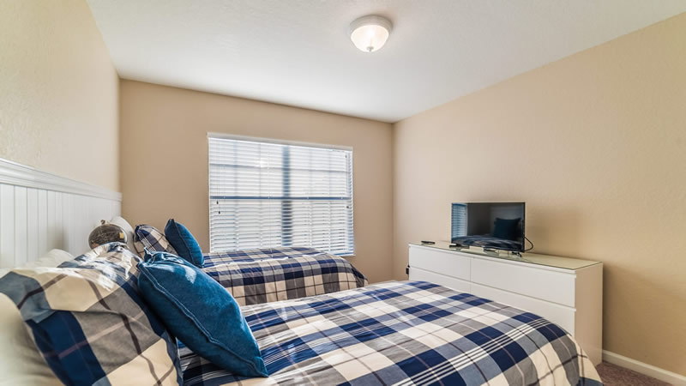
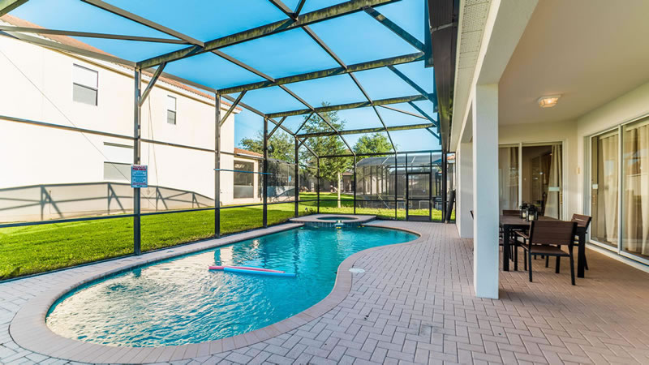
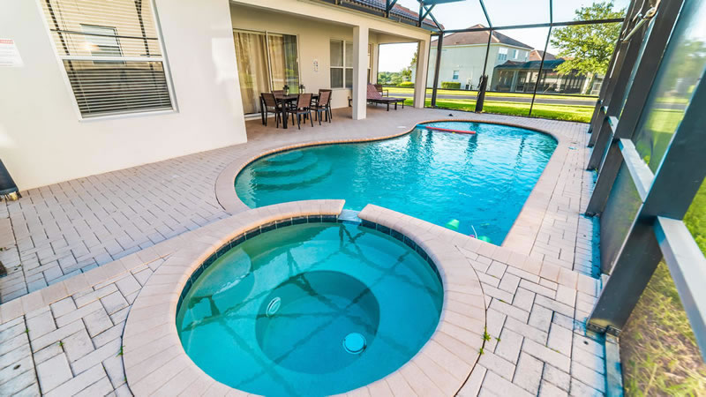
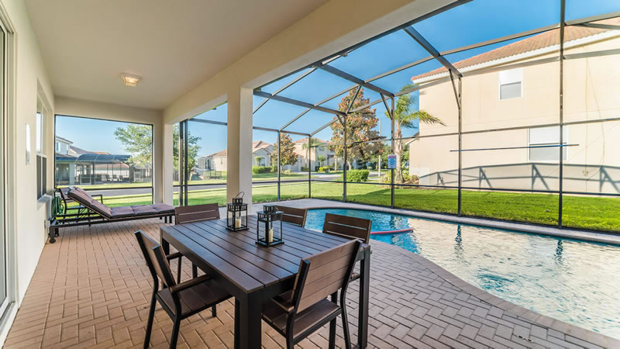
Welcome to this stunning rental home located in the resort community of Windsor Hills. This beautifully decorated home is perfect for a weekend getaway or long stay here in Central Florida. To begin, this spectacular open floor plan home features 5 spacious bedrooms with plenty of space for you and your guests. The bedroom configurations consist of two king bedrooms, one queen bedroom, one full bedroom and one bedroom featuring two twin beds. In total, this large house can sleep up to 10 guests. The wonderful home also features a kitchen that will inspire the inner chef within you. The granite countertops, upgraded appliances and cabinetry add a nice bonus to the already beautiful layout. The kitchen opens up to the breakfast bar and dining room which offers seating for everyone. The living room is centered around a flat screen TV which is perfect for catching up on your favorite TV shows or finishing off the day with a movie. Head on out to the pool and swim, play or tan in this home's very own pool area. Eat dinner on the patio and relax as the sun goes down. This magnificent home also comes with full access to the clubhouse at Windsor Hills. If a full game room, movie theatre and water slide isn't enough, this clubhouse also comes with a gorgeous pool and many amenities. This home also comes with an in-unit washer and dryer for all those bathing suits and wireless internet is available throughout.

