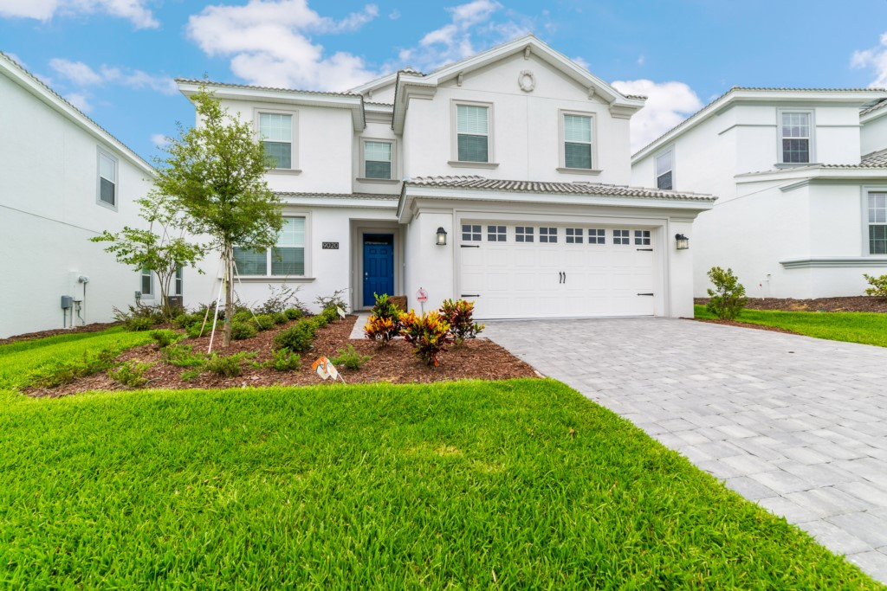
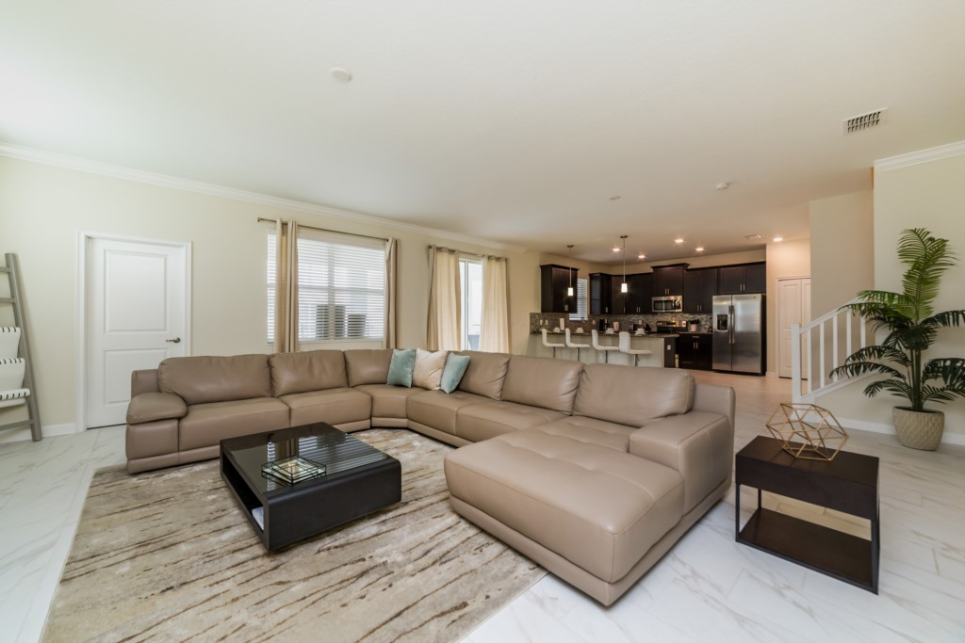

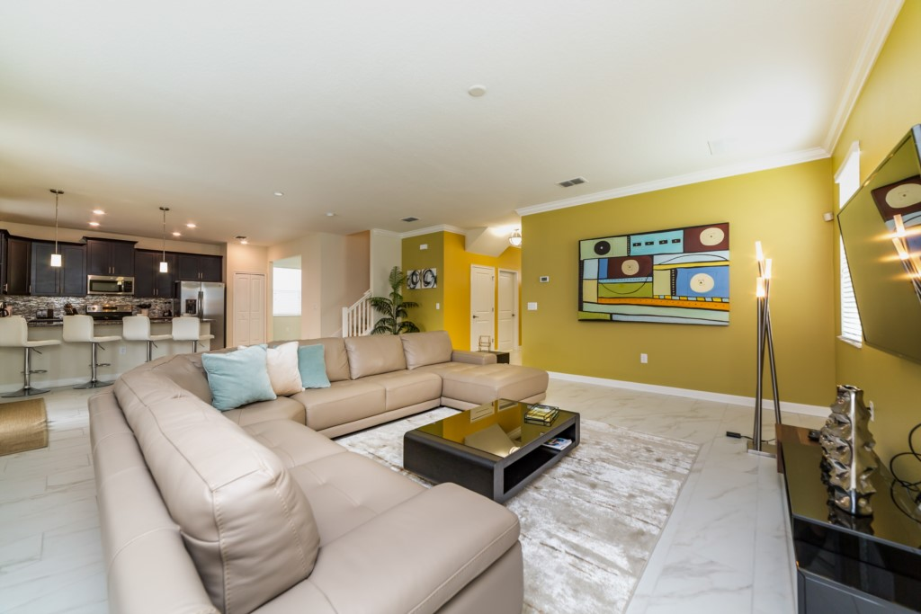
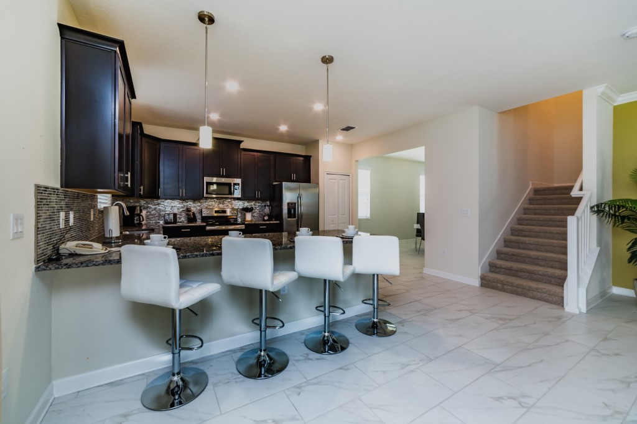
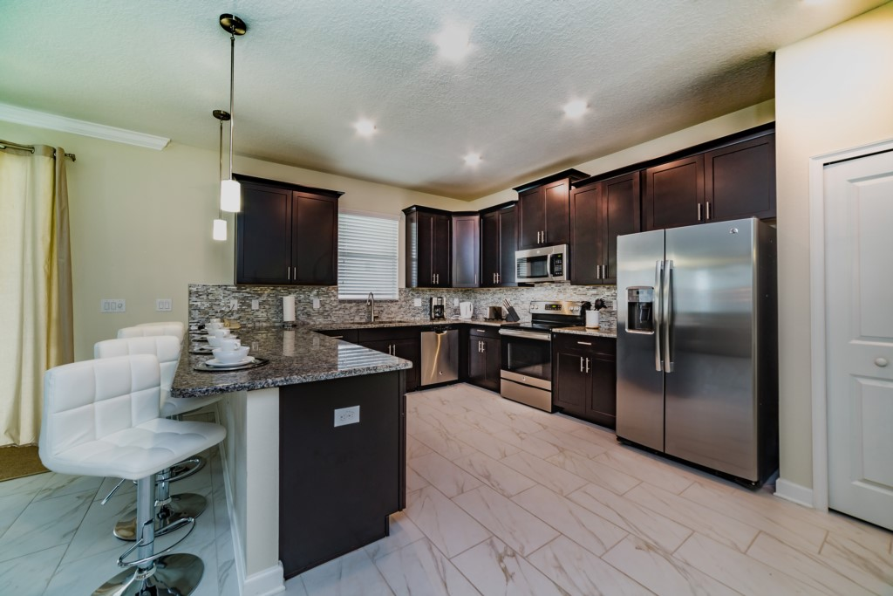
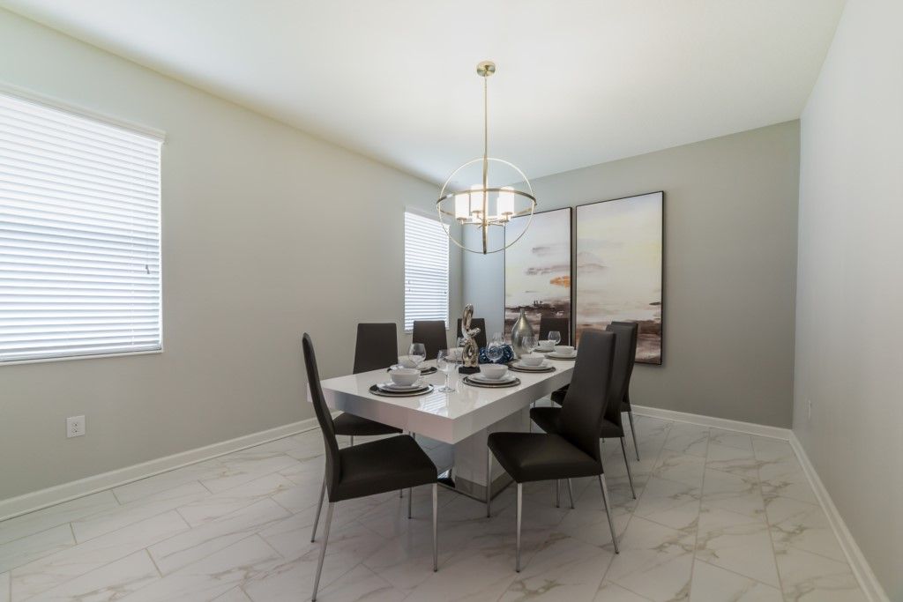
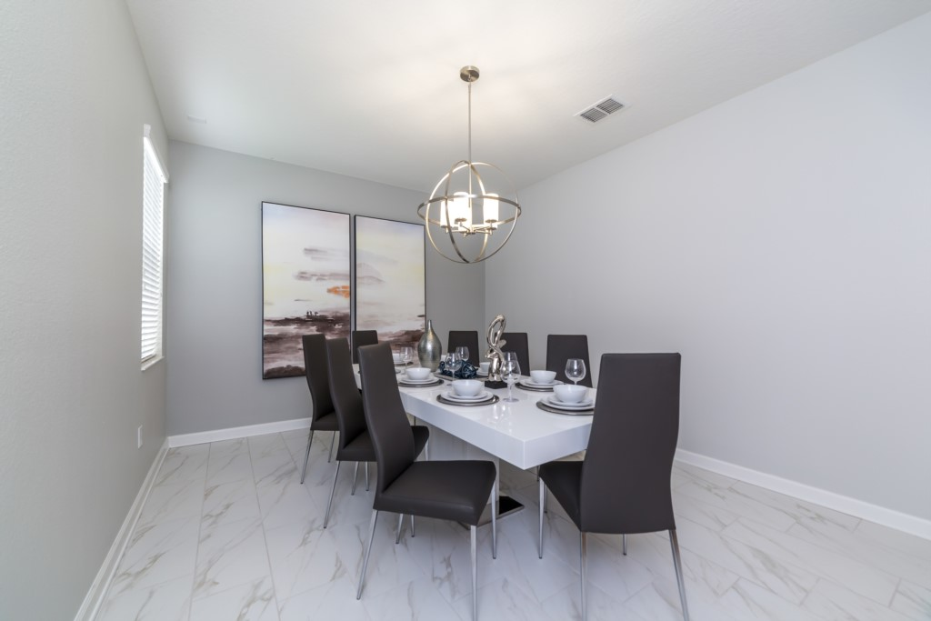
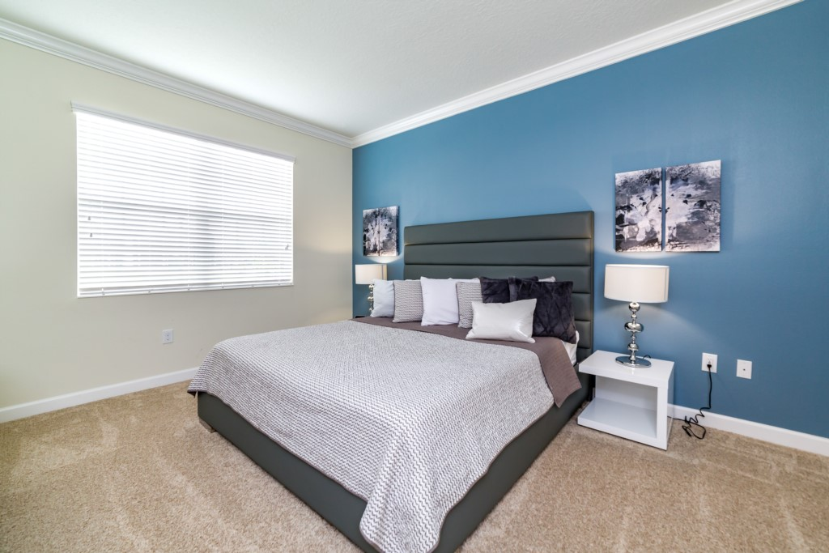
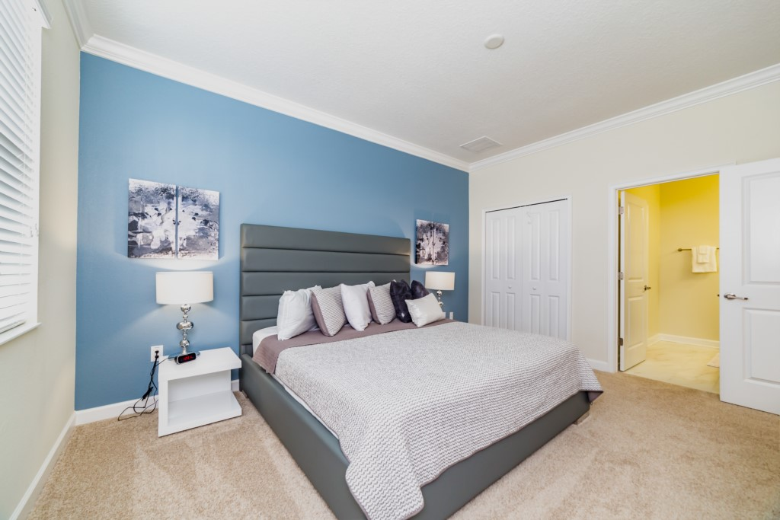
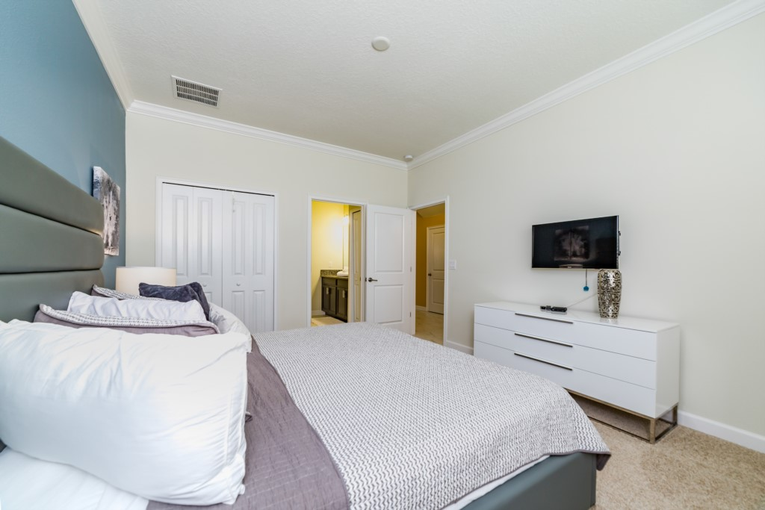
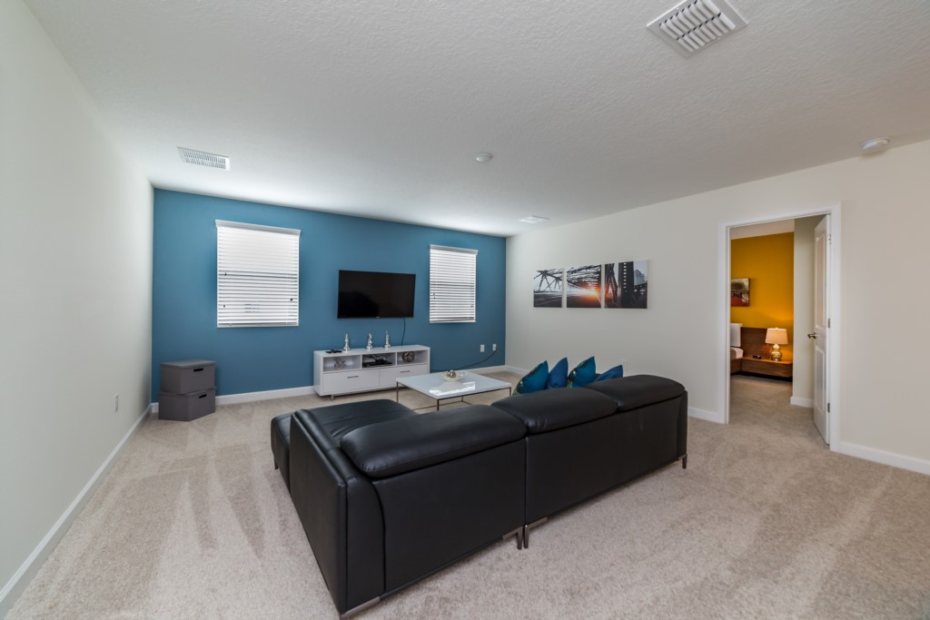
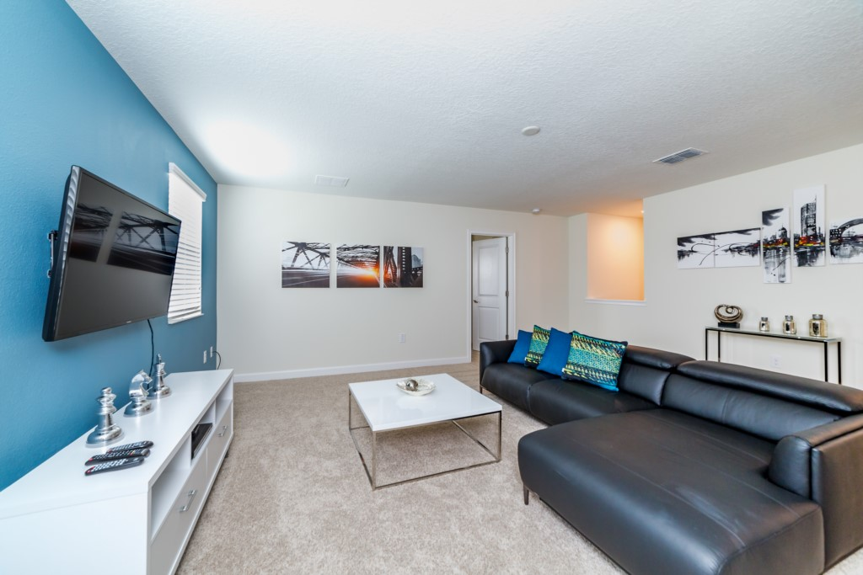
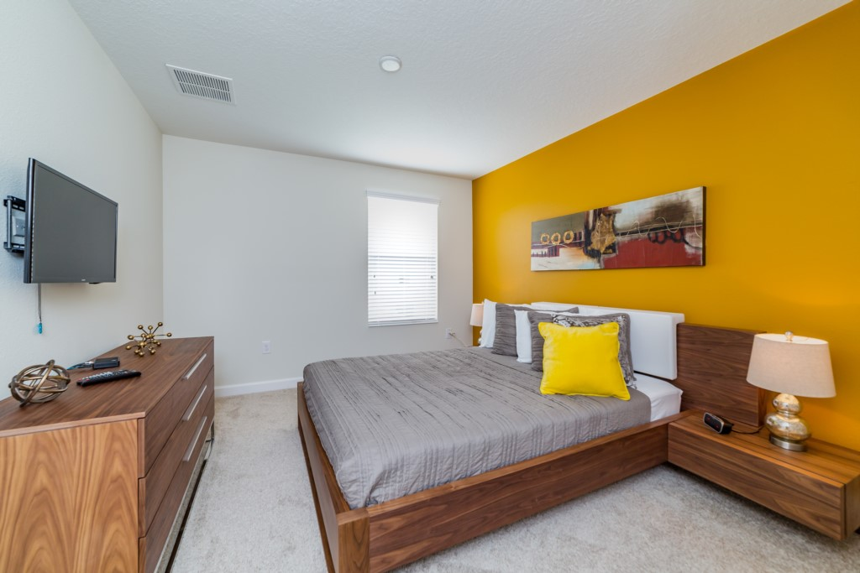
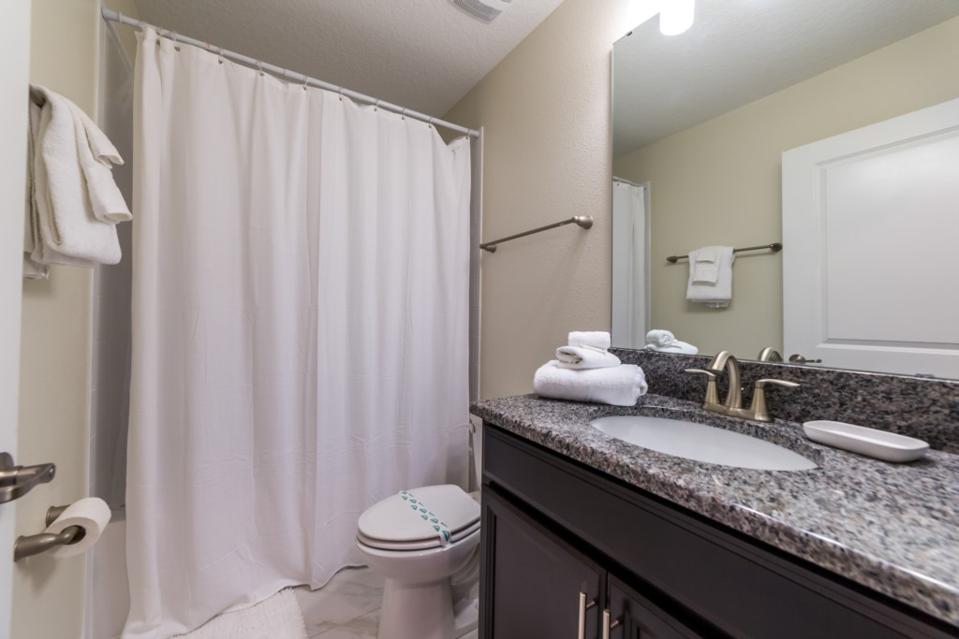
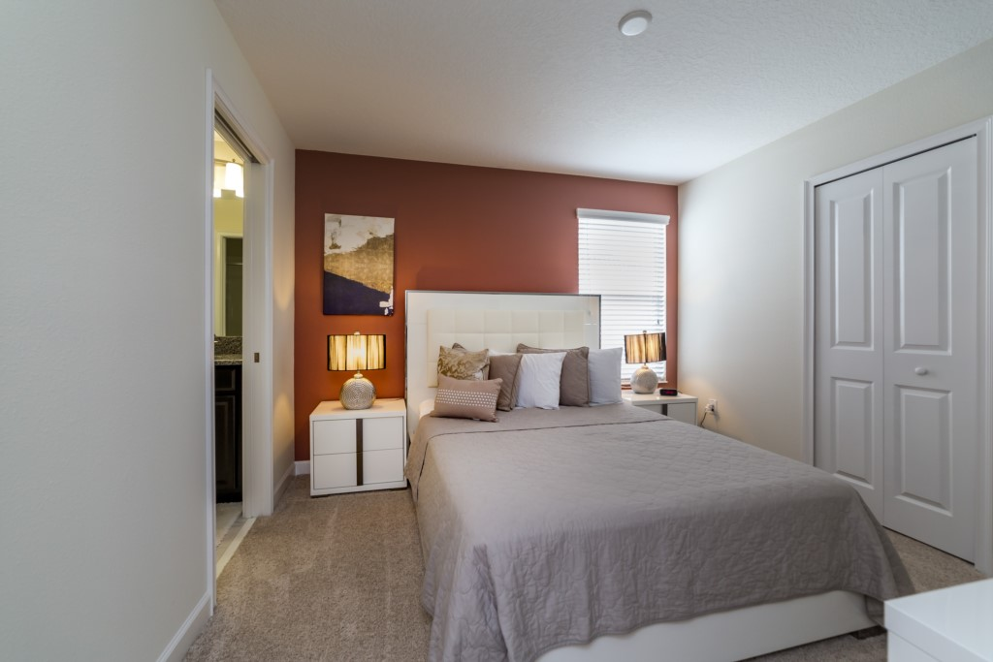
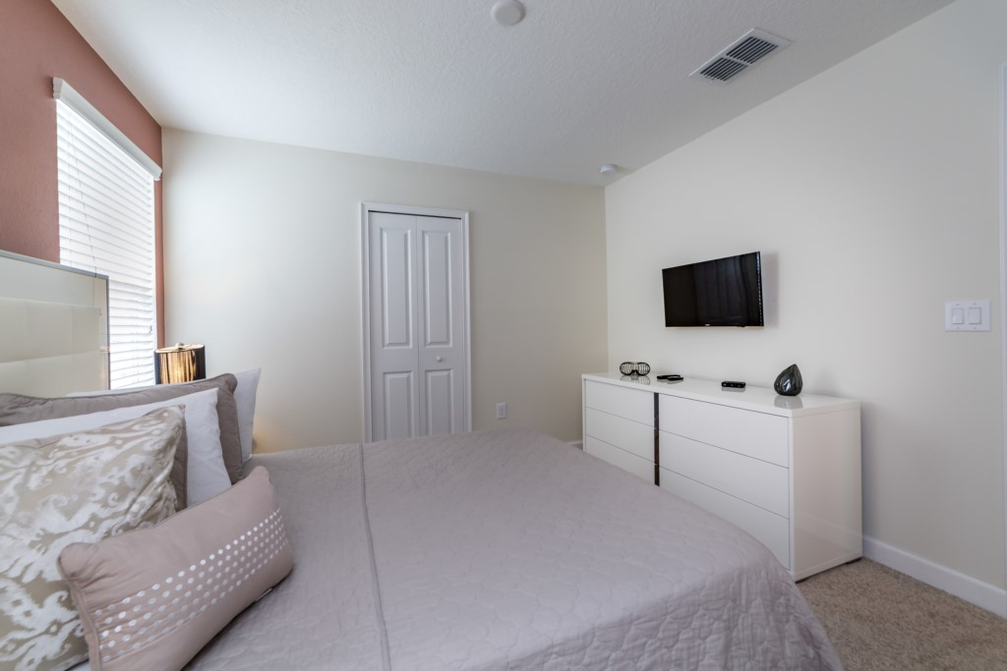
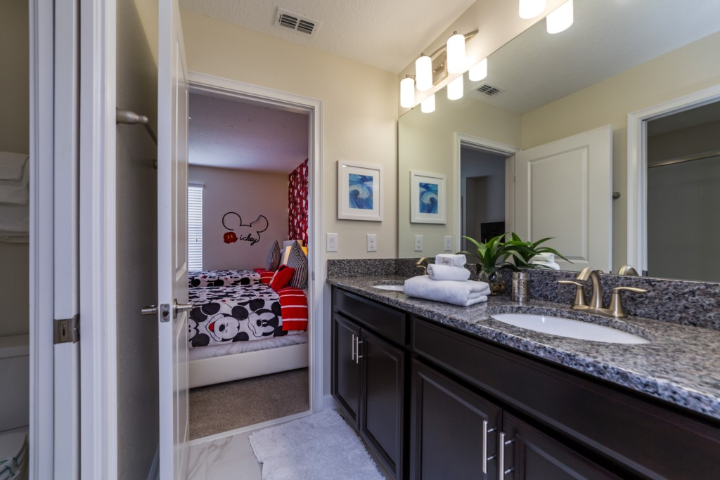

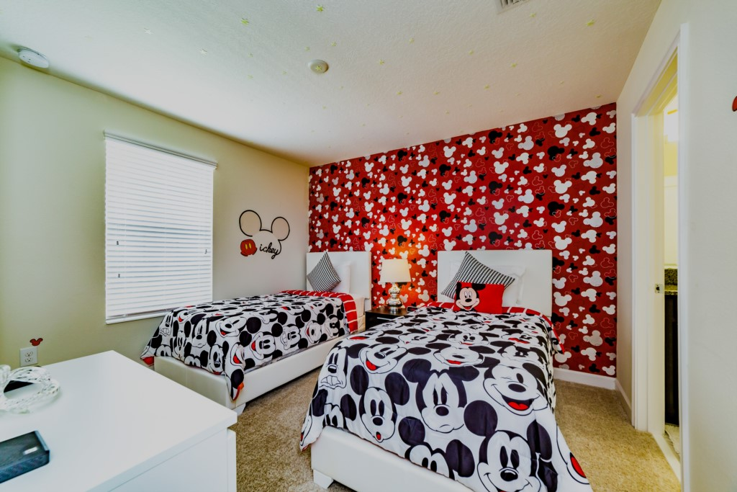
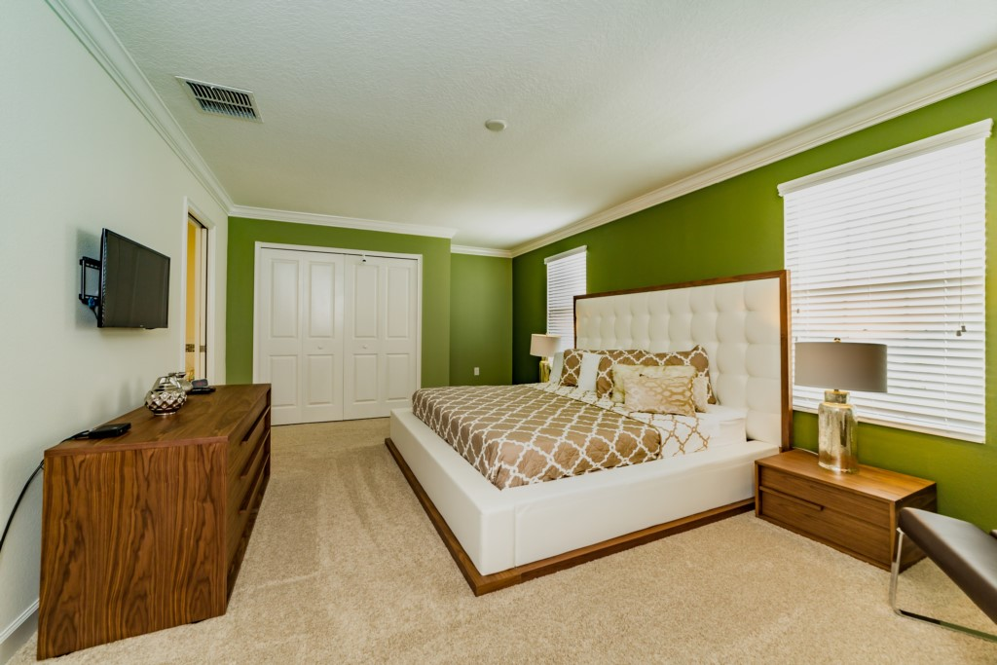
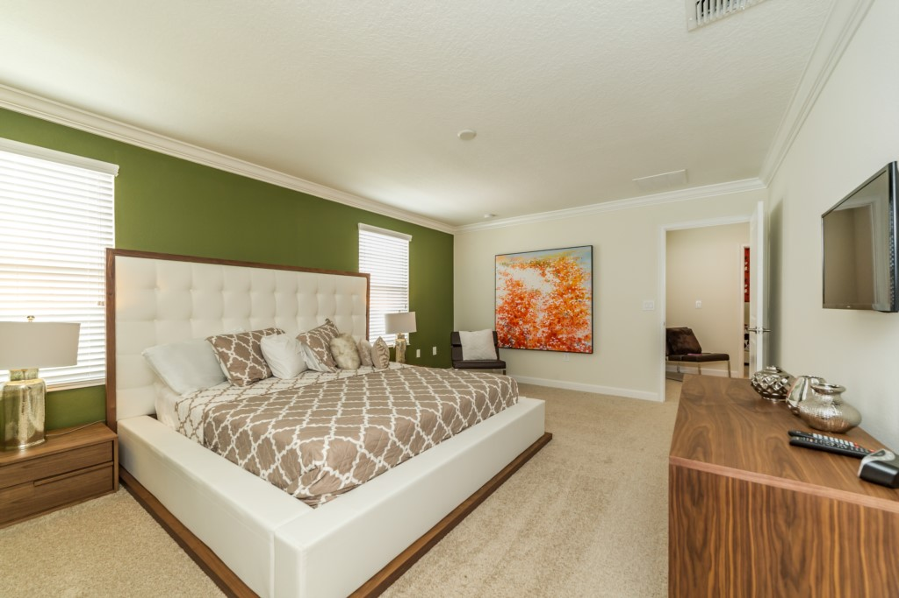
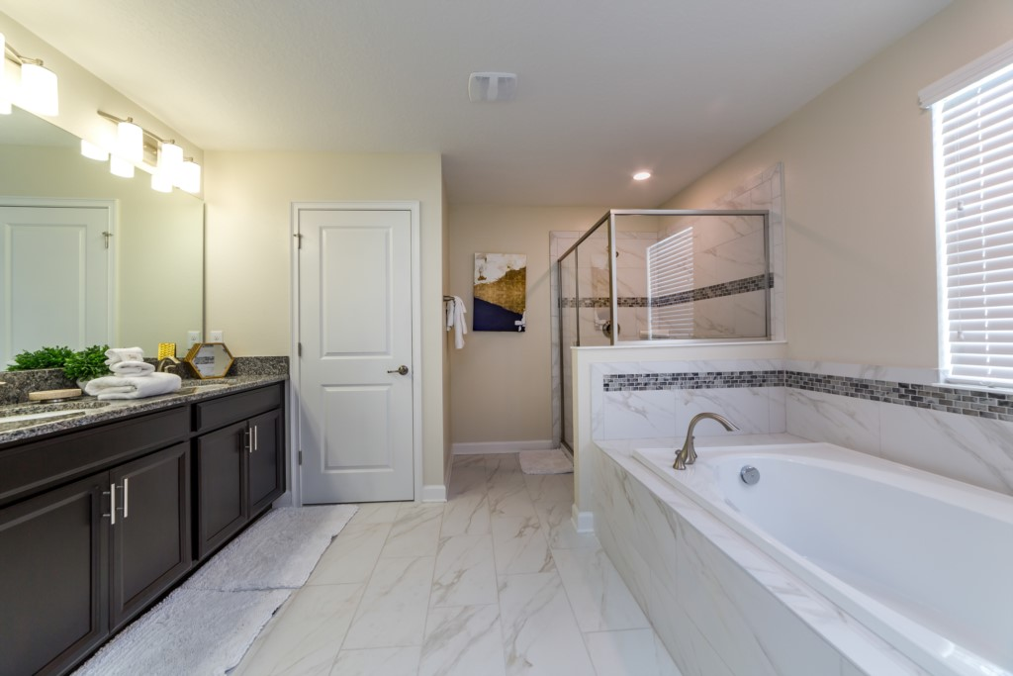
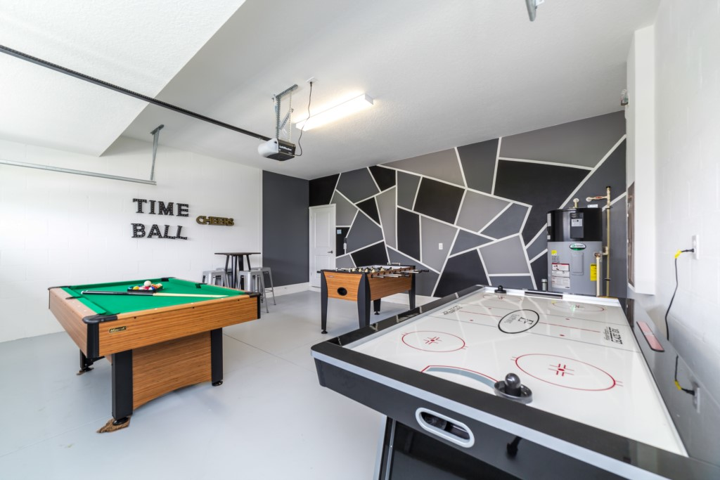
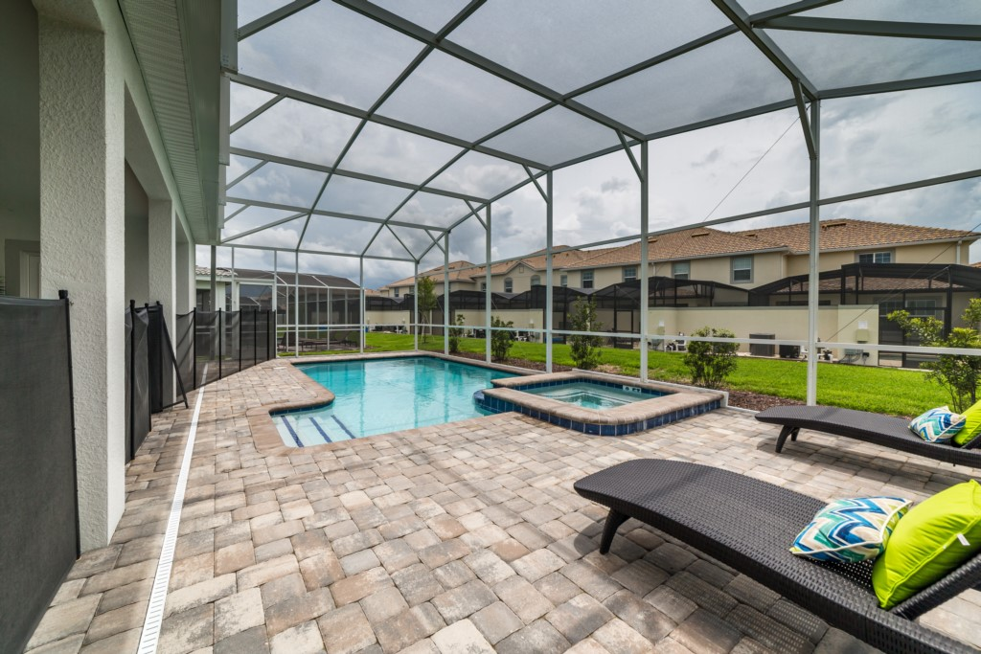
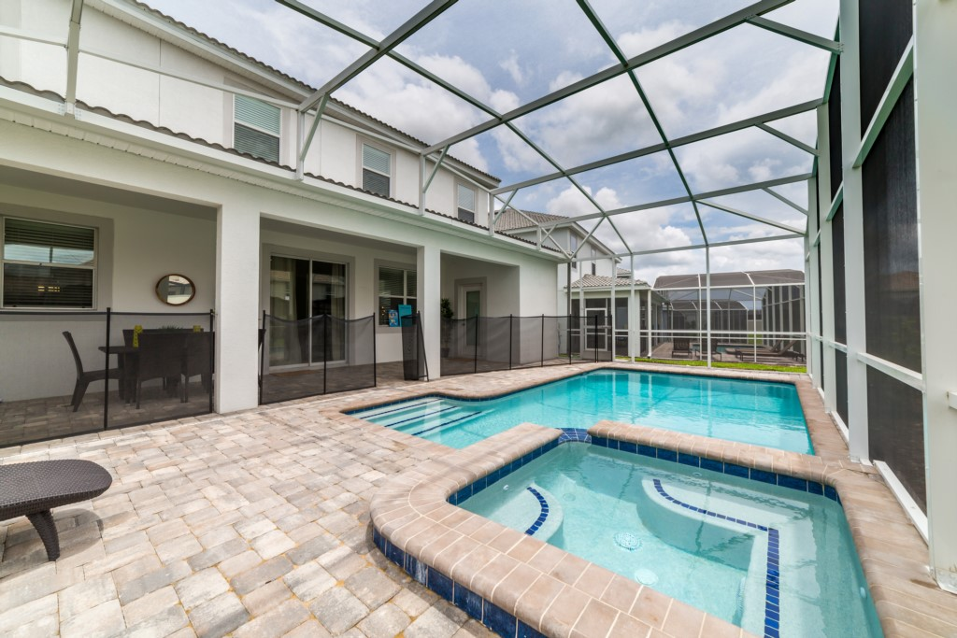
This massive 3,348 square foot home offers six bedrooms and six bathrooms, allowing up to 12 guests to sleep comfortably during your next visit to Orlando! Relax and enjoy the privacy of your very own crystal clear pool and bubbling spa, or unwind after a long day in the game room equipped with a table soccer, air hockey game, and pool table. This stunning private home has everything you need to make your next trip to Orlando the adventure of a lifetime. Located only 10 miles from Walt Disney World®.
Property Summary
* Pool with raised, bubbling spa
* Sun deck and shaded lanai
* Contemporary furnishings and decor
* Full kitchen with granite counters and stainless appliances
* Laundry room with washer and dryer
* Air-conditioned bonus games room
* Pool, foosball, and air hockey tables
* Two themed bedrooms (Mickey Mouse and Princess)
* Flat screen HDTV in every bedroom
* WiFi high-speed internet provided FREE
* Local and long-distance (US) calls FREE
* Digital entry/lock system with unique, private code
Community Summary
During your stay, be sure to explore and experience the Oasis Clubhouse at the ChampionsGateResort - with its fabulous amenities and fun atmosphere you are guaranteed to have an excellent time.
* Resort clubhouse with two pools and a lazy river
* Resort water park with splash-zone
* Resort poolside tiki bar and cabanas
* Resort hot tubs
* Resort tennis, volleyball, and basketball courts
* Clubhouse bar and restaurant
* Clubhouse games room and movie theater
* Clubhouse fitness center and sundry shop
* Clubhouse children's play center
* 18-hole championship golf course, pro-shop, restaurant, and bar
* Gated and guarded entrance
Offering the widest selection of the highest quality vacation homes in Orlando. We are accredited by Walt Disney World® Resort and can guarantee that your vacation property will be within easy reach of all of the theme parks and attractions. Book your perfect Florida family vacation getaway today.
* Professionally managed, inspected, and cleaned
Whether you're traveling for pleasure or business, your accommodations are located strategically for easy access to Orlando's must-see attractions. You can enjoy the nearby theme park destinations such as Magic Kingdom, Epcot, Hollywood Studios, Animal Kingdom, Universal Studios, Islands of Adventure, Sea World, Legoland, Aquatica, Discovery Cove, Typhoon Lagoon, and Blizzard Beach.
Being in the heart of the number one family travel destination, you will always be able to enjoy world-class entertainment, outlet mall shopping, championship golf courses, great museums, and world renowned dining from places such as City Walk, Disney Springs, International Drive, and the Orange County Convention Centre

