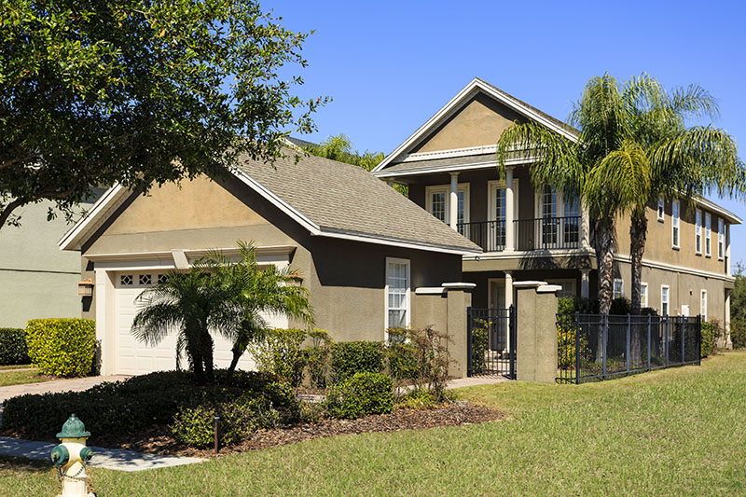
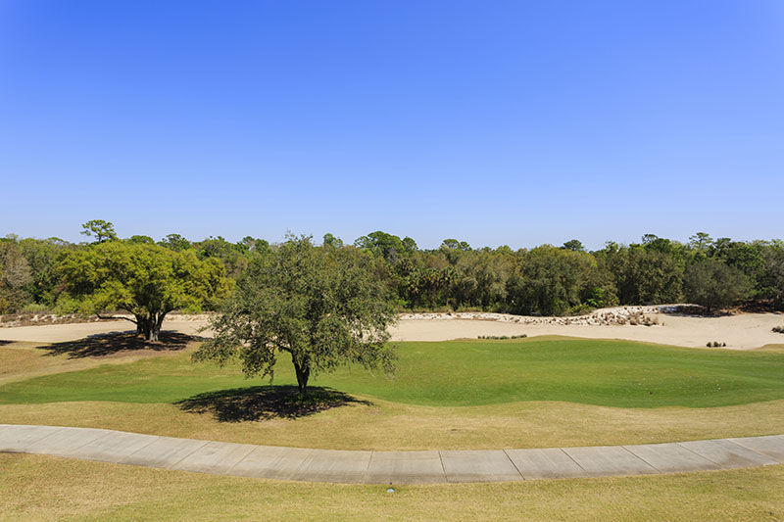
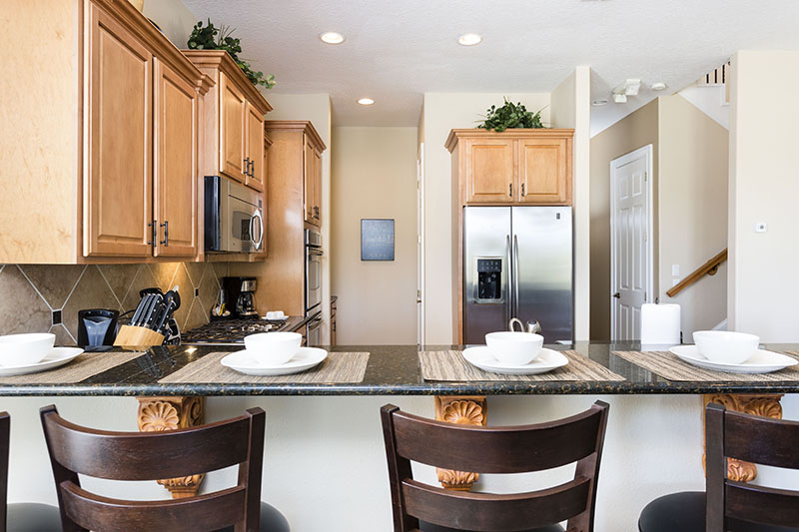

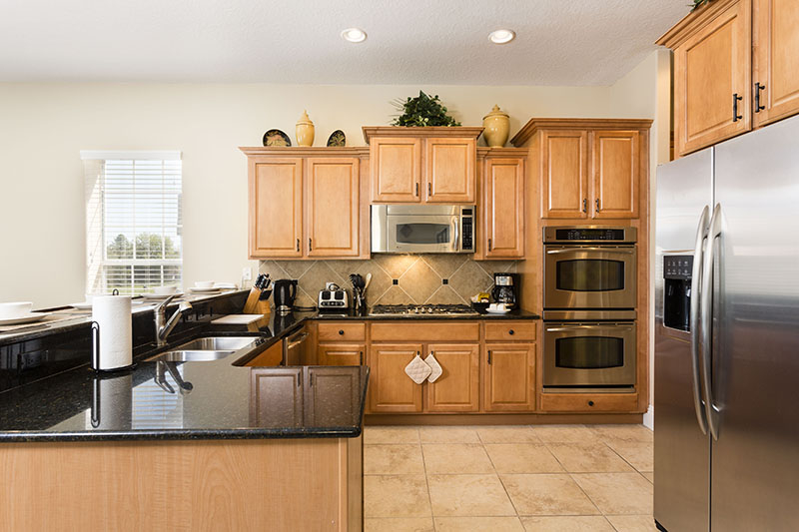

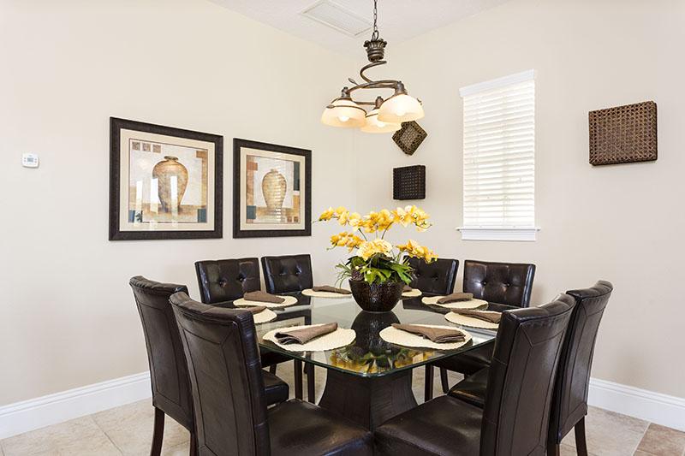
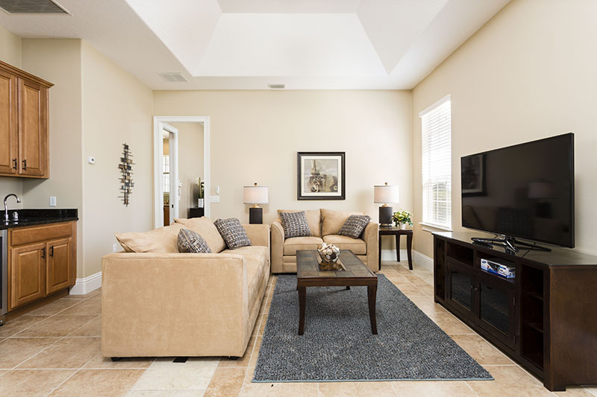
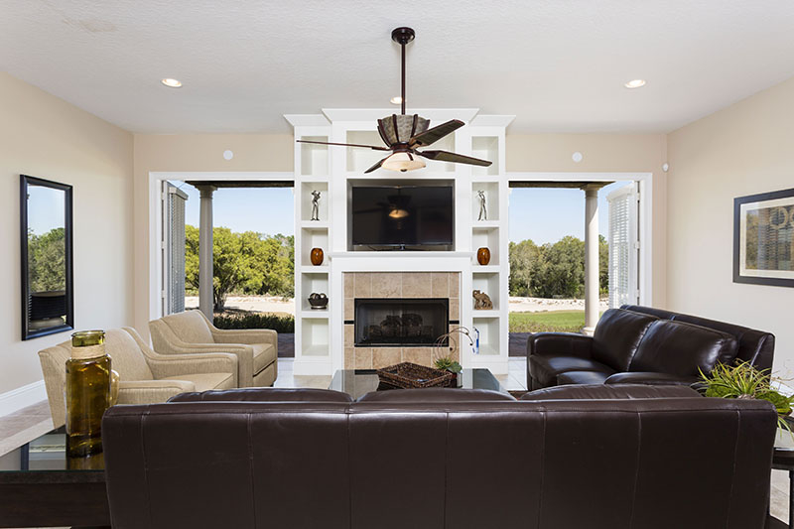
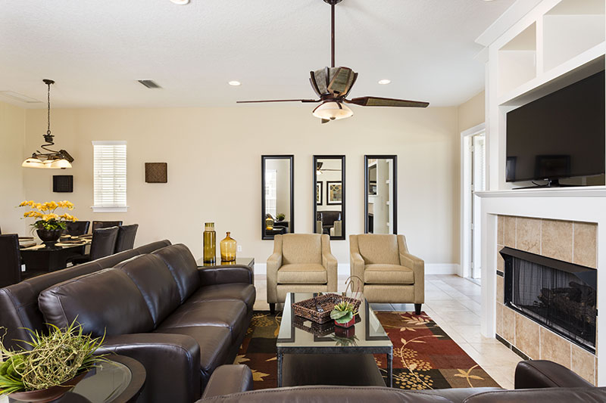
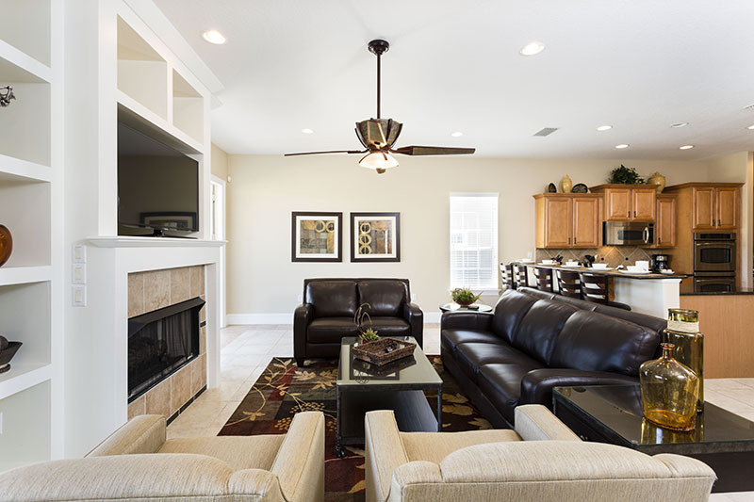
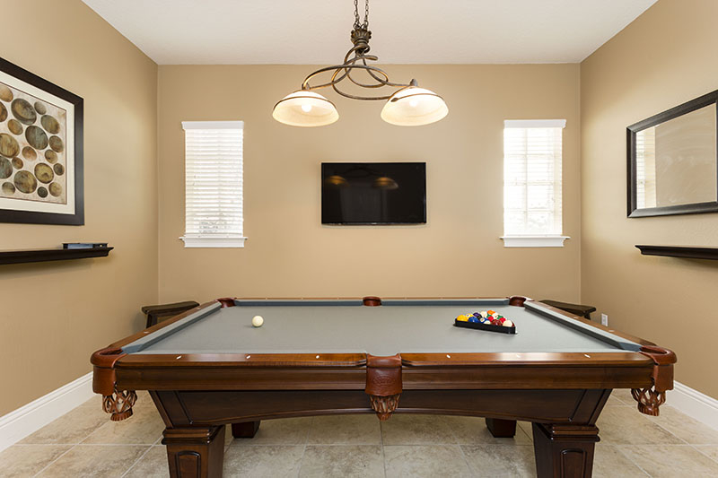
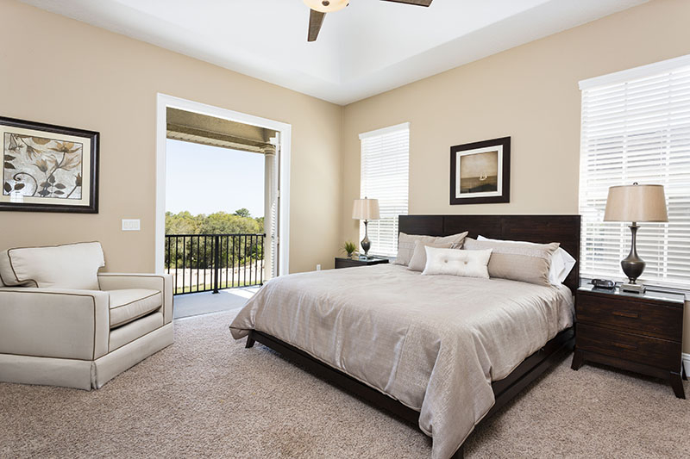
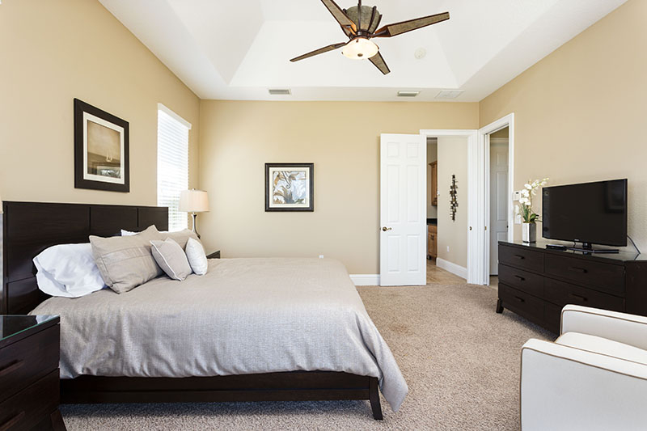
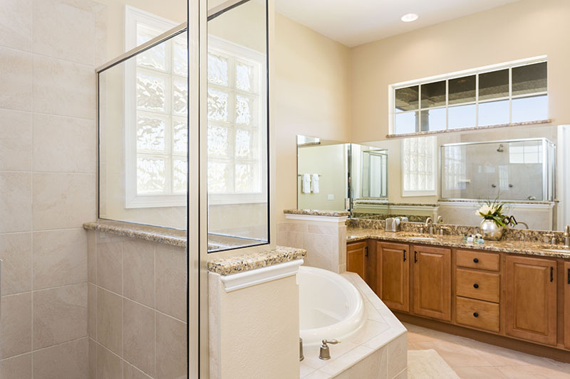
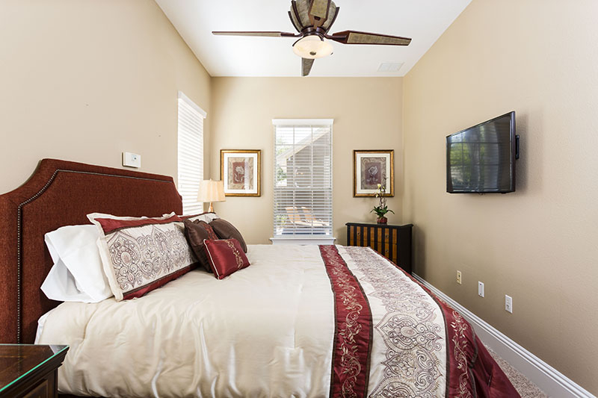
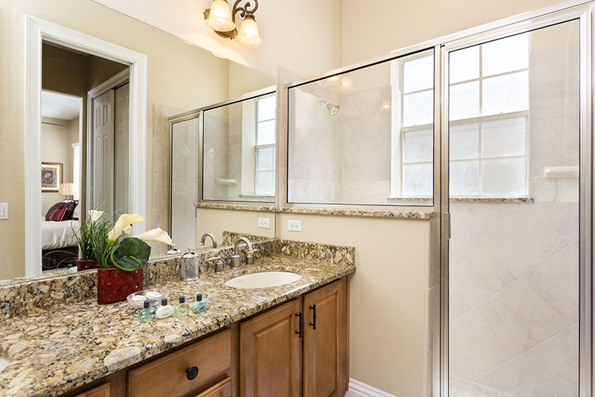
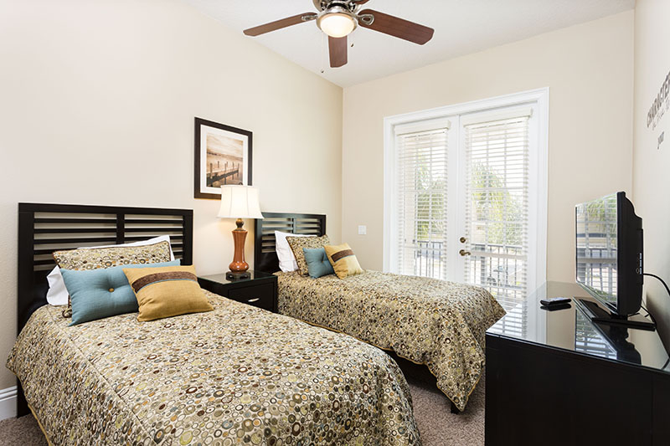
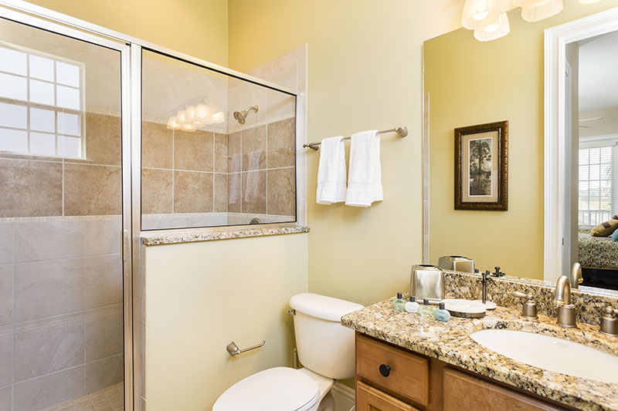
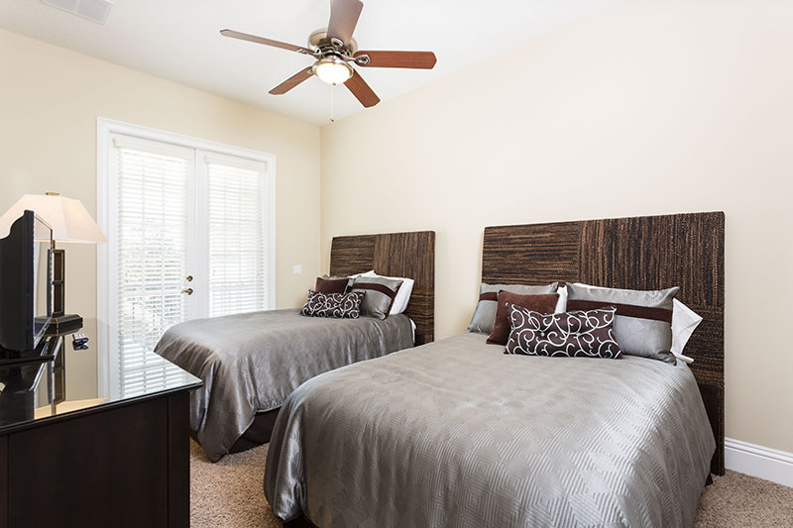
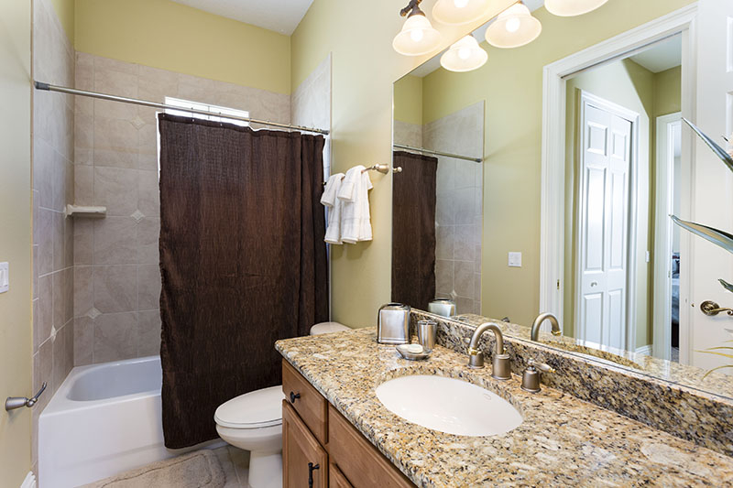
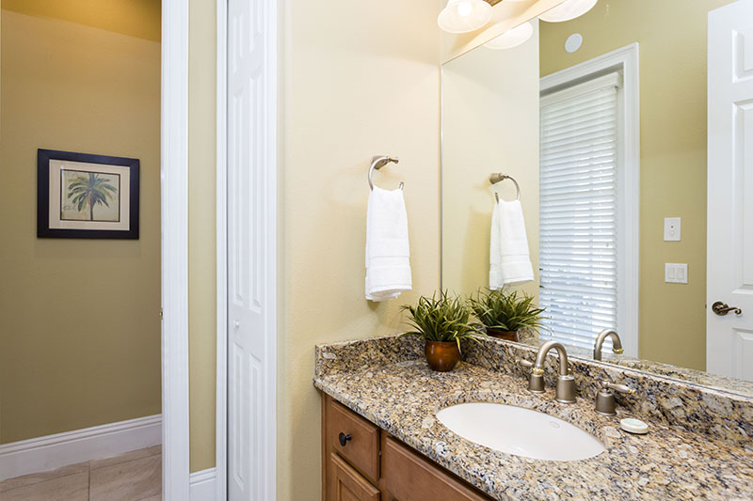
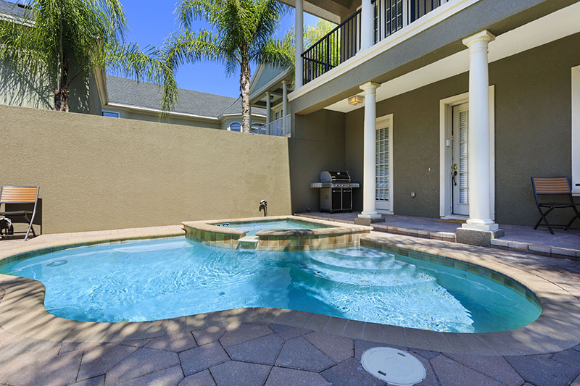
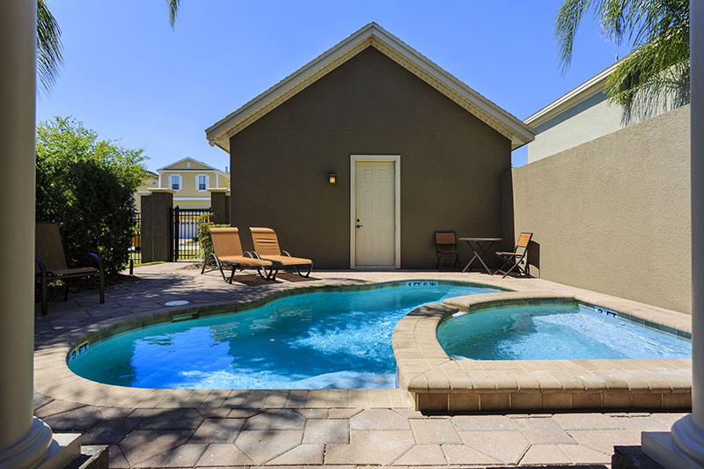
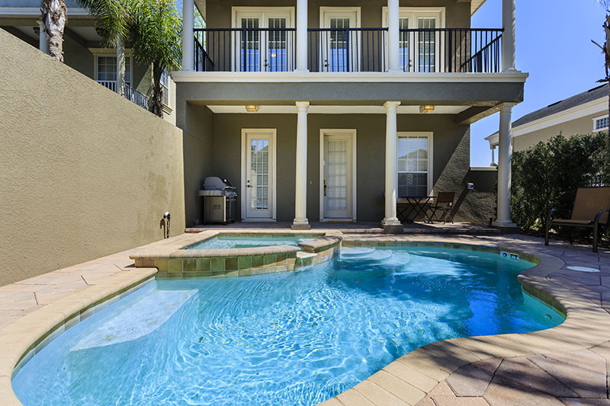

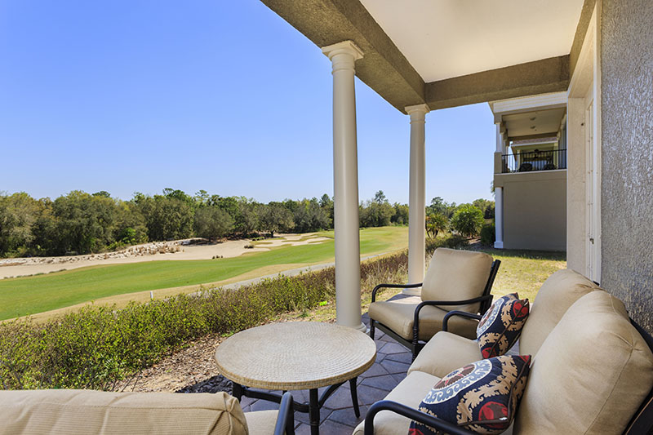

This beautiful executive family home is brand new to the vacation rental market for Easter 2013 having been completed by one of Reunion's renowned interior designers. A fabulous combination of elegance and comfort have been acheived in the overall feel of the home. Come and Enjoy!
Located on Excitement Drive in the Liberty Bluff section of the Reunion Resort overlooking one of the three PGA golf courses that Reunion is home to - having Palmer, Watson and Nicklaus courses which no other resort in the world can claim. In addition to golf, the Reunion Resort and Spa has a wonderful array of amenities including excellent restaurants, an outstanding spa, tennis, waterpark, cycling trails and beach volley ball courts to name a few though membership is required for certain activities.

Bedrooms:
King sized master with en suite (shower, tub, twin vanities) and balcony access
King sized bedroom with en suite (shower, twin vanities)
A bedroom with a Full and Twin sized bed and an en suite (shower)
A bedroom with a Full and Twin sized bed and an en suite (shower/bath combo)

Main Living Area:
Spacious comfortable seating area with a leather sofa, love seat, and two accent chairs as well as a feature fireplace
Extra living space with a sofa and love seat

Kitchen:
Fully equipped with a black granite five seat breakfast bar
Refrigerator/freezer, oven, microwave, dishwasher, coffee maker, toaster
All utensils, cookware, dinnerware, glassware

Dining:
Table seats eight people

Entertainment:
Each bedroom is furnished with a TV and capable of Wifi
Both living areas both have a large flat screen TV
Pool table

Outdoor Living Space:
Private pool and spa
Built in summer kitchen with a grill, 2x two seat patio tables, and four sun loungers

