1. @Ramcharan
wo NPS ki tesing me amendment form ka question kiya tha tumne mujhe.. ki WB me hoga ki nhi..
I asked you to check and inform me ki ho raha h ki nahi.. have you got the chance to check?

Question - https://ocean-holidays.leankit.com/card/855562762 Ye card iss issue se related hai kya? Developer isko dekh rha hai.

2. @Mohit @Devendra Sir - feefo post review - kya isko bhi webconfig se manage kiya hua?
i know feefo is 1 key for API but on this API we have 2 type of review
pre and Post

but agar kisi ek me issue aya and isse off karna hua toh webconfig se key off karke kar sakte... Ye agar manage nhi h toh please isse karwa lena.. LINK generate nhi hoga... and feefo pe link bhi nhi ayega..
Ans - Yes, We are manage by key.

- rc2x URL
SPP- OC/OC- G2B
maine G2Bquote banaya uspe nights 12 h enquiry pe
flight product me lekin wo show nhi ho rahi... 0 ke according calculation h
It should be based on 12
deafult enquiry and booked wali same honge duration.. enquiry wala change nhi hota auto..but booked wala hoga.. like we discussed and it will be same as dept date concept
check this on MONDAY
Ans - This is working fine as per discuss with cathy.

4.@Mohit
Jo case live pe aya tha ek agent ki booking confirm nhi ho rahi thi u said that was a case of full payment.. jisme full payement lena tha but user ne split kar diya deposit in today's deposit and second deposit me..
well exact same case maine abhi Rc2x pe banaya and wo booking same case me confirm ho gyi.. so what you were saying that day is not matching...
ISKO WAPAS DEKHNA.. i dont what did you investigated but i was able to confirm with same scenario and worked but use din agent wali booking nhi hue thi confirm....
ISKA CATHY SE KUCH CONFIRMATION AYA???
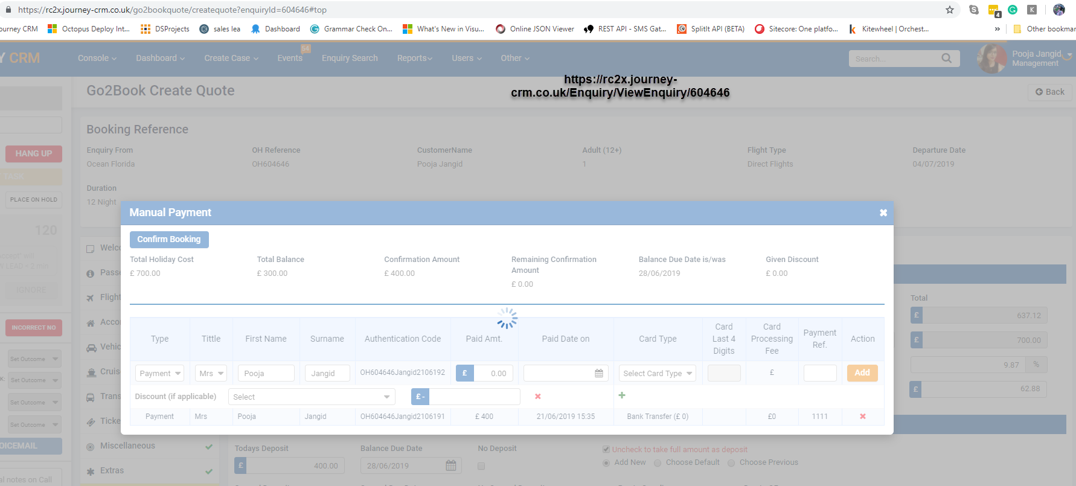

5. @all https://ocean-holidays.leankit.com/card/734079289/comments comment dekh liya tha ispe? about scheduler time setup?
Ans - Ye scenario get nhi hua hai abhi.

6. Sail Date auto fill hoke nahi aa rahi.. i think product pe date auto fill hoti h... Dekh lena please…
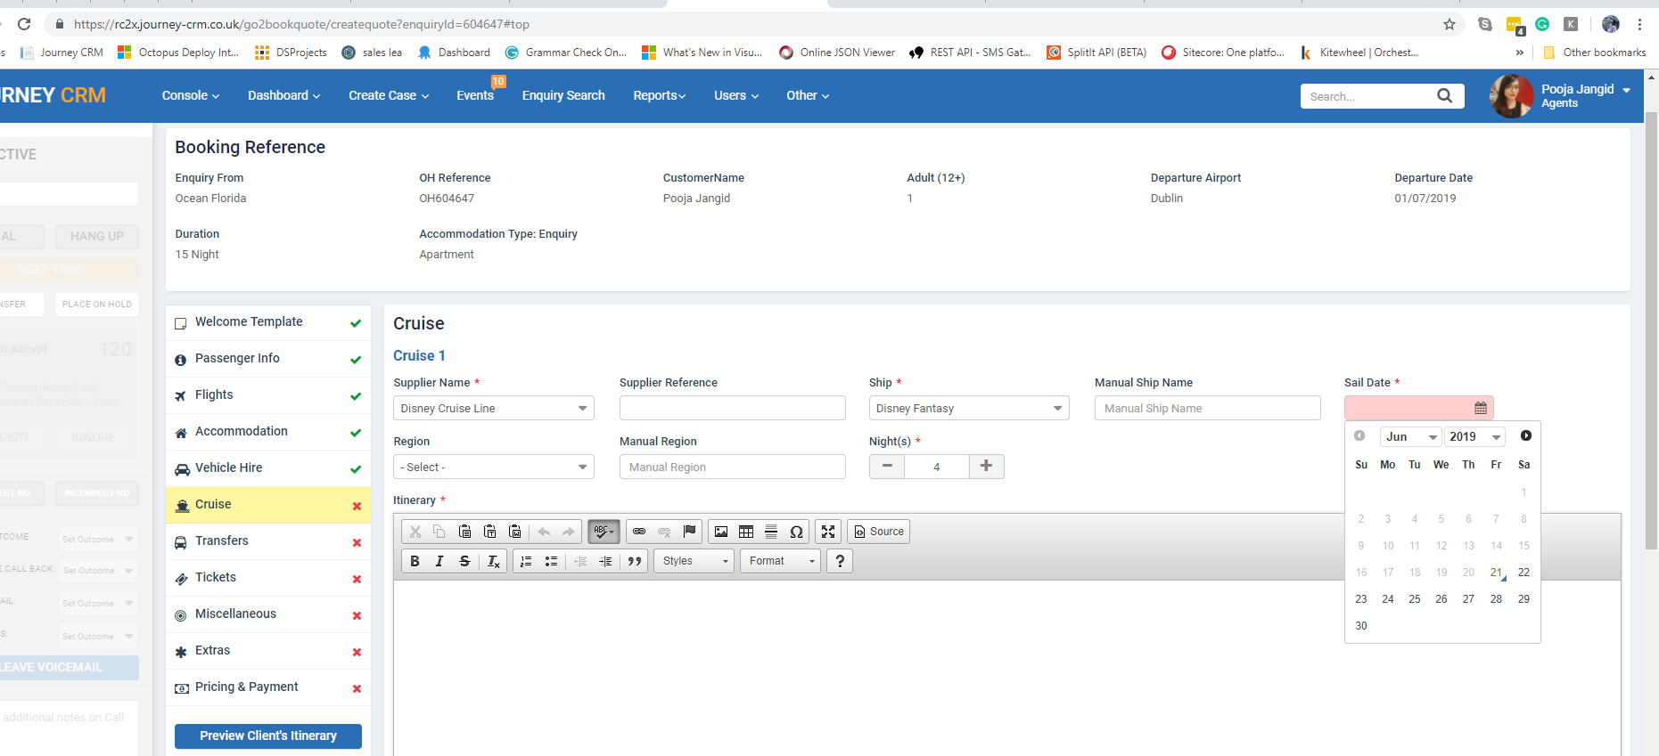

Ans - Done on Staging.

7. NPS - Feefo post review
isme 1 hi product ka review aa rha
i thought it will be for all products... OH604647
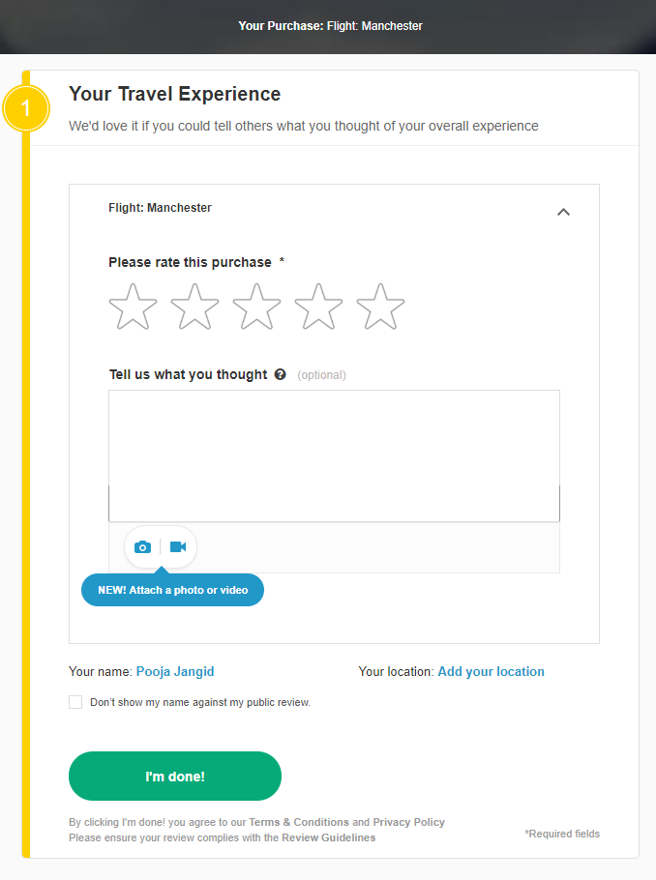
Ans - This is issue. We will fix this issue.

- Low priority - WB g2B form payment tab
alignment should be same as second deposit for
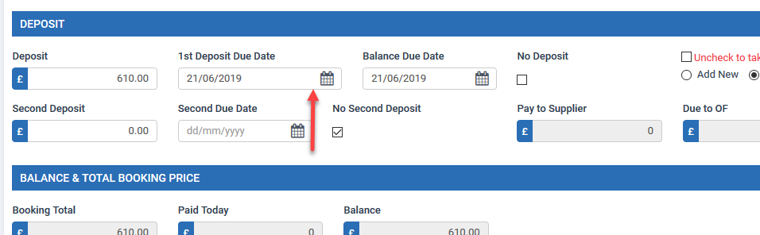

Ans - Done on Staging.

9. all brands- g2b form- payment tab
jab mai second deposit me date add karti hun which is greater/lesser than 1st deposit or balance due date then error messge 2 aate h
1 invalid date format ka and 2nd for date should be greater..
yahan 1st wala message kyon aa raha h?? Date format toh sahi add kiya h maine
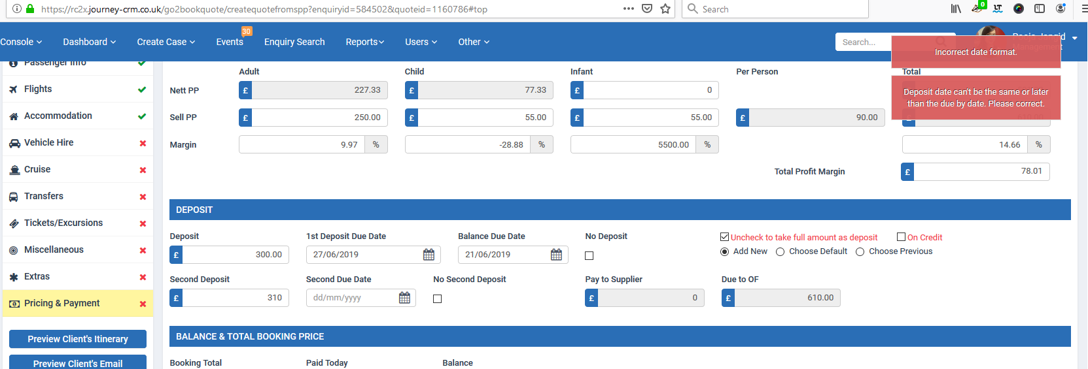

Ans - Done on Staging..

- @Gaurav - Confirm but dont email - is button pe click pe successmessage me commit booking without email aa raha h WB me. jabki confirm booking ana chahiye not commit.
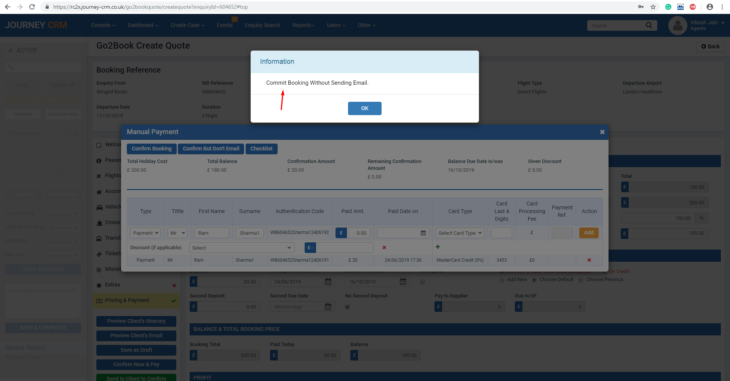

Ans - Ye initial stage se hi aisa chal rha hai. But agar aap change change karna hai to change kar denge.

- Question: jab hum Live pe dept and return date update kar denge as per TD toh contact ke journey status kab update hoga? Scheduler run pe if so then do we run that manually?
or if not scheduler then kaise hoga?

Ans - Scheduler run hone par staus update ho jayenge.

