301.a
Also the 4 - is that relating to current live referrals? Because if it is, it needs to be relabelled to say ‘Current live referrals’ and the table needs a separate heading to say ‘Number of referrals by month’
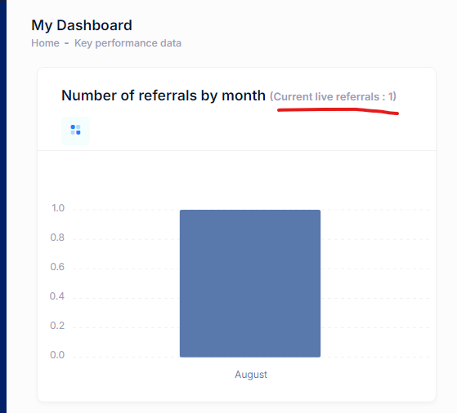

301.b
The data here does not appear to be calculating properly - can you check this? Specifically for:
Number of current live referrals
Referrals in each month
Showing live refral

302
Change this to say ‘Internal referral reference’
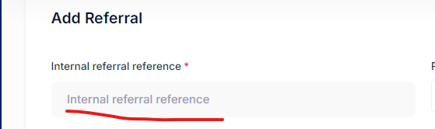

303
Change this to say ‘Internal referral reference’

Same on draft and archived referrals, and live placements and archived placements

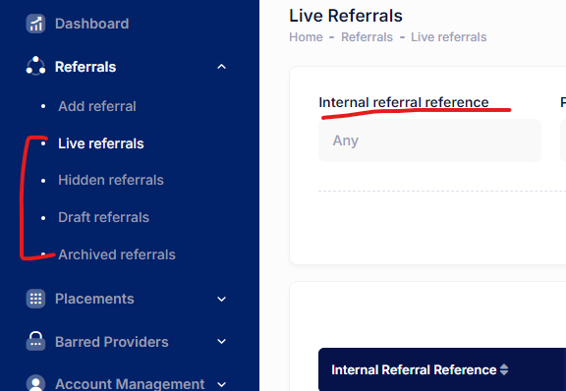

Same text not available on placeholder

304
Add Non-binary as an option

Change ‘Any’ (which was meant for ‘Gender requirement’ not ‘Gender’ field) to ‘Other

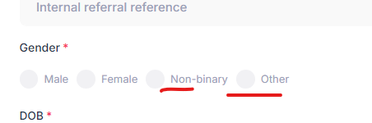

305
Make these fields non-mandatory

Should only be visible to LAPT not CP when they view the referral

Visible fot LAPT
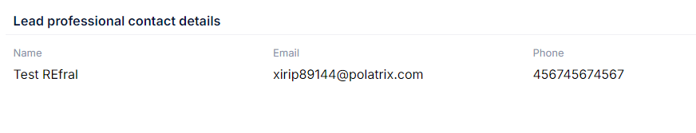

Not visible for care provider
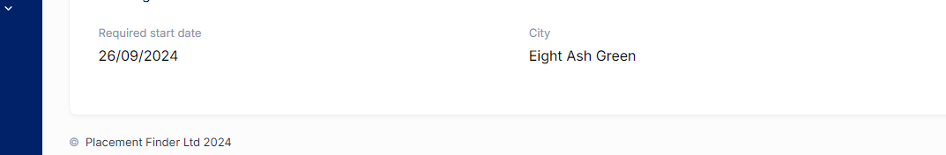

309
This should say ‘Local Authority’ instead of ‘Company’

Company is for CP profiles

Not showing local authority text

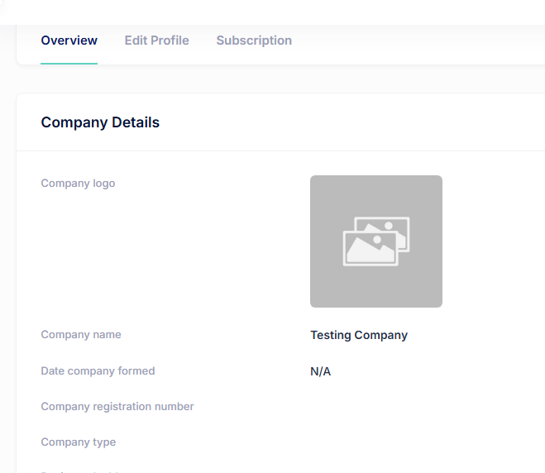

310
Rename this to ‘User profile’

Not Fixed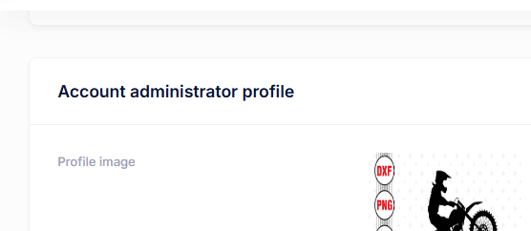

311
Remove column in yellow from every table on the system- Done

For LAPT do we need the columns in green and red? They won’t be on any plans as they will just have the system for free on an ongoing basis
May be this page just needs to show account start date, number of active users etc? - DS response: Please elaborate

Not clear
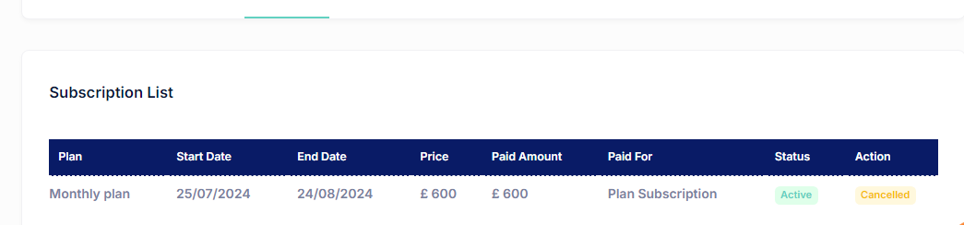

312
Need to have ‘Any’ option

DS Response: You only asked us to remove this, please let me know the final one.

Male only/ Female only / Any

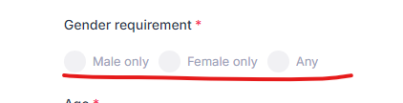

313
Add White (British)
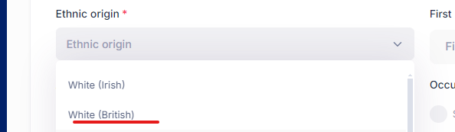

314
Lapt sidebar options
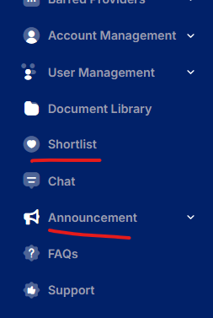

Not Fixed

315
Change font colour on all green buttons and areas across the whole site to blue like this - looks much better and easier to read than the white.
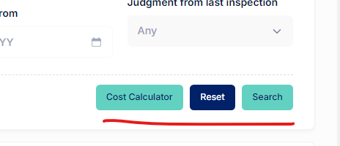
Not Fixed

316
Remove the word ‘year’ so it just shows a number
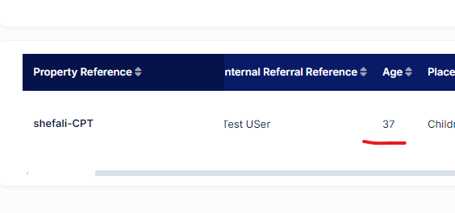

306
Is there a way to add the discounts to the blue costings box above so it’s all the same design? Doesn't look good as a separate box and makes the page too busy
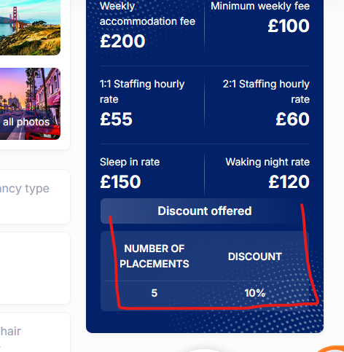

307
know we’re changing the design of the section that contains key information about the provider but can you do something about the spacing as it looks squashed together - move the buttons row down a little so more space between that row and the info above

Also the buttons did not work when clicked

See what colours look best on these buttons - the green or the blue

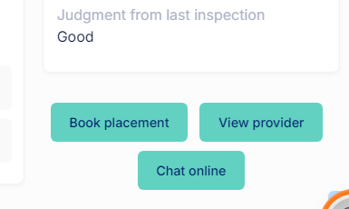

321
Change this to ‘Calculate’
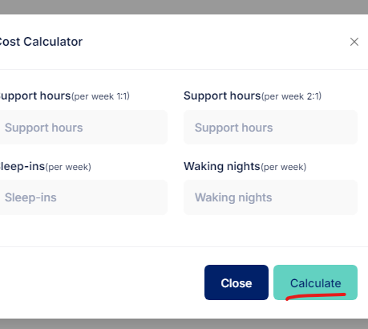

323
Choose Account Type
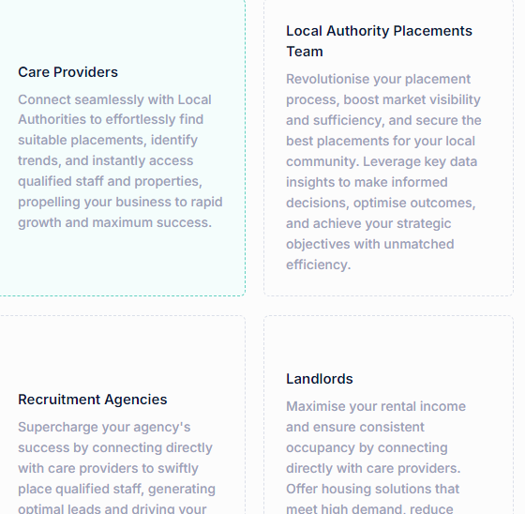

325,326
Email Format
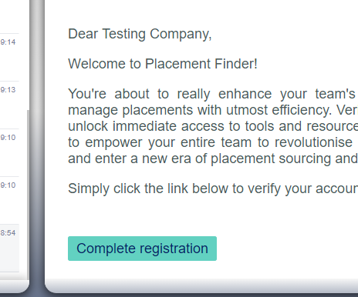

327,328 - Not implemented

331
Account adminstration profile
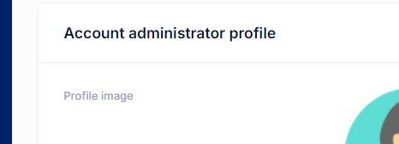

330
Ofsted
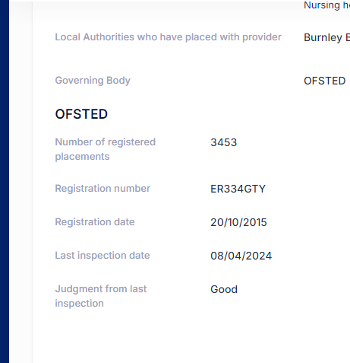

329
Needs to be displayed as a vertical list in alphabetical order

There needs to be a box to check next to each LA name so easier to select multiple without having to keep clicking

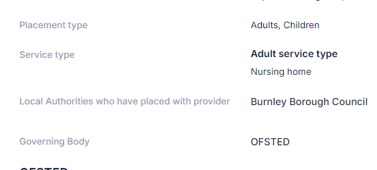
Not fixed

334
Have chat function in this window so they can contact LAPT team directly
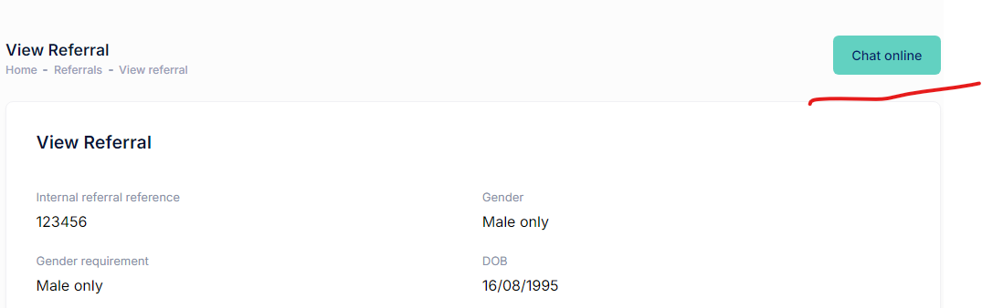

335
This should say female only (or male only, or any)
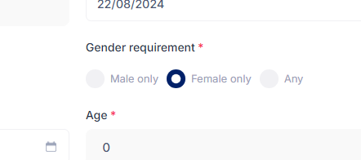

336
Graphs need to be aligned
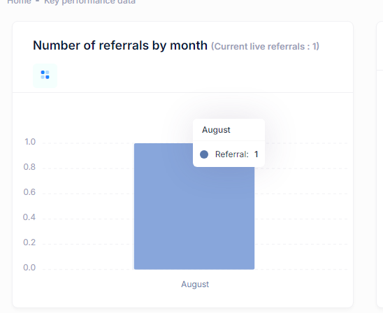

337
These fields are not needed when creating an LAPT account
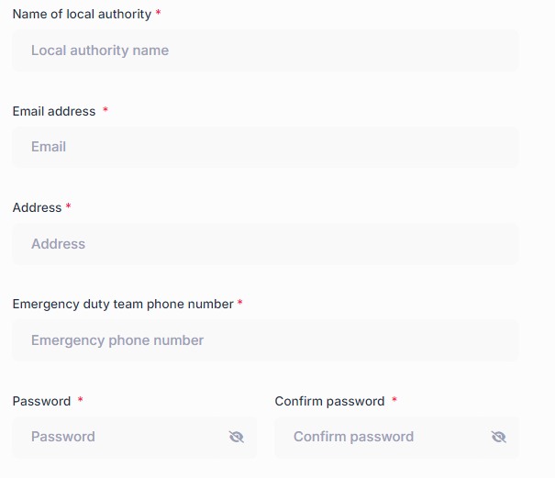

338
This should say male only, female only, Any
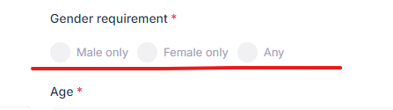

339
Remove the apostrophe in the word childrens

And make P in parenting assessments lowercase
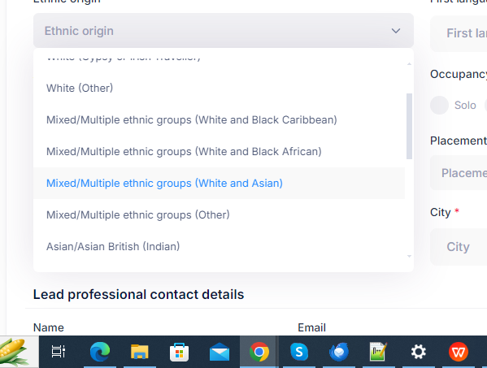

Children not available in option

340
Design needs to match the rest of the site

E.g. the top row need to be blue

The red icons need to be blue or green

Change name ‘Common’ to “‘All placements teams”

Children to Children's Placements Team

Adult to Adults Placements Team
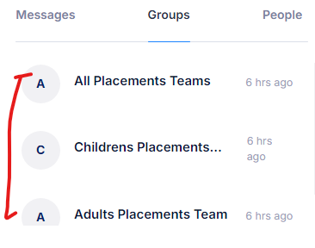
342
Can you make this column a little narrower to make room for the plans? If you view the screen at 100%, you can’t see all the options on one page and you have to scroll across to the right - this needs changing
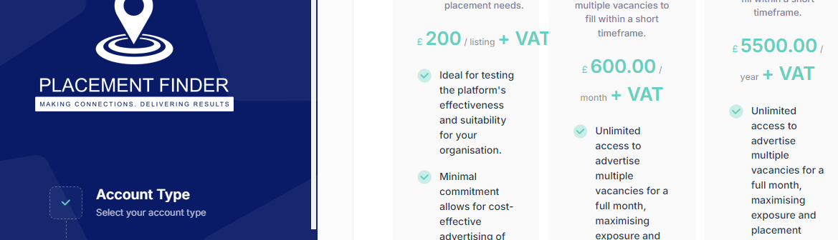

343
Change the wording after each cost to + VAT - text colour to be same grey as that in the text in the description.

The £200 should say First listing for free and £200 + VAT pe

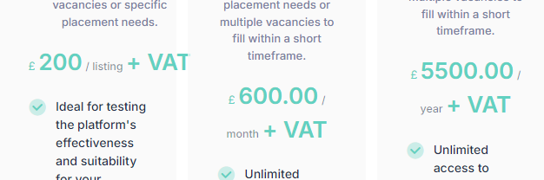

345
Change wording to:

“Free 30 day trial”

“Advertise a placement and explore the features”

Remove the full stop
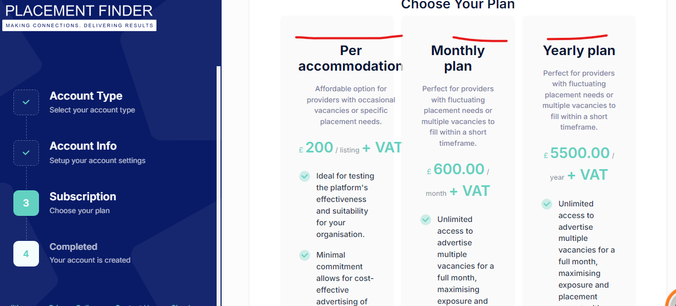

Not Fixed

346
Change wording to:

“Perfect for providers with multiple vacancies to fill within a short timeframe”

Remove the full stop

Not Fixed

347
Change wording to:

“Tailored for larger or growing organisations with ongoing vacancies throughout the year”

Not Fixed

348
Change this wording to:
Post your first placement at no cost for 30 days and experience the benefits firsthand
After 30 days, each listing is £200 + VAT

Not Fixed

349
Change this wording to:

Not Fixed

350
Change this wording to:

Not Fixed

351
Make the logo bigger

Not Fixed

352
Change button wording to “Free posting”

Not Fixed

353
Change button wording to “Unlock more”

Not Fixed

354
Change button wording to “Go premium”

Not Fixed

355
Change orange shade to #F28C28,

Not Fixed

356
Make the TEAM “TEAMS”
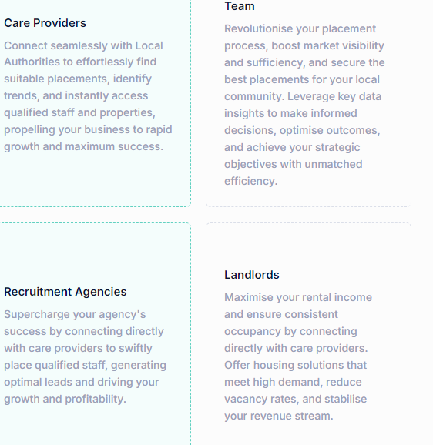

Not Fixed

357
Change these to green

Not Fixed

358
Change wording to “Local Authority logo”
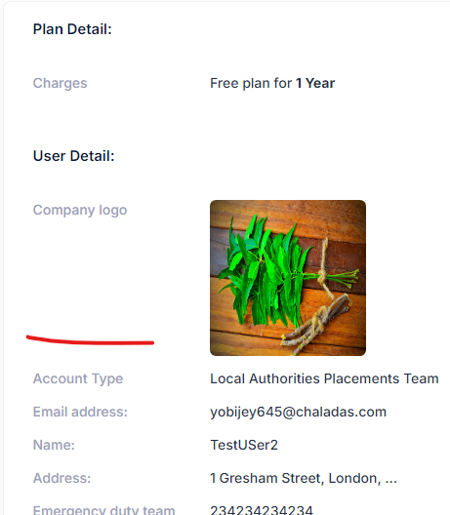

Not Fixed

359
Remove this

Not Fixed

360
Change this wording to “Account details”

Signup should be “Sign up”

Not Fixed

Not Fixed

