Highlands Reserve Ocean 175

The large luxury villa overlooking the conservation, South facing pool deck, has 5 bedrooms and 3 bathrooms, The lay out of this villa commands privacy for all the bedrooms. It is situated in Highlnds Reserve Golf Community, single storey villa including a Master bedroom with King bed and patio door leading to the pool deck; large ensuite Master with a double walk in shower, his and hers sinks and a large Bath. there is a queen bedroom, with a bath room adjacent, a bedroom with anther queen bed and 2 twin bedrooms with a bathroom between. Wi-fi is available and free, a large TV room, with large comfortable couches, dining area, and a second lounge area, The kitchen in well fitted for self catering , there is a breakfast area, patio doors lead out to the pool deck so you can also enjoy the poolside eating area . large size laudry room with separate washer and dryer. The rear of the property has an enclosed swimming pool and spa and pool deck, with a lanaii, overlooking the conservation area. there are loungers, patio table and chairs for relaxing by the pool. The villa is managed by people who live nearby on Highland Reserve. The villa is situated on Highland Reserve a popular area which has a Mike Dasher, designed 18 hole quality golf course, Shops (including a supermarket), restaurants, take-aways. and more are a few minutes away. You will be in easy reach of downtown Disney , all the Disney parks and many other different restaurants and shops are a 10 to 15 minute drive away.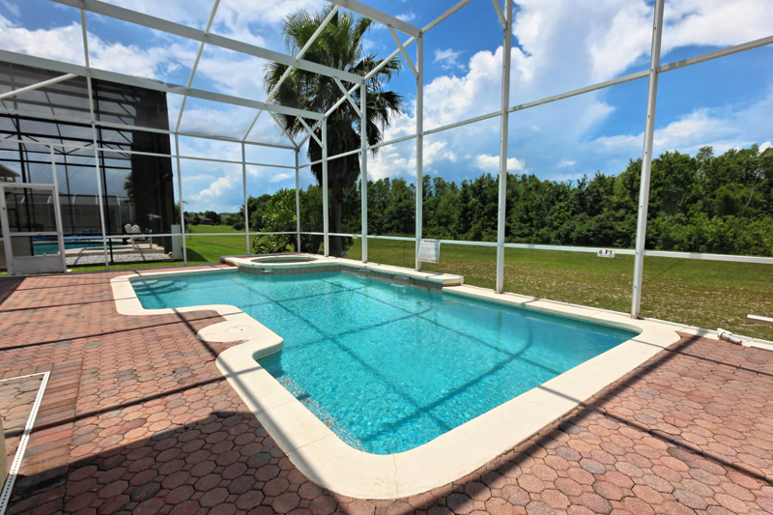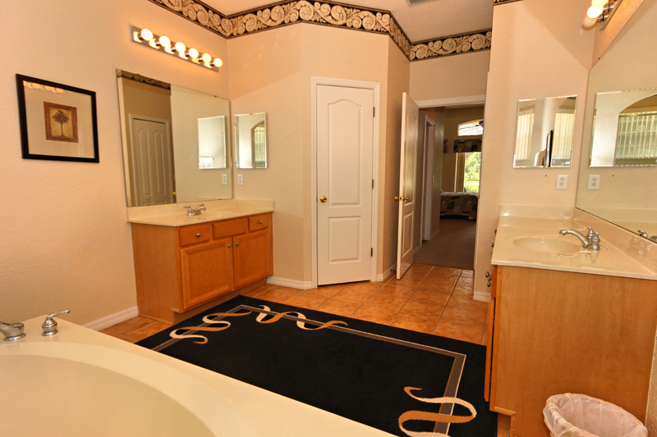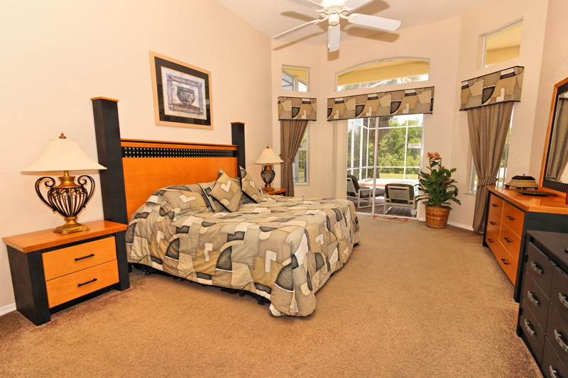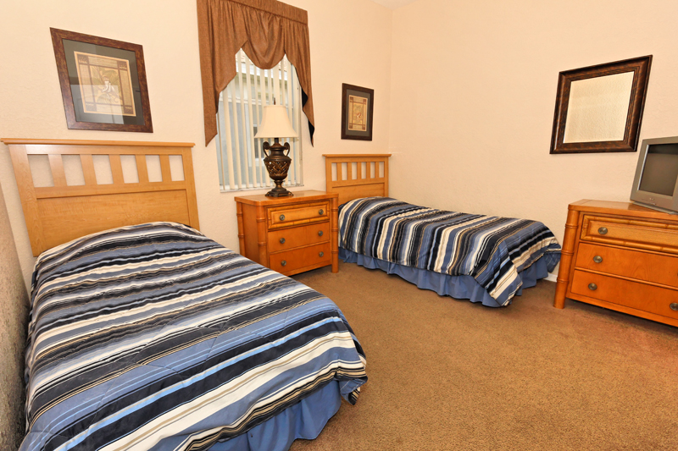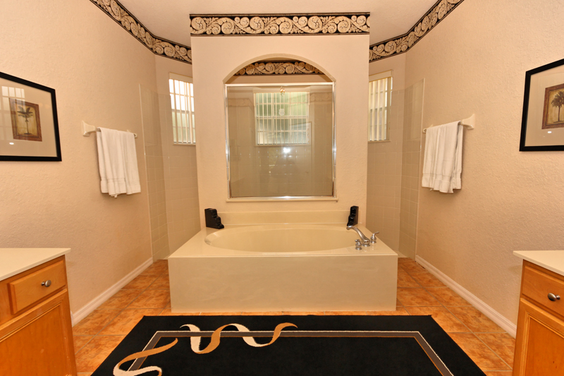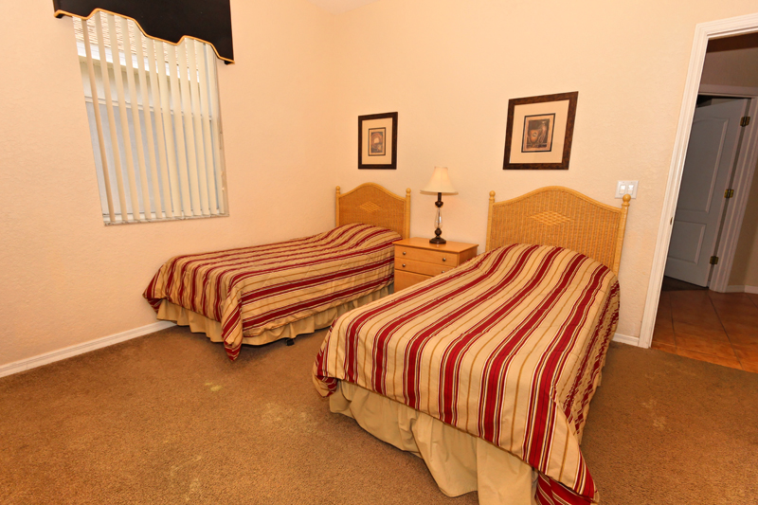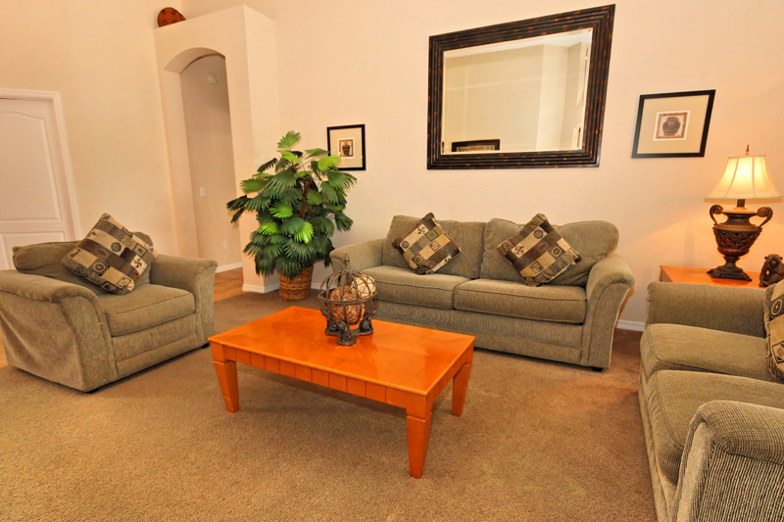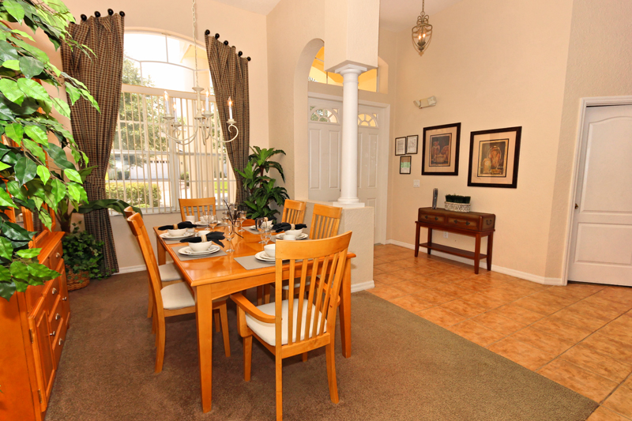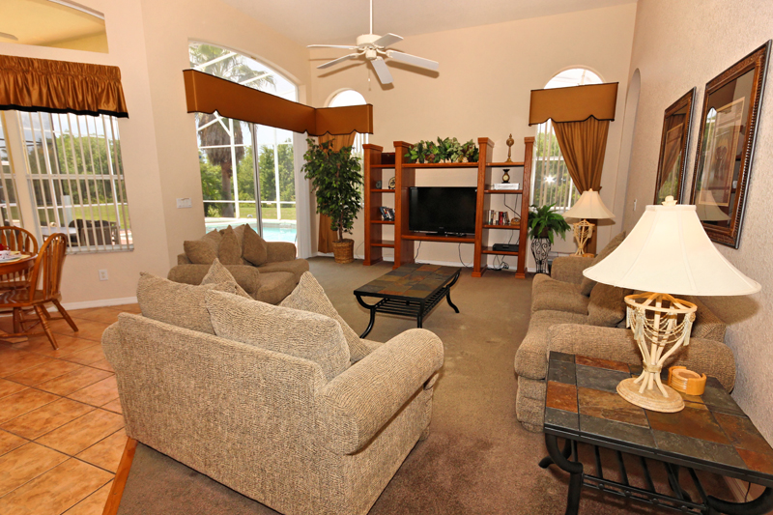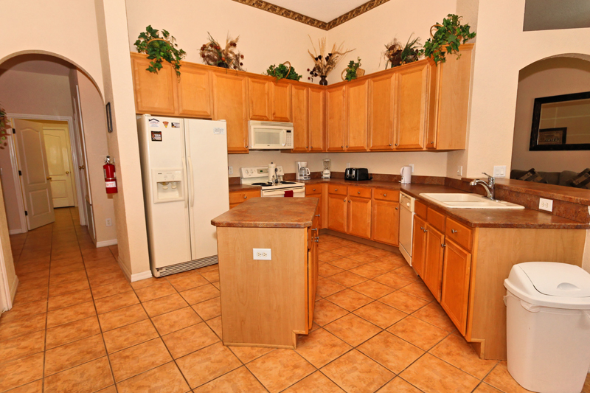

Solterra Resort Ocean 72

This gorgeous brand new 5 bedroom, 4.5 bath vacation home rental in the beautiful Solterra Resort, Davenport, Florida! There is enough space for the entire family in this open, spacious, 1 story Disney area vacation villa paradise. The location could not be any better. Only a few short minutes from Walt Disney World and Orlando's other famous attractions like Universal Studios, Seaworld, and Legoland, our Solterra Resort villa rental sits nestled off Interstate 4 and Hwy 27. Easy access to shops, restaurants, and world class golf. Solterra Resort is a secure gated community only moments from the magic but far enough to experience peace from the busy tourist district. Solterra Resort is 15 minutes to Disney with access to the Interstate only 3-5 minutes from the entrance.
Our luxury villa offers a full living area downstairs and a separate loft area upstairs both with large flat panel tvs to enjoy a movie night and gaming on a relaxing day in from the parks. No detail has been spared as the owners have ensured that your every need is addressed from a fully stocked kitchen to the choice of refreshing paint colors. You can have a Disney area villa rental for less and get a lot less. But here in our villa rental you will have upgraded, plush mattresses for a perfect nights sleep with quality bed linens and so much more. This Solterra Resort villa rental is luxury, fun for the family, and relaxing for the adults!
Resort Amenities Include a 6700 square foot clubhouse, swimming pool, spa, fitness center, business center (with Internet access to ensure you stay connected!), volleyball, tennis, childrens playground, and a picnic area where you can enjoy a meal and relax.
