5 bed, 5 bath Davenport villa, with private pool and spa

• Private Pool & Spa
• Games Room
• 10 Mins from Disney
• Restaurants & Shops Nearby

Spacious and centrally located, this five bed, five-bathroom villa sits in the fantastic community of West Haven. Located close to the US27 and Interstate 4, guests will have easy access to some of the best shops, bars and restaurants that Florida has to offer. What’s more, Walt Disney World is only a few miles away, and Universal Studios and SeaWorld just a little further.

Guests staying here will enjoy free local calls and Wi-Fi. BBQ hire is also available for a small charge – an ideal addition the villa’s private outdoor space and pool.

For keen golfers, The Champions Gate Golf Course, which has two 18-hole courses, is located just over three miles away. Venture a little further and guests will find the world famous Reunion Resort golfing facilities. In fact, there are a total of 15 top-quality golf courses located within a 30-minute drive of West Haven.

Information

King-size 2
Queen 2
Twin 1
Bathroom 5
Private Pool Y
Spa Y
Internet Y
Games Room Y

Description
This beautiful five bed villa at West Haven has plenty of space for everyone in the family. There’s a bright and spacious luxury kitchen, with all the modern appliances that one might need, along with a breakfast nook and formal dining area with seating for 10. When it comes to the bedrooms, guests can choose from two king bedrooms, two queen bedrooms and one twin bedroom to sleep in.

The private pool and spa area is one of the major perks of the villa, and the best place to sit back, relax, and make the most of the Florida sunshine. The luxury doesn’t stop there though, the garage has been turned into a games room and is equipped with its very own pool table!

Location
West Haven is a master-planned community located on Loughman Road, just north of Davenport in Orlando, Florida. The community is made of several neighbourhoods of single-family holiday homes, each individually gated, housing residents from all over the world.

West Haven has been, and remains very well managed, and offers spacious homes with superb floor plans and amenities. There are also communal facilities, including a clubhouse, available to all guests, a resort-size pool, gym, tennis courts and volleyball courts.

Guests will also have easy access to the I-4, putting them at all the heart of all Orlando’s attractions.

Driving times:

Disney World Resort 10 min
Animal Kingdom 15 min
EPCOT / Hollywood Studios 20 min
Downtown Disney 15 min
Universal Studios 30 min
Orlando International Airport 35 min
Sanford Airport 55 minutes

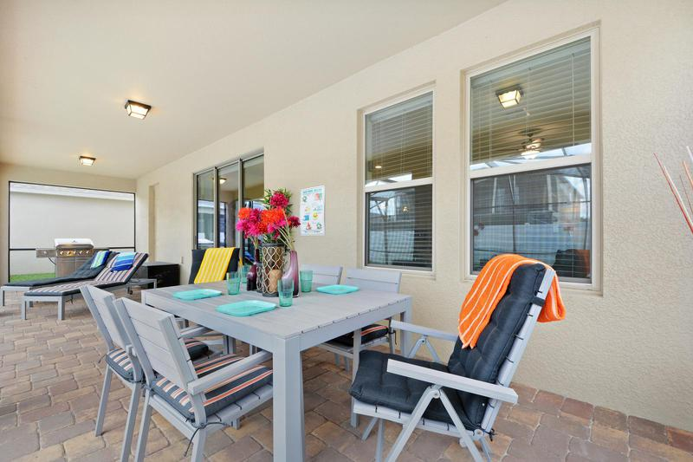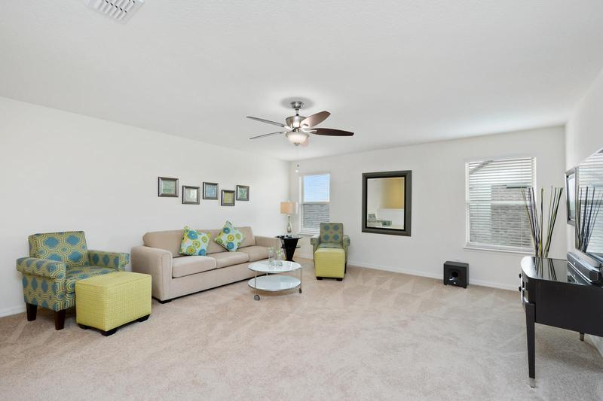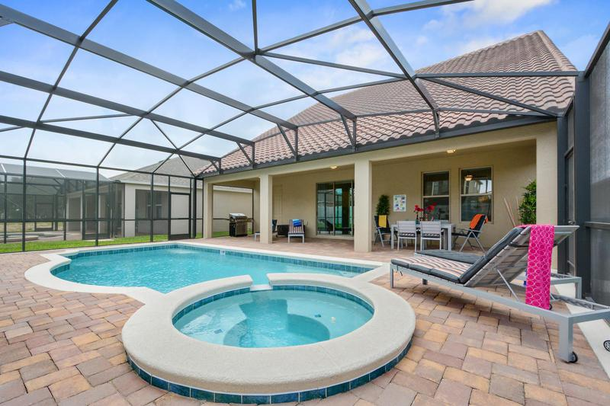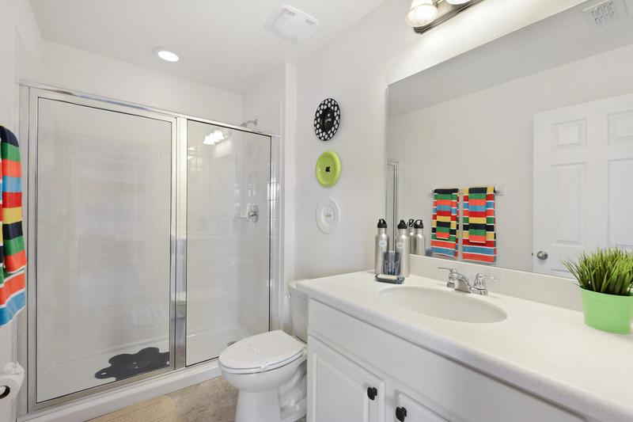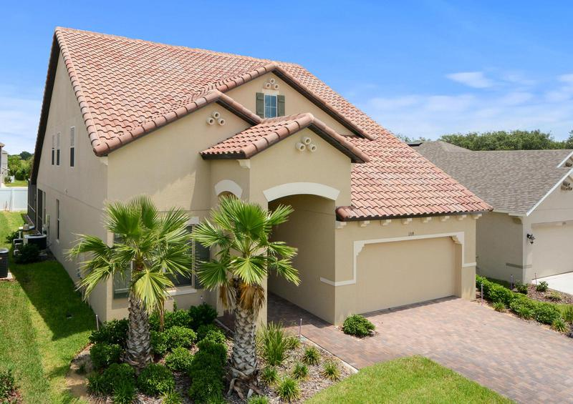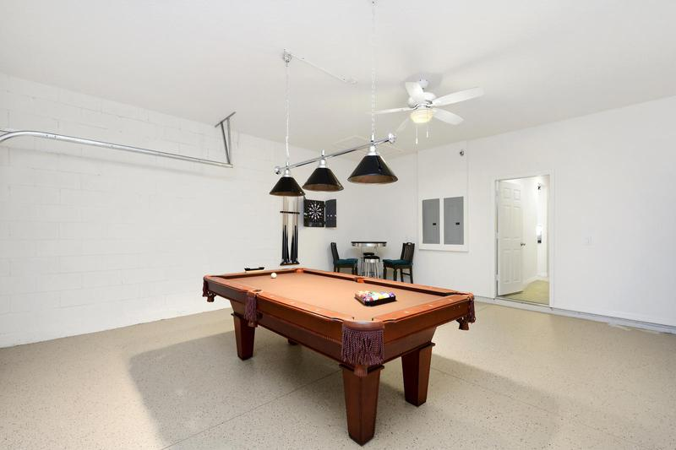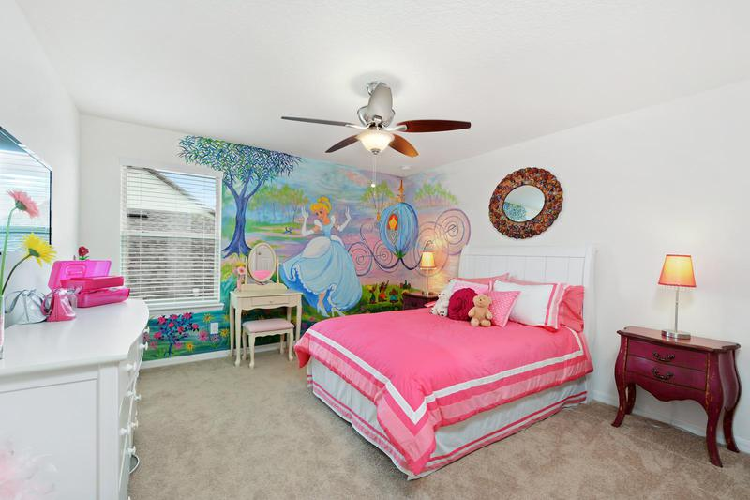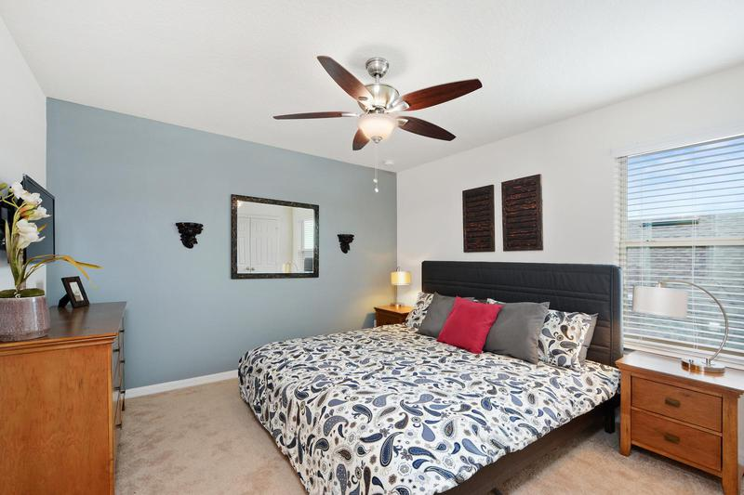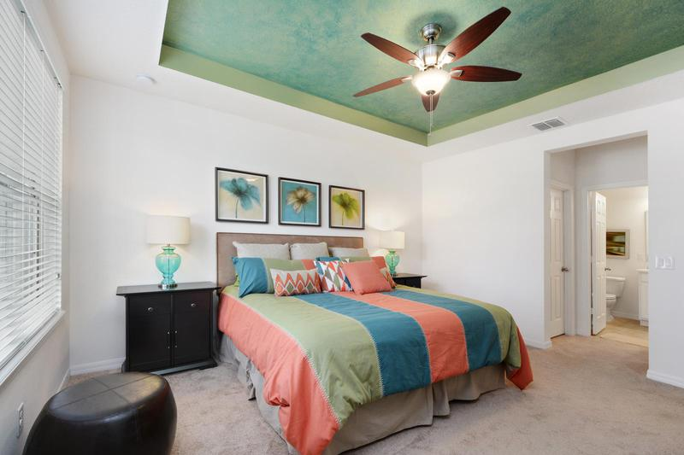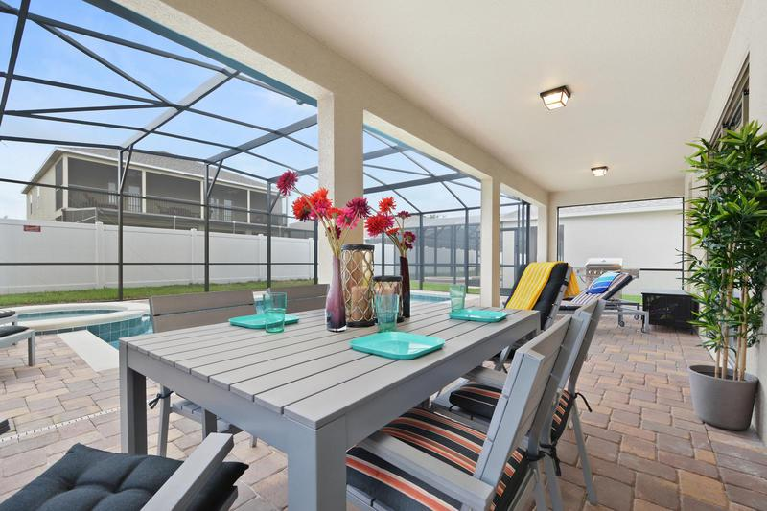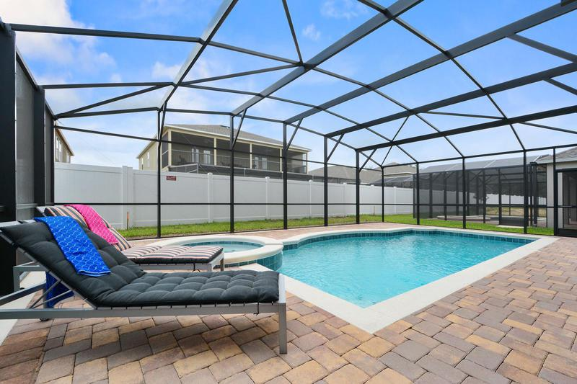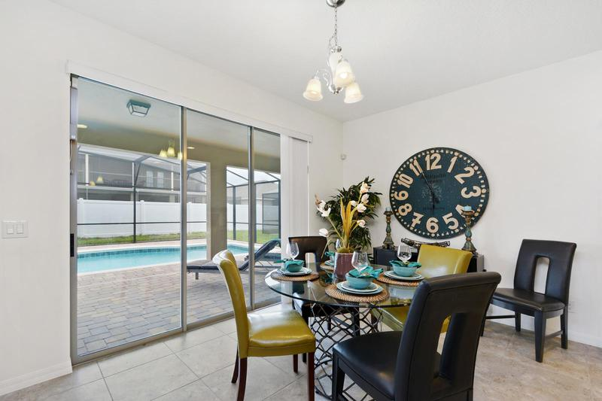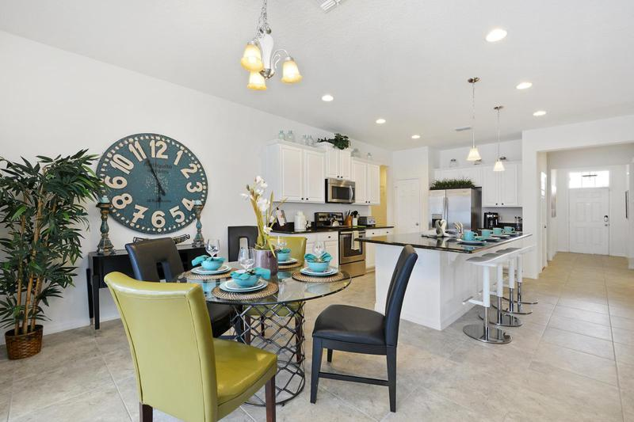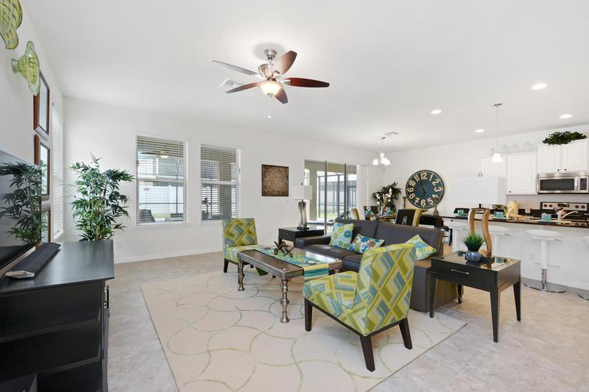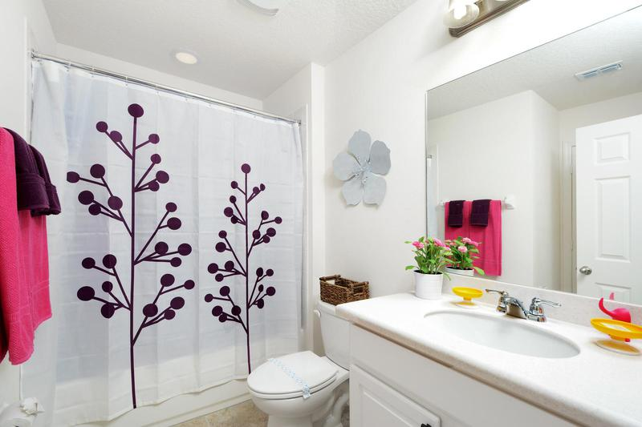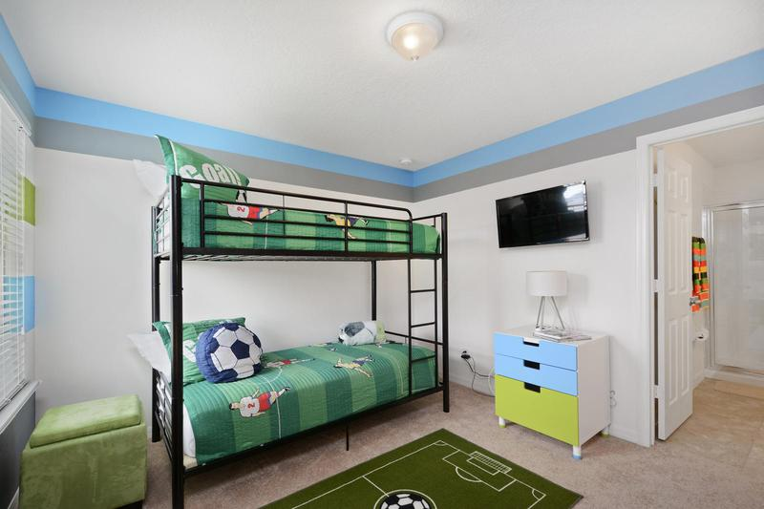v