- Internal Note (IT Module only)
This section will be added into Ticket system only and all ticket system user can add note. Ticket owner will receive the notification if any not adds just like we have in SPP.
Note will be plan text without any attachment so please user text-area instead of CK editor here.
When owner is adding note then it will send a notification to last sender, but last sender is also owner of the ticket then notification will not send to anyone.

E.g. A ticket TD1234 allocated to Sarah Stewart. Sam Taylor added a note on that then an email notification will send to Sarah Stewart.
Now, Sarah added a note on her own ticket then Sam Taylor will get notification
If now Sarah again add a note, then notification wont sent to anyone because Sarah (owner) is the last sender on that.

Internal Note section will add just below to Attachment
Previous notes will show in desc date order. Most recent at the top.
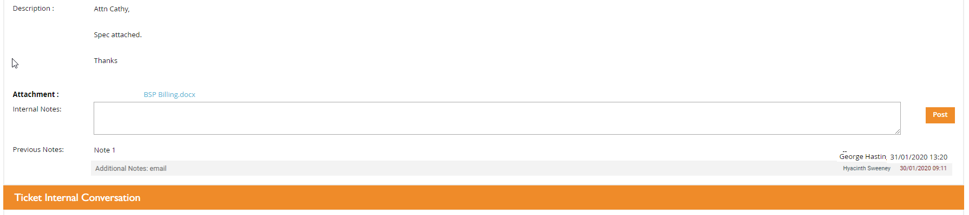
Sarah – tested and working as expected

- IT Documents (All Modules)
Add a menu icon under Create Cases, called IT Documents
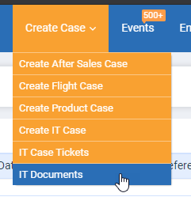
When users click on this then a pop up will come and show all the document URL from where users can download the doc.

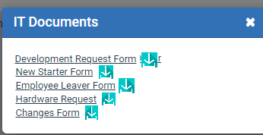

1/. Development Request Form
2/. Change Form
3/. Hardware Form
4/. Leaver Form
5/. New Start Form

Documents will be store in the CRM (static). I have attached all the documents on the leankit card.

Users can download the same form from the IT Case create form. Document name will list in the dropdown. When user select any document then that form will auto download.

CMS management not require in phase 1.
Remove/hide the checkbox of Development Request Form and the form from all modules.
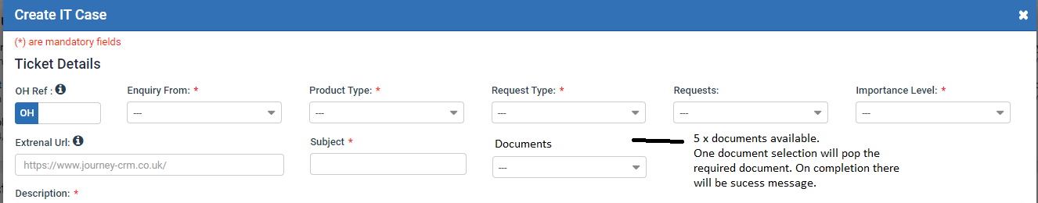

Sarah comments – small spacing issue with the wording can you amend the word to show
‘Download Document’
