Task - Campaign Creator
Module - CSB
Brand - Ocean Florida only

We currently have a Campaign creator function available for Ocean Florida brand within the SPP module.
The concept will work like this but also with some differences.
Existing VSTS card - https://oceanholidays.visualstudio.com/JourneyCRM/_workitems/edit/9432
(DS use only)

CMS => 2 Days
We need to be able to manage the email content for any given template in the CMS. This needs to be different from SPP as they run different campaigns:
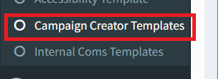
- Currently in CMS we have section called ‘campaign creator templates’ which is managed for different brands and SPP.
- We need to make a new one for CSB so there is no confusion and rename:

Rename to: SPP Campaign Creator Templates
All functions within this will work as currently do and will not be affected by the new CSB creator and concept.
We would like to add another function to the CMS as this is to automatically delete campaigns from the CMS that have been made Inactive for 7 days or more. Currently in the CMS there is over 50% of campaigns that are Inactive and will rename this way as they are out of date. Please create this new feature when working on the CSB Campaign creator.

Create new: CSB Campaign Creator Templates
New section added in the CMS and the page will work exactly as does now for SPP.
We would like to add another function to the CMS as this is to automatically delete campaigns from the CMS that have been made Inactive for 7 days or more. Currently in the CMS there is over 50% of campaigns that are Inactive and will rename this way as they are out of date.

CRM Changes for CSB Campaign creator – CSB Module => 4 Days
Within the CSB Module we would like to have the campaign function separate to the Enquiry search function like we do in SPP, as their requirements of who we send to etc don’t follow the same.
Please can you add a new section under the reporting tab:
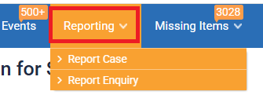
Called ‘campaign creator’
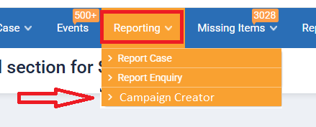
On clicking on the campaign creator tab the page will display as per below:
User will be able to upload an csv file only:
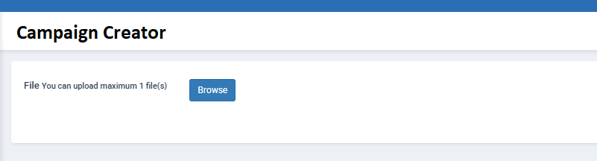
Once the file has been uploaded then the successful file type will appear and the option to then search results will appear:
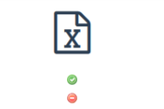


All the applicable results will appear like below for the user to see them.
Below is sample design. System will show only below columns:
Brand, Enquiry Date, Booked Date, OH Ref, Name, Check-In Date, DPT Date, NTS, Pax
System will show count of all matched records. E.g. Total x record matched
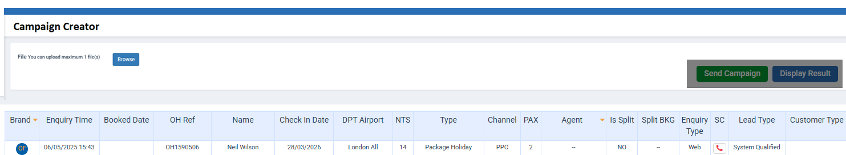

User would click on the ‘Send campaign’ box as shown above and be presented with this box.
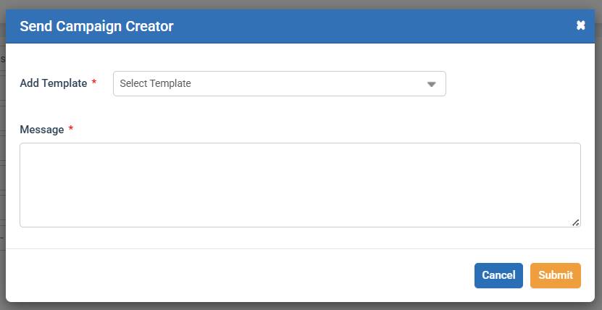

User can select to ‘Add template’. This will surface only the templates in the CMS under ‘CSB Campaign’ creator templates.

Rules on what results will be surfaced: 1 Day ???
The user will be uploading a CSV file with some data within it.
- CSV report should only have TopDog Reference column (e.g TD Ref).
- File format will be CSV
This will contain multiple bookings, and they will be identified by booking reference only. TD Ref field will be used to lookup to references in the CRM for matches.
Please note when we move to IVector we will have IVector booking references, so this logic need to pull booking references for both TD and IVector. (Pooja will discuss more information with the development team here)
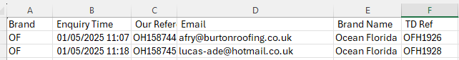
If a user was to upload a CSV file with 100 bookings to the system, it will surface at 100 or less results returned to the user based on matched rule.
On clicking on Send campaign it will be look to see what bookings are eligible to have a campaign sent and filter out the ones that are exempt.
DS Reply: We assume that if 100 or fewer results are returned to the user based on the matched rule, and 70 bookings are eligible for the campaign, then we can highlight those eligible records and display the count on the Send Campaign Creator popup.
What bookings are exempt from having a campaign sent => 2 Days
If there are any bookings that have an OPEN case within the CSB module then we won’t send any campaign to them. Please note the definition of an OPEN case is any case within these queues:
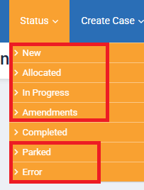
This means the only status that is included is the ‘Completed’ queue. There will also be bookings that are not in ANY status within the CSB module so these will also be included.
Example – CSV file upload had 100 bookings within it.
10 bookings were in Allocated queue
5 bookings were in Amendments queue
15 bookings were in In-progress queue
20 bookings were in Completed queue
This means in the CSB module there is 50 out of the 100 bookings in there and 50 not.
So from the 100 bookings in the CSV file, it would send to the 50 not in CSB and the 20 that were in the completed queue. Total campaigns to send = 70

What happens when campaigns are sent: ??? Days
There will be a NEW case created automatically for every campaign that is sent. It will however automatically move the case from the NEW queue to the COMPLETED queue.
DS Reply: If a CSB already exists, will a new case still be created in that scenario?
As per the current functionality, when a case moves to "Completed" status, the linked FS and PS cases are also marked as completed. Does this rule also apply to the scenario mentioned above?
If there is a requirement to assign an enquiry type and nature, we will create a new one for campaign creator.
The campaigns will not be allocated to any agent of CSB so there will be no CSB agent name on them.

Timeline => 0.5 Day
We require the enquiry timeline to be updated showing the campaign sent just like we have in SPP as a feature now.

Customer responses to campaign creator => 2 Days
As we know as soon as ANY campaign is sent from the CSB campaign creator the case will be in the COMPLETED queue.
If a customer is to respond to any campaign by email, then it will just create a NEW case in the NEW queue.
We will need below information to create a case
- Enquiry Type
- Enquiry Nature
- Enquiry Origination
Please let us know if new information needs to be added.
DS Reply: Yes, Enquiry Type, Nature, and Origination information will be required. As mentioned above, we can use "Campaign Creator" as the Enquiry Type, but what should we use for the Enquiry Nature and Enquiry Origination names?

