Basic Conditions:
- Clients cannot pick up an RV rental on the same day of arrival, therefore they would need an overnight hotel following a transatlantic flight.
- Clients can pick up an RV after 1PM. Should they want to pick up any earlier, they will need to pay an early pick up charge
- Clients must drop the RV off between 9 & 11am.RV Rental locations are closed on Sundays.
- If a client want’s to pick up an RV on a weekend, they can only do so on a Saturday, before 3pm. All RV Rental locations are closed on Sundays
- Drivers must be aged over 21 and have a valid UK Driving licence – not that there is no young driver surcharge on RV Rental
- No GPS is provided from any USA Location
- You must advise clients that a security deposit of $500 by credit card is required. If paying by cash, clients must leave a deposit of $1000
- Everything is pre-paid before departure, including Generator Usage, State Tax, Personal & Providing Kits & Mileage Charges.
- One way drop fee’s apply for different pick up / drop off locations

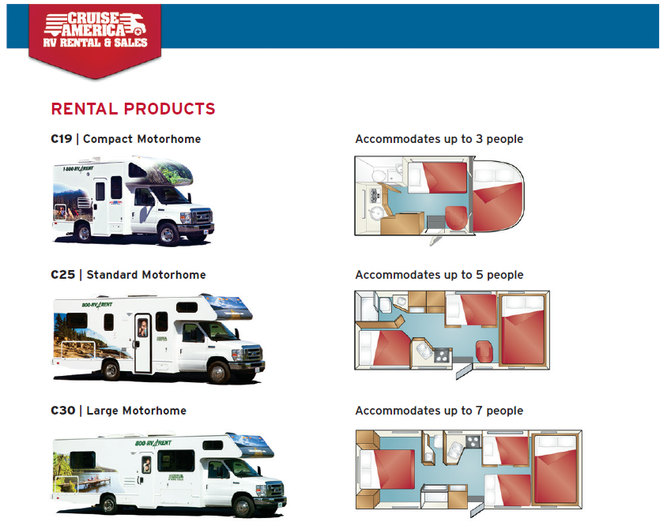

All Below prices are in USD and convert at the local exchange rate when paying the Drop Fee
