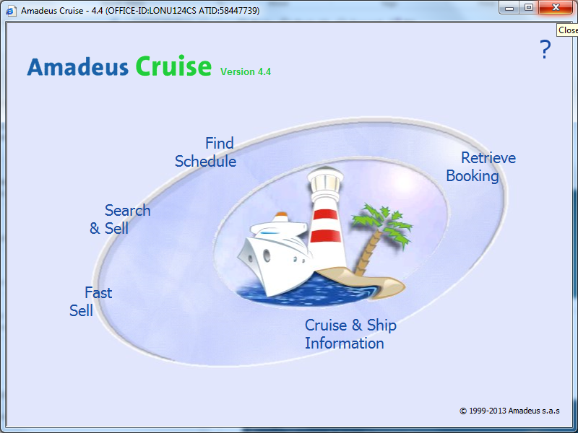
To search a flight, click the ‘Search & Sell’ tab.
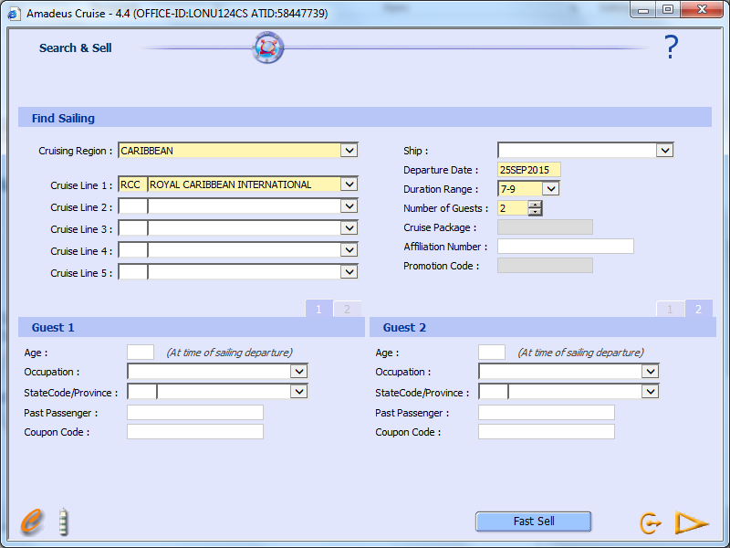

Choose your cruising region, the cruise line you would like, the date field (in the format shown above), the duration range and the amount of guests. (for 5 or more in a cabin, you will need to call the relevant cruise line)

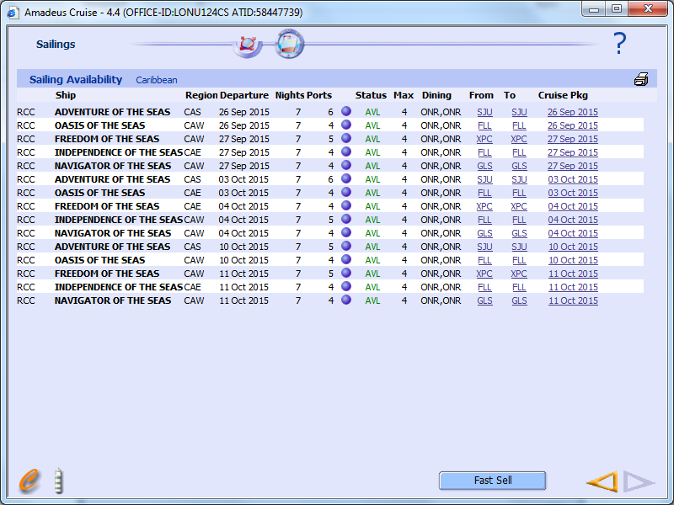

Click on to the name of a Ship Displays Itinerary
To proceed to pricing

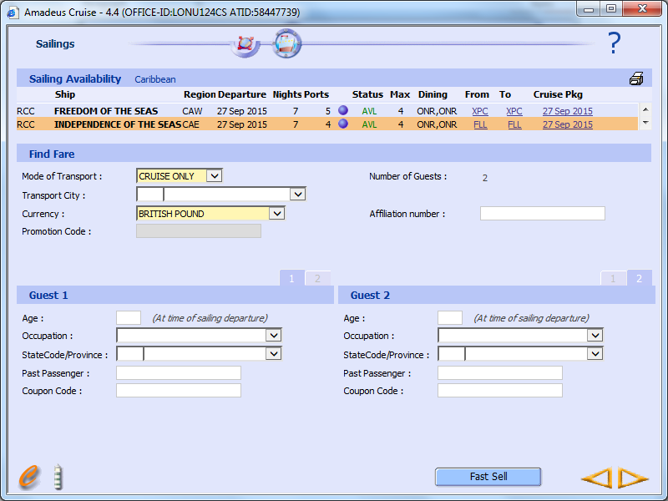

Click on a cruise you want and select Cruise Only in the ‘Mode of Transport’ selection field and click
the right Yellow arrow to proceed
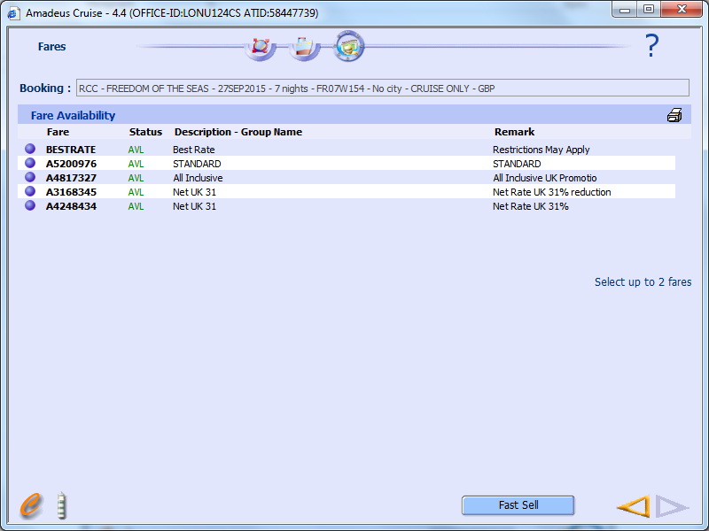
Choose a rate band that you would like to search. Generally you are better to compare the best rate and the Net UK rates, however sometimes they have offers on (as shown above) where they have an All Inclusive upgrade, so you will want to compare these also.
You can choose to compare to rates at a time.
Then click the right yellow arrow again

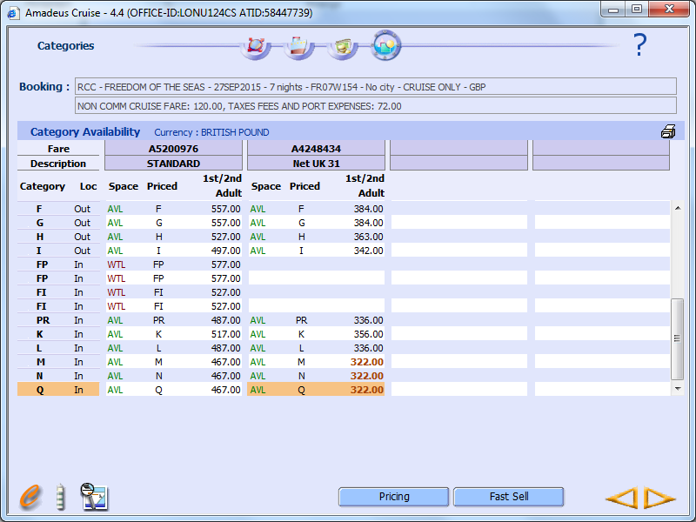
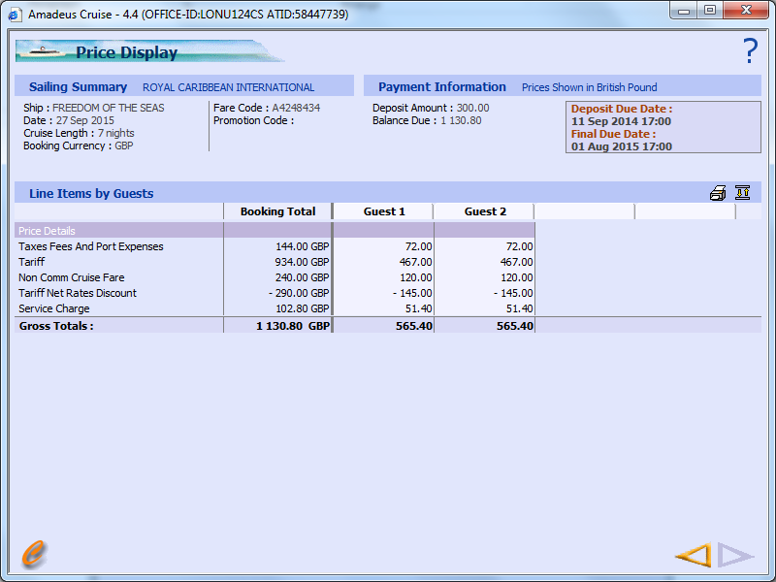

You will then come to the pricing screen. To get the total price, click on the price rate you want and it will take you to the Price Display. Alternatively click the Right Yellow arrow and it will take you to the Cabin Selection screen to see what cabin numbers are available.
If you are choosing a NON-NET UK rate search from the selection, you will need to view the commissions to deduct

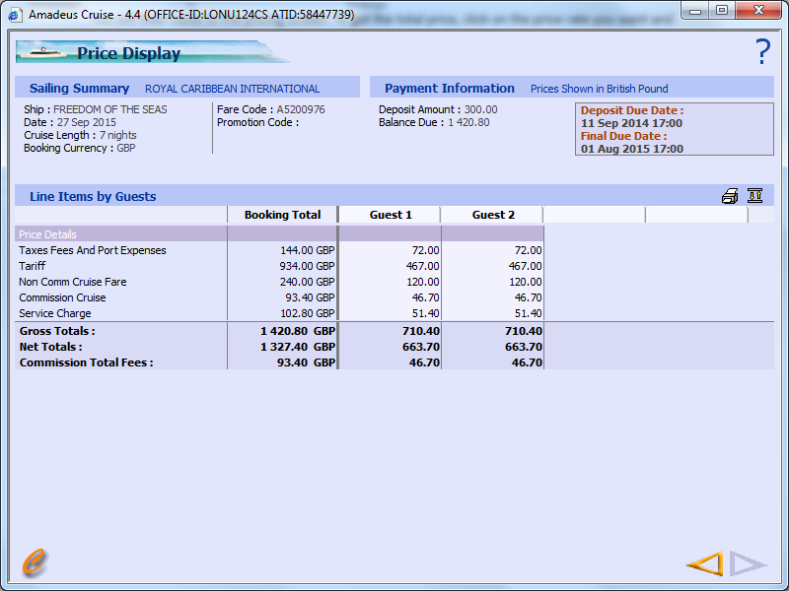

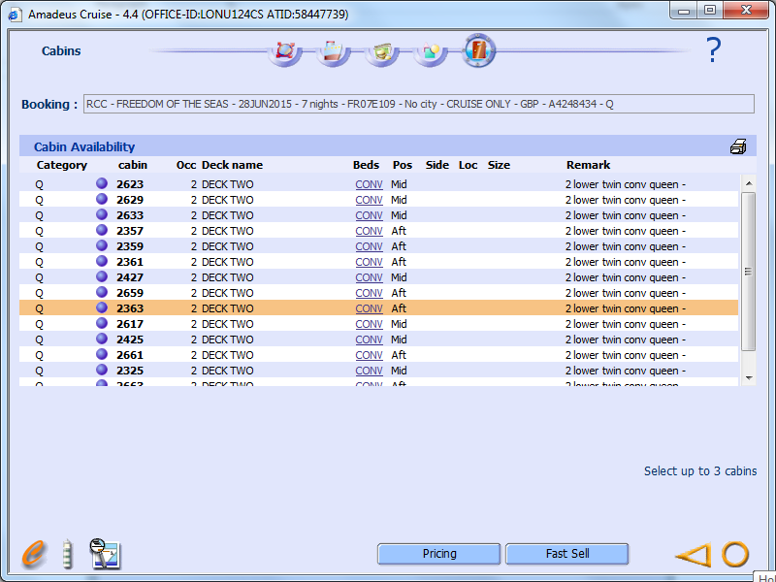

This is the Cabin Selection screen that will give you information on the Cabin Numbers and Deck Locations. If you want to proceed any further, you need to choose the Yellow circle.
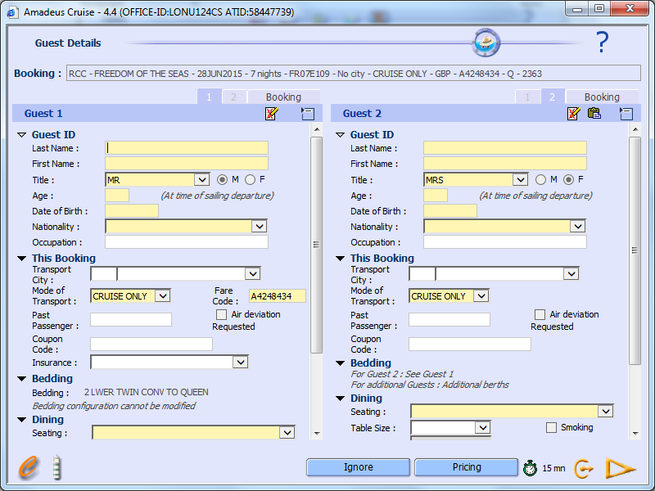

You then need to fill all the boxes in yellow to pull all passenger details in to the booking. You have 15 minutes to do this as the cabin you have chosen goes in to a courtesy hold. To complete the booking, use the Yellow Arrow on the right.

