Florida Store
Florida Store have a total of 88 that are typically Executive to Exec Plus standard and will appeal to the more price conscious customer rather than higher end new community product.

- Agents can search on the following site: www.floridastoremanagement.com
- Once dates have been entered search results will appear as per the below;
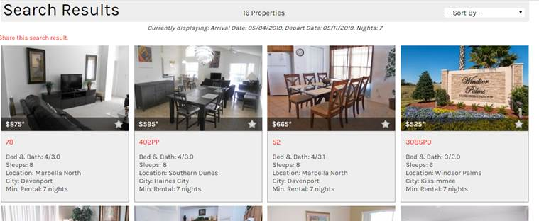
- The Agents are to ignore the initial price shown in this summary of homes screen and click on the home to obtain the actual price to calculate the final price from
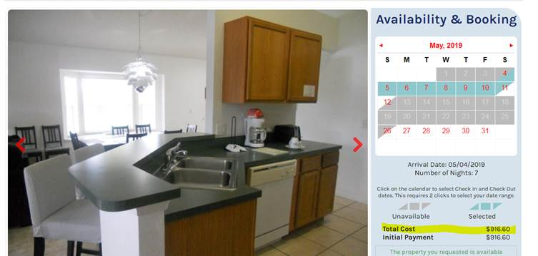
- To quote the agent can take 5% off of the rate on the screen, for example for this home $916.60 – 5% = $870.77.
- When submitting the case to book agents MUST include the USD price, they have quoted
- No deposits are required on these bookings
- Please note the cancellation for these bookings are set to 8 weeks prior to travel, so anything cancelled within 8 weeks will be at full cancellation charges, anything outside of this will be free of charge
- Welcome Packs – all homes will receive a standard welcome pack
- Any questions on the villas that cannot be found on the website will only be able to be answered Monday to Friday 1pm to 6pm, Florida Store are not open on a Saturday.

