UNIVERSAL TV AD
Ocean Florida is apart of the Universal TV AD campaign again this year – VERY EXCITING!
It will be featured on our TVs between 25th – 31st December 2018 on various channels.
Please see details of the campaign, along with the associated INCENTIVE.
THE AIM OF THE CAMPAIGN: -
- Generate Ocean Florida enquiries and bookings
- Speak with every customer about Universal hotels and tickets
- Increase sales of Universal Tickets and Universal hotels
- Encourage customers to stay in Universal hotels for a portion of their stay
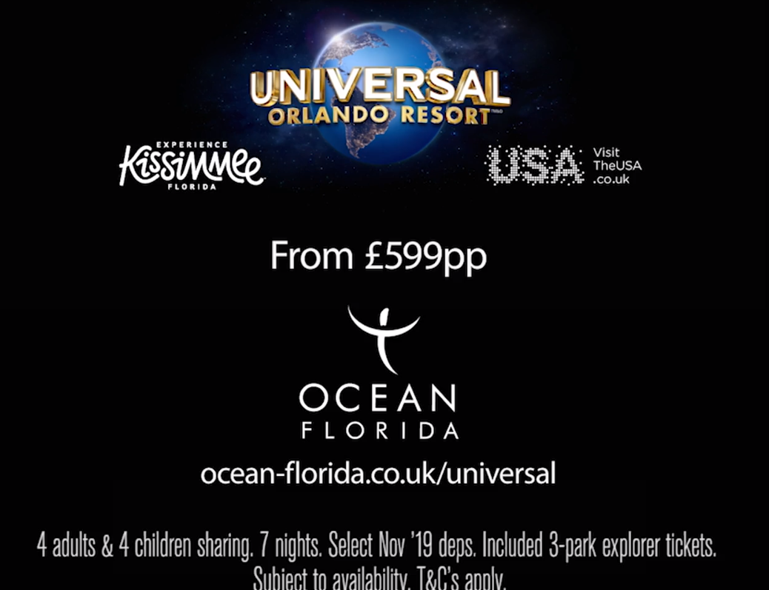
THE TV ADVERT ITSELF: -
At the end of Universal’s advert, our logo, a link, a price of £599pp and some T&C’s are shown.
- 4 adults & 4 children sharing
- 7 nights
- Selected Nov 19 Deps
- Included 3-park explorer tickets
- Subject to availability
- T&Cs apply
Voiceover says, “Book your Florida villa holiday including Universal 3 Park tickets from just £599”
This price is based on DOC2282
Link goes to www.oceanflorida.co.uk/universal
THE DEAL: -
DOC2282 is a loss leader, like how Black Friday worked
£599pp is only available for 8 passengers travelling exactly matching the below:
We have THREE bookings available at the £599pp price:
26th November 2019 8 pax sharing (4 adults & 4 children)
VS flights from either LGW/MAN direct to MCO £400ad £330ch (loaded onto TopDog)
7 nights in a 5 Bedroom villa at Windsor Hills £1,096 (Ocean Beds)
Universal 3 park tickets £281ad £273ch
Your net will vary but SELL at £599pp
If your customers’ requests are different from this deal in any way, then do your quote using regular pricing and generate your sell price like normal.

T&Cs: -
- Flights will be loaded on Top Dog for the Tuesday 26th November 2019
- This is for 7 nights only
- LGW or MAN airports only with VS
- £400 per adult / £330 per child
- 24 seats only for this date only
- Only 3 bookings will be applicable for this offer
- Maximum of eight discounted seats per booking. Extra seats at GAL prices
- Booking must have a total of 8 pax to be entitled to use this flight price offer and have the Windsor Hills Villa included (e.g- you can have 8 adults using the £400pp and sell the deal as high as you can as they wouldn’t be applicable for the £599pp offer)
- If all 24 seats are sold, there’s a possibly of adding an extra 16 seats for an extra 2 bookings
- You will need to email the whole floor to let everyone know how many seats you’ve booked and from what airport
- You will need to make clear note on the G2B form that the booking is for the Universal TV Ad Deal
THINGS TO DO: -
- Talk about Universal wherever possible
- Add Universal hotels as alternatives on quotes
- Offer customers tickets and nights at Universal hotels where appropriate, even to villa holidays by doing Twin/Multi Centres
- Mention the average UK Holiday Goer to Universal Resort spends on average 4-7 days in the parks and CityWalk
THINGS TO AVOID: -
- If a customer calls in off the back of the Universal Advert, avoid using the term ‘Disney Area Villa’ or allocation upon arrival homes. Try and offer Named Communities or Exact Homes
- Don’t be afraid of the extra cost of Universal product. They’re great hotels with benefits included and our Ocean Beds rates are the best out of all our suppliers!
- Why not try and suggest to the customer about doing a Twin Centre? 10 Nights in a villa and then 4 Nights in a Universal Hotel to get the benefits? No harm in asking/offering/trying!
SALES INCENTIVE: -
The normal Universal Ticket Incentive will be combined with a Love2Shop Incentive:
- £5 (real English pounds) per Universal ticket as per usual
- £10 Love2Shop voucher for every booking with Universal tickets included
- £10 Love2Shop voucher for every booking with a Universal hotel included
This means that for a 4 pax booking with UOR hotel and tickets you earn an extra £40 in £££ and Love2Shop vouchers
(This will run from 26 Dec 18 – 06 Jan 19. This could change to the whole of January. We will let you know)
WHAT’S NEW AND COMING AT UNIVERSAL RESORT: -
- Aventura Hotel – NOW OPEN
- Endless Summer Resort – COMING SUMMER 2019
- Harry Potter Themed Rollercoaster – Islands of Adventure – COMING SUMMER 2019
- Live Action Experience (replacing Terminator 2:3D, which closed early 2018) - TBC

SWITCH SELLS
£375ad £270ch
1 . VS 27 O 11MAR LGWMCO HS1 1140 1715 O E MO
2 . VS 28 O 18MAR MCOLGW HS1 1945 #0745 O E MO/TU

£375ad £270ch
1 . VS 27 O 06MAY LGWMCO HS1 1005 1420 O E MO
2 . VS 28 O 13MAY MCOLGW HS1 1735 #0650 O E MO/TU

£375ad £270ch
1 . VS 27 O 10JUN LGWMCO HS1 1005 1420 O E MO
2 . VS 28 O 17JUN MCOLGW HS1 1735 #0650 O E MO/TU

£430ad £310ch
1 . VS 15 O 09SEP LGWMCO HS1 1300 1720 O E MO
2 . VS 16 O 16SEP MCOLGW HS1 1950 #0905 O E MO/TU

CUSTOMER STUCK TO SCHOOL HOLIDAYS (ish)

£575ad £450ch
1 . UA 123 S 15FEB LHRIAD HS1 0730 1105 O E FR 1
2 . UA 778 S 15FEB IADMCO HS1 1230 1451 O E FR 1
3 . UA 2389 K 22FEB MCOIAD HS1 1550 1755 O E FR 2
4 . UA 918 K 22FEB IADLHR HS1 1830 #0640 O E FR/SA 2

£550ad £410ch
1 . UA 15 T 08APR LHREWR HS1 1005 1305 O E MO 1
2 . UA 730 T 08APR EWRMCO HS1 1500 1754 O E MO 1
3 . UA 1601 T 15APR MCOEWR HS1 1328 1612 O E MO 2
4 . UA 110 T 15APR EWRLHR HS1 1800 #0620 O E MO/TU 2

£525ad £415ch (£470pp average)
1 . MT 2604 Q 30MAY MANMCO HS1 1145 1605 O WE
2 . MT 2605 E 06JUN MCOMAN HS1 1805 #0725 O WE/TH

£699pp
TUI 18JUL GLASFB 1140 1520 TH
TUI 25JUL SFBGLA 1720 0610 TH/FR

£670ad £520ch
1 . VS 49 N 05AUG LGWMCO HS1 1205 1625 O E MO
2 . VS 50 N 12AUG MCOLGW HS1 2030 #0945 O E MO/TU

£550ad £415ch
1 . VS 27 O 27AUG LGWMCO HS1 1005 1420 O E TU
2 . VS 28 N 03SEP MCOLGW HS1 1735 #0650 O E TU/WE

£470ad £350ch
1 . DL 33 V 15OCT LHRATL HS1 1455 1928 O E TU 1
2 . DL 1166 V 15OCT ATLMCO HS1 2055 2228 O E TU 1
3 . DL 2392 V 22OCT MCOBOS HS1 1555 1855 O E TU 2
4 . DL 58 V 22OCT BOSLHR HS1 1951 #0720 O E TU/WE 2

