AC7 Thomas Cook Booking Manual
Here is the link which you will need to access AC7: https://tcx.aircenter7.com/aircenter7/login
USERNAME: OCEANF
PASSWORD: Romford123

SEARCHING
Click on the icon 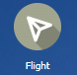 to start searching.
Fill in boxes as shown below, and then click on
Example search results are shown below:
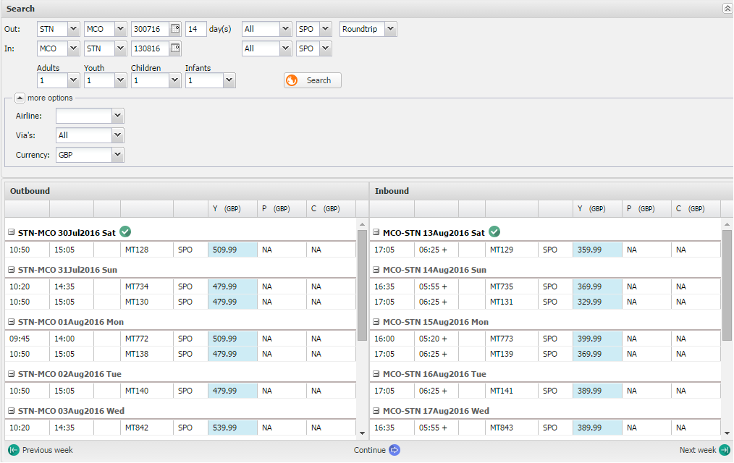
From this screen you can have a good estimate of the flight price by adding the outbound and inbound flight prices. As a rule of thumb kids and teens get £70 off the adult price.
Please note there is a £3 fee on top of these fares per seat (Thomas Cook ATOL fee)
Y = Economy and P = Premium Economy.

BOOKING - Entering Passenger Details
After clicking to select your flights, press .
Add your passenger details as below.
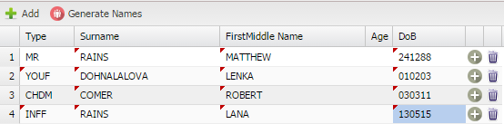
THINGS TO CONSIDER
- Every single name correction costs over £80 – can only do one at a time so the system will charge per name, whether it’s a whole name or just one letter
- DO NOT ENTER MIDDLE NAMES. There is a 20 character limit.
- YOUM = 12-15 y/o male. YOUF = 12-15 y/o female
- CHDM = 2-11 y/o male. CHDF = 2-11 y/o female
- INFM = male infant. INFF = female infant
After adding passenger details click
BOOKING - Extras (Seats and Meals)
At this stage you can if required pre-select customer seats, this comes at an extra charge.
To do this select the seats as shown below:
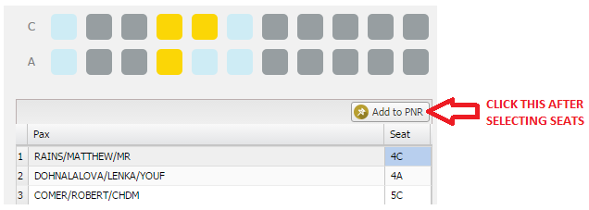
The price of the selected seats will show in the extras box on the left of the screen
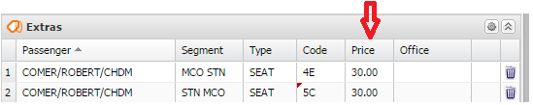
You MUST add meals on for all passengers, select from dropdowns and click
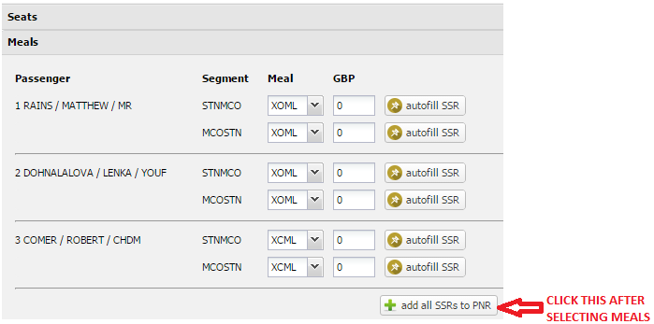
After this click
BOOKING - Finishing booking
Tick ‘no insurance’ and then click .
Fill in the contact box as follows:
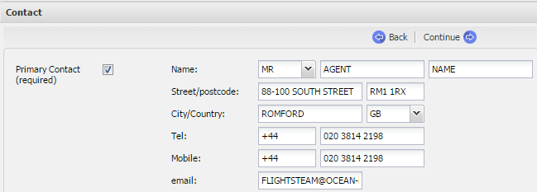
Click .
Make sure ‘agency’ is selected and click .
In Booking Remark enter ‘NA’.
Finally when you are done click at bottom left of the page.
Keep a note of your reference number for your go2book form.

