VSTS Best Practice – Version 1

VSTS Developer & QA Task Management

- Every day a developer should have a task in ACTIVE within VSTS.
- Any given task in ACTIVE should have an assigned effort and Start and End date.
- If there is delay on task, then notes should be added. Example – holding task due to X, adding more time due to X.
- Tasks should be allocated to BAU developers based on priority. (I.e., 1 to 4). 1 being taken first.
- If a developer is moved from a task and can’t complete their current ACTIVE task, then please remove the developer’s name and move to status Ready to Start Development. That way the next available developer can take and continue to work in priority order.
- BAU developers should work to current sprint unless a HF has been added before this.
- Core developers should stay with current Core task unless agreement has been given by Sarah to move from this to another task.
- QA’s when taking a task to test should update their timelines for Start and End date and effort for their task.

VSTS Sprint Example

There are tasks in ACTIVE, but dates have passed today’s date.

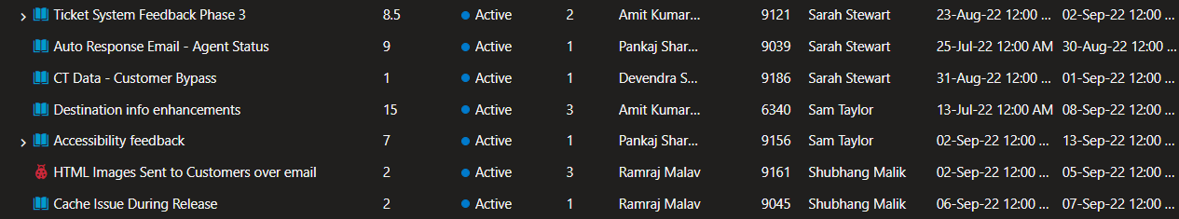
(Taken on 5th September)

VSTS Deployment Management - Commits

It would be beneficial if the Journey team assigned commits to work items, for several reasons:

- It allows all users to view the code, which is associated with the work item, this includes lines of code added or removed.
- This also enables the user to view the build in which the commit is related to.
- It enables code reviews to take place as we can clearly see the commit related to the work item, so any mistakes can be identified.
- Help to troubleshoot issues, if we know a particular commit broke something then we would also know which work item this is related to.

Using the following work item as an example - https://oceanholidays.visualstudio.com/Ocean-X/_workitems/edit/9210

- Here you’re able to see that the associated commit is 82187dba: Fixed Accessible Holidays Accommodation Landing Page Defect...
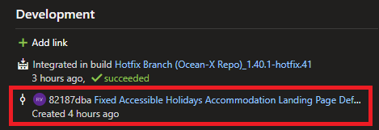

- The description of the commit should clearly explain what work has been implemented and would usually contain the work item name
- The user is then able to view the commit which was made https://oceanholidays.visualstudio.com/Ocean-X/_git/6635d192-6565-4ed7-86ee-8de608281527/commit/82187dbae73de19445e6c3333c4f15ce3552efc9
- This contains lines of code added (green) and lines of code removed (red)
- It also shows information on which user made the commit and when it was made etc.
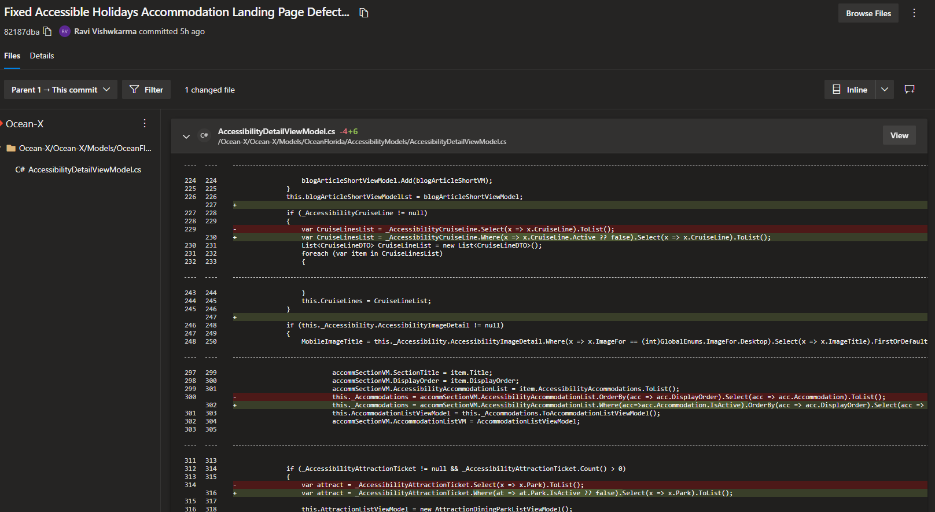
- Furthermore, we’re able to see the build which this commit is related to
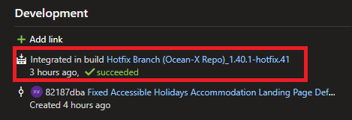

- This would typically be the feature or hotfix iteration, along with a success or failed message
- Similar to the commit you can view the build in more detail, for example https://oceanholidays.visualstudio.com/Ocean-X/_build/results?buildId=10020&view=results
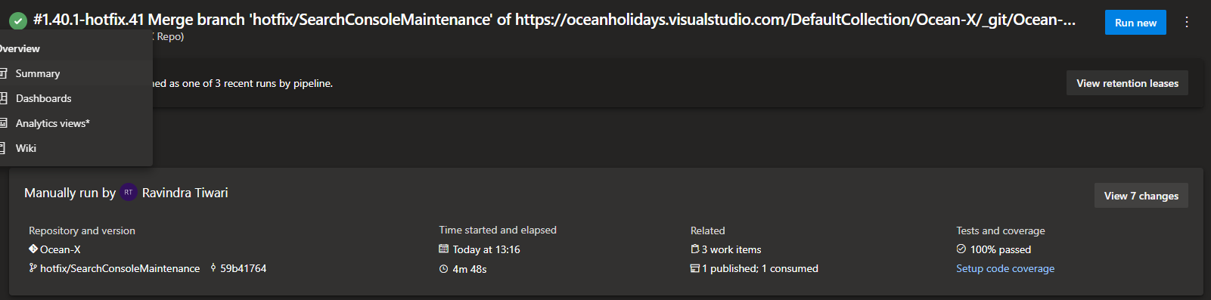

In terms of the process on how commits are assigned to work items there is an Azure integration where a comment can be added along with the work item number.

We are aware that Amit on the website team is familiar with this, so we believe he be good to guide the team on this.

VSTS Code Review

There is also a code review process which can be managed via VSTS.

We’re not currently doing this as far as we know so we have just explained the basics below.

- Prior to the QA testing the work item, a developer not assigned to the work item can review the code
- This is to ensure that the code meets the correct standard and that there are no obvious mistakes
- It may be beneficial to code review the work from the more junior members of the team, or for larger work items for example
- Perhaps not all work items need to be code reviewed
- A Pull Request can be made for the work item from where the developer can review the code
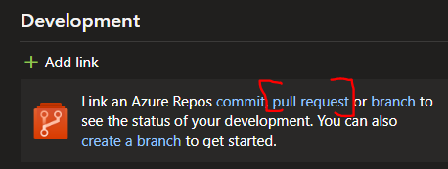

- In the left side navigation Pull Requests are managed from Repos > Pull Requests
- Example URL: https://oceanholidays.visualstudio.com/Ocean-X/_git/Ocean-X/pullrequest/2
- The code reviewer can see an overview, files, updates and commits before being able approve or reject the code
- The primary goals here are to reduce bugs and ensure consistent coding standards across all projects
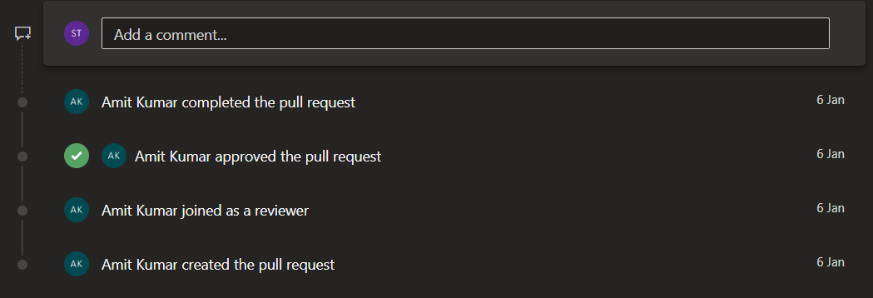

System Training

We are aware there is new starters within the business, and we want to ensure that all users are supported within the systems we use.

If you feel there is a requirement to conduct extra training within VSTS on any of the aspects covered above, then we would be more than happy to assist via a Teams Meeting.

