Quote Team Development
- Task Name – Quote Team Development
- Date – 5th April
- UKPM Owner – Sarah
- Task Owner – Matt Rains

User Goal
We want to quote more leads by introducing a new team within Journey CRM called ‘Quote Team’ for Ocean Florida Brand only.
User Story
Normally sales agents can quote 15 enquiries per day maximum, as they speak to customers on the phone, deal with email replies, and place bookings etc. Because of this we can only give them the best enquiry types with high conversions (hotkeys, for example)
Up to 65% of web enquiries Ocean Florida receive don’t get a quote, as they never leave the CT cycle (i.e. don’t answer the phone or reply to email or SMS). More and more customers don’t want to speak on the phone.
We are looking to reduce the number of enquiries that don’t get a quote, by having a dedicated ‘QUOTE TEAM’
The quote team members will be targeted to quote 50 enquiries per day (that would have previously gone to CT nurture), and they are able to quote 50 per day because they never deal with calls or replies, only 1st quotes. All their replies and calls are redirected to the rest of the business
This dev will enable us to bulk allocate ‘any post call 3/4/5 CT cycle enquiries’ to agents of our choosing, taking segments and seasons of our choosing.

Current Setup
1/. Currently within the CRM we have one user role for Sales Agents called ‘Agents’.
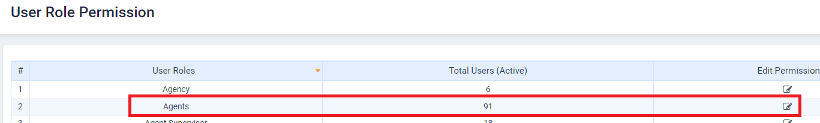

2/. We have some current functions in place to support Change Team/SE and Digital team.
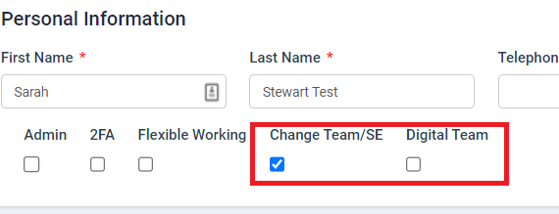
3/. They all use the same user role ‘Agents’ just with some conditions set within User Accounts to allow them to be handle certain things differently.
4/. We have some rules hard coded that allow the digital team:
- Chaser 1 automated.
- Chaser 2 and break up are scheduled to auto send also based on last word = Agent (This is rule for all users of the role ‘Agents’)
5/. Below summarises a breakdown of the Agent role setup across some team functions now/what would be added:
- Hot Key team – This team work on all leads but mainly Inbound phone calls and Hot Key Leads. (Already working)
- Digital team – This team work on leads from pending only allocated via auto allocation on the allocation rule right. (Already working)
- Quote team – This team will work on leads allocated from CT task call 3 to their allocated queue, there may be cases where we allocate other tasks. They may deal with leads from the pending queue but these will only be BP leads the same as the HK team, and they will not deal with any replies to the quotes they send. (This forms part of this new spec for Quote Team)

Development Requirements
1/. Amendment to the function of the current CT Task List - https://www.journey-crm.co.uk/tasklist
Current
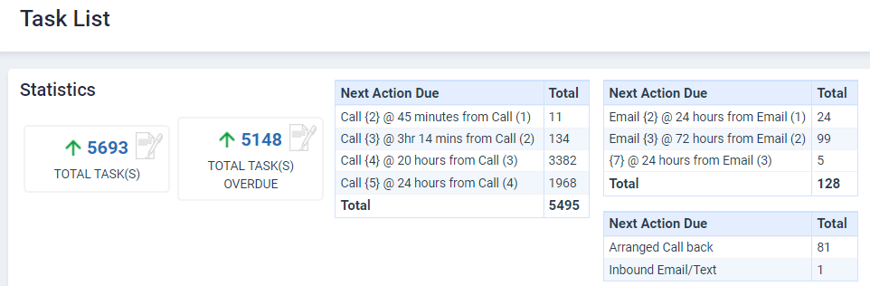
New
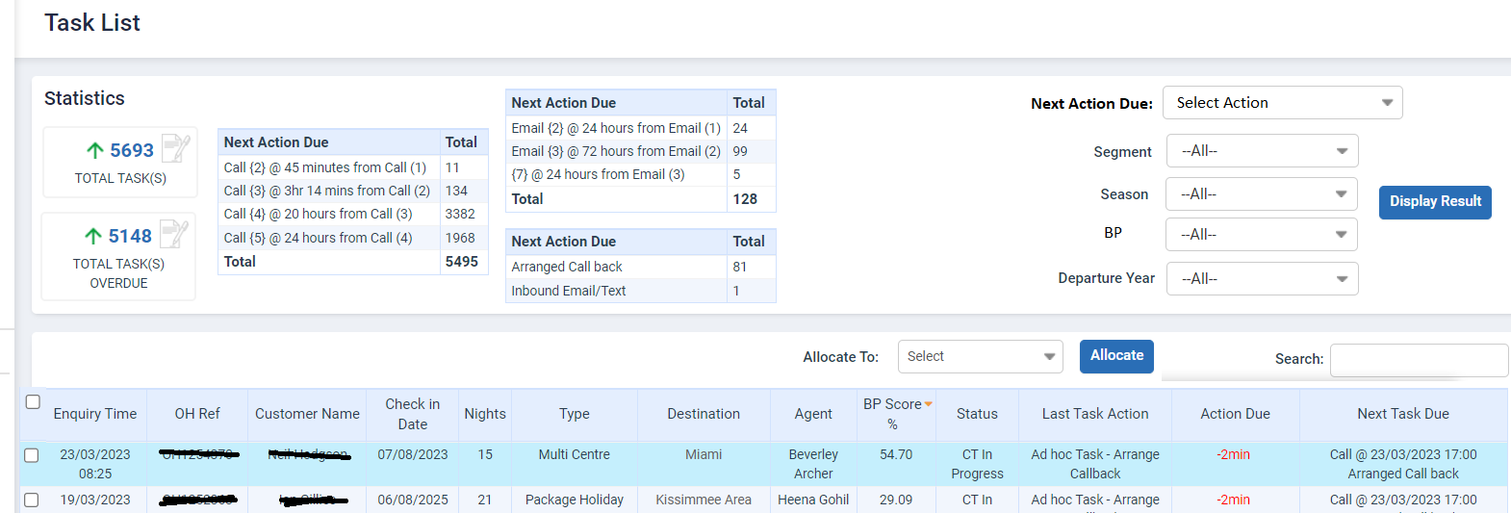

2/. This page currently shares all tasks that are within the CT cycle after call (1) has happened.
3/. We need a new option to be able to filter by Next Action Due. This means based on the selection chosen i.e. Call (3) the page will just display those enquiries.
4/. The page will automatically display with a check box next to every enquiry on first clicking on the Task List page. This will happen regardless of any filtering.
5/. The statistics boxes of data and grid data will need moving further left on the alignment as shown below. Please note this is a sample design so ensure all boxes are top aligned.
6/. There are further filtering options available on selecting a call type – Segment/Season/BP/Year. These are functions currently taken from CT Nurture page with the addition of BP score. BP score will be surfaced as 100+, 50-100, 20-50 and 0-20.
7/. On using the filtering options to select Next task due. Ie Call (3) the results will display all call (3) in newest to oldest enquiry time. Currently they show in task overdue time. The above will work only when applying filter, as the default page load setting will not change.
8/. To ensure that CT users aren’t clicking on next task at the same time as a manager filtering any leads to allocate to the quote team, please don’t show the next 5 due tasks.
9/. Allocate To - The names that appear on the dropdown for a MGT to allocate to are users of the Quote Team and the digital team. (Further details on permissions and allocation rights is shared within that section)
10/. Any leads that are removed from the CT cycle via the Tasks List from any call option we need to be able to show the reason as ‘Quote Team Bypass’. This needs to be shared to Big Query and all applicable CT Reports.
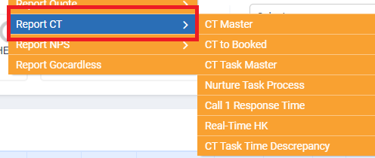
11/. In CT Task tab of enquiry view, it will show outcome as Quote Team Bypass and action as Ad hoc. This will work similar to Management by pass but only difference is, Quote Team Bypass actioned automatically by system.

Allocation Rights and Permissions
- User Accounts
1/. We will add a new identifier within User accounts for ‘Quote Team’. To achieve this, we will add a new section called Role Category (*mandatory for Agent Primary role Only) and under this we will list below:
-Select -
- Hot Key Team (already exists, as all agents are default categorised as Hot key agents.)
- Digital Team (Already exists, moved from checkbox selection to dropdown option)
- Quote Team (new team)
https://www.journey-crm.co.uk/employee
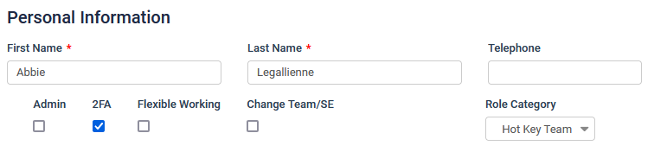
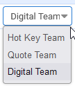
2/. A user can only be selected as one or none from the Hot Key Team, Digital Team or Quote Team.
Ie HK agent maybe none of the above if not SE for example.
3/. If a user has Digital team or Quote team selected within their User Account then this means their name will appear in the CT task page as an option for them to - ‘Allocate to’.
On clicking on ‘Allocate to’ – names will appear with an identifier ie QT = Quote Team and DT = Digital
Sarah Stewart (QT)
Matt Rains (DT)
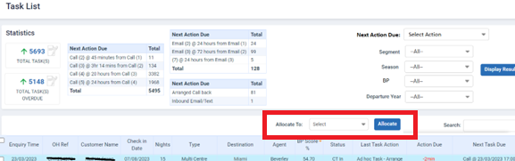
4/. As shared in the spec above if an enquiry or enquiries is allocated from CT task List this is always allocated to the chosen agent and goes to their ‘Allocated’ queue.
5/. Agent will get notification that they have had an enquiry or enquiries allocated to them.
6/. If marked as Quote Team user, you will also get the same rules added as digital user which is currently the automation of Chaser 1. This is the only rule managed from User Accounts for Digital is the automation of chaser 1 so same concept applied here for Quote team now. (Any other permission-based rules will be managed within User Target & Lead permission and outlined below)

- User Target & Lead permission
1/. As we know this page allows us to set rules as to what leads a given Agent can get when clicking on Auto Allocate.
https://www.journey-crm.co.uk/permissions
2/. Anyone can access Pending leads from the sales team right now allocated in BP score order, with the only rule in place outside of this is Accessibility leads.
3/. There are some changes required to how leads from the Pending queue are distributed and how we will manage this is shared below:
A – We will remove the brand column and rule for lead assignment which is applicable for OF/OC brand. Means no brand filter check will be used for lead OF/OC lead allocation.
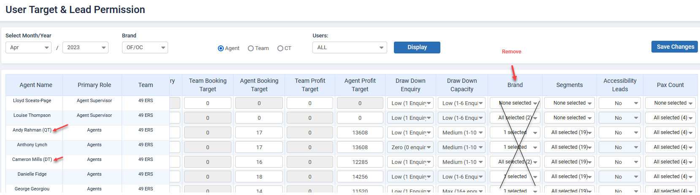
B – We will add QT and DT with agent name based on selection on their user profile. (Refer above screenshot)
- If an agent is selected as Quote Team role category, then QT will be added next to his/her name.
- If an agent is selected as Digital Team role category, then DT will be added next to his/her name.
- If an agent is selected as Hot Keyed role category, then nothing will be added next to his/her name.
C – The main changes to the allocation of lead team comes to what a Digital team and Quote team user can do.
D – Remembering the goal of this task we only want the Quote team to quote new leads. They will have the allocated queue, and in some cases they maybe asked to quote pending leads. The rule on what pending leads they get is outlined above but this is the same as the HK team essentially that they will deal with leads based on BP score and not quote team responses.
E – Any replies to the quote team get will not be given back to the quote team. We need to implement a process where all IB Emails and SMS that are for the Quote team go to the Pending queue.
F – This means they will get visibility of any customer responding in terms of an email notification/ATM. However, there won’t be seeing this response in their queue as the lead will move to pending queue. Any ATM task which created during the lead journey will be dismissed automatically as soon lead move to Pending queue.
G – Any responses for the Quote team will be added to the top of the Pending queue and will be identified in a new colour for clearer visibility. As per this task we are making some features redundant so colours will become free: https://dev.azure.com/oceanholidays/JourneyCRM/_workitems/edit/9698
We would therefore use the colour below and re label for ‘Quote Team Response’.
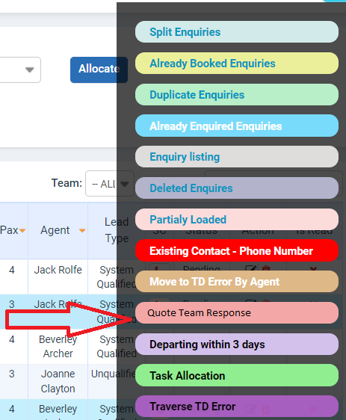

H – Based on the Lead team allocation will determine what a user can do under that team:
Hot Key Team
They will be able to access leads from the pending queue via clicking on Auto Allocate from the Allocated queue and these will be allocated based on BP score. (Currently working)
These will not get any leads in the pending queue that are from the quote team responses.
Digital Team
They will be able to access leads from the pending queue via clicking on Auto Allocate from the Allocated queue. Instead of working on allocated rights based on BP score, we would like them to be allocated Quote team responses firstly. Once all quote team responses are gone then they will be working on leads based on BP score.
We are aware that the leads they work on that are responses from quote team responses will have been allocated to Quote team person already, but this will now belong to the digital team member. All reports will update to show the Digital team member as being the allocated person including quotes/bookings etc.
Quote Team
They will be able to access leads from the pending queue via clicking on Auto Allocate from the Allocated queue and these will be allocated based on BP score.
Core functions of each Team
- Hot Key Team
Automated Chaser 1 sending – No
Automated Chaser 2 and break up if last word = Agent - Yes
Access Auto Allocate button from Allocated queue – Yes
Access quote team responses from Auto Allocated – No
Access BP score leads from Pending queue – Yes
Access responses from IB Email and SMS – Yes
Access ATM and associated to Task-Re Allocation function – Yes
Day off and Holiday Status MGT - Yes

- Digital Team
Automated Chaser 1 sending – Yes
Automated Chaser 2 and break up if last word = Agent - Yes
Access Auto Allocate button from Allocated queue – Yes
Access quote team responses from Auto Allocated – Yes
Access BP score leads from Pending queue – Yes
Access responses from IB Email and SMS – Yes
Access ATM and associated to Task-Re Allocation function – Yes
Day off and Holiday Status MGT - Yes

- Quote Team
Automated Chaser 1 sending – Yes
Automated Chaser 2 and break up if last word = Agent - Yes
Access Auto Allocate button from Allocated queue – Yes
Access quote team responses from Auto Allocated – No
Access BP score leads from Pending queue – Yes
Access responses from IB Email and SMS – yes in terms of email notification.
Access ATM and associated to Task-Re Allocation function – No. As they will never be set the status of Day off/holiday
Day off and Holiday Status MGT - No

Sales Agent Reports
All agent reports will need to be checked to ensure we report correctly on leads that are allocated/quoted/booked. As we know there will be a case that leads are allocated and quoted by Quote team.
If there is a reply from SMS/Email for the quote team we know this reply goes to pending queue.
A member of the digital team will then be allocated this to deal with.
This lead then becomes the digital team and reporting against quote team member will be removed.
Impacted reports:
- All of Report Agent
- All of Report Task Manager
- All of Report Quote
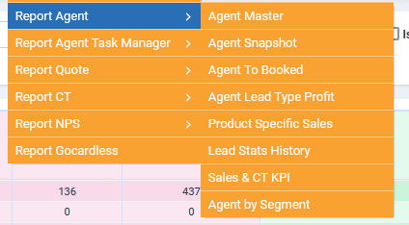
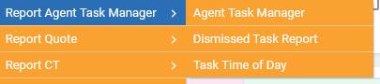
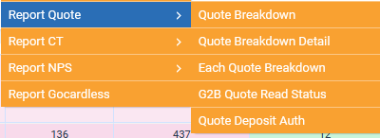

CT Reports
1/. CT Task Master Report
A new column will be added next to Customer bypass column of each section of that report. System is considering this as ad hoc task so stats calculation will be same as we do for MGT by pass task.
Complete task/conversion/profit will be affected by this column as well.
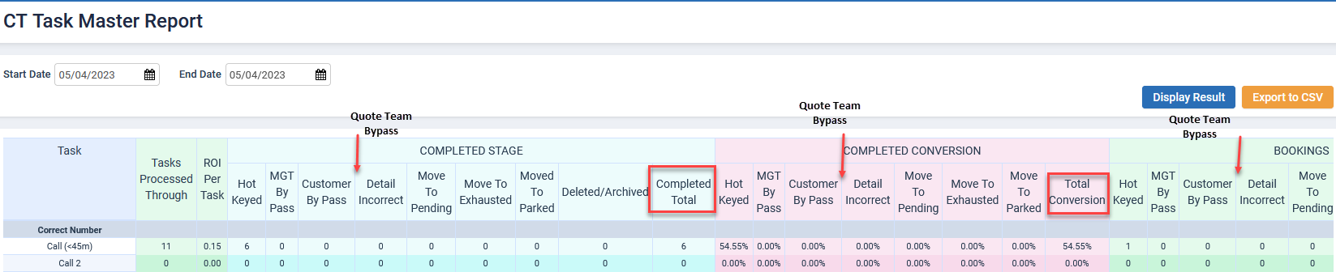
2/. CT Master
- Stats will be added to this report for new outcome.
3/. CT to Booked
- Stats will be added to this report for new outcome.
4/. CT Task Time Discrepancy
- Stats will be added to this report for new outcome.
- Correct the menu spelling for this report.

Quotes
For the Quote team only we require the removal of the CTA in their quotes for the schedule a call concept. This means that when they send a quote to a customer, the customer doesn’t see the schedule a call concept.

