CSB Task Manager Development
IT Owner – Sarah
Task Owner - Matt
- We will start with 3 task types now which are listing below in the priority which will show as due in their Task due/Task list.
- Appointments – This is any Appointments set and when Due.
- Allocated queue case – Any cases within the Allocated queue only will create a task when due.
- Inbound Email – Any Inbound Email replies within any queue within CSB will create a task when due.
Above will be shown in CMS:
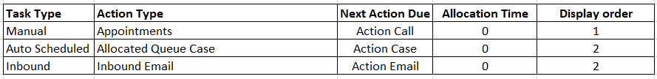
As per the above all 3 task types it will allocate a task to the user immediately based on the Allocation time showing as ‘0’ minutes.
However, as you can see task Allocated Queue Case and Inbound Email have the same priority. This means both will queue together, but we will allocate them in order based on the below:
Allocated queue and Inbound Email are grouped together in priority, and sorted by age with oldest at the top, for example:
- Allocated case with case creation date of 5 days ago
- Allocated case with case creation date of 4 days ago
- Customer reply that came in 3 days ago
- Allocated case with case creation date of 2 days ago
- Customer reply that came in 1 day ago
- Customer reply that came in today
Example – We get 3 tasks due at 12.00pm midday today being 28th June.
CS12345 – Case creation date was 25th June.
CS12390 – Case creation date was 23rd June.
CS12230 – Case creation date 26th June and email reply was 27th June.
If CSB user was to check their queue they would see in this order:
1st - CS12390
2nd - CS12345
3rd - CS12230
- Please note that any remaining queue status that a case maybe in like New/In-progress/Amendments/Completed/parked/Error then no task will complete. It would only create a task for a case within the above queues if there was Inbound Email.
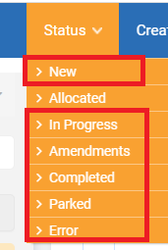
- We will have a separate rule table for OF CSB as rule may change for this brand later and can be different than what we have for OF SPP brand.
- These 3 rules will be managed from the CMS as same way we do for OF. However, the CMS will need some changes to accommodate to modules:
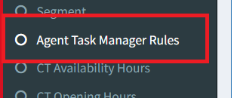
Agent Task Manager Rules will be renamed to:
- SPP Agent Task Manager Rules
New CSB:
- CSB Agent Task Manager Rules
- We will not have SMS task for OF CSB as we are not sending SMS
- Agents and MGT can perform the same way as current SPP agents in terms of what Agents see and what MGT see and do.
- ATM page will show below 5 tabs along with header stats based on active task rule in the CMS
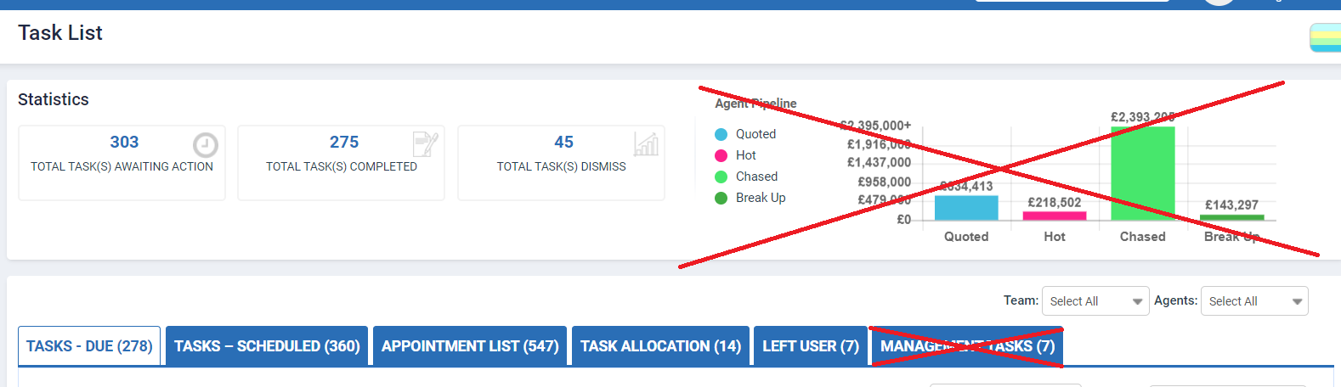
- Email hover function on task list will appear. And will also show the last 3 messages the same as SPP function.
- Create Appointment Feature
This doesn’t currently exist in CSB so we need to setup the concept to allow CSB user to do the same way we do in SPP
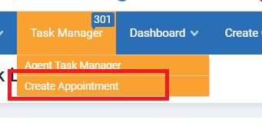
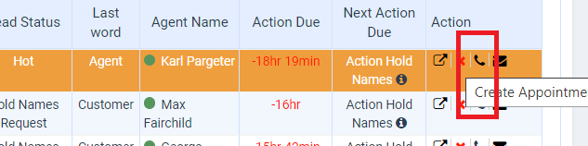
On clicking on create Appointment we need to remove the send email reminder function as shown below.
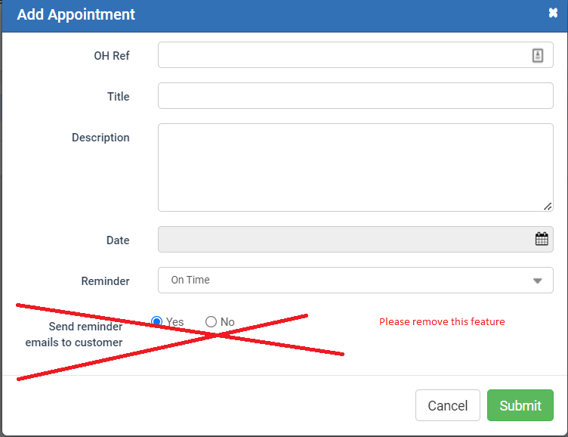
- Task Dismiss button.
If CSB user clicks the dismiss icon, then an email will send to Tessa.bishop@ocean-holidays.co.uk
This will surface within the reports.
Email – DS please let me know do we have email notification setup now and working for SPP. If not let me know and will create the content.
- Task Allocation
This will work the same as it does for SPP users but one main difference:
When a task is reallocated, the case itself is reallocated to the new user. Same principle as Left user which moves the enquiry and task.
In CSB if MGT user allocates a task to another CSB user then the Task and the case will re-allocate to the new CSB user.
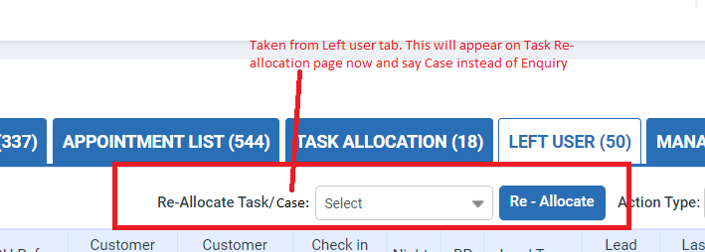
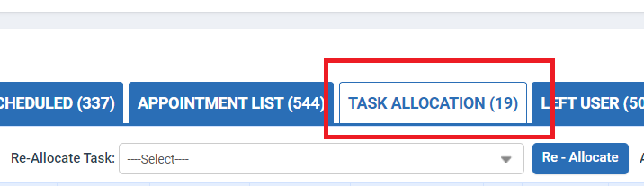
Will now look like:
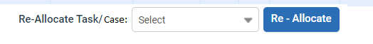

- Left user – will work exactly as is in SPP now.
- Below 3 ATM related reports will be integrated for OFT
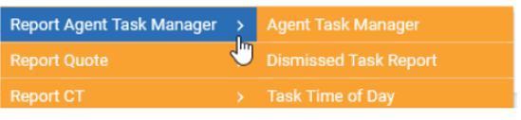
- User Status – This concept already applies in CSB, so dependant on users status then the tasks will form part of the Task re-allocation function like we have in SPP currently.
Anyone therefore on Day off or Holiday and one of the above 3 tasks was due then it would move into Task re-allocation for MGT user to sort.

