Exhausted Journey – Current process
A lead can’t be moved directly into Exhausted by any user of the CRM.
The only way a lead can go to Exhausted is via an automated process and this is 1 of 3 ways:
Cold
Lead is moved into Cold by agent and the agent will select a reason for why they want to cold a lead. The lead will stay in the cold queue for 5 days and if no activity on the lead it will auto move to Exhausted.
Cold reason would update on the stats.
NPS Exhausted email will be sent to customer
Lead stays in Exhausted

Break up
Lead is moved into Break by agent. If the lead is idle for longer than 7 days, it will automatically move the lead from Break up to Cold and stamp the reason as Break Up – No response as the cold reason.
The lead will stay in the cold queue for 5 days and if no activity on the lead it will auto move to Exhausted.
Cold reason would update on the stats.
NPS Exhausted email will be sent to customer
Lead stays in Exhausted

Nurture Parked
A lead is Parked for a certain date. When that date comes the system automatically moves the lead to Nurture Parked and sends the customer an email.
7 days after the lead has been in Nurture Parked and no activity it then automatically moves the lead to Exhausted and stamps the cold reason as ‘No Response – Nurture Parked’.
Cold reason would update on the stats.
NPS Exhausted email will be sent to customer
Lead stays in Exhausted

NPS Exhausted Email



Agent Nurture – Development Specification
We want to send a series of Automated Emails to customers once their Exhausted experience has been completed. This means once the lead has moved to Exhausted queue and the NPS Exhausted Email has been sent to customer.
We will require a new queue called ‘Agent Nurture’ and Agent Nurture Exhausted. This will be added after cold and before Parked:
Cold
Agent Nurture
Agent Nurture Exhausted
Parked
etc
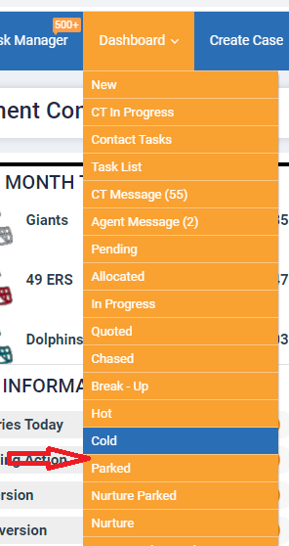
How will Agent Nurture work?
1. Continue to send NPS Exhausted Questionnaire to all leads and the leads will sit within the Exhausted queue. (This is currently working)
2. Then the system will Agent Nurture/Agent Nurture Exhausted leads from the Exhausted queue automatically. Dependant on the leads within the Exhausted queue a series of rules will operate to move to Agent Nurture or Agent Nurture Exhausted.
3. We will only Agent Nurture the leads that have had an NPS Exhausted email sent. As we know some leads in the Exhausted queue don’t have further action available on them so they will be excluded from NPS Exhausted Email and Agent Nurture process.
However, we will exclude some of the NPS Exhausted leads based on:
NPS (Responders) - We would only Nurture the leads based on NPS scores. I.e. - Any detractors we wouldn’t nurture them and only Nurture Promoters and Passives.
Detractor Score – Any NPS Exhausted responses with a score of Detractor they will automatically move into the Agent Nurture Exhausted queue and no further action taken. So soon as customer response comes to CRM and score is Detractor it moves lead from Exhausted queue to Agent Nurture Exhausted.
Passives – Any NPS Exhausted responses with a score of Passives will go via the Agent Nurture process. The lead will sit within the Exhausted queue and be scheduled to send to the Agent Nurture queue and send Agent Nurture Email as per the timeline of Agent Nurture 1.
Promoters – Any NPS Exhausted responses with a score of Promotors will go via the Agent Nurture process. The lead will sit within the Exhausted queue and be scheduled to send to the Agent Nurture queue and send Agent Nurture Email as per the timeline of Agent Nurture 1.
NPS (no Responders) - If no response to NPS questionnaire they will go via the Agent Nurture process. The lead will sit within the Exhausted queue and be scheduled to send to the Agent Nurture queue and send Agent Nurture Email as per the timeline of Agent Nurture 1.

4. Any enquiry going via the Agent Nurture process will stay in Exhausted queue until timeline of Agent Nurture 1 email is due to send, and then move lead to the new queue called ‘Agent Nurture’. Any enquiry not going via the Agent Nurture process will move to the Agent Nurture Exhausted queue automatically.
5. All Agent Nurture emails will send from the original Agents Name. If Agent name is not known, it will send from Brand. Ocean Florida/Ocean California.
6. Agent Nurture Inbound responses would come back to original Agent if Active in CRM and queue task in ATM.
7. Agent Nurture Inbound responses for Left user/No agent name assigned would be managed by Inbound responses in ATM and ‘Is left’ process.

8. What about any Agent Nurture Emails that are sent to customer, and they respond not wanting anything more from ocean?
This means the agent has seen a response from the customer and they deem it that the customer doesn’t want anything more from Ocean and wish to remove them from getting anymore Agent Nurture Emails. The agent would have the option to move the lead from Agent Nurture to Agent Nurture Exhausted.
Please note the Agent can only move the lead to Agent Nurture Exhausted if the lead is in the queue Agent Nurture queue only.
Agent Nurture queue is visible to agent and will show their own leads. They can status move to Agent Nurture Exhausted queue, but they won’t be able to access Agent Nurture Exhausted.
The above scenario is different from the potential OPT out content within emails.

9. What happens when the customer submits a new enquiry via web lead or phone lead, and they have a lead in Agent Nurture cycle?
New Lead creation Alert – Add Agent Nurture queue look up here to advise agent there is another lead in system. Concept already in place just needs queue Agent Nurture adding:
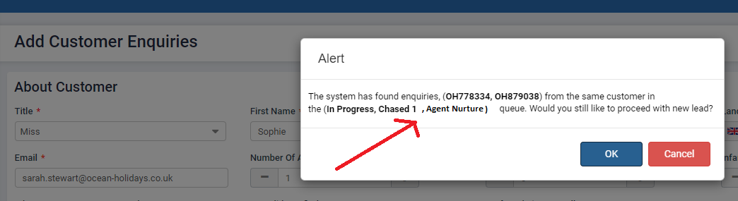
Outcomes of new Lead generation:
Phone Lead - If an agent proceeds (OK) with the new lead then the lead in Agent Nurture will automatically move to Agent Nurture Exhausted.
Web lead – System will automatically move the lead from Agent Nurture and move to Agent Nurture Exhausted.
Enquiry can’t go via Agent Nurture more than once?
There is a potential for 1 lead to go round the system in many ways. We know all leads end up in exhausted from Cold or Break Up no response. Then as per the above spec we send NPS Exhausted Email and then from there the system will perform Agent Nurture or Agent Nurture Exhausted.
When a customer is going via the Agent Nurture process, they may respond to any of the emails sent. This maybe to say they want a new quote or not interested anymore.
We are asking Agents if a customer wants to be removed from the Agent Nurture cycle, they change the status to Agent Nurture Exhausted, and we know by doing this it will not send any further communications to the customer.
However, if an agent quotes the customer and then the lead is back in the CRM journey in queues such as allocated, quoted, chased, hot etc etc there is potential then it will go via cold or Break Up no response again. Then from there to NPS Exhausted and Agent Nurture.
We need to add a flag that any given 1 x OH enquiry can only have 1 x NPS exhausted email/SMS sent and 1 x Agent Nurture email cycle sent. This means the lead would auto move to Agent Nurture Exhausted.

Agent Nurture Timeline
A series of Agent Nurture Emails will be sent.
The email templates will be managed in the CMS. This are TBC so for now user dummy data
Timeline for Nurture consists of 5 series of Agent Nurture Emails:
Agent Nurture 1 – Sent on day 30
Agent Nurture 2 – Sent on day 168
Agent Nurture 3 – Sent on day 365
Agent Nurture 4 – Sent on day 533
Agent Nurture 5 – Sent on day 730

When does Nurture 1–5-day email schedule count from?
NPS Exhausted email sending is day 1 of lead being in the Exhausted queue.
- No Response to NPS Email - The system will send Agent Nurture 1 Email – 30 days from it being in the Exhausted queue if no response to NPS Exhausted Email.
Example – NPS Exhausted Email send to customer on 1st October and no response from customer so the Agent Nurture Email will send on 31st October.
- Response to NPS Email - If there is response from customer and score is Passives or Promoters the system will send Agent Nurture 1 Email – 30 days from the customers response.
Example – NPS Exhausted Email send to customer on 1st October and the customer responds on 5th October, so the Agent Nurture Email will send on 4th November.

Agent Nurture Timeline – Exclusions on when we can email a customer?
Agent Nurture Emails will be sent daily at XXX (Time TBA)
We need to ensure we never send emails on certain days of the year even if the email is scheduled to send as per the Nurture 1-5 schedule above. The email will auto schedule to the next available day missing any exclusions.
Exclusions: 25th December, 26th December, 1st January. (This may change)
Example – Agent Nurture 1 email is due to send on 25th December so based on the exclusions above it will send on 27th December.

