VSTS Best Practice – February 2023

All users from UK team and DS need to follow the VSTS Best practice.

VSTS Developer & QA Task Management

- Every day a developer should have a task in ACTIVE within VSTS.
- Any given task in ACTIVE should have an assigned effort and Start and End date.
- If there is delay on task, then notes should be added. Example – holding task due to X, adding more time due to X. Task state should update to On Hold, if task has been held because or other priority task or awaiting query response.
Reason for delays could be –
  - Scope change/creep
  - Underestimated on initial review.
  - Code Merge from sprint or big project
  - Expand the scope before completion the task.
If any above happens then a comment will be added on task along with new/additional effort and project deadline will be updated on VSTS
e.g.
Total 3.5-man days of effort will be added to project because #reason#
Updated Effort
Development – <current effort> + 3 = <new effort >
QA- <current effort> + 0.5 = <new effort>
Design – no change
Total - <current effort> + 3.5 = <new effort>

End date will update accordingly.
This same applies to QA as well, where possible and applies please update the effort and dates accordingly.
*For India Team: In case of scope creep or expand, new details should be updated in the description by UK PM and if you find that missing the please request UK PM to add before you start work on that task

- Tasks should be allocated to BAU developers based on priority. (I.e., 1 to 4). 1 being taken first.
- If a developer is moved from a task and can’t complete their current ACTIVE task, then below 3 actions can happen based on task priority and complexity.
  - Please update the current task state to On Hold along with a comment. This will happen when a task must be picked by same developer because of domain knowledge or task complexity.
  - If the current task is important, then reassign to available developer followed by a comment.
  - If no developer available and task needs to be picked as next task for next available developer, then remove the current developer’s name and move to status Ready to Start Development. That way the next available developer can take and continue to work in priority order. End date needs to update when developer assigned to task.
- BAU developers should work to current sprint unless a HF has been added before this.
- Core developers should stay with current Core task unless agreement has been given by Sarah to move from this to another task.
- QA’s when taking a task to test should update their timelines for Start and End date and effort for their task.
- Any held work item, which starts again then effort will be revised (based on query response, if require) and end date will be updated accordingly.

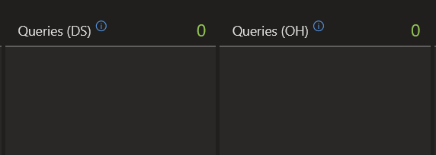

- Any assumptions which made for any work item should be added to assumption area of that work item and an approval require from UK PM.

VSTS Deployment Management - Commits

It would be beneficial if the Journey team assigned commits to work items, for several reasons:

- It allows all users to view the code, which is associated with the work item, this includes lines of code added or removed.
- This also enables the user to view the build in which the commit is related to.
- It enables code reviews to take place as we can clearly see the commit related to the work item, so any mistakes can be identified.
- Help to troubleshoot issues, if we know a particular commit broke something then we would also know which work item this is related to.

Using the following work item as an example - https://oceanholidays.visualstudio.com/Ocean-X/_workitems/edit/9210

- Here you’re able to see that the associated commit is 82187dba: Fixed Accessible Holidays Accommodation Landing Page Defect...
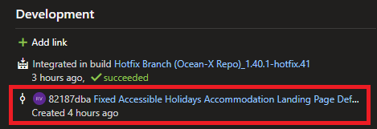

- The description of the commit should clearly explain what work has been implemented and would usually contain the work item name.
- The user is then able to view the commit which was made https://oceanholidays.visualstudio.com/Ocean-X/_git/6635d192-6565-4ed7-86ee-8de608281527/commit/82187dbae73de19445e6c3333c4f15ce3552efc9
- This contains lines of code added (green) and lines of code removed (red)
- It also shows information on which user made the commit and when it was made etc.
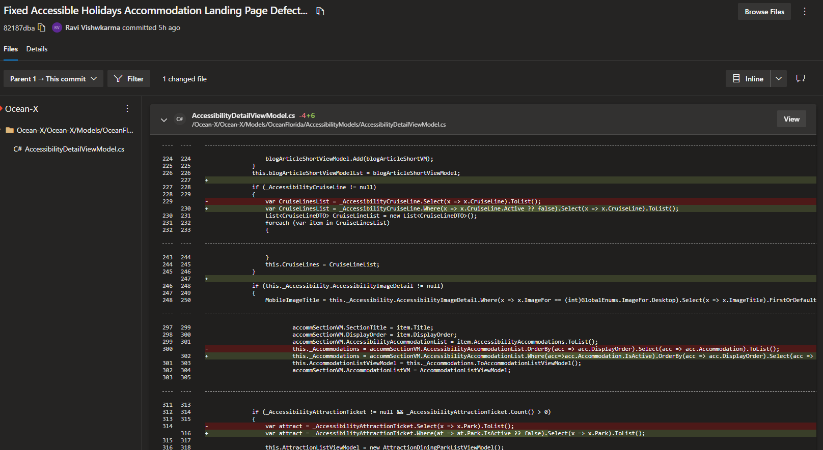
- Furthermore, we’re able to see the build which this commit is related to.
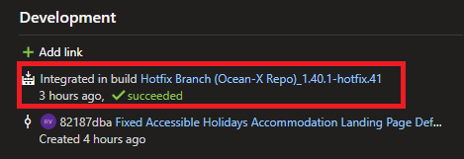

- This would typically be the feature or hotfix iteration, along with a success or failed message.
- Similar to the commit you can view the build in more detail, for example https://oceanholidays.visualstudio.com/Ocean-X/_build/results?buildId=10020&view=results
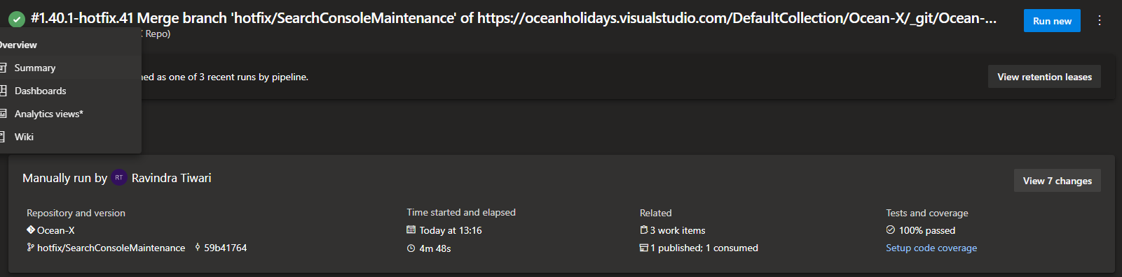

In terms of the process on how commits are assigned to work items there is an Azure integration where a comment can be added along with the work item number.

We are aware that Amit on the website team is familiar with this, so we believe he be good to guide the team on this.

VSTS Code Review

There is also a code review process which can be managed via VSTS.

We’re not currently doing this as far as we know so we have just explained the basics below.

- Prior to the QA testing the work item, a developer not assigned to the work item can review the code.
- This is to ensure that the code meets the correct standard and that there are no obvious mistakes.
- It may be beneficial to code review the work from the more junior members of the team, or for larger work items for example.
- Perhaps not all work items need to be code reviewed.
- A Pull Request can be made for the work item from where the developer can review the code.
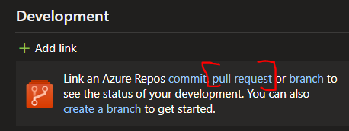

- In the left side navigation Pull Requests are managed from Repos > Pull Requests
- Example URL: https://oceanholidays.visualstudio.com/Ocean-X/_git/Ocean-X/pullrequest/2
- The code reviewer can see an overview, files, updates and commits before being able approve or reject the code.
- The primary goals here are to reduce bugs and ensure consistent coding standards across all projects.
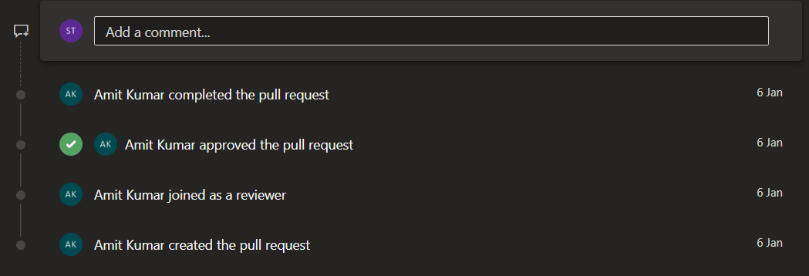

**A fixed time need to be allocated for code review to responsible team members. Responsible team members should inform to UK PM for time and task code which they will be reviewing.

System Training

We are aware there is new starters within the business, and we want to ensure that all users are supported within the systems we use.

If you feel there is a requirement to conduct extra training within VSTS on any of the aspects covered above, then we would be more than happy to assist via a Teams Meeting.

VSTS UK PM Task Management
- When a new project/task added on VSTS then description should have all the information like images (if applicable), support links, email address if any notification need to send, user role, brand etc.
- User Story will be breakdown into task where applicable.
- If Project is big and has impact in all modules, then it should have user stories. E.g. Rebranding, OFT, Accessibility This way, we can manage progress on board view level.
- Any amendment which we do in original spec, should be updated in the description with the date.
E.g.
New addition:
Date 22/11/2022:
A new email alert is added when... (all details will be added)
Added on User Story
Amend:
Cross current requirement and add new just below to that with a date.
Email will send to MGT Group
Date 22/12/2022
Email will send to Account group
And if project has sub tasks, then a sub task should be added for new amendment.
- Bugs can be added as sub-task of a user story (could be same user story or can added new with BUG prefix along with project title.) with prefix bug if bugs are more than 5 in single feedback on a user story/project, e.g OFT project we have got different feedback and bugs and it will be easy to manage if all were added as bug or as task
- Acceptance area will have test case view which should be added along with each project.
- Assumption made by developer on any work item should be reviewed and approved/disapproved by UK PM
- After production deployment, review sprint work item and update them to CLOSED state. If any work item has bug and need to be looked at again then either we move that into next sprint/HF or create a bug for the same for next sprint/HF. This is because, we do not have the visibility on sprint board for past sprint so work item can get lost by team or UK PM.
- After every sprint is completed. Sarah and Pooja will verify every sprint and complete and effort summary on each work item:

