
CONFIDENTIAL
March 17th 2021

Understanding Document

Dating Website and Mobile Application Development
Version 1.0

This document outlines the general scope of your project based on our understanding of the requirements provided and discussions to date. |  | Prepared for: Nathan Spiteri


DISCLAIMER
This document is submitted with the explicit understanding that the contents are confidential and would not be divulged to any third party without prior written consent from Dotsquares Ltd. Services are supplied according to our terms and conditions http://www.dotsquares.com/terms

Table of Content
Purpose of the Document 3
Project Objective 3
Users and Platforms 4
Scope of Work 4
User Journey 4
Admin Journey 5
User Types 5
System Features 6
Technology Specifications 12
Payment Schedule 16
Exclusions 17
Similar Projects 18
Hosting Plans 18
Maintenance Plan 19
Development Process 20
CMMI 21
Why Dotsquares 22

Revision History
Version | Date | Description | Prepared by | Reviewed by
1.0 | 17-03-2021 | Initial analysis and estimate | Nikhil | Ankit

Purpose of the Document

This document outlines the general scope of your project based on the requirements provided and discussions to date. The main objective at this stage is to ensure that all parties agree upon the general scope, budget and schedule of the project prior to commencing work on subsequent stages.

Clients are urged to ensure that all the details contained within this document are clear and fully meet their requirements before any work commences. Timescales mentioned only cover the scope listed, if this changes, costs and timings will change accordingly.

Once you are happy contact us and we will progress into the next stages. This may include further detailing requirements and functionality or it may go straight into design/development. This will depend on the nature of the project.

Project Objective
The project objective is to design and develop an online dating mobile application and the website that often takes advantage of a smartphone’s GPS location capabilities in order to date people via hitting like to each other based on the common interest, hobbies, pictures etc. This app can simplify and speed the process through potential dating partners, chatting and potentially meeting over traditional online dating services.
When the user comes across someone they are interested in, they hit like button. If the user is not interested in someone, they will click on cross(X) button. If two users mutually hit like on each other it’s called a ’match’ and a chat can be initiated between them.
This is the basic mechanism. Users can purchase the subscription plans added by admin (In-App Purchases). We will create an admin panel to manage the users, matched profiles, earnings, subscriptions/Plans and other configurable areas. The complete features of user’s apps, web and admin backend are listed in further section.
The website and mobile application will run in multiple languages i.e. English, Mandarin Chinese, Hindi, Spanish, Arabic, Bangla/Bengali, French, Russian, Portuguese, Indonesian and we will add more at later stage. However as of now we will consider English language only for phase 1.
We will be doing rebranding of the mobile application, website & web admin panel. With rebranding we will create replica of the mobile, website & web admin. We will just change the color theme & logo in the mobile application, website & Web Admin panel. We will have the following users in our system:

- Users
- Admin

Users and Platforms

Scope of Work
The scope of work includes the features and deliverables with the project development process. Here, we have explained the approach, features, deliverables, and workflow to make it easy for you to understand in better way. Please go through with scoped features carefully and feel free to ask for change in case of any questions or amendments into the scope of work.

User Journey
We have explained a high level flow of the User. Below journey shows the interaction of user with different application modules.
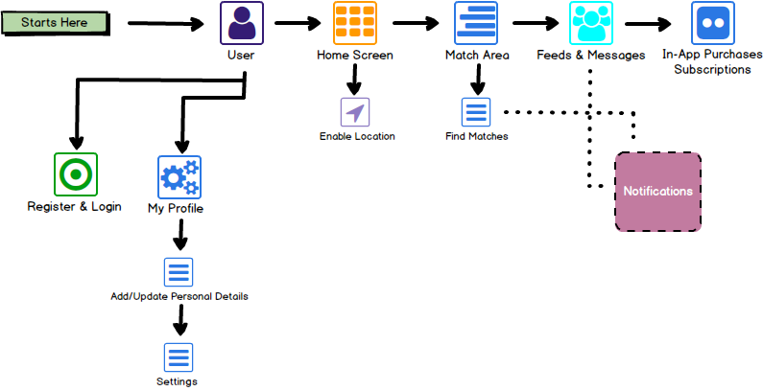

Admin Journey
We have explained a high level flow of the Admin. Below journey shows the interaction of admin with different application modules.
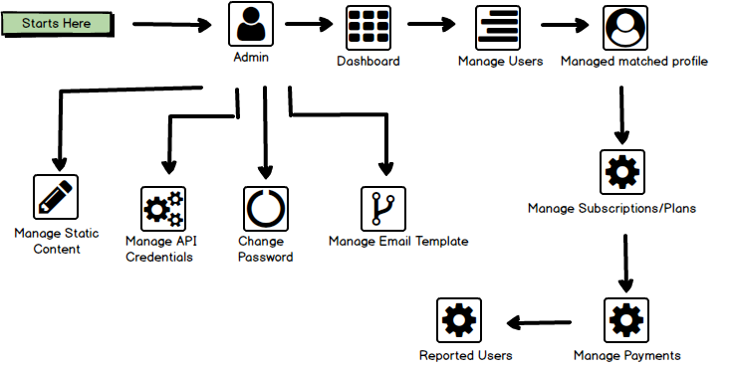

User Types
- Users:
  - On-board on the app/web by registration or login
  - Add/update personal details
  - Setup their profile & Settings
  - Match users by hitting like or cross tabs
  - Ability to see or send the message
  - Purchase subscription/plan (in-app purchases)
  - Real Time Chat with other users after purchasing the subscription plan

- Admin:
  - Admin can view Dashboard
  - Manage Users
  - Manage Matched Profile
  - Manage user subscription/plan
  - Manage payments
  - Reports
  - Manage reported users
  - Manage API credentials
  - Manage Static content
  - Manage email templates

System Features

Features for User Website/Mobile Application
1. Splash (Only For Mobile Application)
- Splash screen is the very first screen of the application that will open with Business Logo and 2 sec animation on screen
- It will appear upon first clicking the app and only last during the initial load time.
- It is useful for the business recognition.

- Login and Forgot password
- If the user already has an account, they can enter their details here.
- For login, user can –
  - Enter Phone Number (An OTP will be sent to user for verification)
  - Login with Google
  - Login with Facebook
  - Login with Email & Password
- In case user gets logout they can login with the –
  - Registered Phone Number
  - Google Account
  - Facebook Account
  - Email & Password
- Also, if a user forgot the password, then he/she can attempt password recovery. System will send a password reset verification code on their email to reset the password.
- We will integrate 3rd party API Twilio for SMS. For the security reason, user needs to verify their phone number before access the system.
  - Twilio: https://www.twilio.com/pricing

- Registration
User can register themselves by following –
- Phone Number (An OTP will be sent to user for verification)
- Entering required details such as –
  - Name
  - Email
  - Password
  - Confirm password
  - Mobile Number
  - An Email will be sent to user’s email id for verification
- Social Media Accounts like –
  - Google Account
  - Facebook Account

Non-registered users can’t access any of the application features. We will integrate 3rd party API Twilio for SMS. For the security reason, user needs to verify their phone number before access the system.
Twilio: https://www.twilio.com/pricing
- Agree Terms & Conditions
User will agree the terms and conditions by tapping on “I Agree” Button.

- Add Personal Details
User will input their personal details like –
- First Name
- Age
- Gender (Can Show/Hide)
- Sexual Orientation (Can Show/Hide)
- Filter or Display (Men/Women/Everyone)
- Add photos (up to 9) can be defined from back-end

- Location settings
- Enabling location is required for the user. It will make searching for users easier & meet people nearby. (Location will be used to display potential matched near user)
- Location will be identified using GPS or data received from the Wi-Fi network.
- Query: global location or within the range

- Home Screen
On home screen, user will be displayed three sections –
- My Profile
  - Settings
  - Edit Info
- Match Area (Like or cross (dislike))
- Rose icon- on being clicked it shows that it is most interested one
- Feeds and Messages

- My Profile
User will be able to see their profile section and can do the following tasks –
- Settings – In settings section, user can –
  - Can see their current location
  - Maximum Distance – User can slide the bar and set the distance from 0 – 100 miles.
  - Discovery Settings (Show me) – This will display the respective gender profiles like male, female and everyone.
  - Age range – User can set the age range by sliding the bar from age 20 – 55+. Application will use this preferences to suggest matches.
  - Show me – User can enable/disable this feature. It is used to hide show their profile to other’s on matches.
  - Show distances – User can set the distances in –
    - Kilometres
    - OR Miles
  - Manage payment account – User can manage their payment account by adding the credit/debit cards. We suggest Stipe payment to do the purchases on the app.
  - Contact Us (Help & Support) –On this section, user will be able to see the FAQ. (Redirected to the web page)
  - Community Guidelines – Here the static content will be displayed to user. They will be redirected to the web page.
  - User can see the static content like licences, privacy policy & terms and conditions.
  - Logout – User can logout of app by tapping on this button.
- Edit Info – Here, user can edit their profile like –
- Add or remove their photos (up to 6)
Query: Allow people to save approximate 10 images as standard and a profile of some length and depth to allow many factors for matching.
Add validation for size- dimension of the image
  - About User – User can add about them. A text box will be provided with 500 characters limit
  - Job Title – User can add/edit their job title
  - Company – User can add/edit their company name
  - School – User can add/edit their school/university name
  - Gender – User can add/edit the gender
  - Control your profile – Here user can on/off the below features –
    - Don’t show age
    - Make distance invisible
- Free V/S Premium Users
- The proposed app with free level will get people interested with limited likes, limited profile views, limited live chat feature etc. Whereas Premium features will allow unlimited chat, video chat/conferencing, profile saving of liked matches and more preference selecting available to see more of a person’s profile and allow a stronger match.
Third party for video conferencing
- Premium users can save more pictures say 20 photos and have filters available etc.

- Match Area (Like or dislike)
On this area, user will be able to see the other user’s profile as per genders and can like or dislike. Following are the criteria will be applied on match area are –
- If they hit like it means they have liked the profile of the other app user.
- If they hit dislike it means they have don’t like the other user profile.
- By tapping on like/dislike of the screen, they can see the photos of the other users.
- User can super like the other user’s profile. They will be appeared on the super like section.
- By tapping on the bottom area of the screen, they can see the other app user profile details like –
  - About User
  - Job Title
  - Company
  - School/University
  - Living In (Location)
  - Gender
  - Age
- Report – User can report the other user’s profile and select the appropriate option.
**The reported user profile will be sent to admin for verification**

- Feeds/Messages
On this area, user will be able to see the messages
- Messages – User can see all the other user’s messages sent by them to user. They can also see those messages which they have sent to other user’s
- User can see the likes section where they can see who like their profile. A list will be displayed of other users.

- Paid Version (in-app purchase)
- App paid version will include:
  - Unlimited Likes
- Boost: There will be only limited no. of users that can be like by any user per day.
- To access the unlimited users, user need to upgrade his plan.
  - Control profile
  - Choose who sees you
  - Super likes
  - User can have video chat or video calling functionality integrated for paid members
- User will also upgrade the plan if he wants to access more details on preferences such as height, age, eating habits, hobbies etc.
- When user opt any of the subscription, they have to pay through google or apple payment gateways
- Once payments details are added, they will do the payment of the amount displayed on the screen.
- App will have different subscription plans based on number of weeks/months such as 1 week, 2 weeks, 3 weeks, 1 month, 3 months and 6 months etc.

- Push Notifications
Users will receive notification on below basis:
- New Match
- New Request Received
- Request Accepted
- Specials events
- Matched profiles and premium users

Features for Web based admin panel
- Login and forgot password
- Admin can login to their secure web panel by entering their email address and password
- Admin can recover the forgotten password by entering their email address.
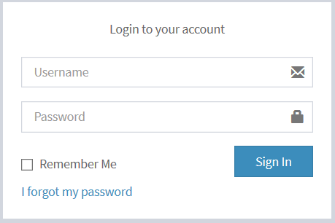
Note: Mock-ups/ Images shown in the system features sections are just for reference purpose and original designs will vary at the development time.

- Dashboard
- We will be showing below statistics on the dashboard
  - Today Users
  - Today Matched Profiles
  - Today Earnings
  - Total Users
  - Total Matched Profiles
  - Total Earnings
  - Today Plan/Subscription
  - Total Plan/Subscription
  - Sales Graph
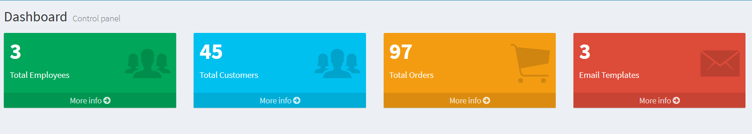
Note: Mock-ups/ Images shown in the system features sections are just for reference purpose and original designs will vary at the development time.
- Manage Users
- Admin can search and view Users list.
- Admin can view user’s information/ profile data.
- Admin can edit or delete the user’s account.
- Admin can add a user by adding following details –
- First Name
- Last Name
- Password
- Phone Code
- Phone Number
- Gender
- DOB
- Photo
- Location
- Status (Active/Inactive)
- Admin can active/Inactive any user anytime

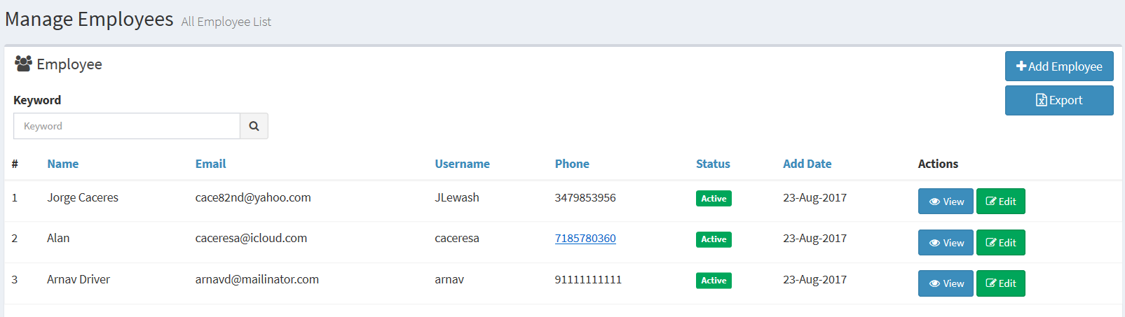
Note: Mock-ups/ Images shown in the system features sections are just for reference purpose and original designs will vary at the development time.

- Manage Matched Profile
- Admin can search and view matched profiles
- Admin can view matched profile’s information/ profile data.
- Admin edit/delete the matched profile

- Manage Subscriptions/Plans
- Admin can search and view subscription/plan list.
- Admin can view the subscription/plan details by clicking any of the subscription/plan.
- Admin can export the order to excel/csv
- Admin can create new subscription/plan by adding following details –
- Free Plan
- Super Plans
- Single Plans
- Duration –
  - Weekly
  - Monthly
  - Yearly

- Manage Payments
- Admin can search and view payments and transactions.
- Admin can filter the transaction by months/ weeks/ days or date range.
- Admin can export the report to excel/ csv.
- We will also show total earnings.

- Reports
- Admin can view the user’s reports on this section.
- Admin can filter the reports by date range and categories like users list, matched profile. Subscription/plan, Orders etc.
- Admin can export the report to excel/csv.

- Reported Users
- Admin can search and view reported user list.
- Admin can view the user reported user details.
- Admin can export the order to excel/csv
- Admin can take action on the reported users accordingly (active/inactive the users)

- Manage Static Content
- Admin can manage (view/edit) the static content like Terms and conditions, privacy policy etc.

- Manage Email Templates
- Admin can view pre-built templates
- Admin can edit or disable any template

Technology Specifications

Mobile App, Website and Admin Panel
Component | Technology
CMS/Framework | MVVM (Mobile App) and Laravel (Web Admin and Website) | MVC
Database | Realm (Mobile App) and MySQL (Web Admin and Website)
Server | Linux
Programming Language | React Native (Mobile App) and PHP (Web Admin and Website)

Deliverables
 | Deliverables |  | Deliverables
1 | Website and Application Design and Integration | 5 | Project Plan, Sprint Planning, Team Meeting by BA / PM
2 | Website and Mobile App Frontend Development | 6 | SRS by BA /PM
3 | Admin/Backend Development | 7 | Delivery Schedule, Gantt chart by BA / PM
4 | Test Cases Creation, Execution, System Testing by QA | 8 | Project Plan by BA / PM

Important Points

Third-party API/Tools
Please note that any delays or complications that may occur during or after the development that are a result of any 3rd party tools, scripts and hardware, are not included in the estimated timeframe. These will be assessed separately and may affect the development time required.

Assumptions
- The understanding provided in this document is based on the requirements provided by client. It may get changed or updated based on further details.
- Mock-ups/ Images shown in the system features sections are just for reference purpose and original designs and scope will be dependent on final agreed scope.
- We expect that client will supply the domain & hosting details to make website live.
- We expect that client will supply the google and apple developer account to make the app live.
- We expect that client will supply the payment gateway details.
- We have provide our technology suggestions based on the requirements provided and our experience of the best way of realizing these. If you have any specific technology requirement or would like us to explore other opens, please just get it touch to let us know.
- The website functionalities are similar to the app requirements.

Identified Risks
- Increase in estimated time if any readymade module/extension conflicts with the third-party theme or other extension and that time will be separately estimated.

Client Receivables
- Website and Content
- Web Hosting and Domain Details
- Google and apple developer account
- In App Purchase and Google Purchase Account
- SMS API - https://www.twilio.com/pricing
Ballpark Estimates
Mobile Application (React Native)
Option 1: Offshore Team and Project Manager
Estimated Timeframe of deliver (Man Weeks)  - (One Developer x 6 weeks) | 6
Estimated Cost | AU $10,080

Above Estimate(s) are valid for 30 days from date of issue

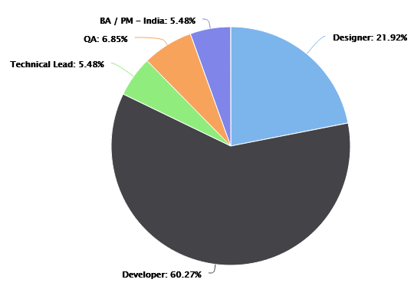
Resource Utilization
 | Profile | Nature of Engagement
1 | Application Developer | Full Time
2 | Designer | Partial
3 | Quality Analyst | Partial
4 | Technical Lead | Partial
5 | Business Analyst/ Project Manager (Offshore) | Partial

Option 2: Offshore Team and AU based Project Manager
Estimated Timeframe of deliver (Man Weeks)  - (One Developer x 6 weeks) | 6
Estimated Cost | AU $10,800

Above Estimate(s) are valid for 30 days from date of issue

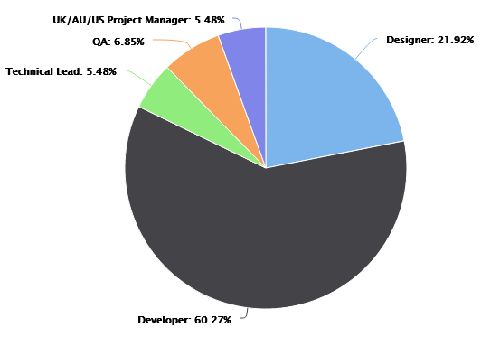
Resource Utilization
 | Profile | Nature of Engagement
1 | Application Developer | Full Time
2 | Designer | Partial
3 | Quality Analyst | Partial
4 | Technical Lead | Partial
5 | Business Analyst/ Project Manager (Onshore) | Partial

Website
Option 1: Offshore Team and Project Manager
Estimated Timeframe of deliver (Man Weeks)  - (One Developer x 4 weeks) | 4
Estimated Cost | AU $6,400
Above Estimate(s) are valid for 30 days from date of issue

Resource Utilization
 | Profile | Nature of Engagement
1 | Application Developer | Full Time
2 | Designer | Partial
3 | Quality Analyst | Partial
4 | Technical Lead | Partial
5 | Business Analyst/ Project Manager (Offshore) | Partial
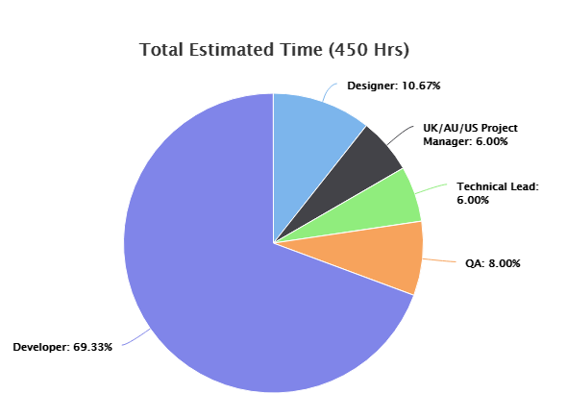

Option 2: Offshore Team and AU based Project Manager
Estimated Timeframe of deliver (Man Weeks)  - (One Developer x 4 weeks) | 4
Estimated Cost | AU $7,200

Above Estimate(s) are valid for 30 days from date of issue

Resource Utilization
 | Profile | Nature of Engagement
1 | Application Developer | Full Time
2 | Designer | Partial
3 | Quality Analyst | Partial
4 | Technical Lead | Partial
5 | Business Analyst/ Project Manager (Onshore) | Partial

Payment Schedule
Mobile App (React Native)
 | Weekly Invoices | Payment Method | Amount | Total Amount
1 | From Week 1 to 6 - Option 1 | Pay in our Australian account | AU $1,600 + 10% GST per week | AU $10,080+ 10% GST
1 | From Week 1 to 6 - Option 1 | Pay in our India account | AU $1,600 per week | AU $10,080
2 | From Week 1 to 6 - Option 2 | Pay in our Australian account | AU $1,800 + 10% GST per week | AU $10,800+ 10% GST
2 | From Week 1 to 6 - Option 2 | Pay in our India account | AU $1,800 per week | AU $10,800

Website
 | Weekly Invoices | Payment Method | Amount | Total Amount
1 | From Week 1 to 4 - Option 1 | Pay in our Australian account | AU $1,600 + 10% GST per week | AU $6,400 + 10% GST
1 | From Week 1 to 4 - Option 1 | Pay in our India account | AU $1,600 per week | AU $6,400
2 | From Week 1 to 4 - Option 2 | Pay in our Australian account | AU $1,800 + 10% GST per week | AU $7,200 + 10% GST
2 | From Week 1 to 4 - Option 2 | Pay in our India account | AU $1,800 per week | AU $7,200

Exclusions
Below features are excluded from the scope at the moment.
- Mobile Application is not multi-lingual as of now. It will be in English language only.
- This estimate does not include any paid images, paid plugins, or paid 3rd Party resources to be used in the project.
- The estimation which we shared for mentioned points only. If anything else need to added, then we will re-estimate the things.
- Chat between users will only be visible to the front-end users.

Important Note:
- We would like to inform you that the dating apps got rejected these days on apple store due to patent issues. Apple changes their review process all the time and doesn’t provide any sort of information to app developers around the world.
- When an app goes into the review process then only both business owners and developers get to know what sort of changes are required and again sometimes no changes are required and sometimes they are required which is when we estimate those changes and inform our clients and based on their approval, we go ahead and implement them.
- We don’t control App review policy and thus if in case the proposed application will get rejected on apple store because of any reason, we are not responsible for that.
- In order to make it live again, whatever changes requires, or additions apple asks and if they are not part of our estimated proposal, then you have to pay for it as it’s your own app and we just charge for our time.

Estimate Notes
The exact speed of design & development will be affected by client turnaround times, i.e. responding to queries and providing feedback. All services are supplied according to our T&Cs http://www.dotsquares.com/terms

The above estimate is based only on the features which we have listed in this document. If you need any other feature (not listed in this doc) then the estimate is likely to change. It may also vary after sharing your response on any queries being asked in this document.

Note: Your project will be managed & developed by your Dotsquares Team. Other than Developers indicated in a full time capacity, all team members will be involved partially as required for specific hours in a week.

Similar Projects
- iPhone App: https://tii.page.link/v8my

After installing you might need to enable trust in using this app, so please follow the below process to do so -
Settings -> General - > Profile/Device Management - > Dotsquares LTD -> Trust

- Android App: https://ds212.24livehost.com:8018/637274594902421797
Installation instruction is as follows –
- Open your Android's web browser. Go to above URL and hit the download button.
- Wait for the APK file to finish downloading.
- Open your Android's file manager app and find the downloaded APK.
- Tap on APK file and INSTALL. It's in the bottom-right corner of the screen. Doing so begins installing the APK file. Tap DONE when prompted. This is at the bottom of the screen.
- Sign up with mobile number. An OTP will be prompted, enter it and login into the app to see the features.
- In your review, please avoid signing up with social media as this a demo version.
- Web Admin Link:
URL: http://tinder.projectstatus.in/admin/login
Username: admin
Password: Dots@123

Hosting Plans
We can provide a range of hosting packages to suit your requirements – please enquire for more details.
Based on the known requirements our network team would recommend the follow
Fully Managed Cloud Server  1. CPU : 2 Core  2. RAM : 4 GB  3. HDD : 80GB SSD Storage  4. Dedicated IP : 1 IP  5. Bandwidth : 4TB  6. OS : Linux Centos  7. Control panel : cPanel/WHM  8. Server Backups  9. 24 hours emergency support  10. Fully managed account services  The cost of the above package will be AU$190 per month  Server Setup Charges : AU$50 One Time  SSL Certificate : Included  Fully Managed Cloud Server  1. CPU : 6 Core  2. RAM : 16 GB  3. HDD : 320GB SSD Storage  4. Dedicated IP : 1 IP  5. Bandwidth : 8TB  6. OS : Linux Centos  7. Control panel : cPanel/WHM  8. Server Backups  9. 24 hours emergency support  10. Fully managed account services.  The cost of the above package will be AU$490 per month  Server Setup Charges : AU$50 One Time  SSL Certificate : Included | Fully Managed Cloud Server  1. CPU : 4 Core  2. RAM : 8 GB  3. HDD : 160GB SSD Storage  4. Dedicated IP : 1 IP  5. Bandwidth : 5TB  6. OS : Linux Centos  7. Control panel : cPanel/WHM  8. Server Backups  9. 24 hours emergency support  10. Fully managed account services.  The cost of the above package will be AU$350 per month  Server Setup Charges : AU$50 One Time  SSL Certificate : Included

Maintenance Plan
Our on-going support & maintenance and server cost is a separate model and based on how much support and server configuration you needed there are variations in it.
Generally we provide 30 days warranty period upon project completion and making it live where we will provide the required support needed within that timeframe.
However, For Ad-hoc support and ongoing maintenance related requirements we have a Bucket Model in place. Please see features and pricing of this model below.
- 10/ 20/40 hours can be purchased on pre pay basis and purchased hours can be utilized on as and when required.
- Purchased hours are valid for 6 months from the date of purchase.
- We can remove validity period if you are willing to purchase larger slot of hours.
- No monthly fees or recurring contracts. Only the Time used will be removed from Bucket – in amounts as small as 15 Minutes.
- The Bucket is kept with Developer/PM & authorization is not required from our accounts.
- Team & Accounts will keep you posted on Bucket hours and the same will be shared on our Project Management system too.
- You can top up bucket with same of less number of hours when purchased hours are exhausted.
- Cost: $1,800 + VAT for 40 Hours Bucket

Development Process
Project Management Tool  Dotsquares will provide free access to DS Projects our project management and collaboration platform for project planning, communication and tracking.  - Daily updates provided  - Keeps digital track of conversations  - Milestones and tasks for planning  - Maintain task list for deliverables  - E-mail notifications about updates & other activities | 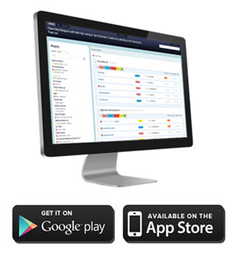

Testing
We provide unit testing services for your project as a standard package. Unit testing is completed by the developer during the development cycle. We ensure all the code blocks (paths) in the software are executed at least once and produce the desired results.

Environment  Where possible, Dotsquares provides free of cost hosting during the project for you to test at your convenience. If the project dictates specific environment requirements, a separate estimate will be provided for these.  When the project is finished and signed off, we ask you to choose a hosting provider and deploy the project to live environment. |  | Deployment  Dotsquares will deploy the complete solution for the project. Code can also be supplied directly to you or any repository account held.  Web based developments will normally be transferred to your own hosting account and put live as required.  Mobile applications will be uploaded to the relevant App Store under your developer account.
Warranty  Your software is delivered with a free warranty of 30 days. You must notify the team during the 30 day warranty period if you identify an error in the code / system / program. Once it has been agreed Dotsquares will correct any errors made in the construction of the code / system program no cost. Dotsquares reserves the right to define a bug / error. |  | Intellectual Property Rights  All the Intellectual Property created, written, developed, furnished or produced by us during the term of the agreement / project, that are within the scope of the agreement or any applicable Statement of Work shall be the exclusive property of the client.  All the code base, assets, documentation (if any) will be provided to you after development.

CMMI
What our CMMI Maturity level rating actually means for you.
Improved Quality
- Well-defined processes limit opportunities for error.
- Smart supplier management ensures quality results.
- Strategic people management enables team members to develop skills that will help the organization succeed.
Decreased Costs and Enhanced Productivity
- Streamlined processes allow teams to integrate and collaborate more efficiently.
- Standardized project management practices reduce redundancy and waste.
- Identifying skill gaps helps break down workflow bottlenecks.
Higher Customer Satisfaction
- Service delivery strategies strengthen weak customer touch points.
- Elective product development instills customer confidence.
- Project management practices help teams meet and manage customer expectations.
Improved On-Time Delivery
- Field-tested project management standards keep work on schedule.
- Clear development processes reduce scope creep and deadline extensions.
- Careful vendor management mitigates supplier delays.



Why Dotsquares
We thrive on seeing ideas grow. Since 2002, we have been working with individuals and global brands to embrace the evolving digital industry.

We are big on trust, reliability and mutual respect so we will take the time to understand you, your product and your business. We work closely with all our clients and are always looking to forge ongoing trusted relationships.

Taking your IT project offshore allows you to cut down on the costs whilst maintaining a quality that onshore companies struggle to match. We take the pain out of your IT projects and let you concentrate on the business you know best:
Your own.

Dotsquares are an international creative digital design and development company striving to make your vision a reality.

What we do…

WEB   | GAMES   | APPS  
Our web development professionals bring years of experience to meet both the business and technical requirements of a project. | Our game developers use platforms such as Unity, Maya, Cocos2D, Unreal, ARKit, Maya, Max and more to create the best gaming experience. | We provide cutting-edge mobile app development that can efficiently and creatively meet current business demands.
CRM   | DIGITAL MARKETING   | IT SUPPORT  
Each company is different and we can create bespoke CRM systems to manage your client relationships in the most efficient way. | The industry is becoming saturated. Using methods like SEO, SMM, PPC and Google Ads, our marketing experts can give your brand a voice. | Server support, network troubleshooting, remote installation, our hosting experts are on hand 24/7 to keep your business alive.

Portfolio

What our clients say
Daniel Ox
Ocean Holidays Group
UK
Significant cost savings can be made working with an outsourced development company you can trust. Dotsquares have an exceptional team of quality engineers who work quickly and are always aware of deadlines.”

John Wussah
Education & Training Company
Australia
“You have been one of the best developers I have ever worked with. You have excellent technical and interpersonal skills and you got my website development and design project done to my amazement and satisfaction!”

Brian Riback
New York Daily News
USA
Dotsquares went beyond the requirements. The Team are amazing and working with them is a winning formula. I feel extremely lucky to have these gentlemen on my Team with their unyielding dedication to excellence.”


Affiliations


