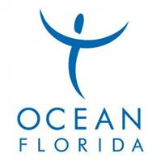

Insert logo

This Voucher entitles the holder to a
Clearwater Beach Tour including Transfers

Please contact Florida Dolphin Tours quoting reference number “Ocean Florida”
At this point you will also be advised where your nearest
pick up point for the Tour will be.

Telephone number: UK No. 0800 368 7412
US No. 1 (407) 352-4646

Exclusions: Lunch is not included in this trip

