Booking Status – Waiting Flight Bookings

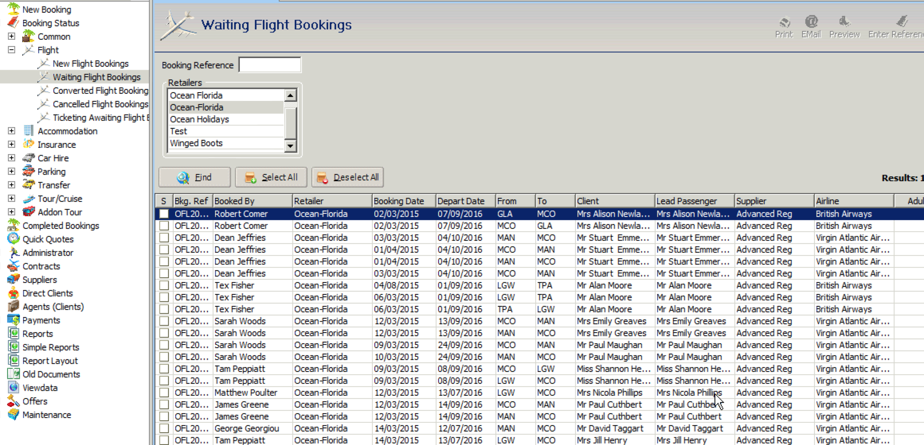

We need to add the following columns to the Waiting Flight Booking display in Bookings Status.

We would also like to be able to control these columns in the retailer settings so we can choose to hide columns we don’t need to display and change the sort order (much like we can for results columns in Bookings)

Some of the below aren’t available within a booking yet but I have included details of what’s required to include them further down this document.

- Cabin Type (eg economy, premium, etc)
- Nett Cost
- Flight Status (this is a new status drop down we want to add to a booking, explained below)

Additional Requirements:

- Within a contract flight booking could you add a new drop down called Flight Status with the following options
- Held high fare
- Held outbound Only
- Awaiting Amendment
- Upsell
- Airline switch

We will need to be able to report on the new Flight Status options (Held/ Held Outbound Only/Awaiting Amendments) within Simple Reports using the Accomplished Bookings and Contract Flights datasets.

