Supplements By Departments

Highlighted in red are the suggested new supplements based on departments. You should only ever use the supplement that has your department code in front of it. These supplements are for internal adjustments and should be hidden from the clients documents.

Please check through these and ensure nothing has been missed.

OPS Advance Reg
OPS Accommodation Nett Adjustment
FLT Advanced Reg
FLT Schedule Change
FLT Miscellaneous
FLT Flight Net Adjustment
ACCR Accounts Adjustment
ACCR Flight Net Adjustment
ACCR Accommodation Supplement
ACCR Car Hire Supplement
ACCR Transfer Supplement
ACCR Attraction Ticket Adjustment
ACCR Accounts Miscellaneous
ACCR Accounts Adjustment
LOAD Agent Accom Adjustment

Below is the feedback from each department. Helen, you suggested renaming Administration Fee as Amendment. As this is a fieldthat has been here since day one and is a TD standard field, it would be better to create new options under ‘Types’

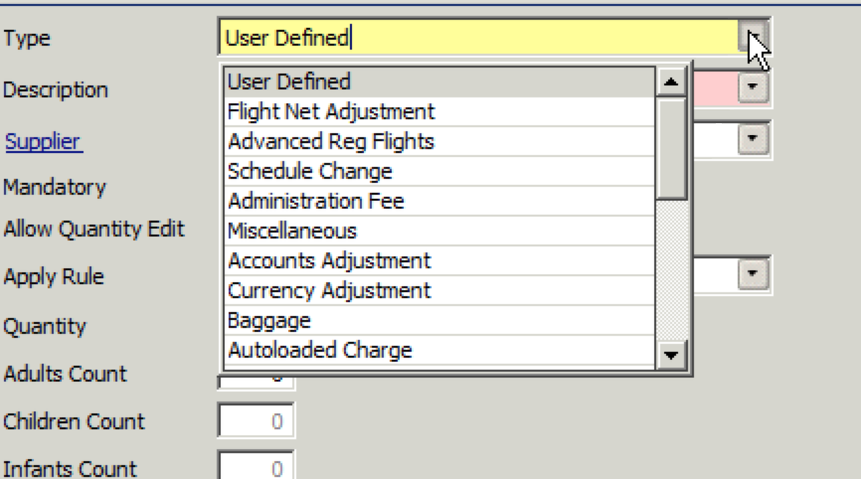

Ops

Type - Only use - Administration Fee (This could be changed to amendment maybe?)
Description - Ops
Advance Reg (All types)
Accommodation Nett Adjustment

Flights

Advanced Reg (with different descriptions)
Schedule Change (with different descriptions)
Miscellaneous (with different descriptions – mainly flight upgrades or flight requests which we log with zero value)
We might occasionally use flight net adjusted for losses due to system error / agents who already left the company etc.

Accounts

Karen and myself,
Accounts Adjustment
Flight net Adjustment

Patsi
NSP Complaint refund – not sure if you need this as I would think this is an extra rather than a supplement?

Accounts Receivable
NSP Accounts – same as above

Accounts Payable
Flight net adjusted
Accommodation supplement
Car hire supplement
Transfer supplement
Attraction Tickets Adjustment
Miscellaneous - SFC
Accounts adjustment ( this is only used occasionally when nothing else is available)

