UK PM Development Specification Document
Please ensure you complete all fields and provide any additional supporting evidence as further attachments within the ticket raised.
Your Name: | Pooja Jangid
Today’s Date: | 24/12/2019
Associated UK PM Name: | Daniel, Steve

Request Type: | ☒New Development ☐New Report ☐Improvement

Parent task  Connection: | ☒Yes ☐No  If yes, please share task ref/connection:  https://ocean-holidays.leankit.com/card/780645701

Brand(s) | ☒Ocean Florida ☒Ocean California ☒Winged Boots  ☐Ocean Beds ☐Ocean Holidays
Product Type/Module(s) | ☒Sales (SPP) ☐Product (PS) ☐Flight (FS)  ☐Concierge (CG) ☐Customer Service (CSB) ☐Ticket (TS)  ☐Travelling Web ☐OF Website ☐OC website  ☐OH Website ☐WB Website ☐G2B  ☐MMB ☐Journey Admin ☐Qubit  ☐PPF ☐NPS ☐My Quote  ☒Other
User Role(s)  Required | ☐Management ☐Agent ☐Agent Supervisor  ☐Contact Agent ☐Contact Supervisor ☐TD Load  ☐Contractor ☐Ocean Beds ☐Destination  ☐Agency ☐Analyst ☐Analyst Restricted  ☐Admin ☐Contact Referrer ☒NA

Project Title: | Sync Booking Prediction from Big Query to CRM
Importance Level: | ☐Critical ☒High ☐Medium ☐Low
Task board URL and Task Ref: | Insert the task URL you have used when creating this task on the task board:  https://ocean-holidays.leankit.com/card/952514738

Project goal: | Using bullet points please tell us what you hope this project will achieve/solve:  - Sync booking prediction from the BQ to CRM which will help agent in the booking process
User story: | Using bullet points please explain how you expect a user to interact with this development/task and include impact areas:  - Add a new Method in below file to fetch data from BQ and add that in CRM table  AnalyticsMQ/AnalyticsMQ.Client/GoogleBigQueryClient.cs  Using below query (refer method called GetEstimatedLeadValueBySegmentBQ  )  SELECT enquiryreference, booking_Probability * 100 AS booking_Probability FROM  (SELECT *,max(Timestamp_pred) OVER (PARTITION BY enquiryreference) AS max_timestamp FROM  (SELECT * FROM `journeyml.JCRM_EU.Model1_Prediction_Final`)  )  WHERE timestamp_pred=max_timestamp  - Create a table (BQModelPredictionDailySync) in CRM with 3 columns  - EnquiryReference (string)  - BookingProbability (Decimal)  - AddDate  - Design scheduler/hangfire job which will run in every 6 hours in a day and pull data from BQ and store in new CRM table (BQModelPredictionDailySync). Each time when we pull data, it should remove the old data and then add the latest pull.  - Create a table (EnquiryBQModelPrediction) in CRM with 4 columns  - EnquiryId (integer, PK)  - EnquiryReference (string) (will be useful when match value from sync table and insert/update in this table which means doesnt require join with Enquiry Table)  - BookingProbability (decimal)  - LastUpdatedDatetime (Datetime2)  - Design a trigger on BQModelPredictionDailySync to manage data for EnquiryBQModelPrediction table (through on insert) and update the enquiry data accordingly (update if exist and insert if not).  For example, BQModelPredictionDailySync table got 10 enquiry records from sync call, so we need to match all these 10 references in EnquiryBQModelPrediction and if find any existing record then system will update it, else insert a new row with new reference.  This (EnquiryBQModelPrediction) table will be used by CRM business logic to show booking prediction in all required sections which I have mentioned below  - On Enquiry Form – Replace engagement score by booking probability on view and edit enquiry form. This will show data from EnquiryBQModelPrediction table. If record doesn’t find in the table then it will show NA.  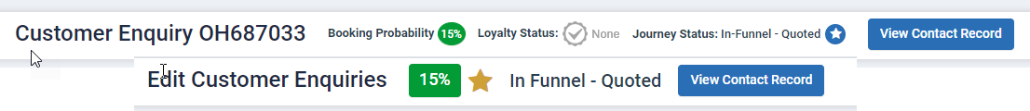  - Contact Record –  - Add a new column called BP Score under Enquiry / Case History. If value is not relevant then it will show NA  - Replace Engagement score with booking probability score in the header  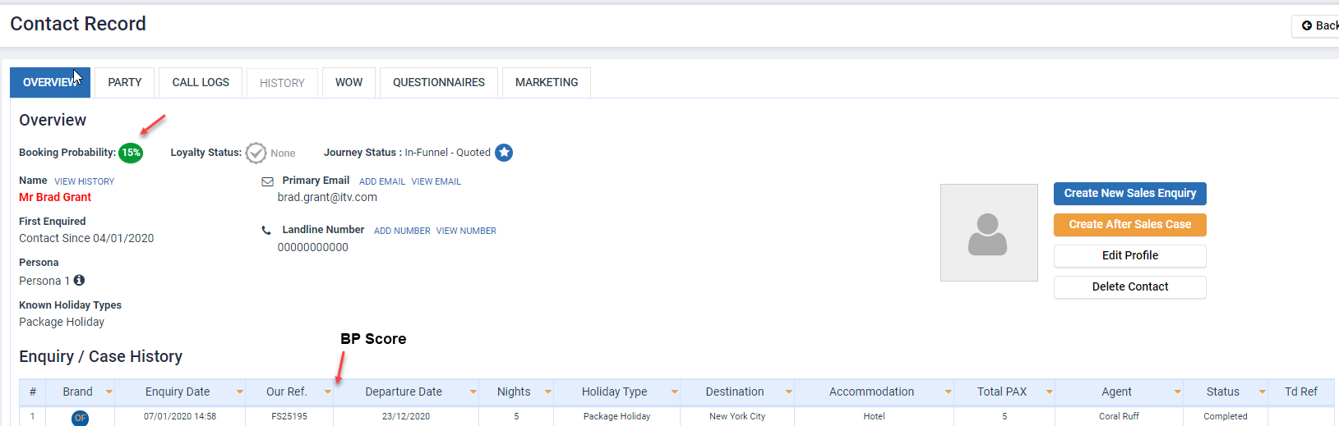  - Queues – Replace Lead Score column value with booking probability and rename the column by BQ Score %. Same will apply on Task List, Enquiry Search, export data in CSV (enquiry search).  This will apply on only active queues which are, NEW, CT In progress, Allocated, In progress, Quotes, Chased, Break up, Hot, Cold, Nurture, Nurture Exhausted, Pending, Hold Name request, Parked, Awaiting confirmation, Committed booking, Park Nurture.  Hide/remove the Lead Score column for TD Load, TD Complete, TD Error and TD confirmation queue. But for these on enquiry view/edit score will show as 100% and same as in the Contact record enquiry listing section.  Sorting on BP score will be applied.  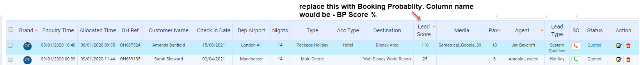  - Rule to show score on contact and enquiry page.  - Contact Record will show score based on most recent enquiry on that contact (not deleted or archived) [DB-Store score at contact and enquiry level both.]  - Enquiry Page will show score from EnquiryBQModelPrediction table if data exists. If not, then it will show NA (Dan confirm for this, as BP score is based on the enquiry not on the contact so it will show if exist else not)  - If contact doesn’t have any score which means BP score doesn’t exist for any lead of that contact, then it will show as NA on both contact level as well as at enquiry level.  - Queue, task list, enquiry search- these will also show data based on rule 1,2,3.  - Push BP score back to the Big query, in all 3 tables. (*Ask Steve to add new column in all 3 tables with type decimal) (*Asked Chindu to check if this can be done by him from data studio)  Phase 2 –  Allocate lead as per booking probability to agent and CT users so add this as permission criteria in Permission section
Add external system URL link: | Please provide external system URL link if known:

For DS purposes only:
DS Developer Name: | Please insert developers name who will be working on this task:
DS Designer Name: | Please insert designers name who will be working on this task:
Specification reviewed and agreed with UKPM: | Please insert details once the task has been reviewed and both parties are agreed:  Name of Developer (s) that have reviewed this task:  Please insert total amount of days you have estimated for the task:  Estimated Designer Time:  Estimated Development Time:  Estimated Testing Time:  Total Development and Testing Time:

