UK PM Development Specification Document
Please ensure you complete all fields and provide any additional supporting evidence as further attachments within the ticket raised.
Your Name: | Sarah Stewart
Today’s Date: | 14th January 2020
Associated UKPM Name: | Sarah Stewart

Request Type: | ☐New Development ☐New Report ☒Improvement

Parent task  Connection: | ☐Yes ☒No  If yes, please share task ref/connection:  https://ocean-holidays.leankit.com/card/941245422

Brand(s) | ☒Ocean Florida ☒Ocean California ☐Winged Boots  ☐Ocean Beds ☐Ocean Holidays
Product Type/Module(s) | ☒Sales (SPP) ☐Product (PS) ☐Flight (FS)  ☐Concierge (CG) ☐Customer Service (CSB) ☐Ticket (TS)  ☐Travelling Web ☐OF Website ☐OC website  ☐OH Website ☐WB Website ☐G2B  ☐MMB ☐Journey Admin ☐Qubit  ☐PPF ☐NPS ☐My Quote  ☐Other
User Role(s)  Required | ☒Management ☐Agent ☐Agent Supervisor  ☐Contact Agent ☐Contact Supervisor ☐TD Load  ☐Contractor ☐Ocean Beds ☐Destination  ☐Agency ☐Analyst ☐Analyst Restricted  ☐Admin ☐Contact Referrer ☐NA

Project Title: | Agent Task Manager Report – Dismiss % column
Importance Level: | ☐Critical ☐High ☒Medium ☐Low
Task board URL and Task Ref: | Insert the task URL you have used when creating this task on the task board:  https://ocean-holidays.leankit.com/card/959937522

Project goal: | Using bullet points please tell us what you hope this project will achieve/solve:  - Seeing as a clear view what the % dismiss count is per agent and what the average is  - MGT can see people working to higher dismissed figures to other
User story: | Using bullet points please explain how you expect a user to interact with this development/task and include impact areas:  - On the current report we would like to add in a further column.  - Please see design below showing this  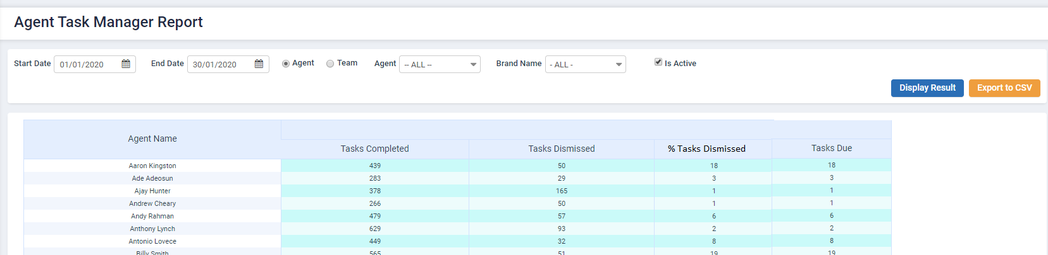  - The formula for the % Tasks Dismissed column will be:  Task Dismissed / (Tasks dismissed + tasks completed) x 100.  Aaron example –  Dismissed = 50  Completed = 439  50/489 * 100 = 10.22%
Add external system URL link: | Please provide external system URL link if known:  https://www.journey-crm.co.uk/reportagenttaskmanager

For DS purposes only:
DS Developer Name: | Please insert developers name who will be working on this task:
DS Designer Name: | Please insert designers name who will be working on this task:
Specification reviewed and agreed with UKPM: | Please insert details once the task has been reviewed and both parties are agreed:  Name of Developer (s) that have reviewed this task:  Please insert total amount of days you have estimated for the task:  Estimated Designer Time:  Estimated Development Time:  Estimated Testing Time:  Total Development and Testing Time:

