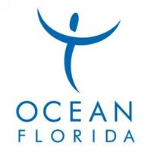

Insert logo

This Voucher entitles the holder to a
Clearwater Beach Tour including Transfers

Please contact Florida Dolphin Tours quoting your surname and Discount code: Ocean Florida

At this point you will also be advised where your nearest
pick up point for the Tour will be.

Telephone number: UK No. 0800 368 7412
US No. 1 (407) 352-4646

