- Admin role not showing on user role page - DONE
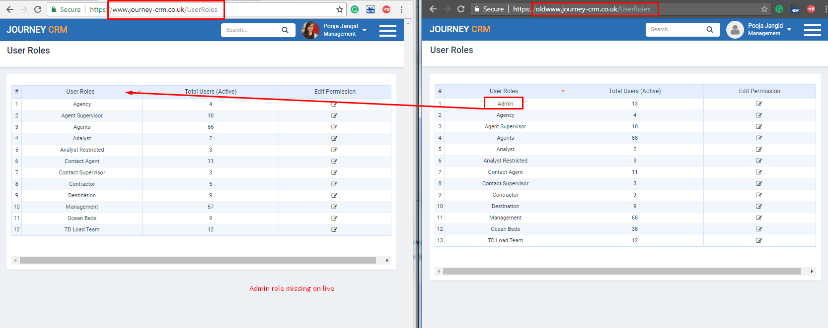

- Permission not showing in the User roles - DONE

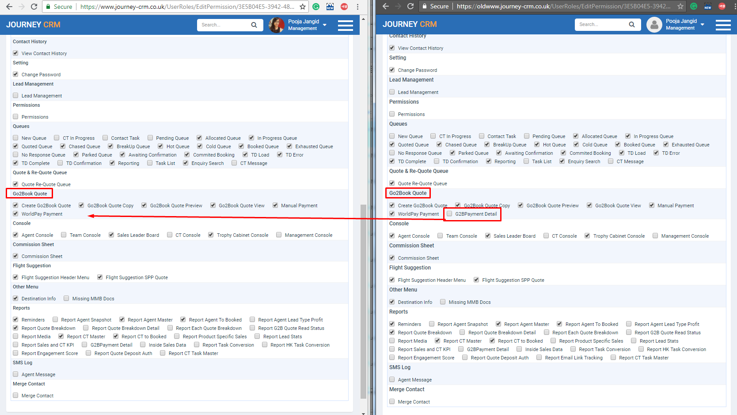

- Permission not showing in the User roles - DONE
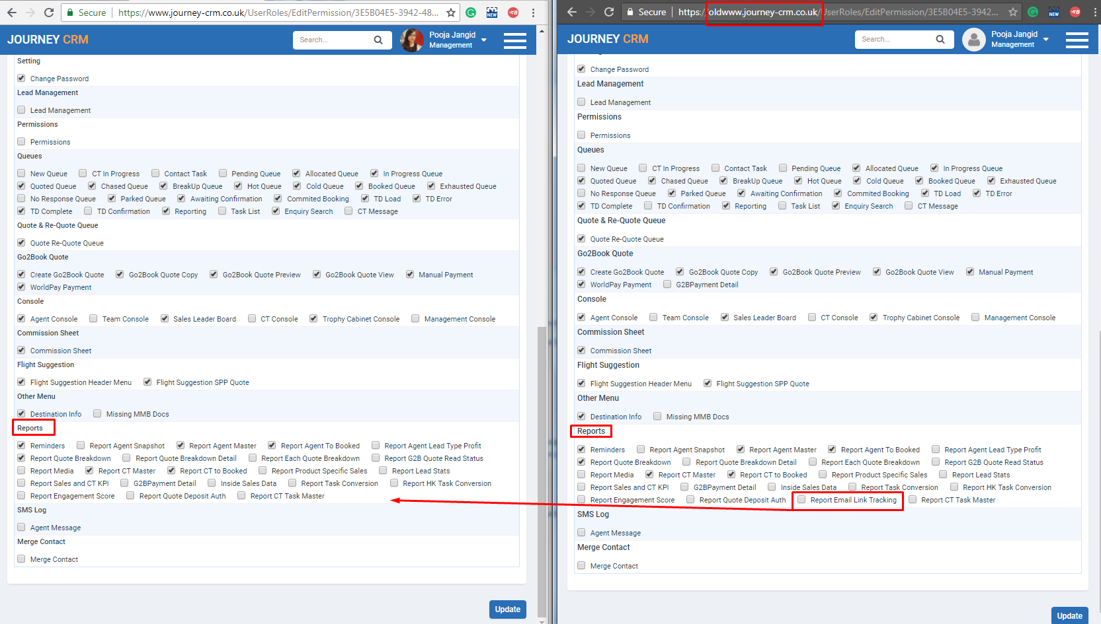

- When CT user allocate lead to agent. DONE
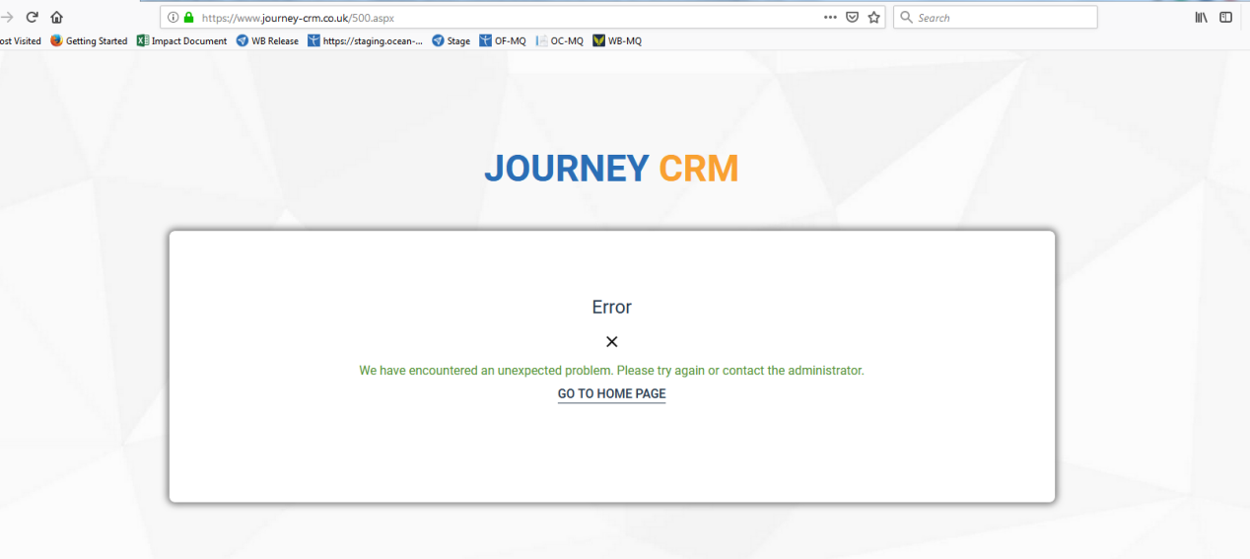

- Showing text out of the page when edit lead by agent.
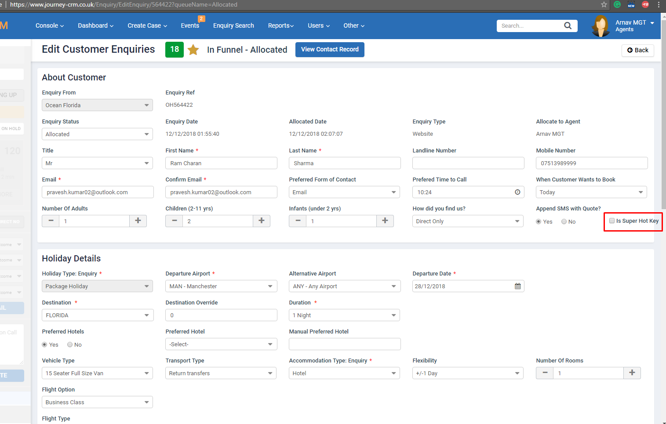

- When adding Cruise product in SPP quote and add another one. DONE
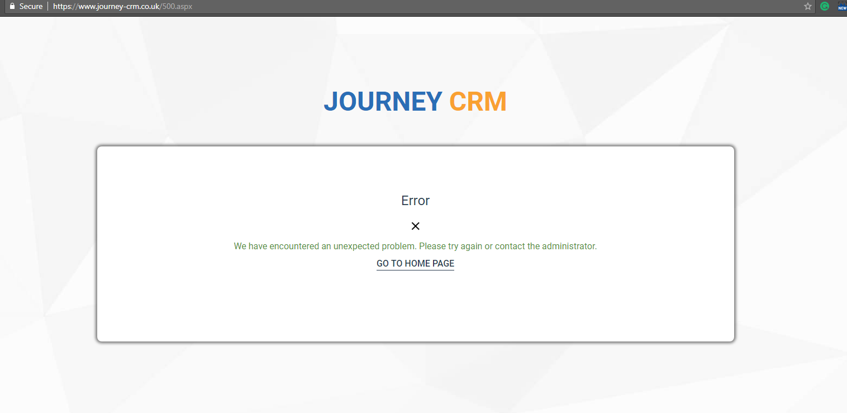

- Showing error on G2B transfer product. DONE
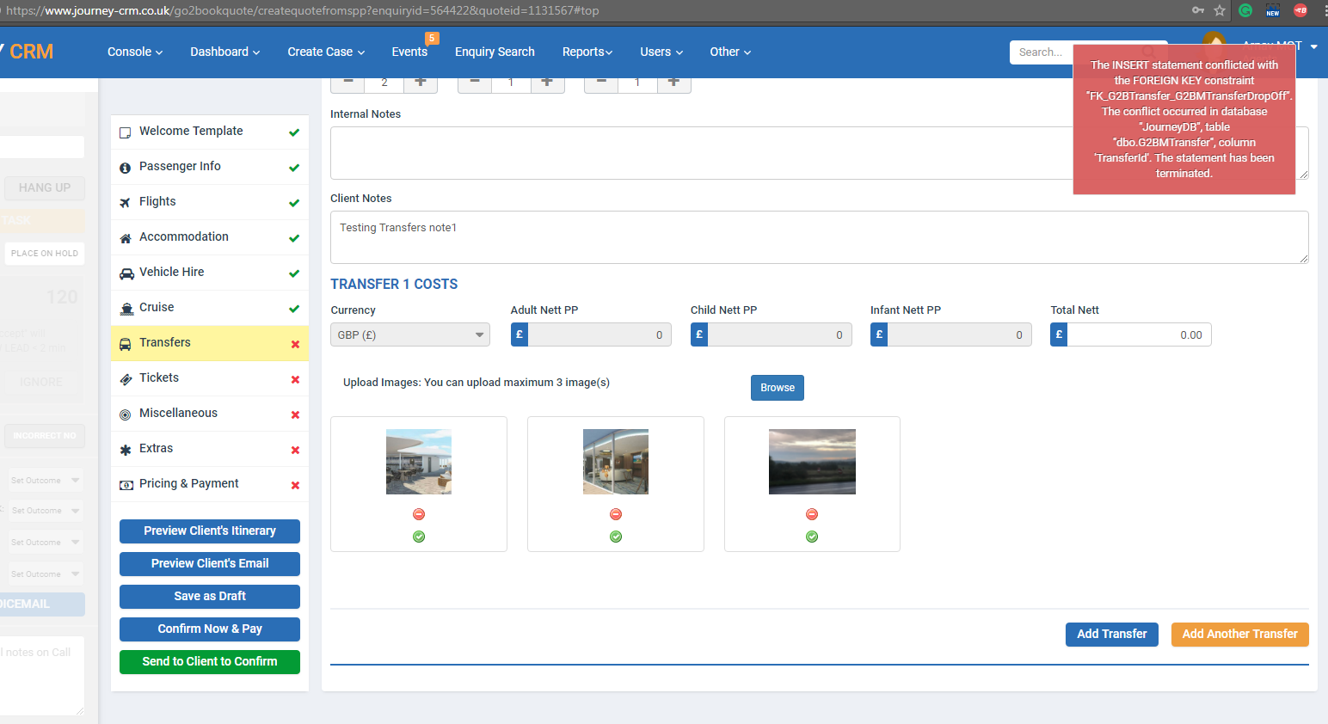

- Selecting infant name in the Ticket product. DONE
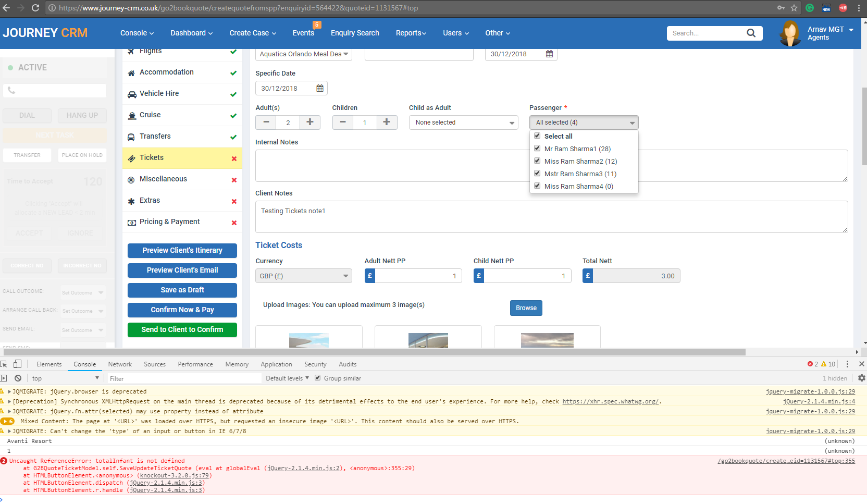

- Toast not showing to agent when user read out SPP quote and G2B quote sent email. DONE
- Showing HTTP error when create IT case from SPP module. DONE
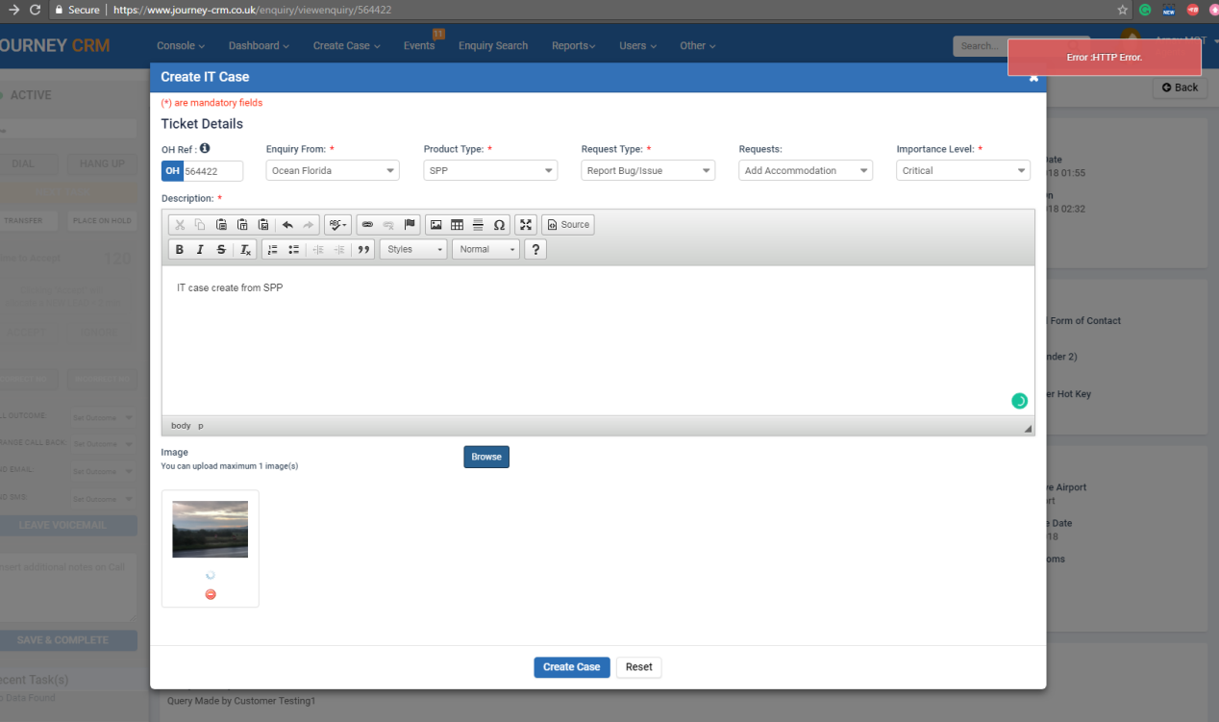

- When login CSB system. DONE
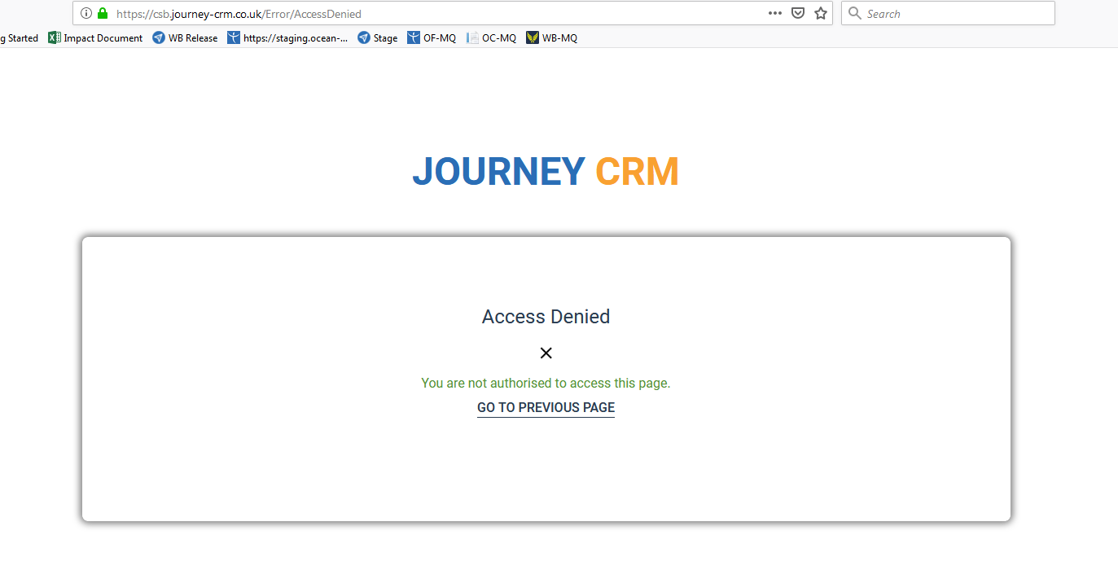
- When click on the FEEFO link then showing 500 error.
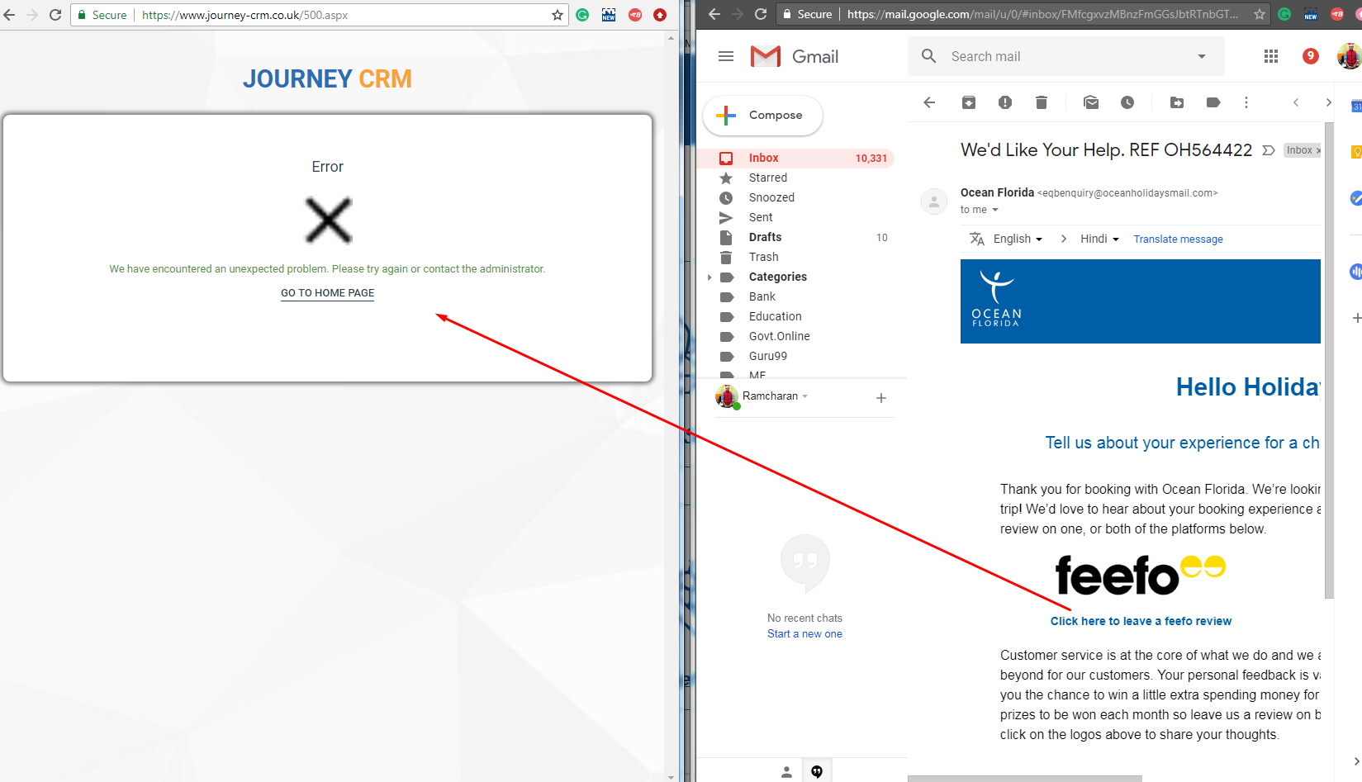

- When click on the MMB URL - DONE
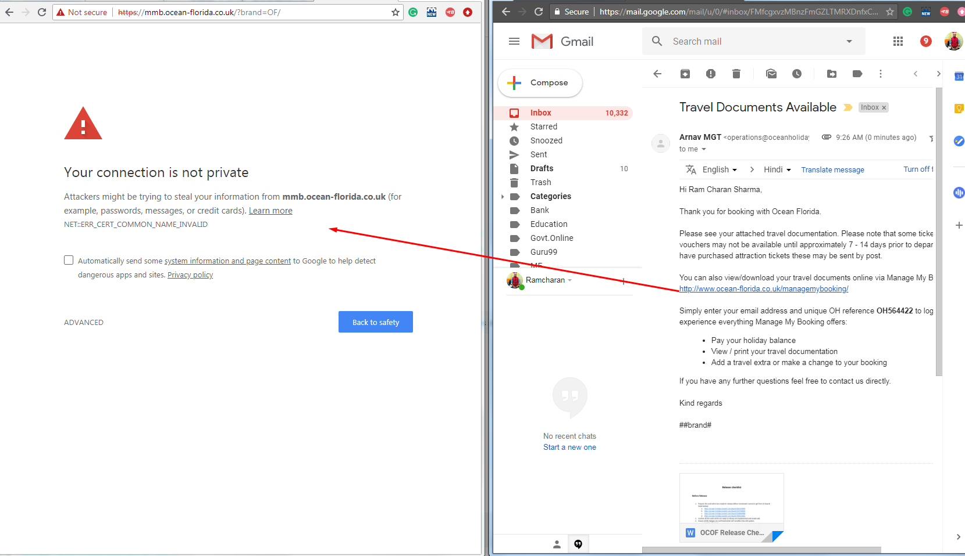

- Date format showing wrong in the excel file when view PS details on CSB. PENDING
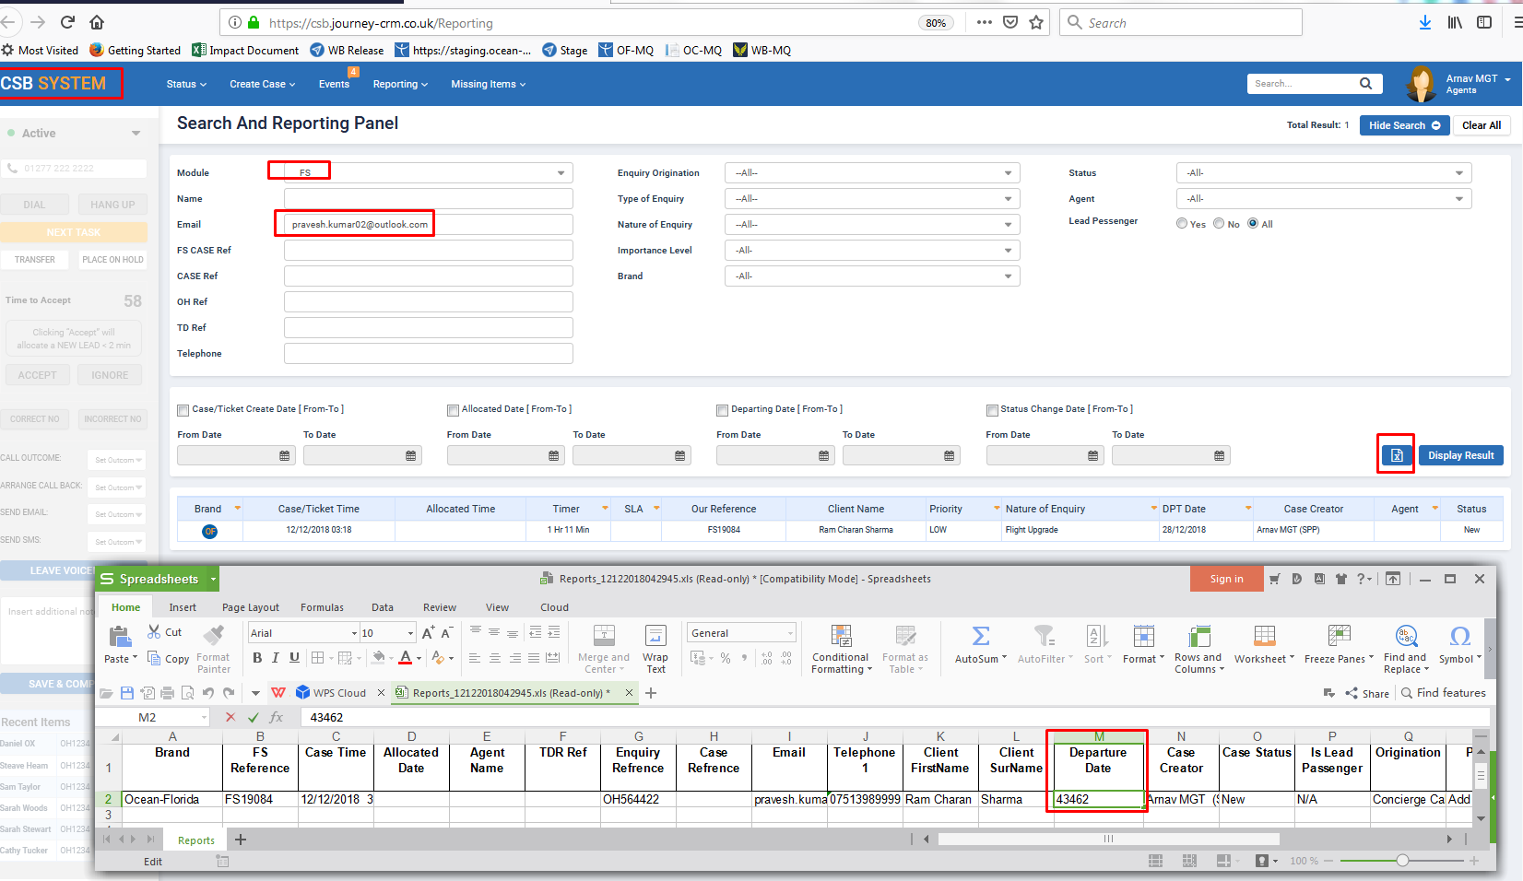

- Arnav MGT agent name not showing in the drop-dwon. DONE
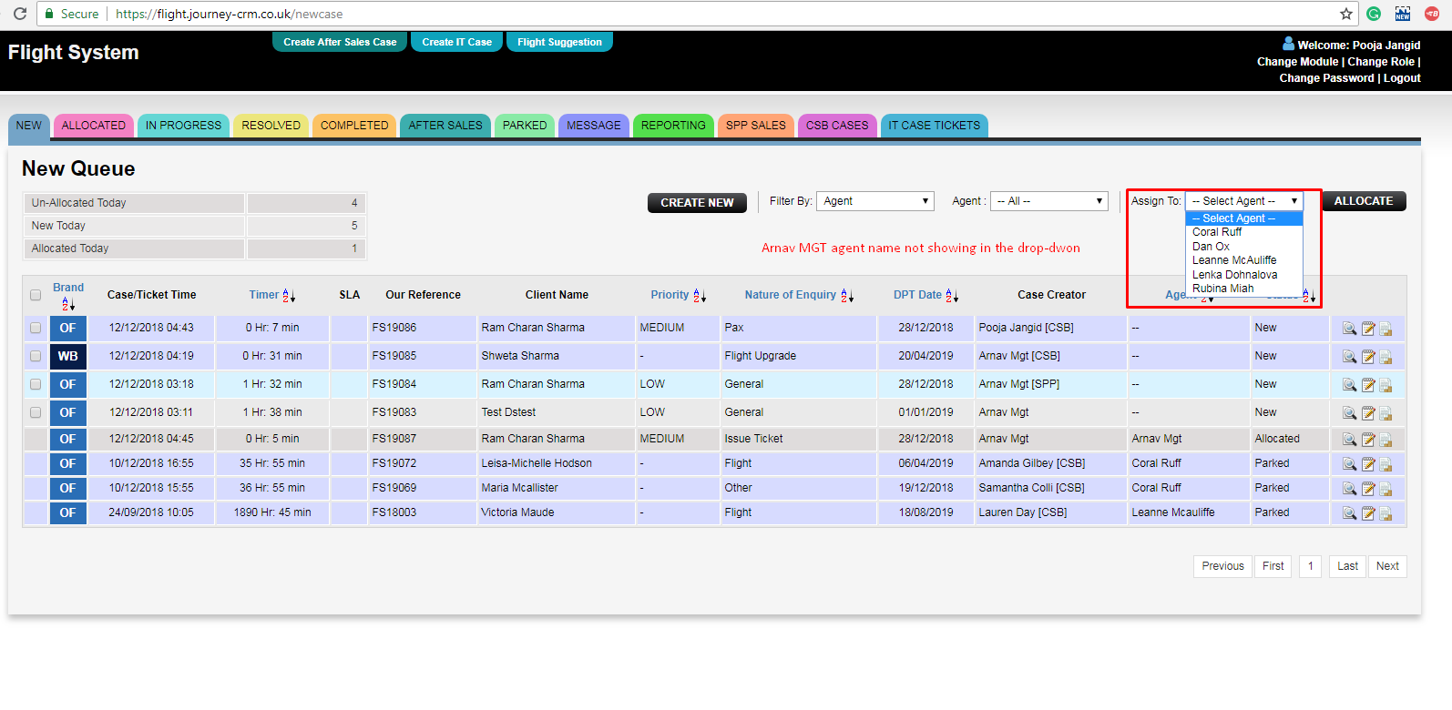

- Showing a single reference a three time in FS- SPP reporting. DONE
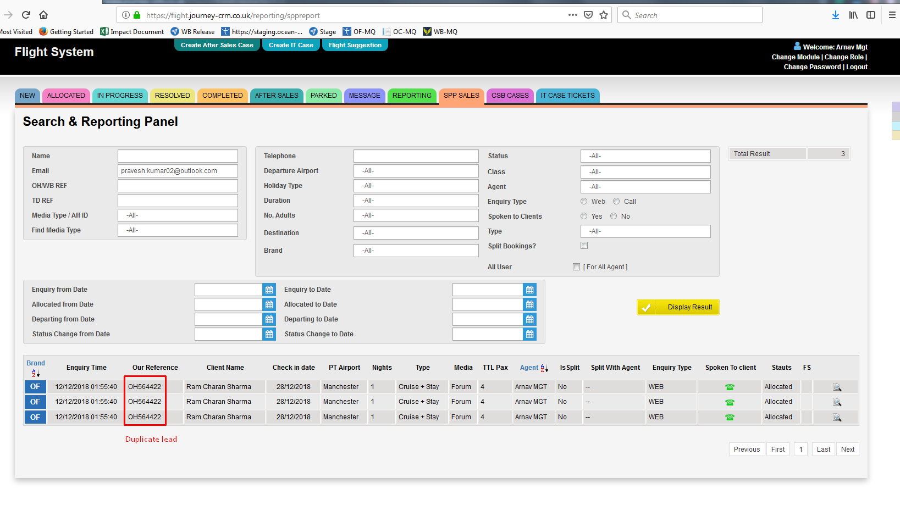

- Below module and actions where toast pop-up not showing to agent:
- SPP Quote read out by customer. DONE
- G2B Quote read out by customer.DONE
- Lead move into TD error.DONE
- Case allocate to agent in CSB.DONE

- Pop-up not open when view flight details in sale history on PS module.
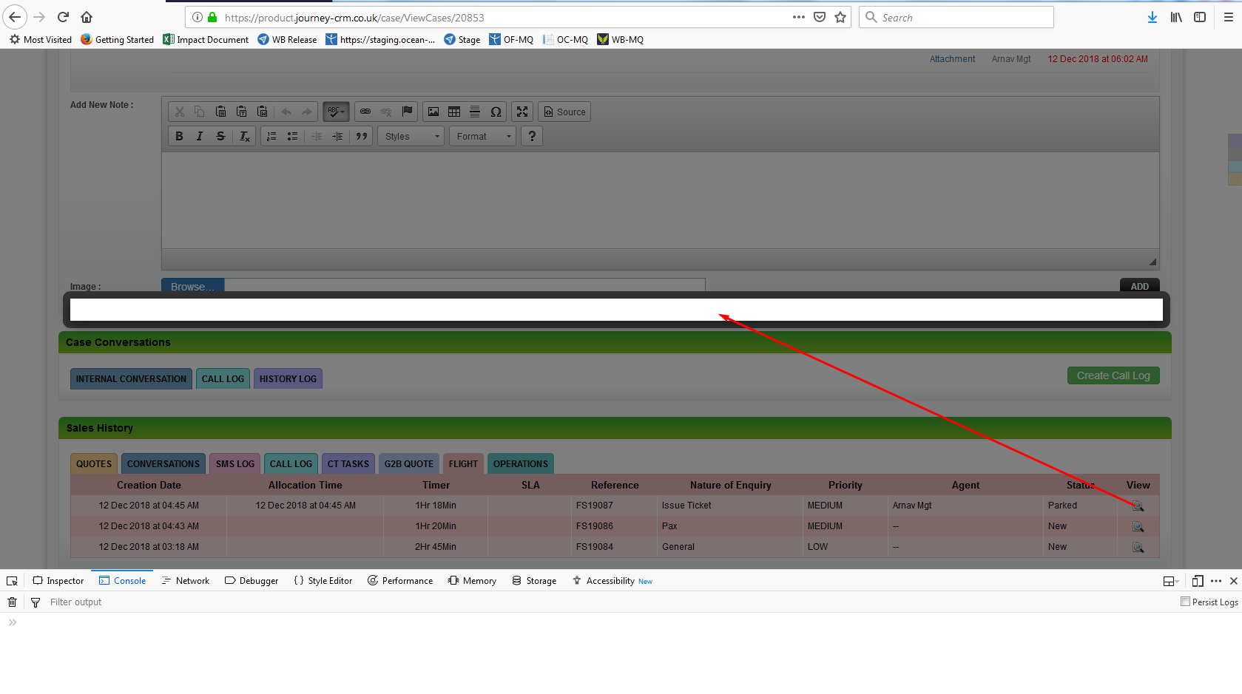
- Attached file in notes not showing when edit CG case. PENDING
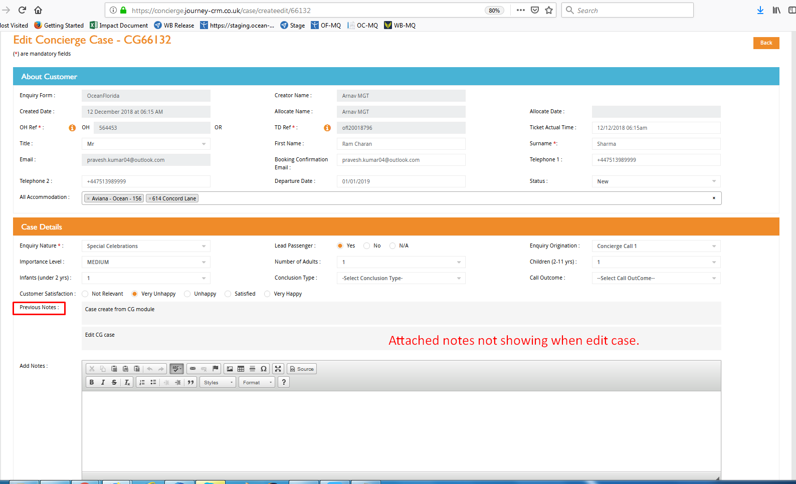

- Showing error when view TD Complete Agent Outro preview on SPP- OC lead. PENDING
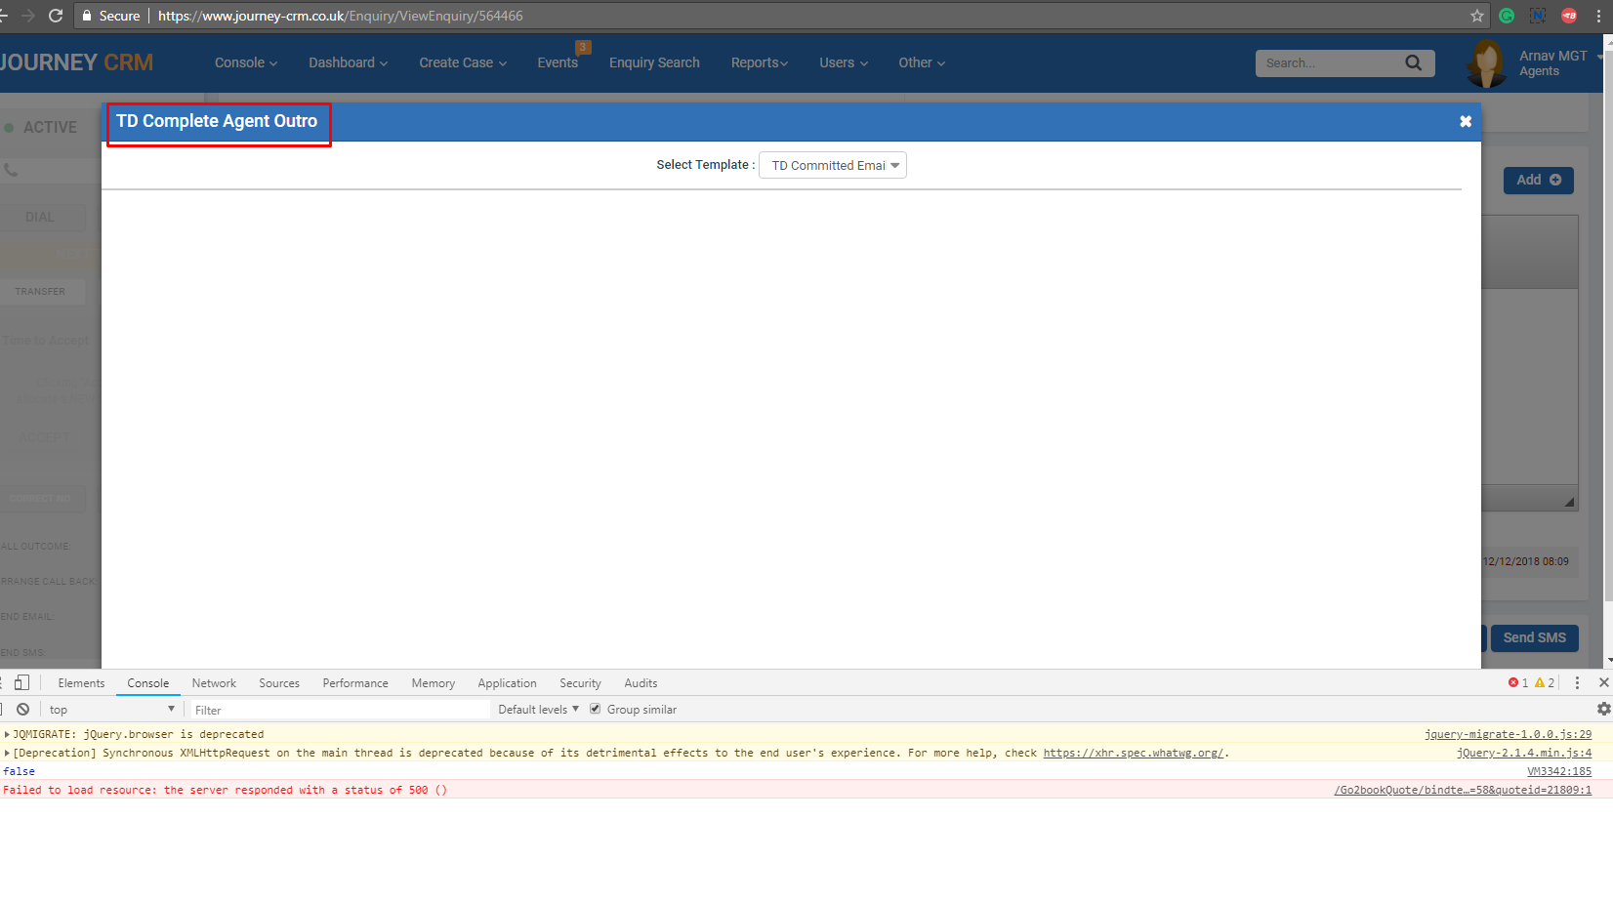
- Sending URL of MMB for OC lead showing wrong in the email. When hiot URL then opening OF MMB URL. PENDING
