1. Archive should be Archived
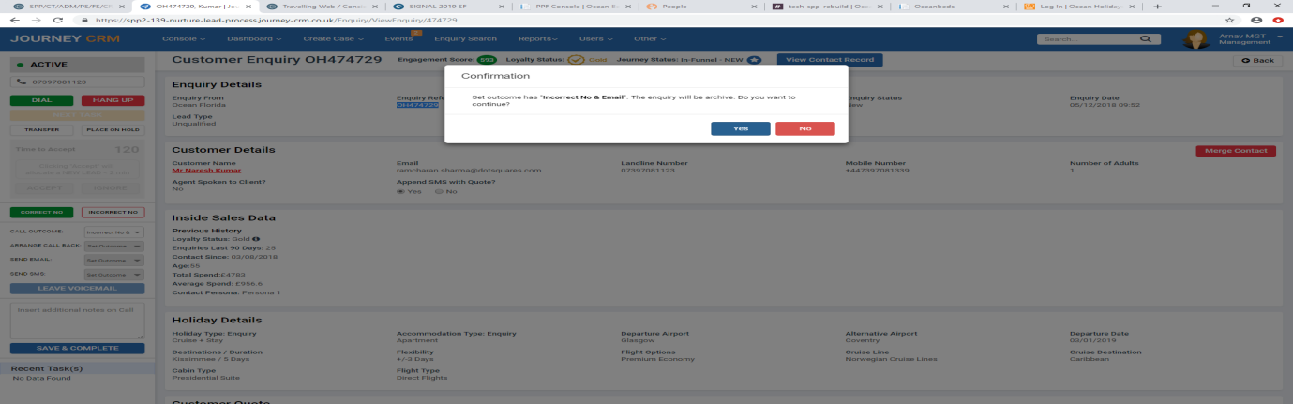

Testing CT User – 3 leads
OH474725
OH474727
OH474726
Testing MGT User – 2 leads
OH474729
OH474728
DS Team moved in testing on 5th also – 1 lead
OH474730

2. CT Master Task Report
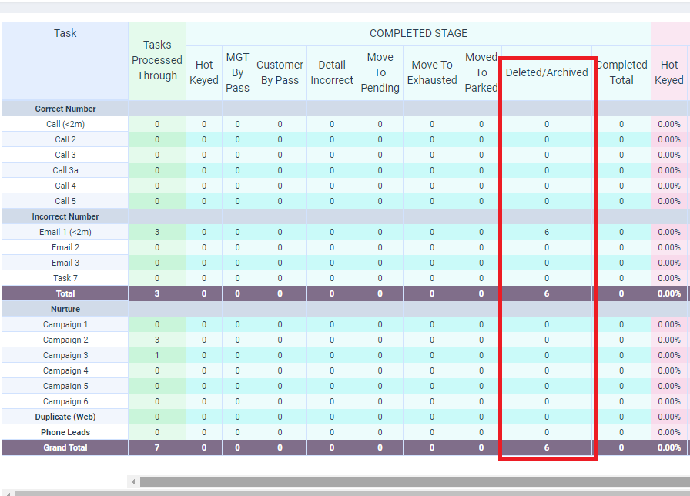

3/. Enquiry Search
Enquiry Deleted – This needs to be Enquiry Deleted/Archived
