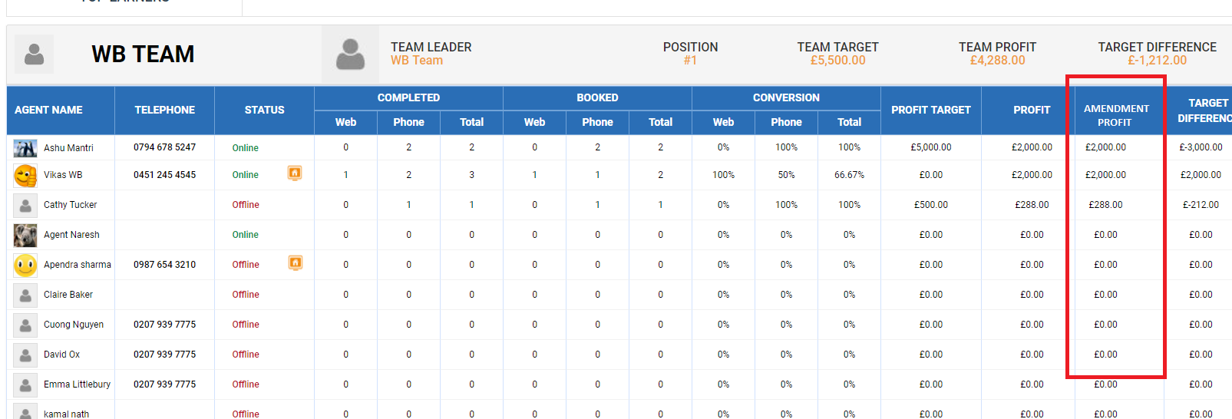

Amendment Profit – This would take the amount made from WB Agent in any Amendments they do. Same field is what is populated from Agent Console from Amendment Profit Leader board.

