MGT Console – Supporting notes
Most fields on the new WB MGT Console are the same as OF currently have but there are some differences:

- Profit – Month to Date
Agent Profit – Soon as agents makes a new G2B booking and the lead moves to TD load it registers the profit here. Like we do currently in OF System
Amendments Profit – This is new feature and will be unique to WB only. So, when user creates a CSB case amendment form the figure shown in ‘Profit owner’ (insert this field name). Whatever Name is shown here is who gets the profit awarded to them.
Total Profit – This is the total amount of ‘Agent Profit + Amendments Profit’ = Total Profit
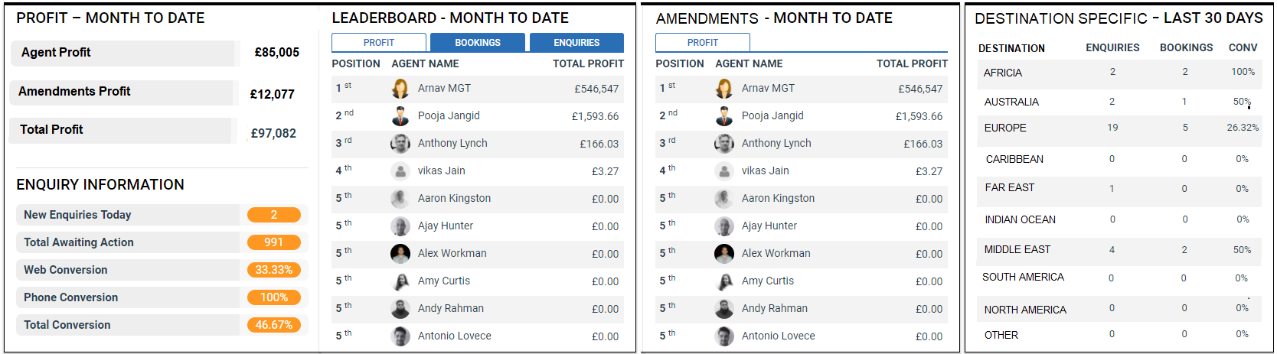

- Enquiry Information
Exactly the same as we have in place now but just for ‘Total Awaiting Action’ we don’t have sum to include CT queues.

- Leaderboard – Month to Date
Exactly the same concept as we have in Journey CRM for OF

- Amendments – Month to Date
This is a new feature, and this is because WB agents do amendments to their booking. Where as in OF they don’t touch amendments as they are done purely by CSB user only.
Here we have a change and is for WB brand only. When they select ‘Create New After Sales Case’ (As per separate specification)
So when WB agent opens this and completes an amendment with an Amendment form attached whatever the profit is associated within there is attributed to WB Agent. However, only when the case has been COMPLETED by WB CSB user on their side will the profit register on the above leaderboard.
Please use the name field to attribute the amendment to. Ie if the amendment was added by Ryan Collins (WB Agent Name) and his name was in the box, but when the amendment was added and completed in CSB by Charlotte Ince (WB CSB user) the profit on Amendments – Month to Date would show against Ryan Collins.

- Destination Specific – Last 30 days
This works exactly the same as current Journey System for OF but instead of returning results at product type it will do this on Destination level.

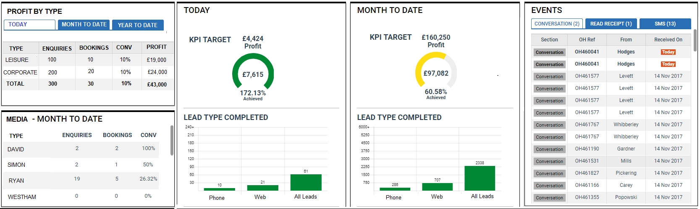

- Profit By Type
This is a new feature. So, every time a user creates a new enquiry they are asked to fill in the type. Based on that selection will be able to fill in the enquiries/bookings/Profit.
As per card ENQ-002-A we have had to consider how we track WEB leads and their type so by checking this card you can see this

- Media – Month to Date
Exactly same concept as we have now from the Media Report. Pull the data and show the highest performing to lowest performing. Due to the numbers they have with different amount of Media’s we need a scroll bar.

- Today and MTD
Same concept as OF now but in WB they only have one KPI so this is profit as above.

- Events
Same concept as OF now

- Dashboard
This feature doesn’t currently lie in new Journey CRM for OF but did in the old SPP MGT Console.
So can you adapt to be as per below columns.

