
CONFIDENTIAL
October 19th 2020

Admin User Manual

Virgin Hanger
Version 1.1

This document outlines the general scope of your project based on our understanding of the requirements provided and discussions to date. |  | Prepared for:  Virgin Hanger

DISCLAIMER
This document is submitted with the explicit understanding that the contents are confidential and would not be divulged to any third party without prior written consent from Dotsquares Ltd. Services are supplied according to our terms and conditions http://www.dotsquares.com/terms

Revision History

Version | Date | Description | Prepared by | Reviewed by
1.0 | 22/09/2020 | Website Visual Documentation | Hariom | Nikhil
1.1 | 19/10/2020 | Admin User Manual - Updated | Hariom | Nikhil

Table of Contents
Revision History 2
How to Access Virgin Hanger’s Admin Panel 6
1. Dashboard 6
1.1 View Orders & Amount Summary Using Graph 6
1.2 Advanced Reporting 7
1.3 Sales 7
1.4 Message Inbox 8
1.5 Global Search 8
2. Order Mapping 9
2.1 Temp Customer Order Mapping 9
2.2 Existing Customer Order Mapping 10
3. Customers 11
3.1 Manage Allocation Rules 11
3.1.2 Edit Allocated Rules 11
3.1.2 Add New Items 12
3.2 Assign Customer Group 12
3.3 Store Credits 12
3.3.1 Manage Credits Products 12
3.3.2 Manage Customers Using Credits 13
3.3.3 Manage Credits Transaction 14
3.3.4 Customers Credits Report 15
3.3.5 Setting 16
3.4 Rewards Points 17
3.4.1 Earnings Rates 17
3.4.2 Spending Rates 17
3.4.3 Manage Points Balancers 18
3.4.4 Transactions 19
4. Order Management 20
4.1 Order Processing 20
4.1.1 Verify Orders 20
4.1.2 Prepares Ship 21
4.2 Order Listing 21
4.3 Settings 22
4.3.1 Order Configurations 22
5. Hangers Report 23
5.1 Alteration Reports 24
5.2 Name Badge Reports 24
5.3 MTM Reports 25
5.4 Back Order Report 25
5.5 Shoe Reimbursement Reports 26
5.6 Group Number Reports 26
5.7 Detailed Invoiced Reports 27
5.8 Credit Memo Detailed Reports 27
5.9 Back Order Report 28
6. Stores 28
6.1 Manage Stores 29
6.2 Manage Tag 30
6.2.1 Add New Tag 30
6.3 Manage Schedules 30
6.3.1 Add New Schedules 31
6.4 Manage Holidays 31
6.4.1 Add New Holiday 32
6.5 Manage Special Day 32
6.5.1 Add New Special Day 33
7. Inventory Management 33
7.1 Stock Listing 34
7.2 Prediction 35
7.2.1 Supply Needs 35
7.2.2 Low Stock Rules 35
7.2.3 Low Stocks Notifications 35
7.3 Transfer Stock 36
7.3.1 Send Stock 36
7.3.2 Request Stock 36
7.3.3 Transfer to External 37
7.3.4 Transfer from External 37
7.4 Transfer Stock History 37
7.4.1 Send Stock History 37
7.4.2 Request Stock History 38
7.4.3 Transfer to External History 38
7.4.4 Transfer from External History 39
7.5 Stock Control 39
7.5.1 New Stock Adjustment 39
7.5.2 New Stocktaking 39
7.5.3 Adjust Stock History 40
7.5.4 Stocktaking History 40
7.5.5 Stock Movement History 41
7.6 Configuration 41
8. Purchase Managements 42
8.1 Purchase Order Management 42
8.1.1 Create Purchase Order 42
8.1.2 Purchase Order 43
8.2 Quotation Management 44
8.2.1 Create Quotations 44
8.2.2 Quotation 44
8.3 Supplier 45
8.3.1 Manage Suppliers 45
8.3.2 Add New Supplier 45
8.3.2 Manage Pricelist 45
9. Marketing 47
9.1 Gift Card 47
9.1.1 Manage Gift card Products 47
9.1.2 Manage Gift Codes 49
9.1.3 Generates Gift Codes 51
9.1.4 Gift Codes History 51
10. Shoe Reimbursement Setup 52
10.1 Customer Group Limit 52
10.2 Manage Reimbursement 52
11. Banner Slider 53
11.1 Manage Slider 53
11.1.1 Edit Slider 53
11.1.2 Add New Slider 54

How to Access Virgin Hanger’s Admin Panel
This user manual explains the usage and functions of the Virgin Hanger’s Admin panel. You will also see details descriptions of the navigation menus i.e.
- Dashboard
- Sales
- Order Mapping
- Customers
- Banner Slider
- Allocation Rules

1. Dashboard
The dashboard is usually the first page that appears when you log in to the Admin, and gives an overview of sales and customer activity. The blocks on the left provide a snapshot of lifetime sales, average order amount, the last five orders, and search terms. The graph shows the orders and amounts for the selected date range. You can use the tabs above the graph to toggle between the two views. The tabs at the bottom provide quick reports about your best-selling and most viewed products, new customers and those who have purchased the most.
The dashboard is the default startup page for the Admin, although you can change the configuration to display a different page when you log in. You can also set the starting dates used in dashboard reports, and disable the display of the charts section.
You can produce Dashboard snapshot reports for each store view. The tabs at the bottom of the page summarize your best-selling and most viewed products, new customers, and those who have purchased the most during the time period specified.
This section explains how to access dashboard, what information you will get on this page. Here, you will get the information about your sales, orders (average and last), amount received, bestsellers, most viewed products, new customers. Here some detail description of how to access dashboard’s menus –

1.1 View Orders & Amount Summary Using Graph
You can view numbers of orders and amount you collected in graph format. If you want to view orders summary, click on orders tab and select what data you want to see such as current month order summary, last 24 hours order or last 7 days order summary. Same procedure applied with amounts.
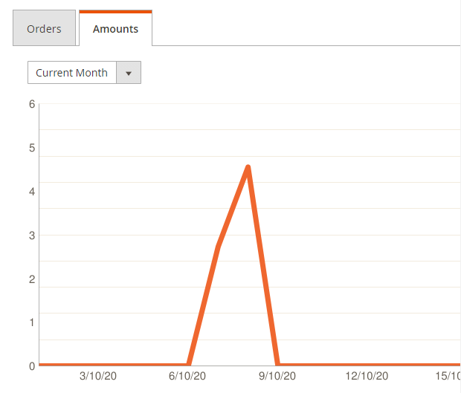

1.2 Advanced Reporting
You can gain new insights and take command of your business' performance, using our dynamic product, order, and customer reports tailored to your customer data using this section.

1.3 Sales
In sales you can get information about lifetimes sales, average orders, last orders, last search terms, top search terms, best sellers, most viewed products, new customers, and customers.
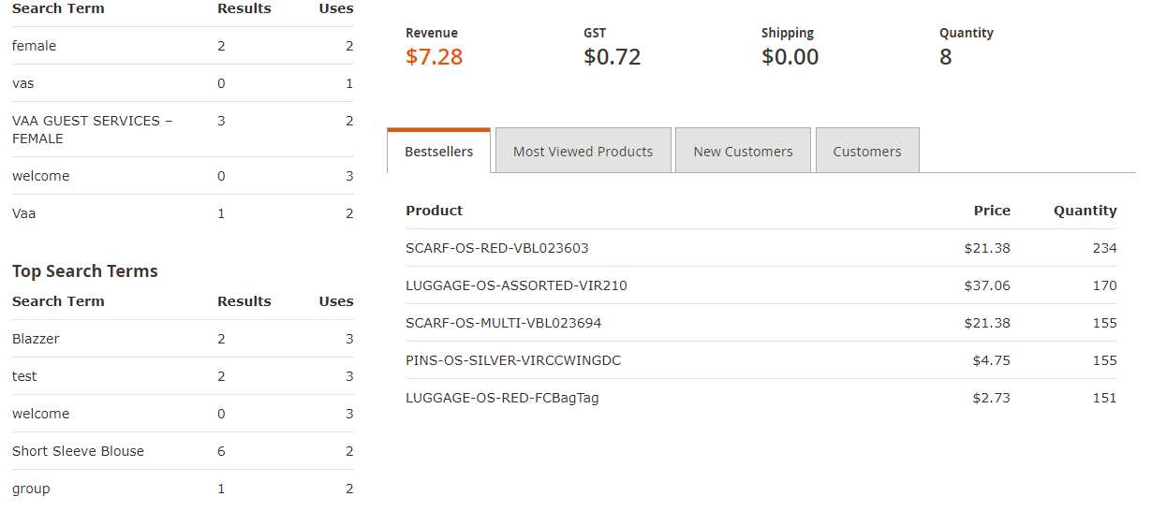

1.4 Message Inbox
Your store receives messages from Magento on a regular basis. The messages might refer to system updates, patches, new releases, scheduled maintenance or upcoming events, and are rated by importance. The bell icon in the header indicates the number of unread messages in your inbox.
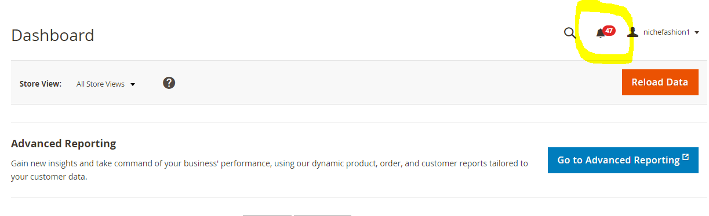

1.5 Global Search
The spy glass in the header of the Admin can be used to find any record in the database. The results can include customers, products, orders, or any related attribute. For example, if you enter a customer name, the results might include the customer record as well as any orders that are associated with the name.
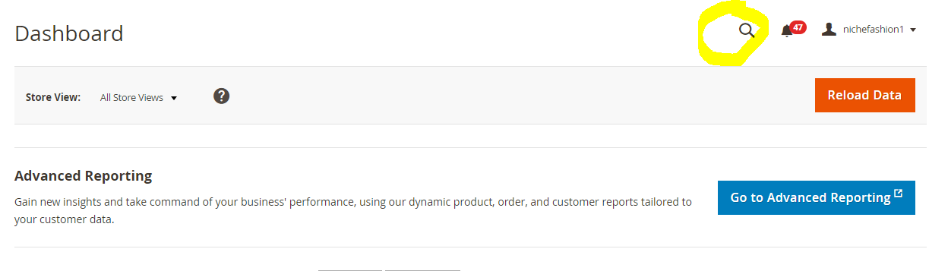

Order Mapping
Tapping on order mapping menu you will get two sub-options –
- Manage Temp Customer Order mapping
- Manage Existing Temp Customer Order mapping
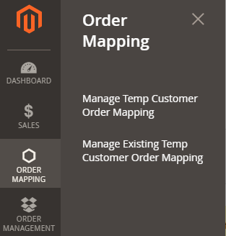

2.1 Temp Customer Order Mapping
- Path - Order Mapping -> Manage Temp Customer Order Mapping
- Uses – List of all the temporary customer can be viewed using this section.
  - Temp Customer – Click on drop down menu and all the temporary customer’s list can be viewed and select from drop-down.
  - Permanent Customer - Search permanent customer which you want to transfer order, list of searched item appear then tap on radio button and finally click on "Assign Order" button.

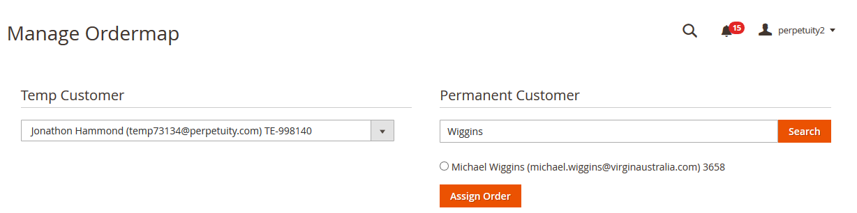

2.2 Existing Customer Order Mapping
- Path - Order Mapping -> Manage Existing Temp Customer Order Mapping
- Uses – List of all the existing temporary customer can be viewed using this section.
  - Existing Temp Customer – Click on drop down menu and all the existing temporary customer’s list can be viewed and select from drop-down.
  - Permanent Customer - Search permanent customer which you want to transfer order, list of searched item appear then tap on radio button and finally click on "Assign Order" button.

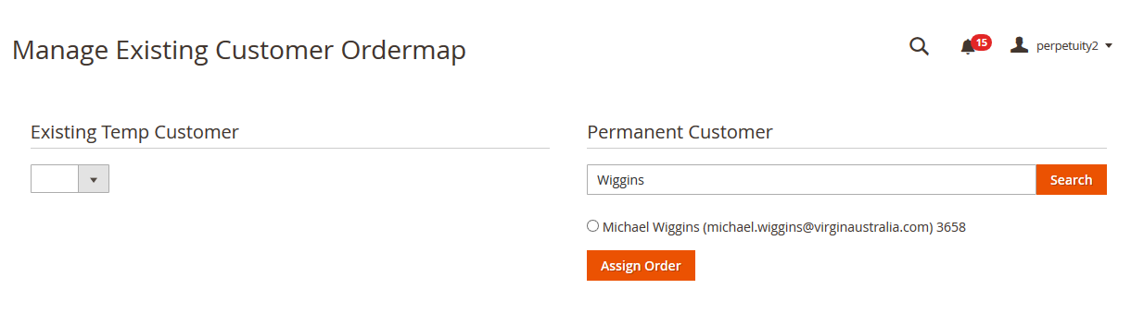

Customers

3.1 Manage Allocation Rules
Admin can check customer allocation type from grid and also can add new allocation rule and assign that rule according to customer position and gender.
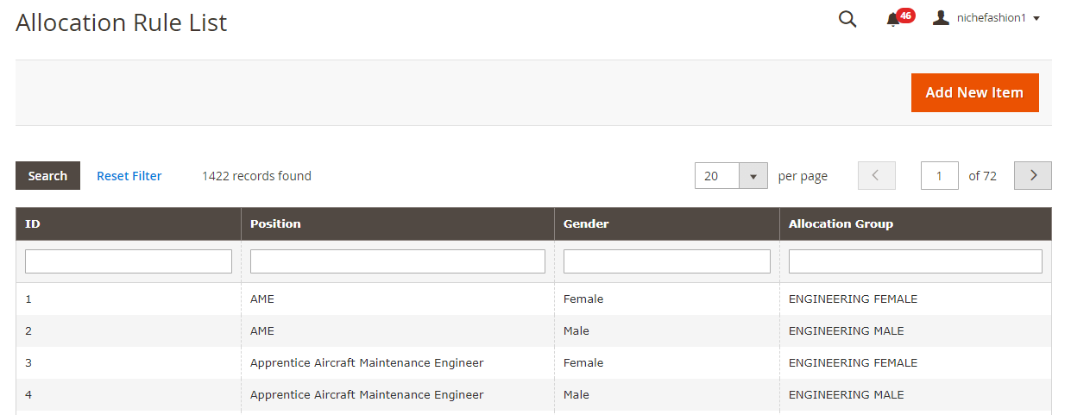
Figure 1: List of Allocated Items

3.1.2 Edit Allocated Rules
By clicking on any allocated rules this below page will open and Admin can edit the allocated rules. Only allocation group can be changed. Position and gender can be changed its fixed.
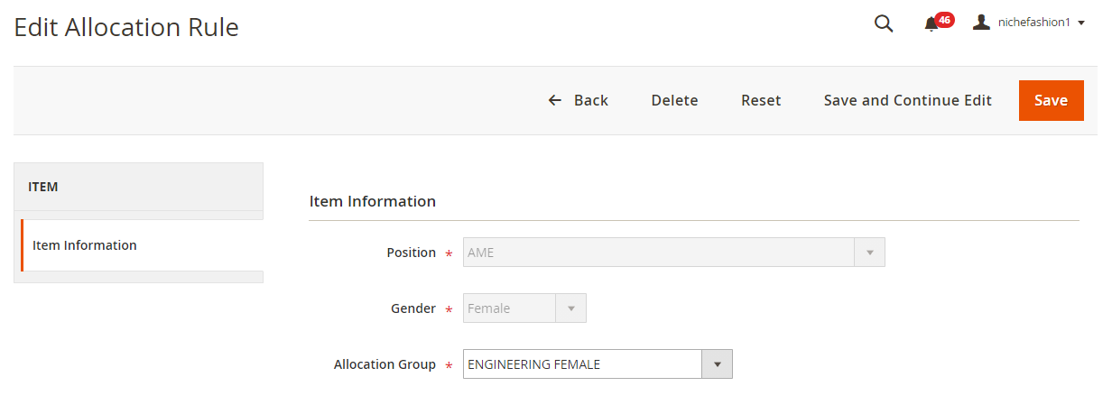
Figure 2: Edit Allocation Rules

3.1.2 Add New Items
Admin can add new allocation rule by clicking on ‘Add New Item’ button. You will get below shown image where you can add item information, position, gender, and allocation group.

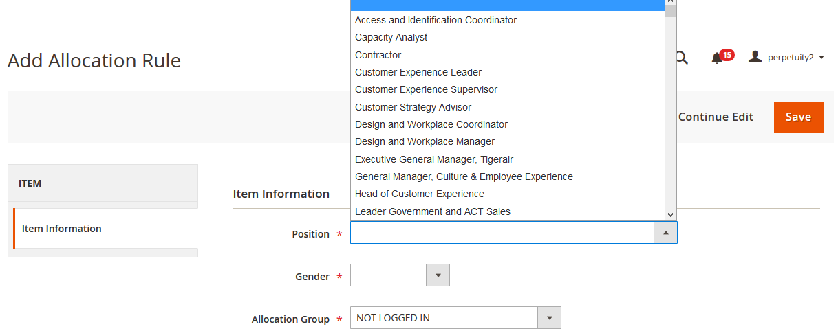

3.2 Assign Customer Group
Customer groups determine which discounts are available, and the tax class that is associated with the group. The default customer groups are General, Not Logged In, and Wholesale. Assign customer group according to customer gender and position which have general customer group. After click on assign customer group its redirect to customer grid with total number customer assign message.
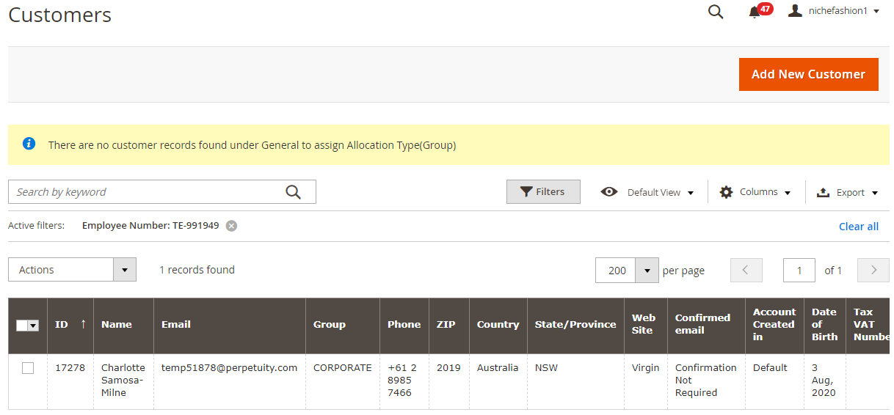

3.3 Store Credits

3.3.1 Manage Credits Products
All credits that can be purchased are available in a grid as well. You can view their ID, name, SKU, amount, visibility, status, and store view. All this information can be exported as well.
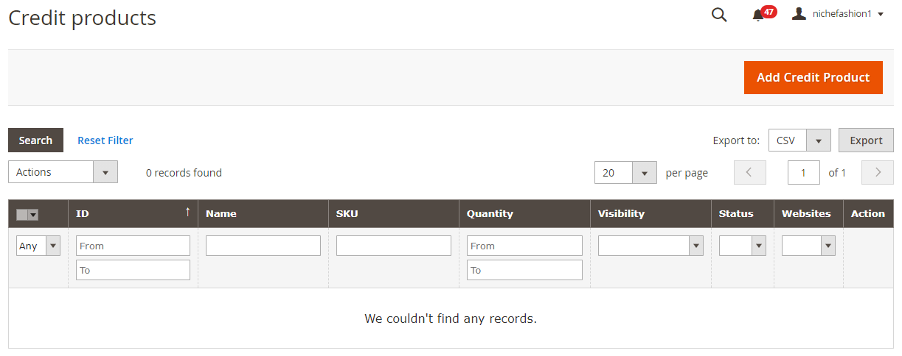
While creating a new store credit product, you have to deal with almost the same settings as in case of other products. Go to the Prices tab – it’s the place where all magic happens. You can select one of three store credit value types here: Fixed value, Dropdown values, Range of values. Depending on the chosen value, the other fields are changed. For instance, for the Dropdown values, you should fill in such fields as Credit Rate and Store Credit Values.
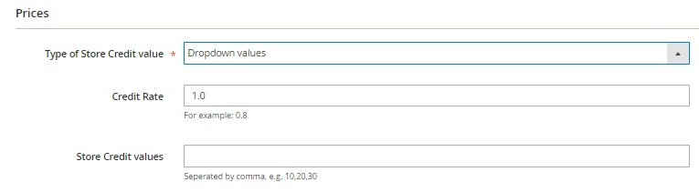

3.3.2 Manage Customers Using Credits
As a Magento 2 backend administrator, you can easily view all customers who use credit in a grid. Note that the data from the grid can be exported. If you need to find a certain user, use filters that are available in each column. The only exception is the Action column that lets you edit each user.
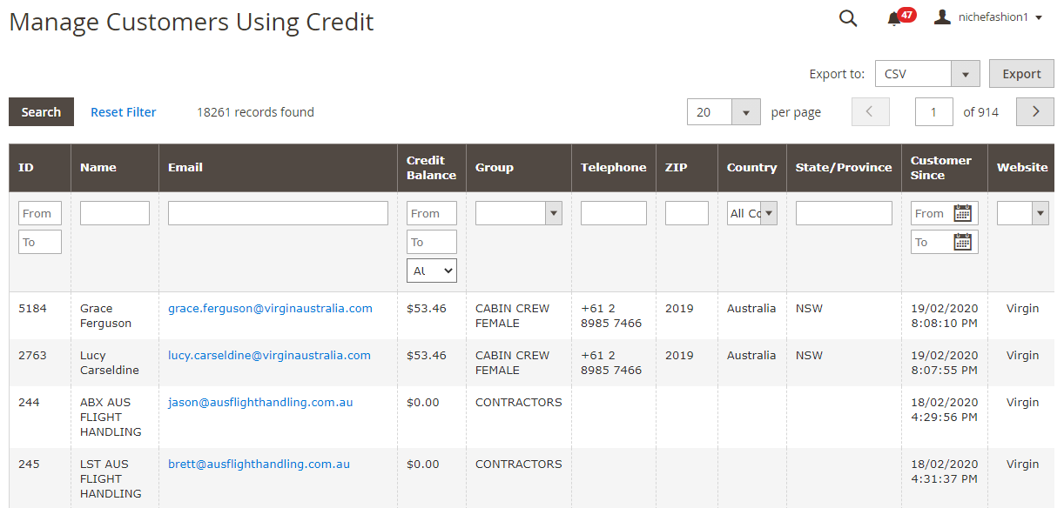
While editing a customer, go to the Store Credit tab. Here, you can see the current balance. The Magestore Magento 2 Store Credit extension allows you to increase or decrease it via the “Add or subtract a credit value”. Enter “50” to add $50 or “-50” to subtract $50. Besides, you can place a comment here and send a notification to the customers. Transaction history is available below.
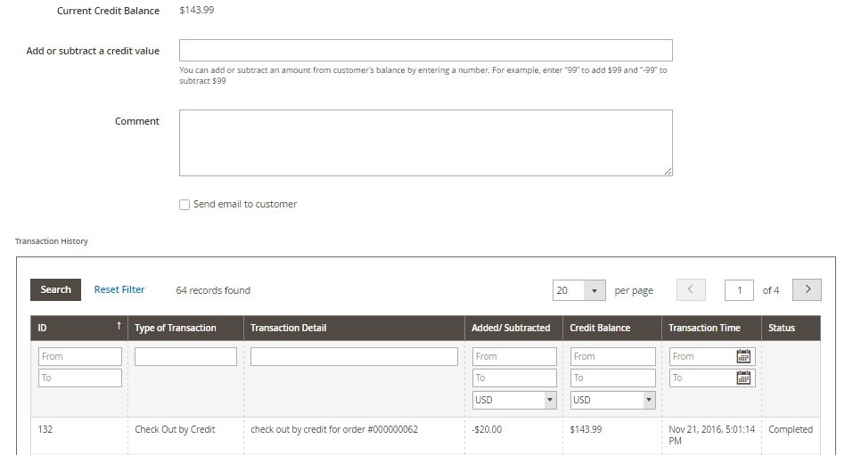

3.3.3 Manage Credits Transaction
It is also necessary to tell a few words about the Credit Transaction grid. It does not provide export functionality, but you can filter columns to find exact transactions. The available information is divided between these columns:
- Transaction ID;
- Transaction Type;
- Transaction Detail;
- Email;
- Added/Deducted;
- Credit Balance;
- Transaction Time;
- Status.
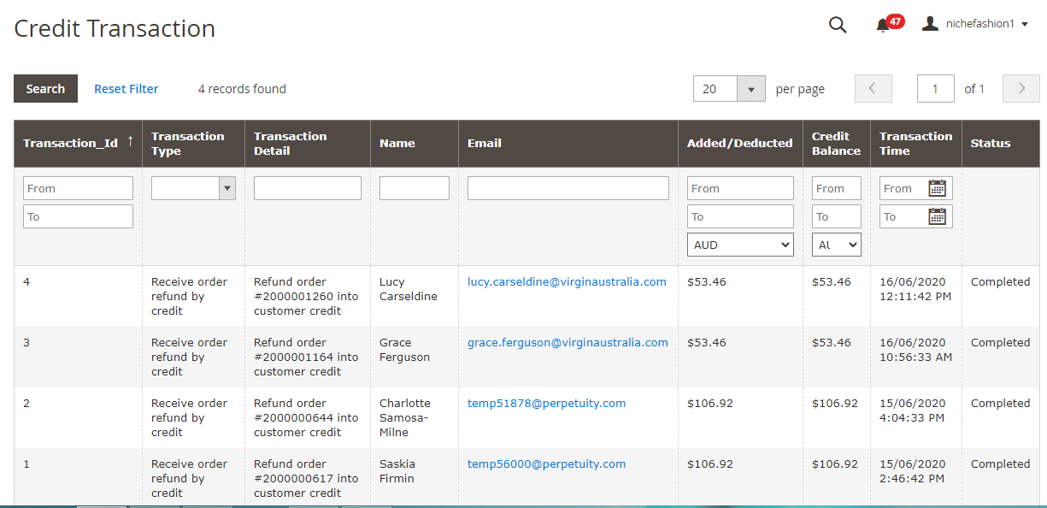

3.3.4 Customers Credits Report
And this is the dashboard that illustrates the complete use of credits within your e-commerce store. It shows a total amount of credits in the system, a total amount of used credits, number of customers with credits, and top 5 customers who use credits. And you can select different time ranges for the diagram that shows used and received credits.
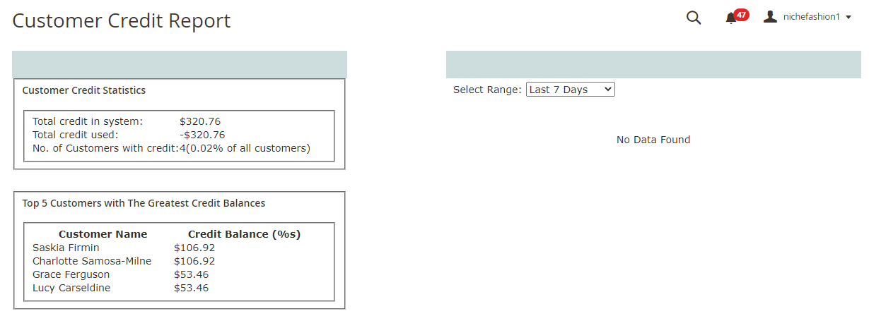

3.3.5 Setting
All extension’s settings are divided into 5 sections: General Configuration, Spend Credit On, Email Configuration, Adjust time for Customer Credit reports on total used and a total received credit, and Style Configuration.
The first section allows you to enable/disable the extension, allow/deny sending credits and specify customer groups that can use the new functionality.
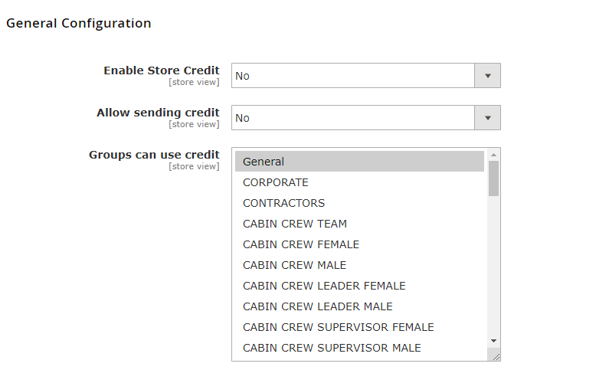
In Email Configuration, you choose templates for various occasions.
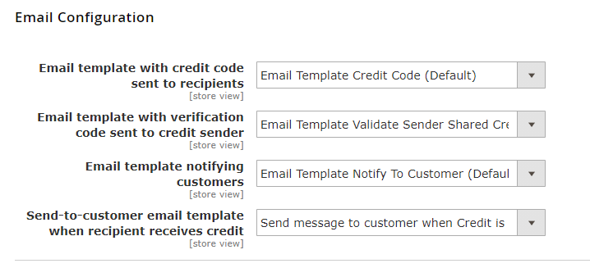

3.4 Rewards Points
Reward Points program aims to help store owners build long relationships with their customers based on a loyalty program. Customers get loyalty points for purchasing at your store or performing certain actions (e.g. sign up an account, reviews, etc). Your customers can use their loyalty points as a discount at the checkout on both Magento site and point of sale. This will, in turn, make your customers feel cared about. Hence, it’s easy to increase your brand loyalty and attract potential customers to your store.
- Flexibly set exchange rates for earning and spending points
- Pay for orders with points
- Manage reward point balance, customer reward points and adjust it as you want
- Refund by loyalty points
- Import and export points easily by CSV file

3.4.1 Earnings Rates
Admin can add new earning rates by providing info like –
- Amount of money spent
- Earning Points
- Status
- Websites
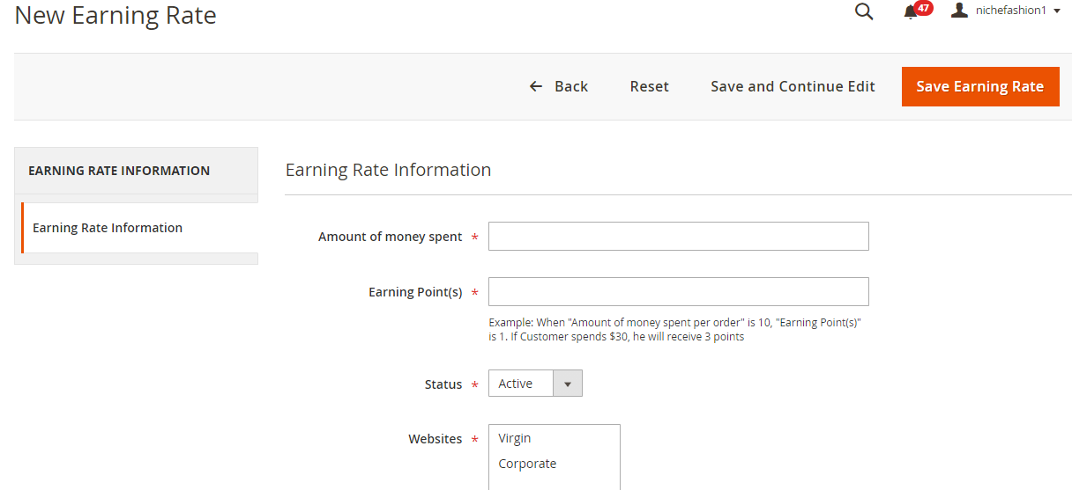

3.4.2 Spending Rates
Admin can add new spending rates by providing info like –
- Spending Points
- Discount Received
- Status
- Limit spending point based on
- Limit value allowed to spend points at
- Websites
- Customers group
- Priority

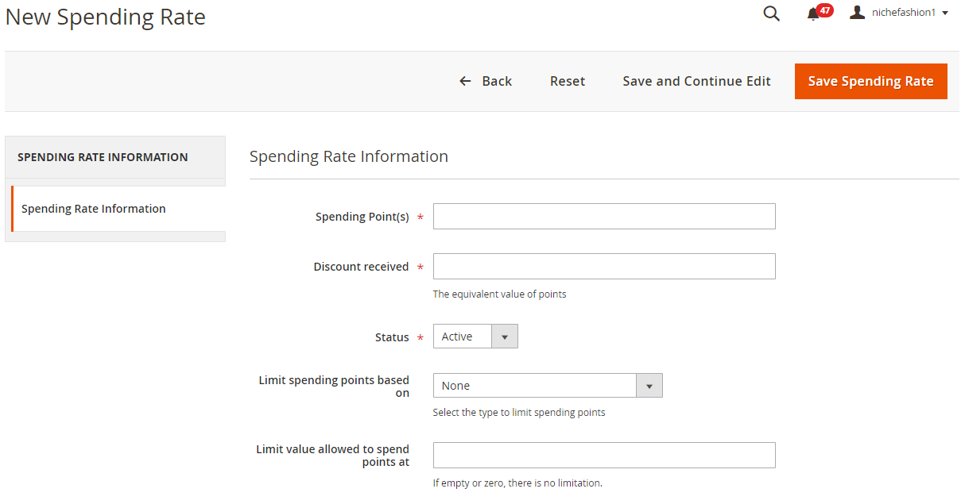

3.4.3 Manage Points Balancers
Importer Plugin allows you to easily import and export customers’ point balances in CSV files directly to and from our Magento Reward Points system. Admin can quickly update the Reward Points system with hundreds even thousands of customers’ point balances in one go.
This is suitable for importing new customers’ balances and migrating data from other points system to your existing Magento Reward Points.

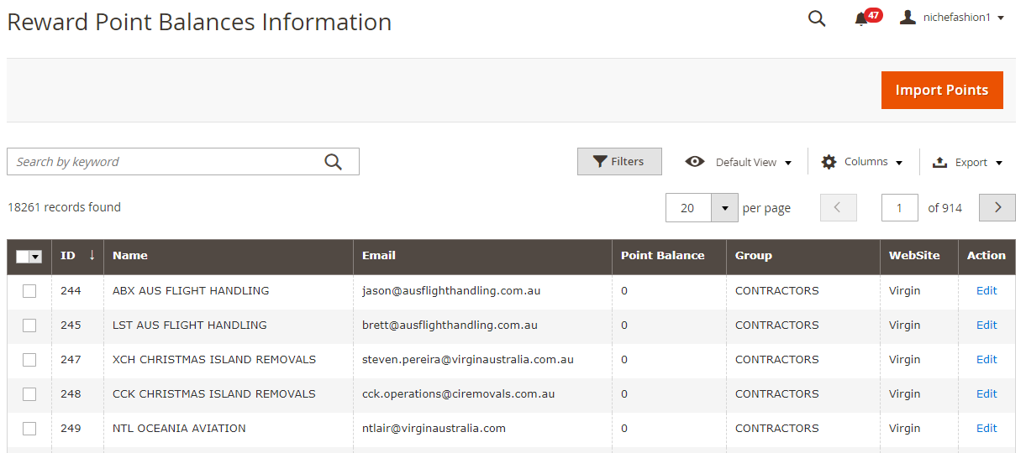

3.4.4 Transactions
Admins can view all point transactions from the Magento administrative interface, as well as manage reward points while creating an order in the backend (Customer, Point Amount, Points Used, etc.).
Seeing the top loyal customers is easy with one click to descend their spent points. Make sure you send them an appreciation gift & they’ll be with you forever for sure!
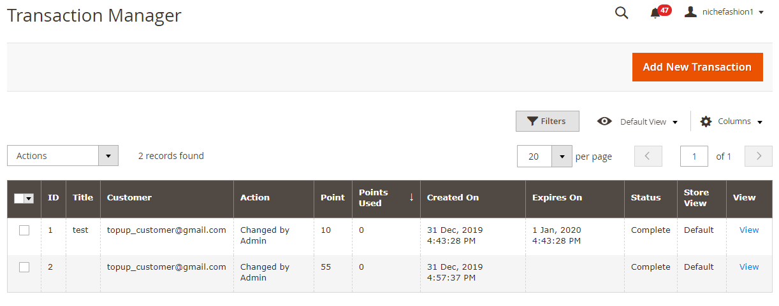

Order Management
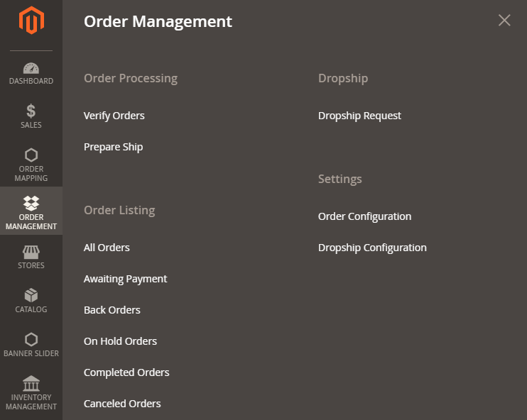
Figure 4: Order Management

Order Processing

Verify Orders
You can see orders in all batches, filter them, export data, view notes, and verify each order separately or in bulk. Other mass actions are: hold, cancel, set tag, move to batch, and print. Each order age is shown in a grid. Other information is available in the following columns: ID, Created At, Recipient, Total, Status, Batch#, Purchase Point, Note, and Tag.
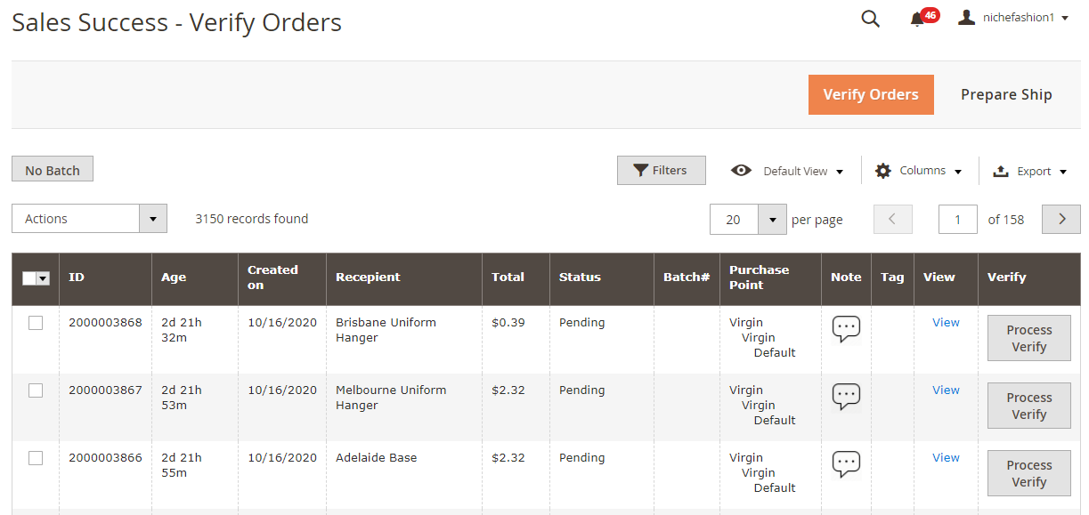

Prepares Ship
As for the Prepare Fulfil screen, it provides almost the same opportunities with some additional data. For instance, there is the Qty column in the Prepare Fulfil grid. Besides, the grid allows you to view each order and fulfill it. As for mass actions, they are: Back to Verified, Dropship, Hold, Set Tag, and Move to Batch, and Print.
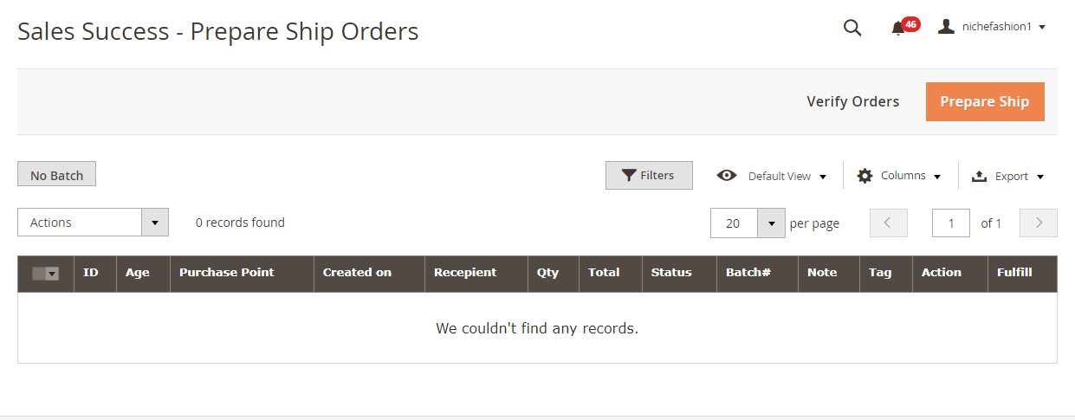

Order Listing
The Order Listing Screen is divided into 6 tabs: All Orders, Awaiting Payment, Back Orders, Hold Orders, Completed Orders, and Canceled Orders. Along with filtering, such structure helps to find certain orders as fast as possible. The available mass actions include Hold, Unhold, Cancel, Set Tag, Move to Batch, and Print. Besides, you can export orders via CSV or XML. Creating a new order is also possible.
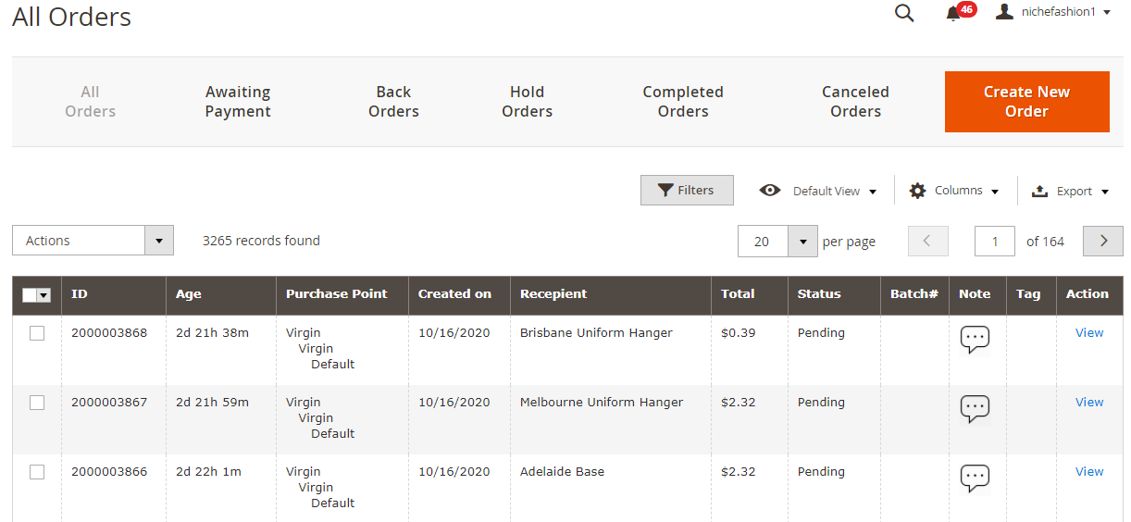

4.3 Settings

4.3.1 Order Configurations
In Order Configuration, you can enable/disable the Verify Order step, keeping order batch number after verified and default Magento ship as well as add tags.
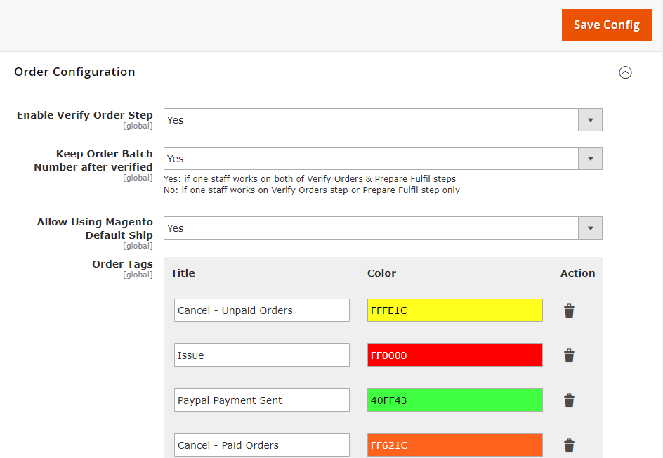

Hangers Report
In this section Admin can view all hanger report under “Hanger Reports" menu. All the report can be -
- Filter and search - Admin can filter data according to date range.
- Export - Export alteration report with csv format.

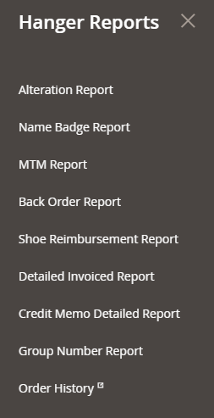
Figure 5: Hangers Report

5.1 Alteration Reports
Show alteration product custom measurement reports according to order number.
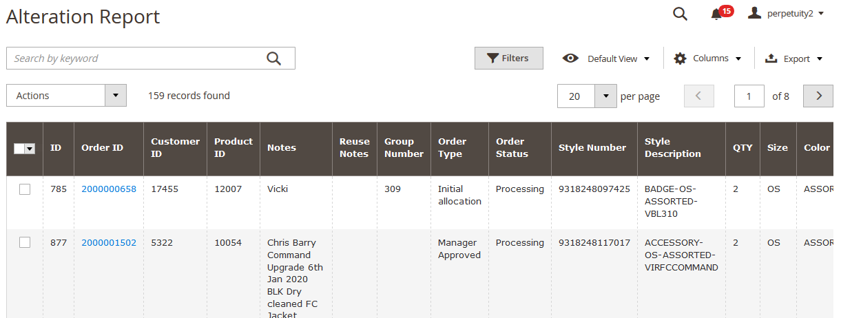
Figure 6: Alternations Report

5.2 Name Badge Reports
Show Name Badge product custom measurement reports according to order number.
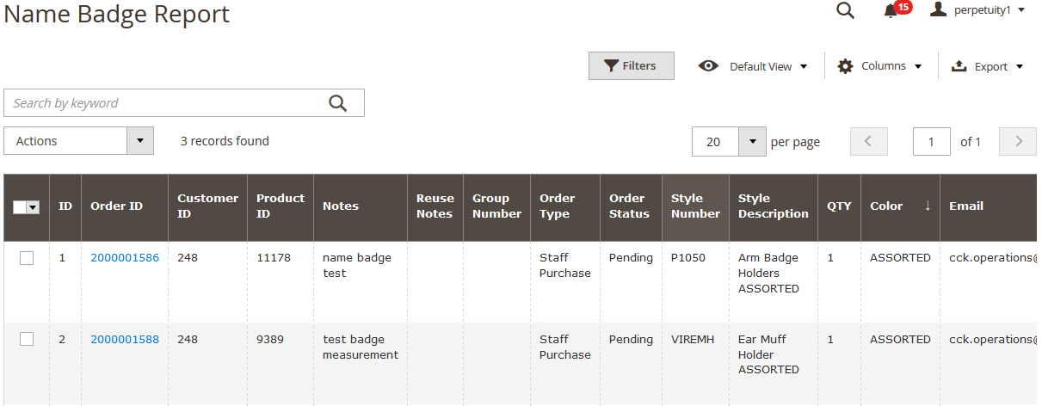
Figure 7: Name Badge Reports

5.3 MTM Reports
Show MTM product custom measurement reports according to order number.

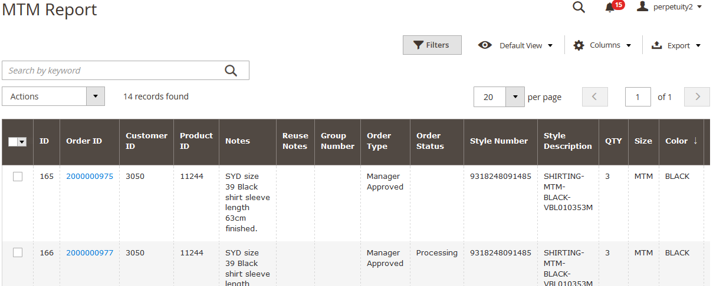
Figure 8: MTM Reports

5.4 Back Order Report
Show Back Order Reports in grid with customer data according to order number.

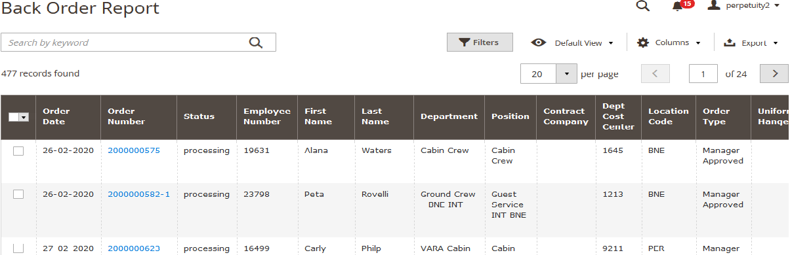
Figure 9: Back Orders Reports

5.5 Shoe Reimbursement Reports
Show shoe reimbursement history in grid report

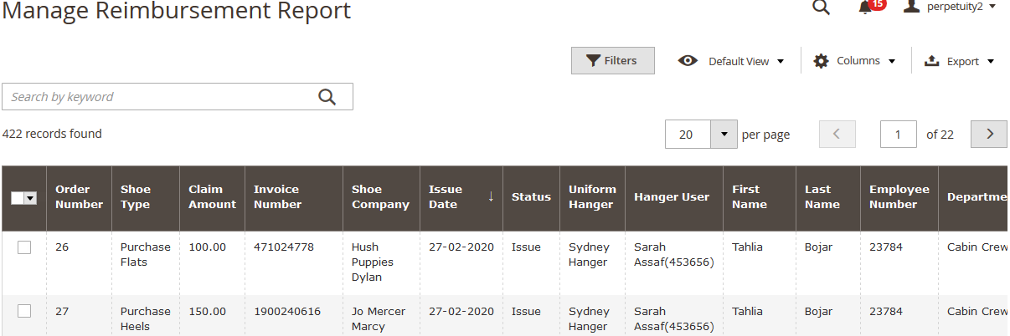
Figure 10: shoe reimbursement Report

5.6 Group Number Reports
Show "Group Number" corresponding to order number in grid
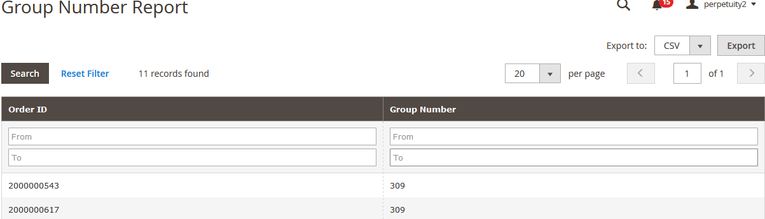
Figure 11: Group number reports

5.7 Detailed Invoiced Reports
Show invoice details information according to invoice number.

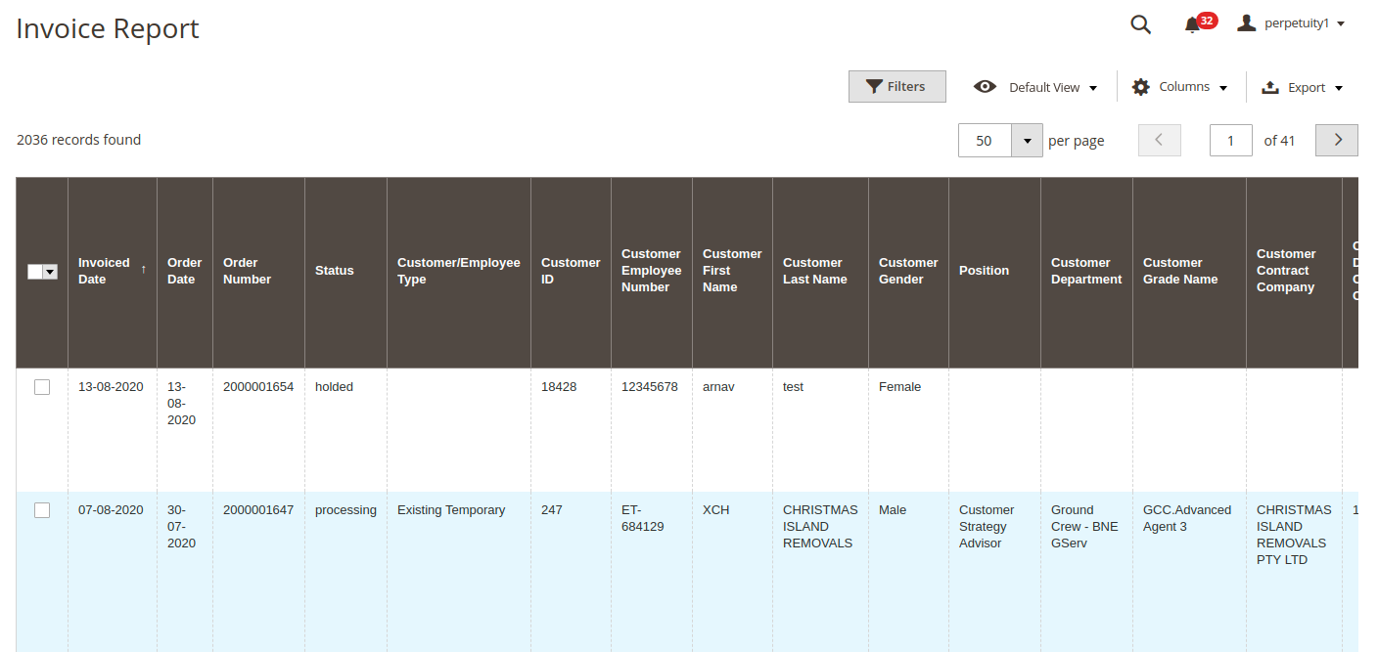

5.8 Credit Memo Detailed Reports
Show credit memo information according to credit item memo number.

5.9 Back Order Report
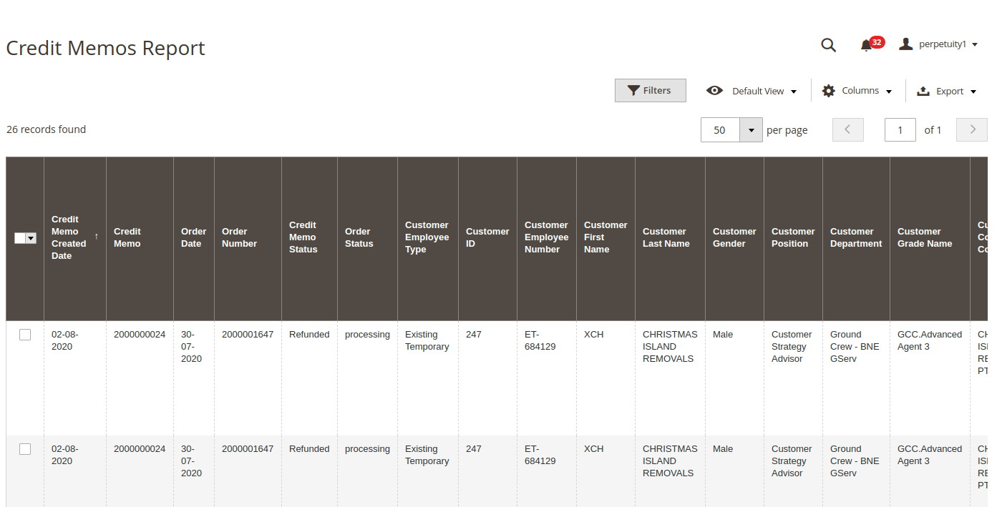
Sales → Operations → Back Order
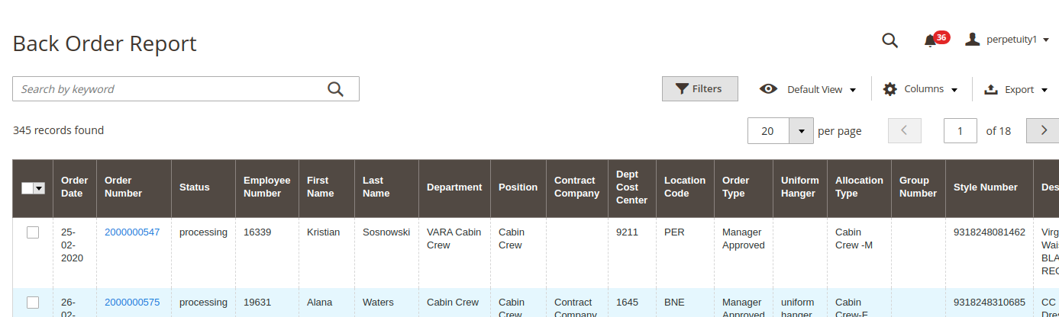

Stores
Using stores pickups it creates a winning situation for both customers and merchants: Customers don’t have to pay a shipment fee, while merchants don’t have to deal with shipping. At the same time, customers can choose the most suitable location to pick up the order at the most convenient time.
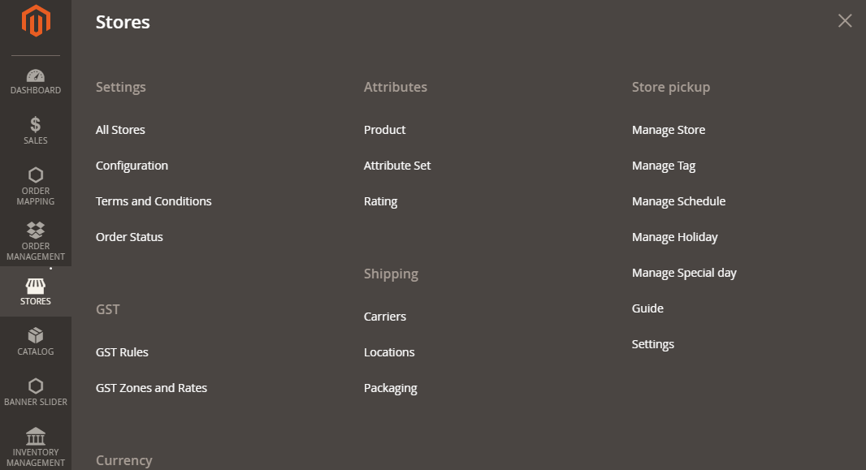
Figure 14: Stores Pickups

6.1 Manage Stores
All offline stores are gathered in a grid. You can search for stores by keywords or find them after applying sorting. There is a dropdown with mass actions, so you can enable, disable, delete, or edit multiple stores simultaneously. Another important feature is the ability to show/hide columns. As a result, you can create a grid view that completely serves your ecommerce needs. This new view can be saved for further usage. Data on your offline stores can be exported.
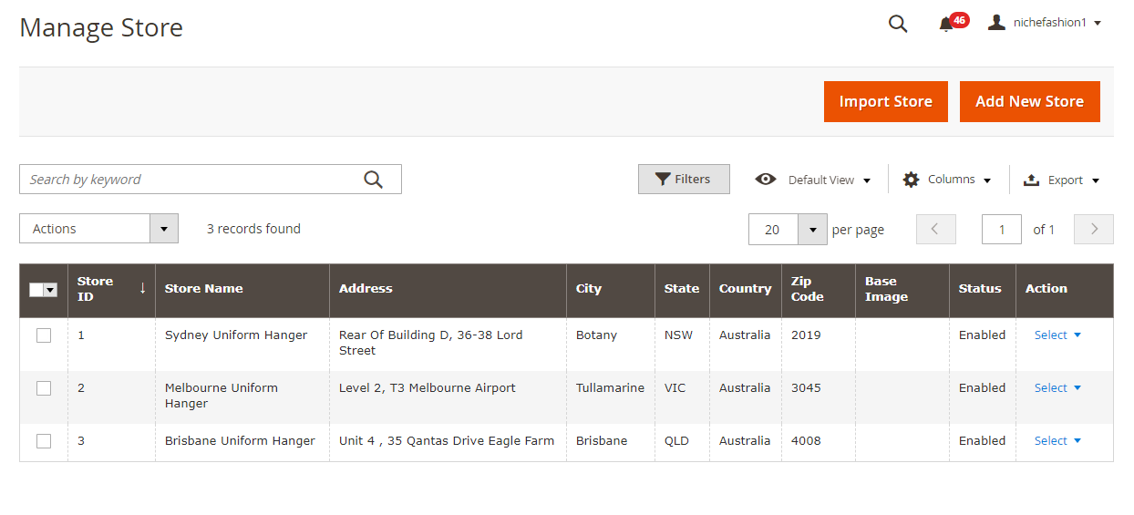
Figure 15: Manage Stores

6.2 Manage Tag
The manage Tags screen provides the same functionality as Manage Stores except CSV import. As for mass actions, they let you edit or delete tags.
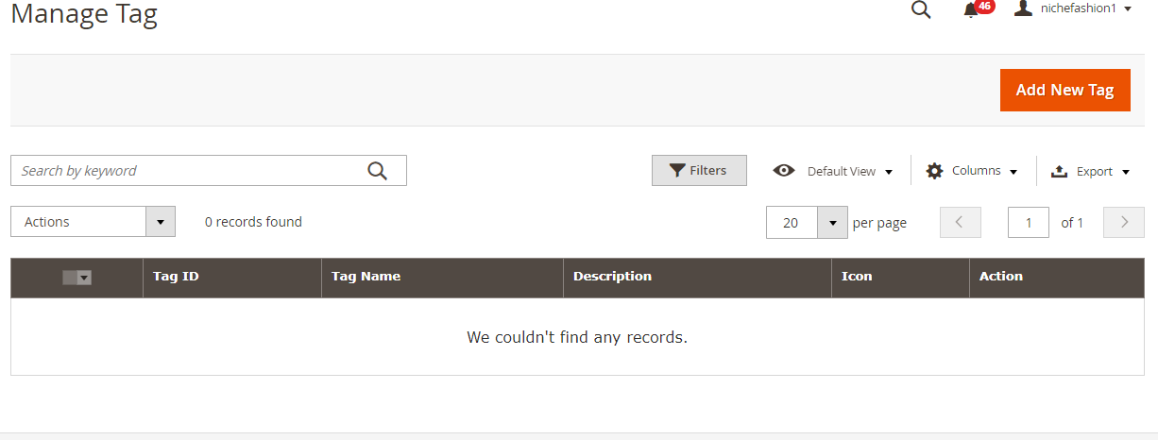

6.2.1 Add New Tag
While adding a new tag, specify its name, add a description, and upload an icon. Next, choose stores you’d like to add the tag to.
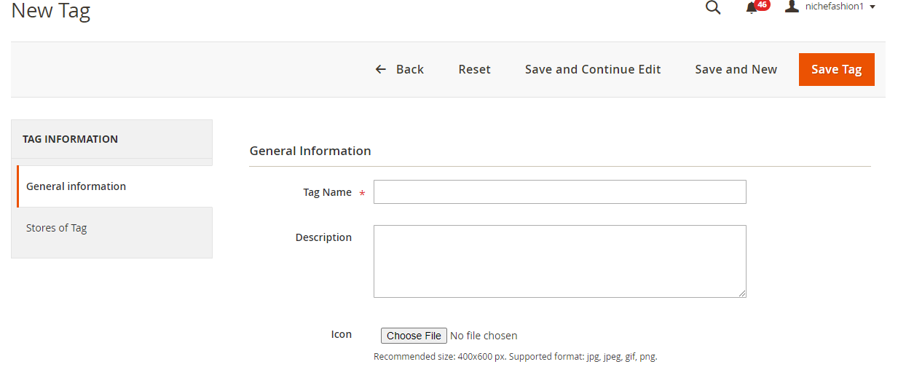

6.3 Manage Schedules
On the Manage Schedule page, it provides standard functionality: you can apply mass actions (edit or delete), show/hide columns, save grid views, and export schedules. The grid itself shows each schedule and day statuses (open/closed), besides, you can add working time, but then the grid becomes too overwhelmed.
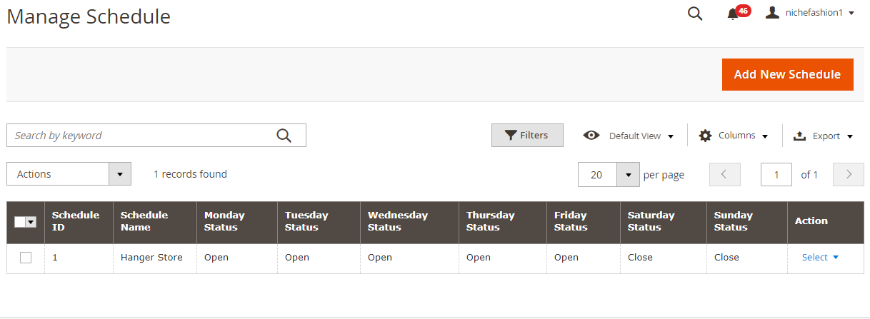

Add New Schedules
While adding a new schedule, specify its name and create a timetable for Monday: Monday Status, Open Time, Open Break Time, Close Break Time, and Close Time. Next, you can apply this timetable to all days.
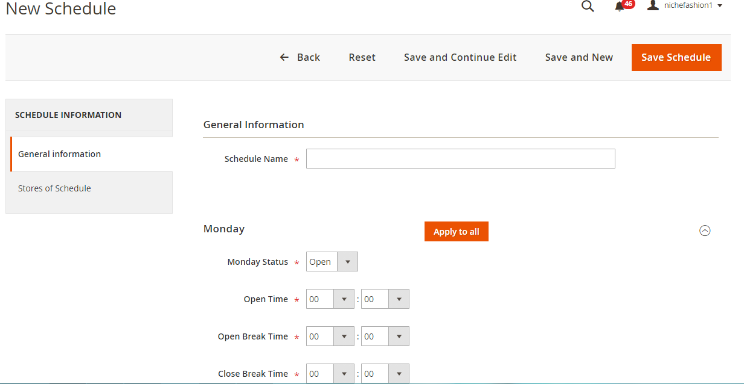

6.4 Manage Holidays
The Manage Holiday grid offers the already mentioned functionality.
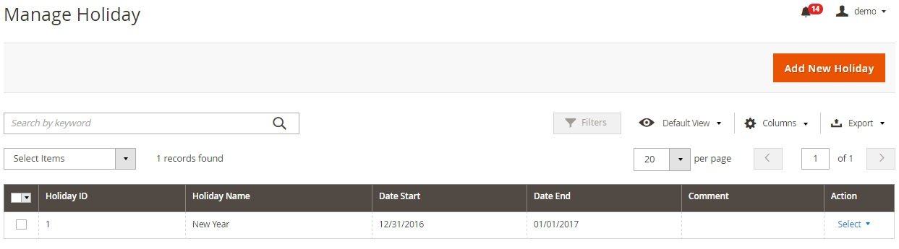

6.4.1 Add New Holiday
While adding a new holiday, specify its name and set time frames. Optionally, you can add a comment.
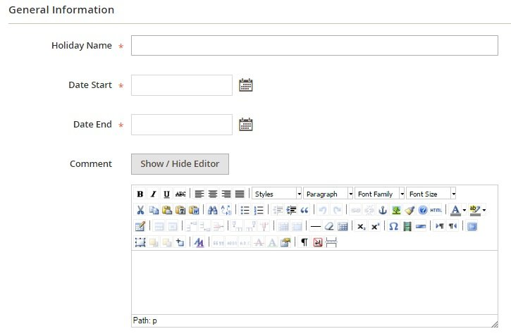

6.5 Manage Special Day
All special days – days with special working time – are gathered in a grid as well. You can apply mass actions, customize the grid and save custom views, and export data.
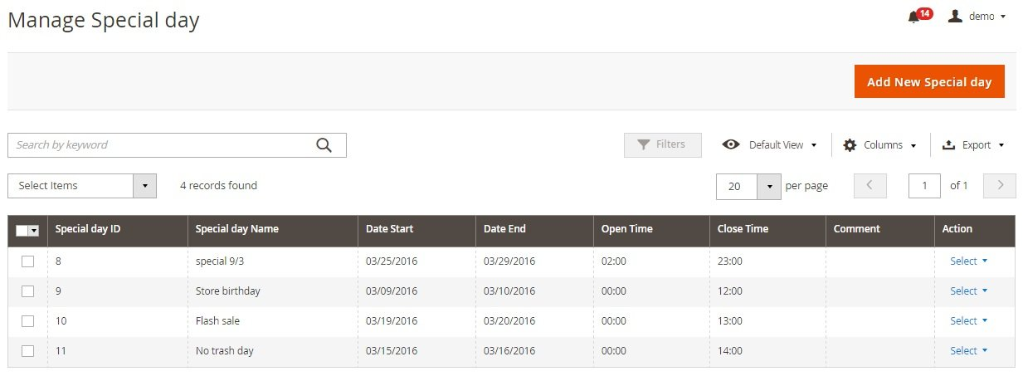

6.5.1 Add New Special Day
While adding a new special days, enter its name, choose dates for start and end, select open and close time, and add comments.
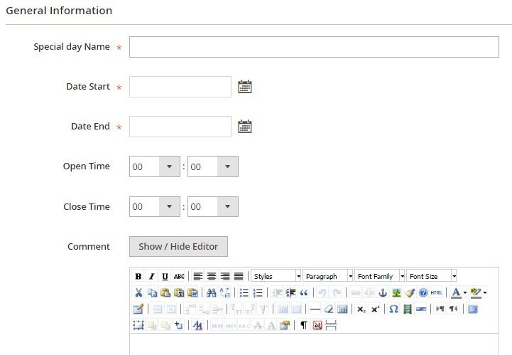

Inventory Management
All features of the Inventory Management can be divided into the following categories: Stock Listing, Prediction, Transfer Stocks, and Stock Control. You can easily update stocks for certain products selecting a necessary warehouse. Besides, it is possible to assign any non-warehouse item to a chosen warehouse.
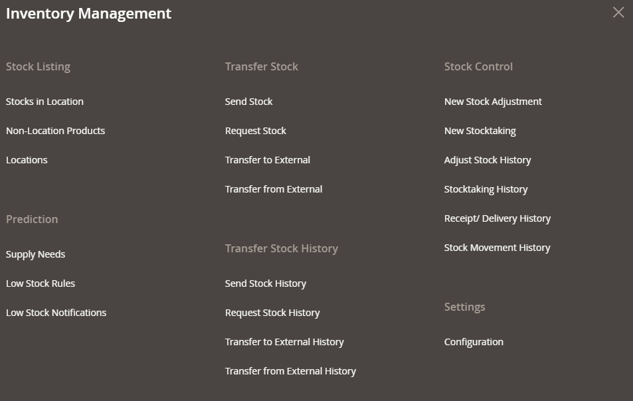

Stock Listing
You can select a location and all the stick will display in grid. The grid itself displays such information as product SKU, name, price, quantity on a warehouse, quantity to ship, available quantity, and status. Note that filters are built into the grid.
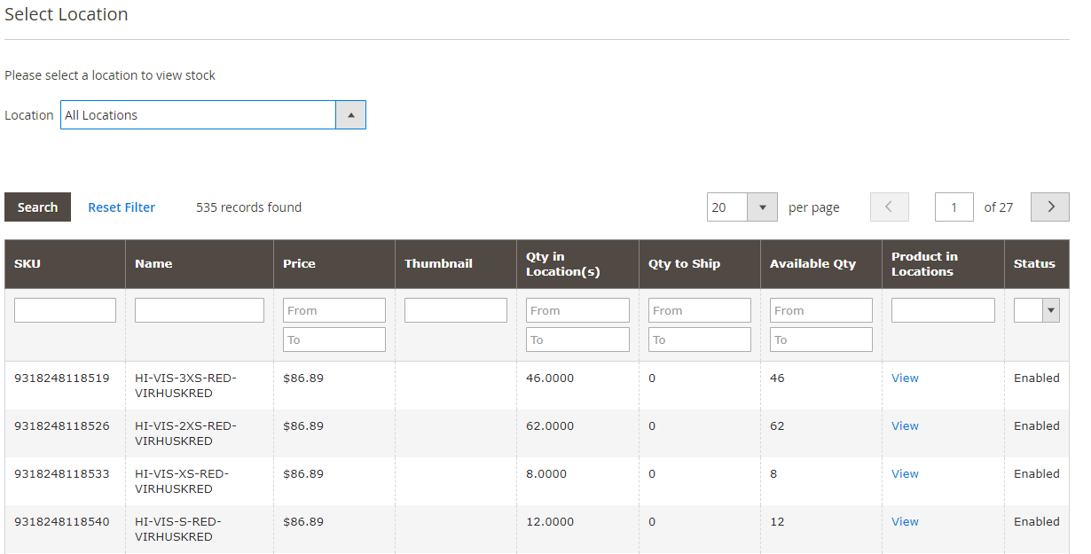

Prediction

7.2.1 Supply Needs
On the Supply Needs screen, you select criteria to create a forecast. Choose a warehouse, a sales period, and a future time point to calculate supply needs, Hit the “Show Supply Needs” button, and get a grid with results. You can export the forecast via CSV or XML.
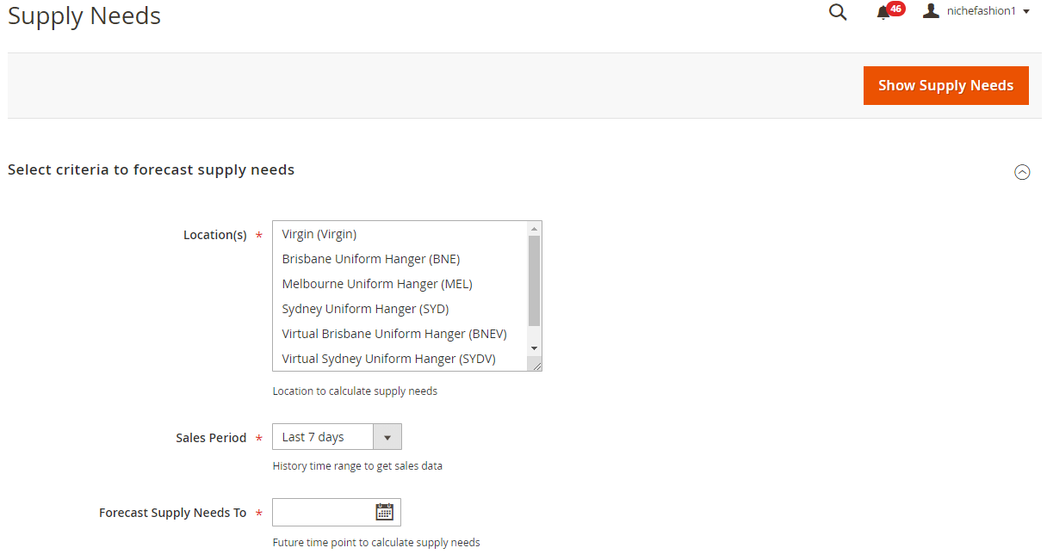

7.2.2 Low Stock Rules
As for low stock rules, they are gathered in a grid on the Manage Low Stock Notification Rules page. The grid consists of the following columns: ID, Rule, Description, Start, End, Apply, Status, and Action. You can edit or apply any existing rule as well as create a new one.
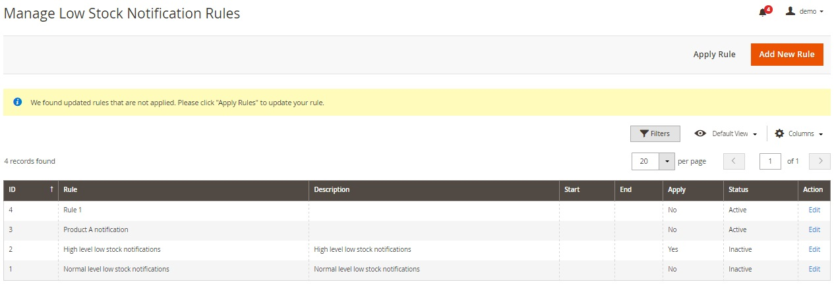

7.2.3 Low Stocks Notifications
All low stock notifications are gathered in the Notification log. Since we are reviewing the demo version of the Magestore Inventory Management Magento 2 extension, the appropriate grid is empty.
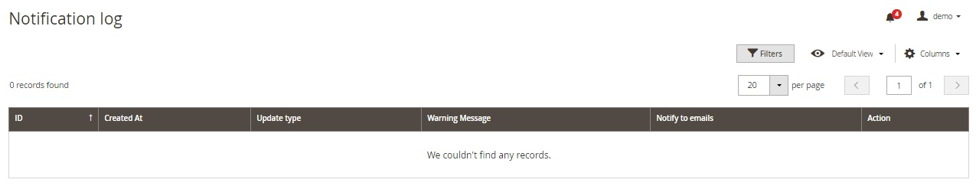

Transfer Stock

Send Stock
While adding a new stock transfer, you should specify such information as a transfer code, a source warehouse, a destination warehouse, notified emails, and a reason for transfer. Next, it is necessary to prepare a product list.
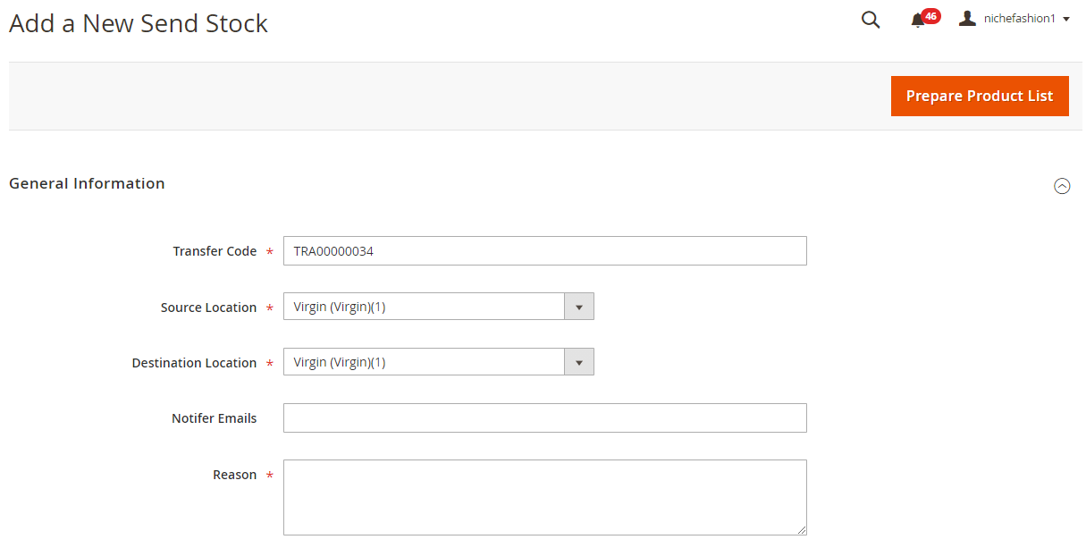

Request Stock
The same is about requesting a transfer:

Transfer to External
While creating a transfer to an external location, the situation is similar:
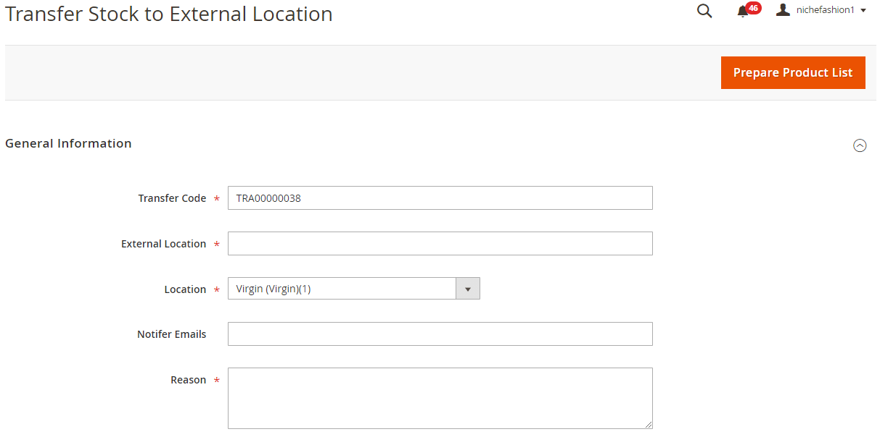

Transfer from External
And this is the form for transferring stock from an external location:

Transfer Stock History

Send Stock History
Send Stock History is represented with the help of a grid. You can apply filters, save views, and hide/show columns. The grid contains the following columns: Transfer Code, Source Warehouse, Destination Warehouse, Qty Sent, Qty Received, Created At, Created By, and Action.
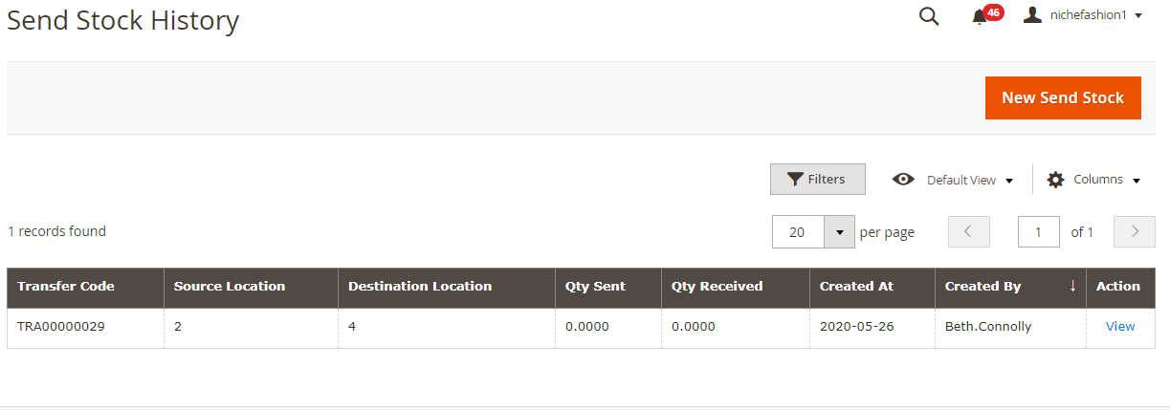

Request Stock History
A similar grid is used on the Request Stock History page:
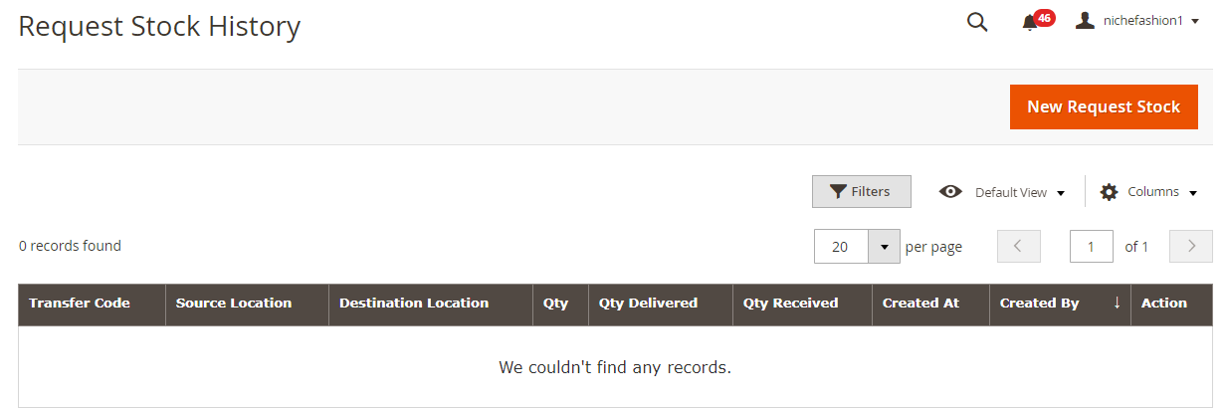

Transfer to External History
Transfer Stock to External Location History:
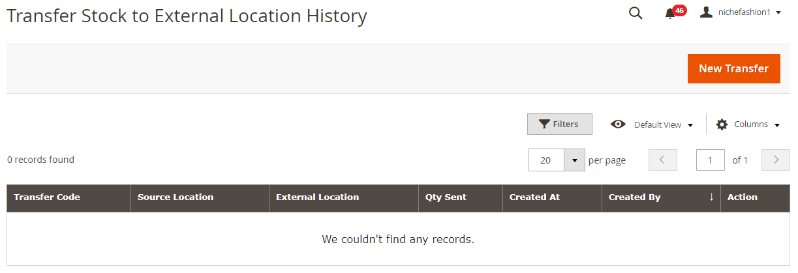

Transfer from External History
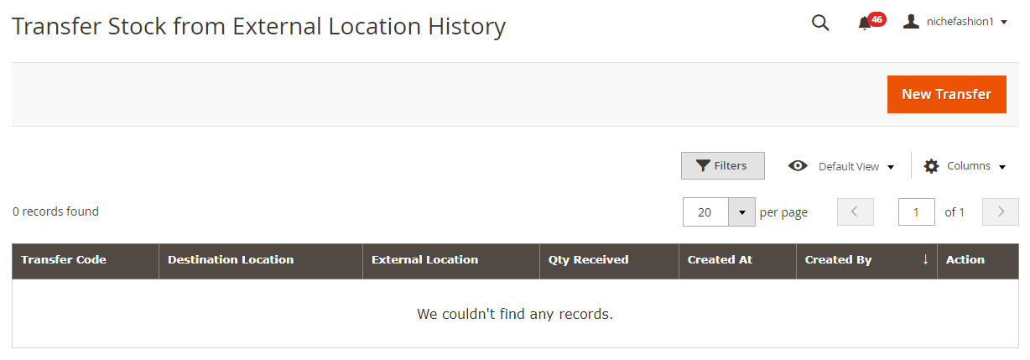

Stock Control
Due to this section, you can keep the data accuracy in practice and in the record all the time. Fixing all differences by selecting products and entering adequate Qty requires only a few clicks.

New Stock Adjustment
While adding a new adjustment, you select a Warehouse, specify an adjustment code, and write a reason.
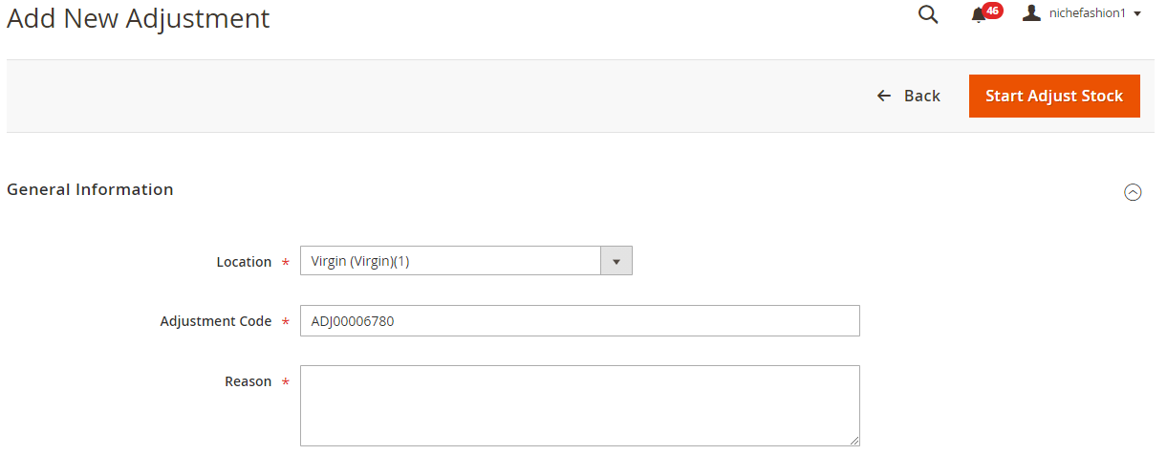

New Stocktaking
While adding a new stocktaking, you run through the following 5 steps: General Information, Prepare Products, Stocktake, Complete Data Entry, and Complete Stocktake.
The General Information section contains the following fields: Warehouse, Stocktaking Code, Participants, Stocktaking Time, and Reason.
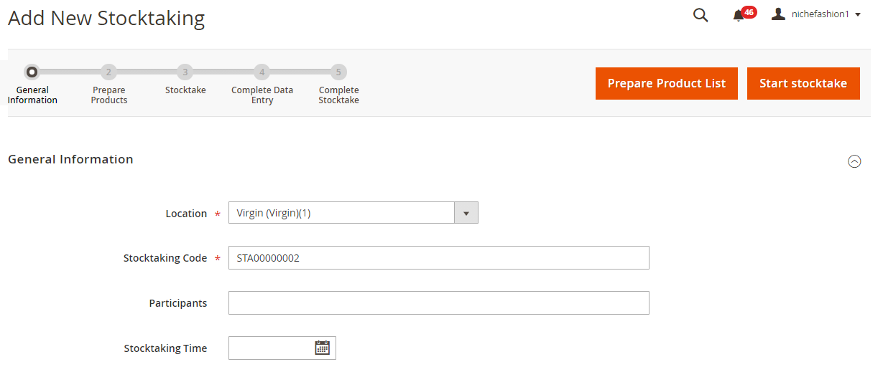

Adjust Stock History
The Manage Stock Adjustments screen contains a grid that illustrates the Adjust Stock history. You can export all data, view existing adjustments, as well as create new ones.
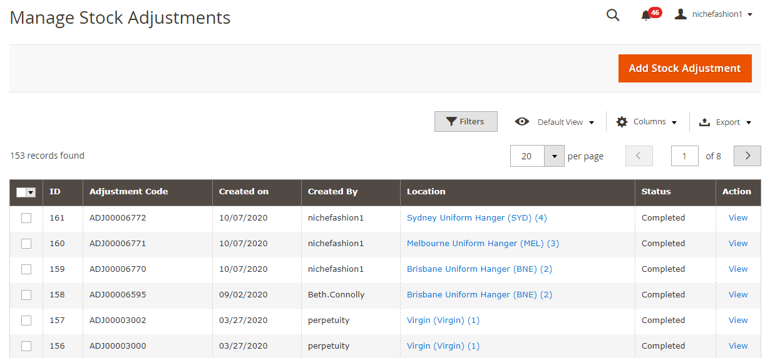

Stocktaking History
The same is about the Manage Stocktaking screen:
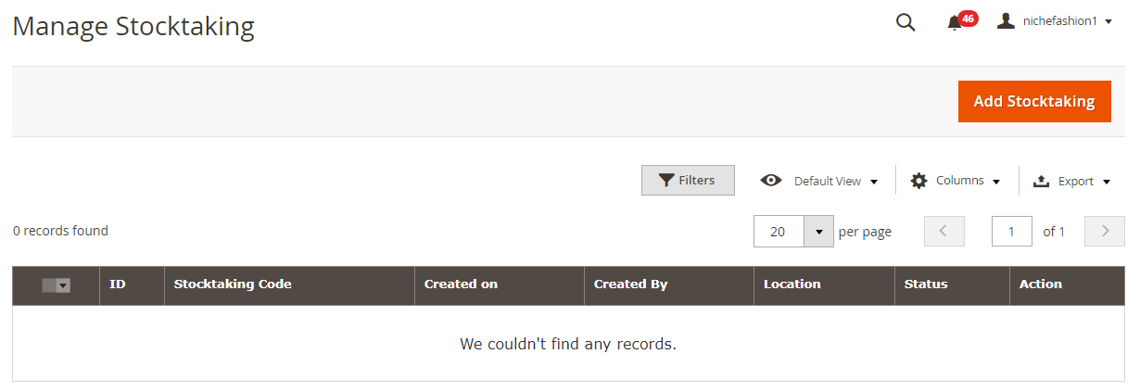

Stock Movement History
The Stock movement history screen contains a grid that illustrates the Stock movement history. You can export all data, view existing stock movement.
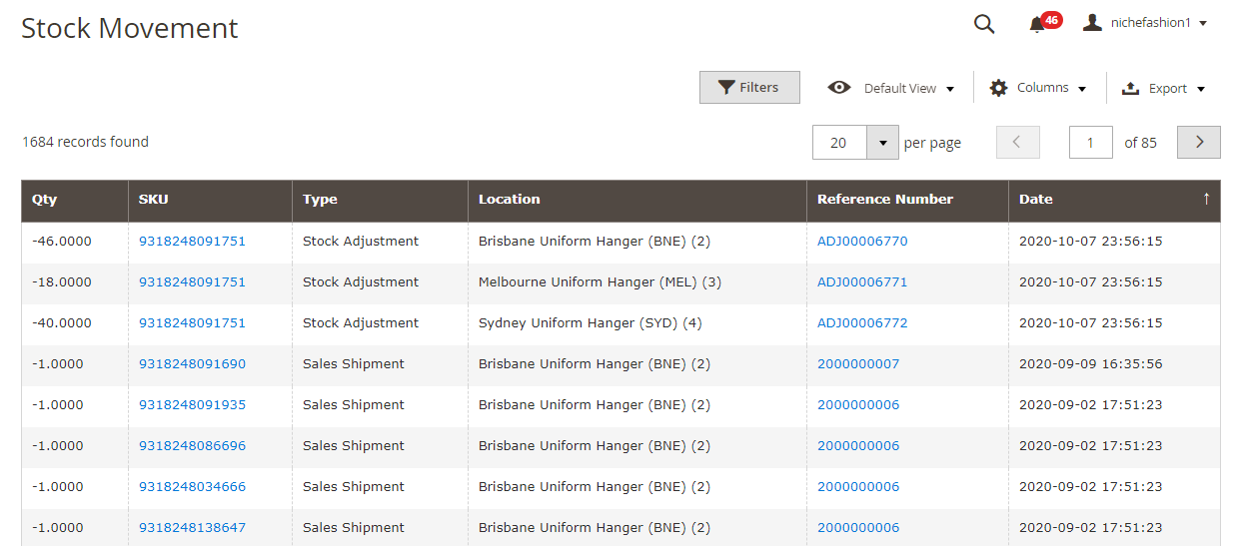

7.6 Configuration
As for configuration, there are two sections of settings: Stock Options and Product Stock Options. The first one allows you to Set Items’ Status to be In Stock When Order is Cancelled; Decrease Stock When Order is Placed; Display Out of Stock Products, set the Only X left Threshold, and Display Products Availability in Stock on Storefront.
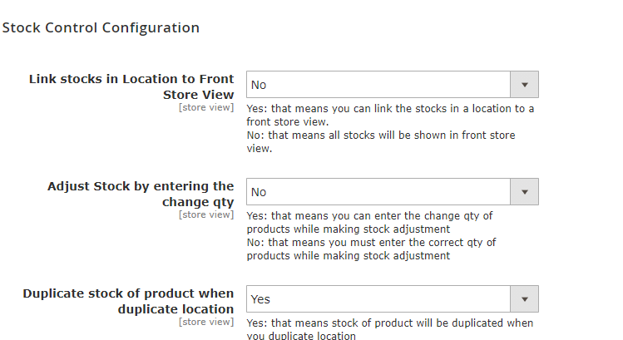

Purchase Managements
All extension’s features are available under the Purchase Management tab. The tab is divided into 3 sections: Purchase Order Management, Quotation Management, and Supplier. Each section consists of several subsections.

8.1 Purchase Order Management

8.1.1 Create Purchase Order
To create a new purchase order, you should complete 4 steps of actions. First of all, fill in general information: Created Time, Supplier, and Comment. Next, you should add products. In the Summary Information section, there are 5 options: Import Products, Supply Need Products, Back Order Products, Low Stock Products, and All Supplier Products. Choose one to fill in the section. Now, you should add Shipping and Payment data. The section contains the following fields: Shipping Address, Shipping Method, Shipping Cost, Start Shipping Date, Expected Delivery Date, Payment Term, and Order Place Via.
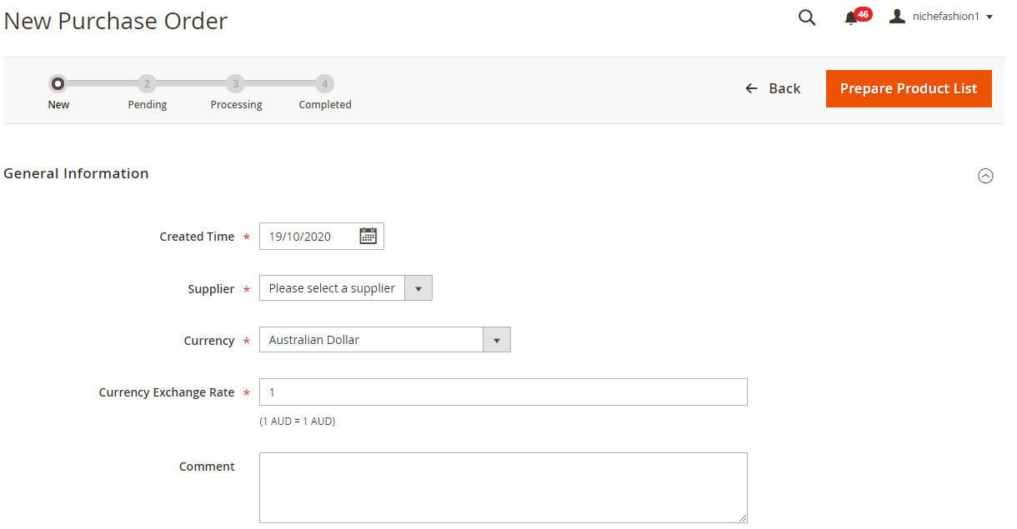

8.1.2 Purchase Order
The Manage Purchase Order screen provides lots of opportunities. First of all, you can view all POs in a grid that illustrates PO numbers, date of purchase, supplier, requested, received, and billed quantity, status, expected delivery date, as well as paid total and grand total. Besides, you can view each PO from the Action column that contains the View link.
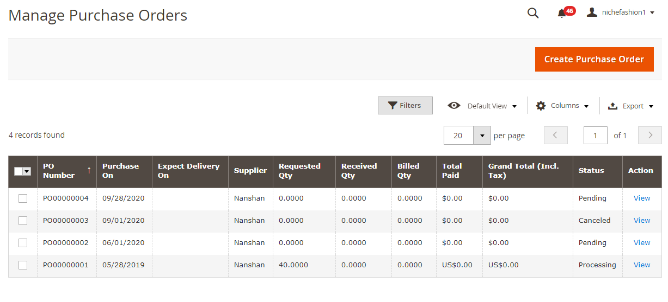

8.2 Quotation Management

8.2.1 Create Quotations
To create a new Quotation, specify general information (Created Time, Supplier, Comment) and hit the Prepare Product List button. You quotation is saved. 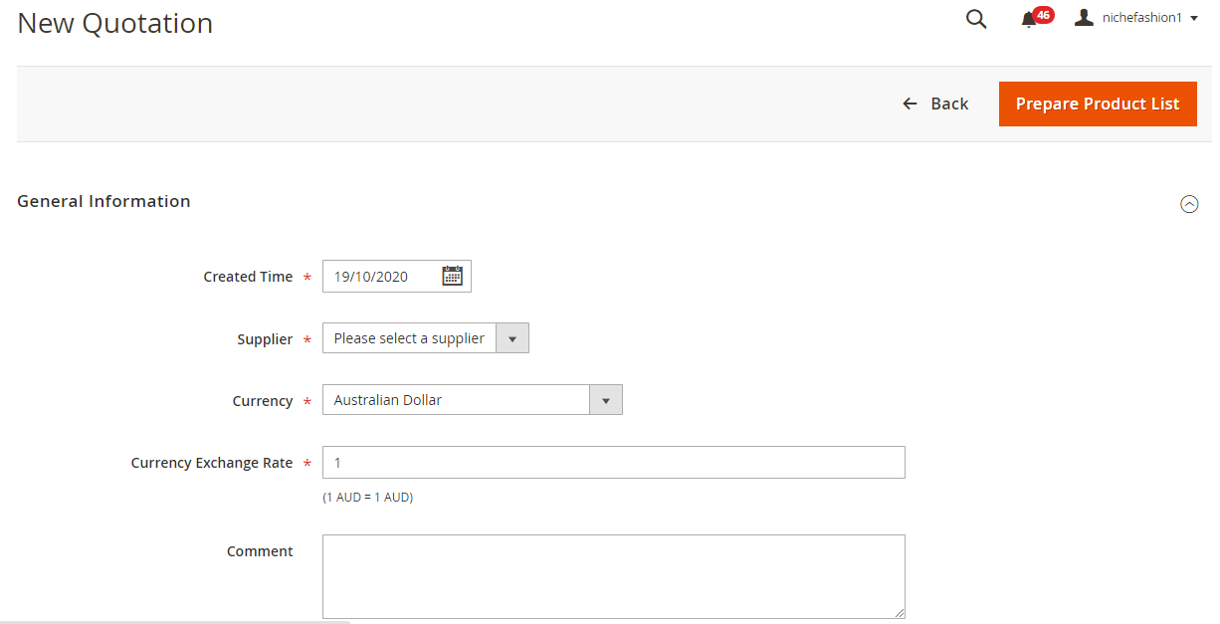

8.2.2 Quotation
Now, let’s have a look at the Manage Quotation screen. It provides the same options as the Purchase Order screen: you can apply filters, save views, enable/disable columns, or export data. As for the Manage Quotation grid, it shows quotation numbers, date of creation, suppliers, requested quantity, status, and grand total. Besides, you can view each quotation from the Action column.
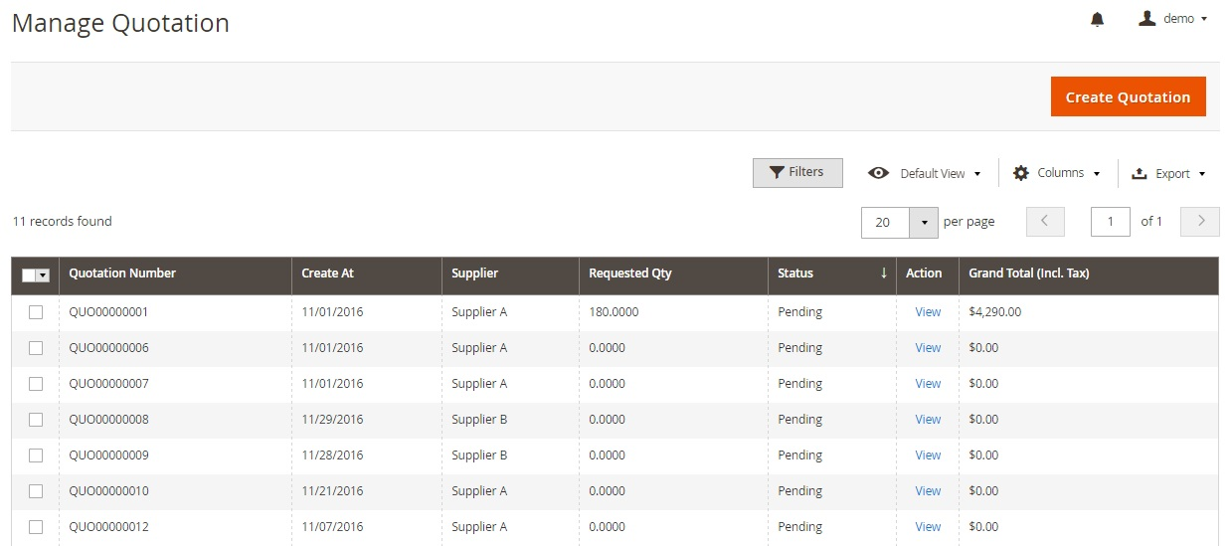

8.3 Supplier

8.3.1 Manage Suppliers
The Manage Suppliers screen also allows filtering, saving views, and exporting data. As for the grid, it shows supplier codes, total SCU count, purchase order value, date of the last purchase order, and status. You can view each supplier from the Action column.
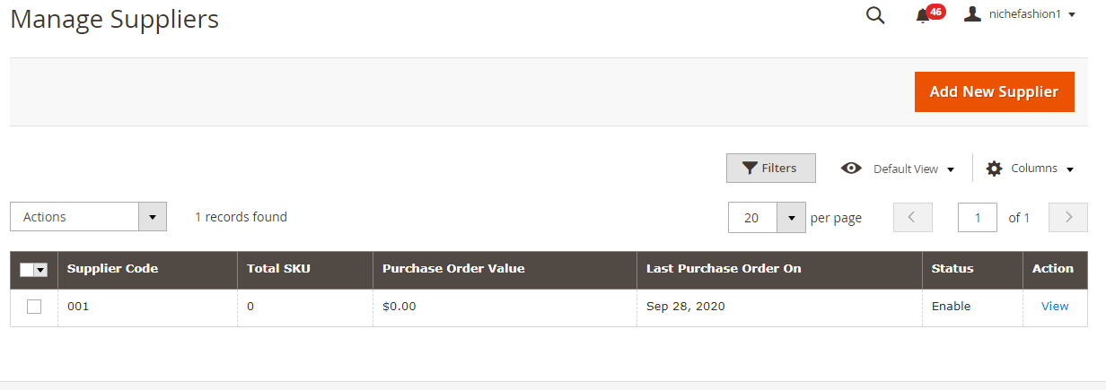

8.3.2 Add New Supplier
While adding a new supplier, you should specify its core information and address. The first section required to fill in the following fields: Supplier Code, Supplier Name, Contact Person, Email, Description, and Status.
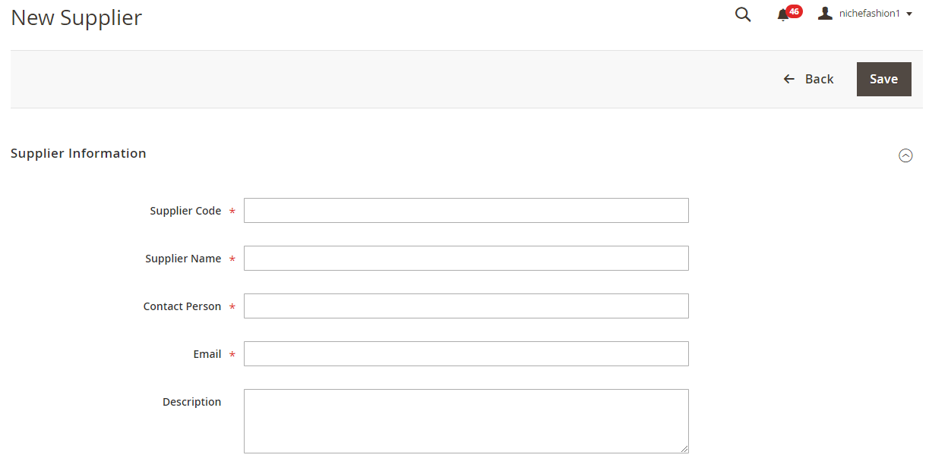

8.3.2 Manage Pricelist
The Manage Price List page has a grid as well. Besides, it offers some standard features: Filters, Default View, and Columns. The grid consists of the following columns:
- Product SKU;
- Supplier;
- Product Supplier SKU;
- Minimal Qty;
- Cost;
- Start Date;
- End Date.
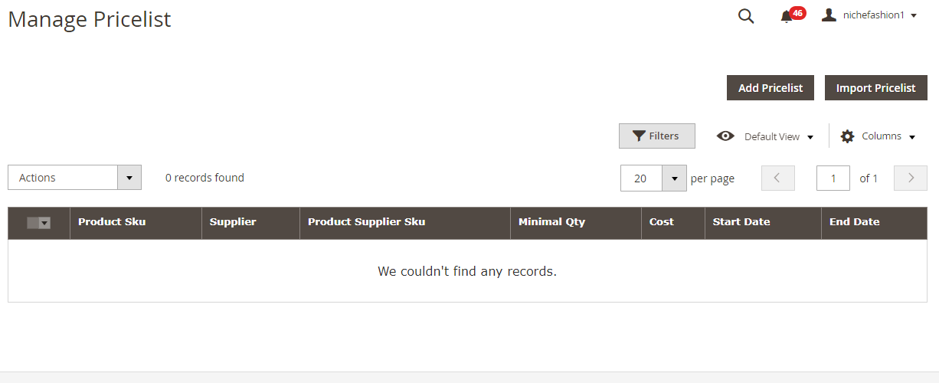
From this screen, you can add a new price list manually or import it via CSV. While adding a price list manually, you should:
- choose a supplier;
- select products;
- specify minimal quantity, cost, and start/end dates.
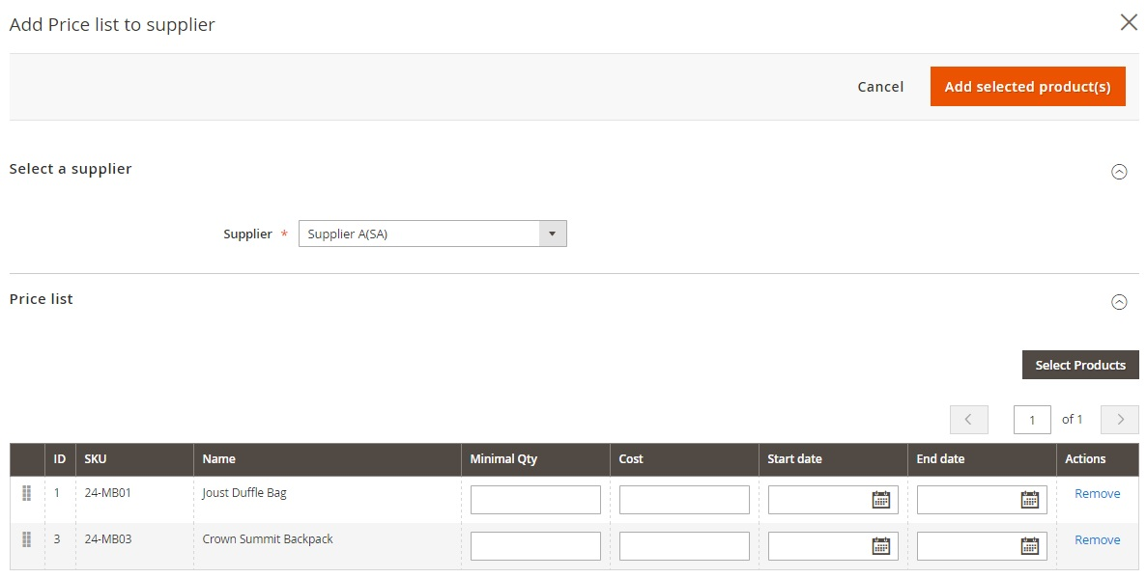

Marketing

Gift Card

Manage Gift card Products
All gift cards are gathered on the Gift Card Product Manager page in a grid. You can delete gift cards or change their statuses in bulk, edit each card product separately, as well as add a new one. The grid supports sorting and filtering. As for its content, there are the following columns available:
- Checkbox;
- ID;
- Name;
- Type;
- Product Template;
- SKU;
- Quantity;
- Visibility;
- Status;
- Websites;
- Edit.
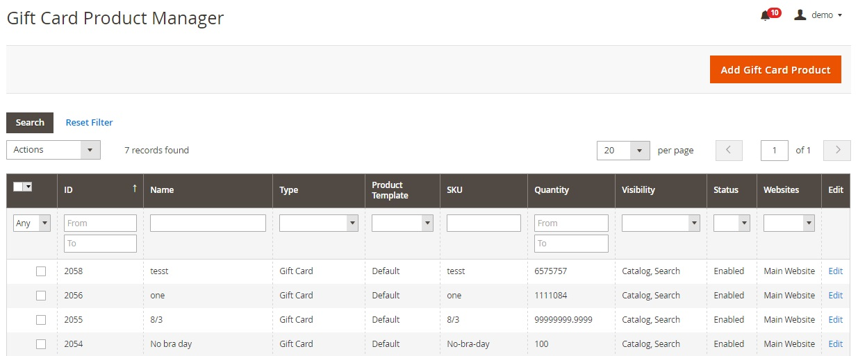
Hit Add Gift Card Product on the Gift Card Product Manager page. You will be transferred to a new product page with basic and advanced settings. Both sections do not provide many new fields in comparison to other products. Thus, on the General tab, you should specify a gift card name, type (virtual, physical, or combined), SKU, and tax class; choose images and videos, add quantity, specify whether the product has a weight or not, enter a category (you can add a new one here), add a description, and select gift card templates and code sets.
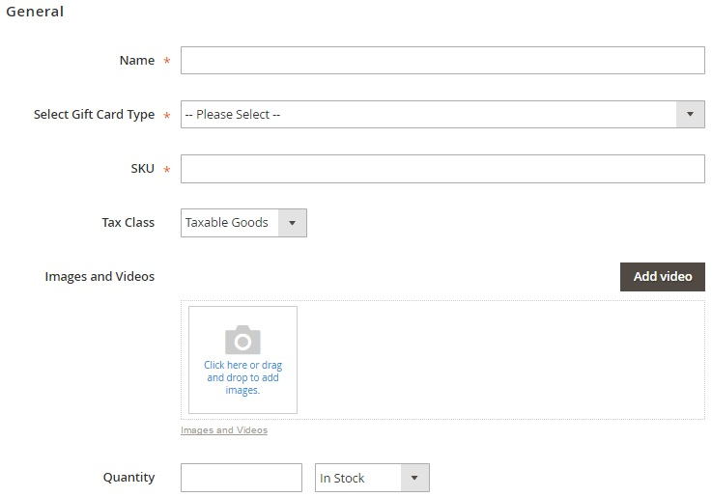
It is also necessary to draw your attention to the Advanced Pricing tab from advanced settings. Here, you select a gift card value type (fixed value, a range of values, or drop-down values). Depending on a selected type, you should specify gift card value, minimum and maximum values, or gift card values. As for gift card price types, they are Same as Gift Card Value, Fixed Price, and Percent of Gift Card Value. Next, you specify the necessary value in the Gift Card Price value.
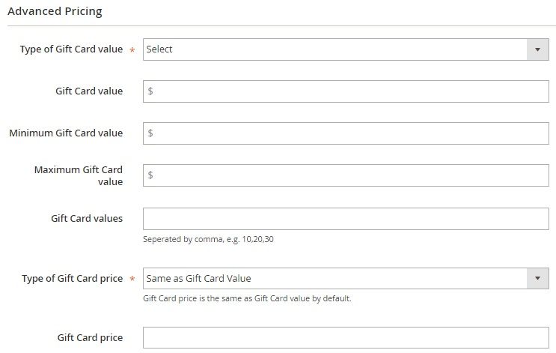

Manage Gift Codes
Gift Codes are gathered in a grid as well. You can perform such mass actions as delete, change status, print gift code, and send an email. Note that it is possible to edit each gift code, import gift codes via CSV, as well as add a new gift code manually. As for the grid, it illustrates the following parameters:
- ID;
- Gift Code;
- Initial Value;
- Current Balance;
- Currency;
- Status;
- Customer;
- Order;
- Recipient;
- Created at;
- Expired at;
- Store view;
- Sent To Customer;
- Action Created by.
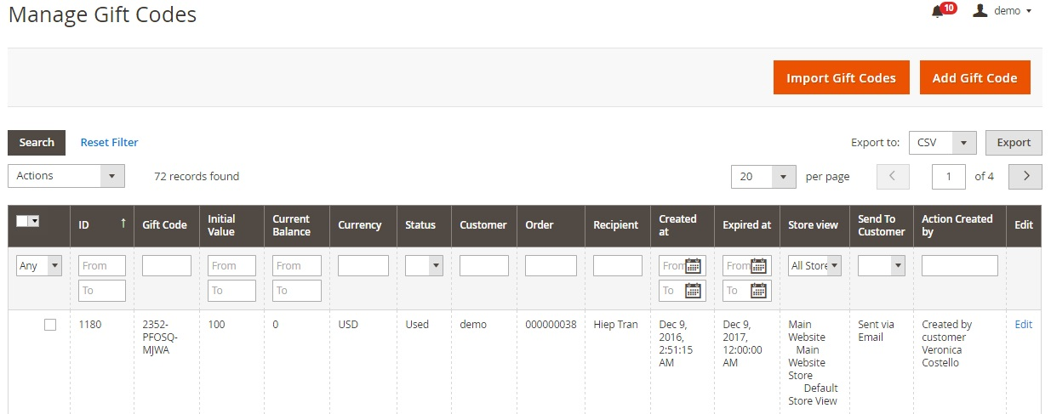
All code settings are divided into 4 tabs: General Information, Shopping Cart Conditions, Cart Item Conditions, and Message Information. The first one allows you to specify a gift code pattern, value, currency, template, status, expiry, store view, and comments.
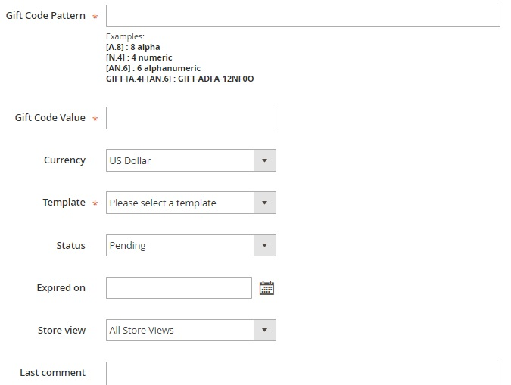

Generates Gift Codes
Gift Code Pattern Manager allows you to view, edit, delete, export, and add new patterns. The appropriate grid consists of the following columns:
- Checkbox;
- ID;
- Pattern Name;
- Pattern;
- Balance;
- Currency;
- Gift Code Quantity;
- Store View;
- Action.
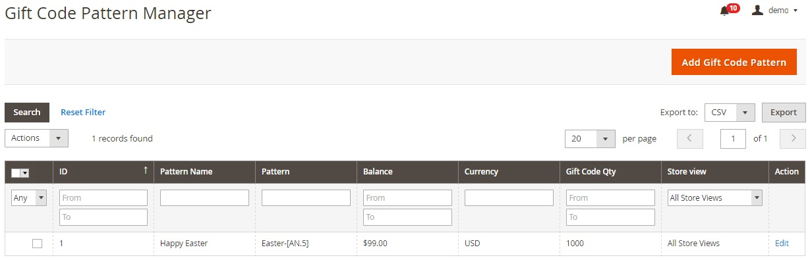

Gift Codes History
There is also a history tab that shows gift card creation date, an action performed with a card, card value, currency, status, corresponding order, and a customer who made the action.
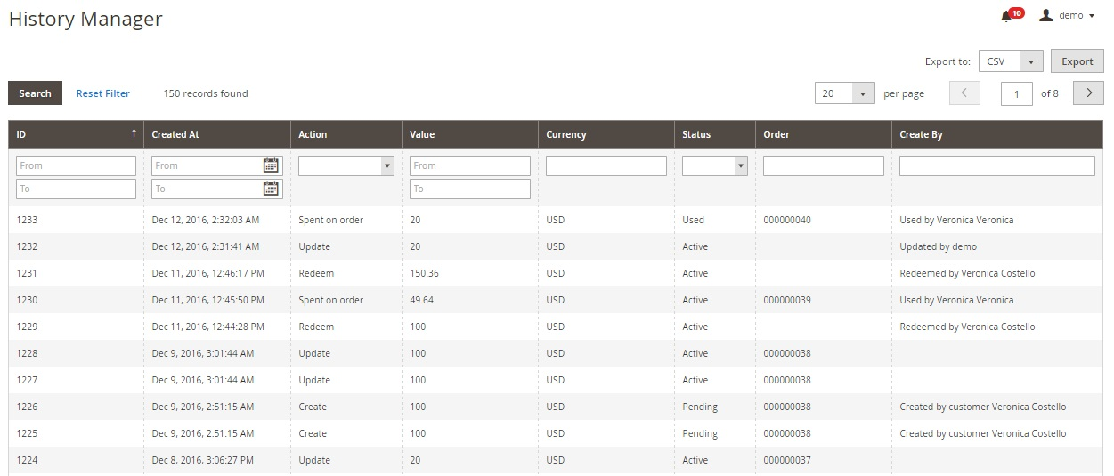

10. Shoe Reimbursement Setup
Add/Remove Shoe Reimbursement data according to customer group

10.1 Customer Group Limit
Path: - Shoe Reimbursement Setup -> Customer Group Limit
Admin can Add "Allocation Period" and "Limit" According to customer order type. Limit is set so that the claim amount shouldn’t be more than that limit.
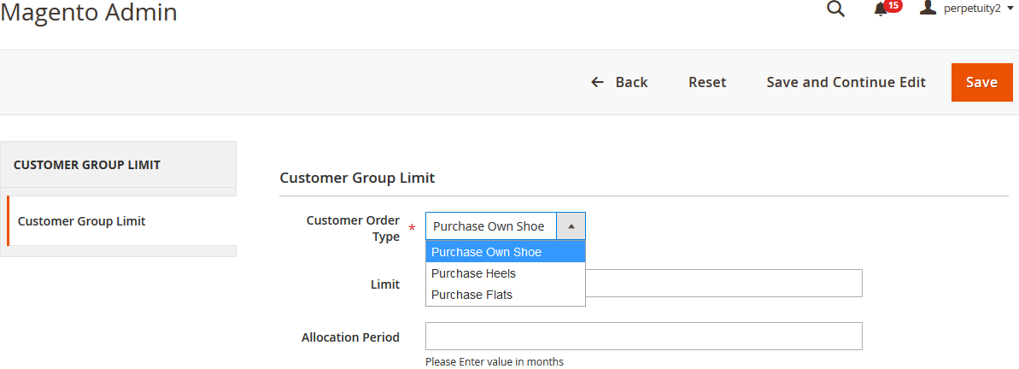

10.2 Manage Reimbursement
Path: - Shoe Reimbursement Setup -> Manage Reimbursement
Add/Remove shoe reimbursement with claim amount and other information. Claim amount should not be more than the limit set by the admin. Shoe Reimbursement allow for below customer group
1. Cabin Crew
2. Flight Crew
3. Guest Services
4. Pit Crew
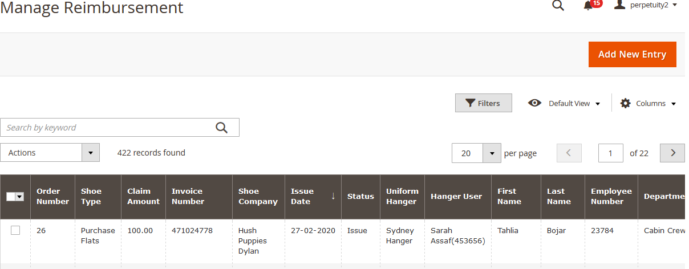

Banner Slider

Manage Slider
Promotional graphics displayed either horizontally on the top of a web page or vertically on the left or right margins. Website advertisements are often displayed as banners. The banner can be edited or can add new one.
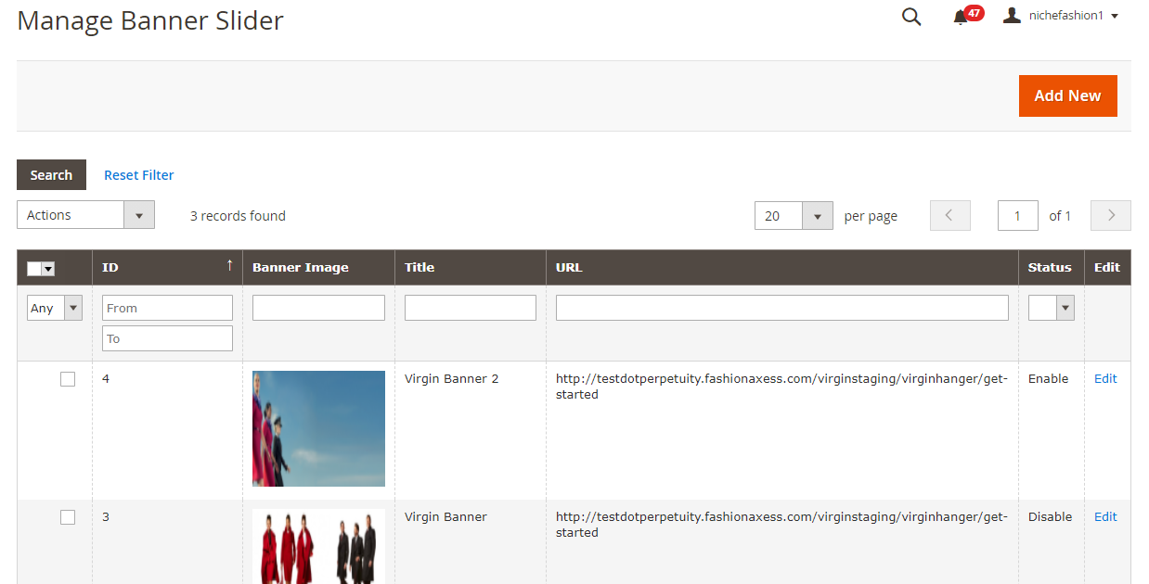

Edit Slider
Admin can edit the slider like name of the slider, can change the images, stores view, description, URL and status.
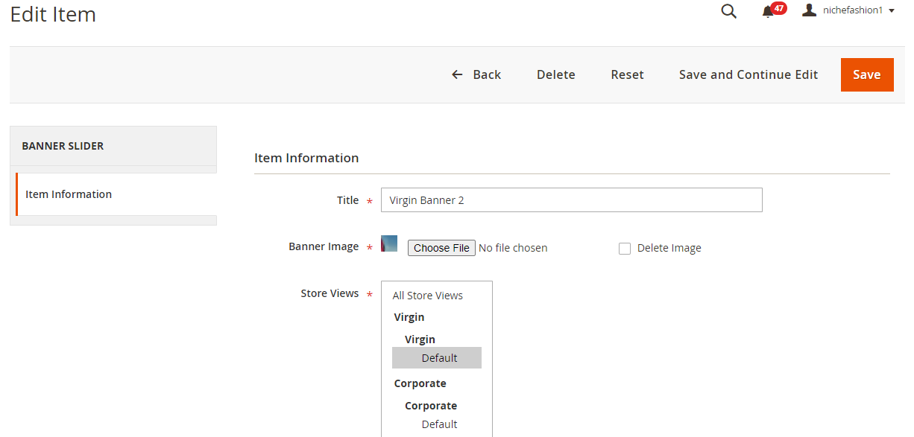

11.1.2 Add New Slider
Admin can add new banner by providing following information –
- Title
- Banner Images
- Stores View
- Description
- URL
- Status

