3/. Product Specific Report
https://www.journey-crm.co.uk/reportproductspecificsales
Currently the data calculated from here is taken from the enquiry form.
So, it looks at:
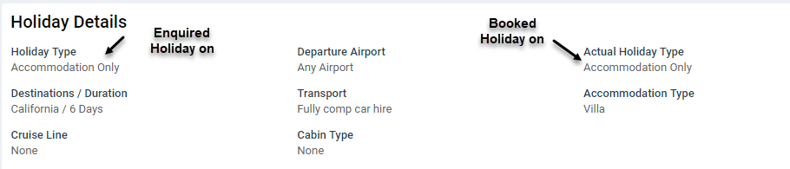
But we want to change this to now do look up based on results added at time of G2B and ignore what is being passed at enquiry time.

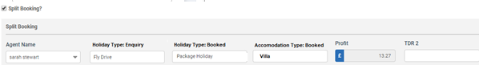
So, based on the above it is saying it is Package Holiday booked and knows the G2B form has Accommodation present and the Type is ‘Villa’ so for this example booking it would go down as ‘Villa Pkg’ on Product Specific report.

