SPP QUOTE
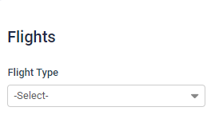
Once the user clicks on ‘Select’ dropdown, they will see five options, just like G2B:
- One Way Direct
- One Way in-direct
- Return direct
- Return in-direct
- Multisector
When user will select the type, the relevant options will be shown (same concept as G2B). Some of the information will not be asked on SPP Quote as it is not needed for it (passenger names, carrier airline, etc)
For the SPP quote, we will have to choose the ‘Flight type’ from the drop-down menu. Once the choice is made, the user will have to choose the supplier and enter the Manual Supplier name. The user will then have to add the supplier reference number and the PNR number from which the details will be fetched. Rest of the details on the screenshot shown will not be needed on the SPP quote.
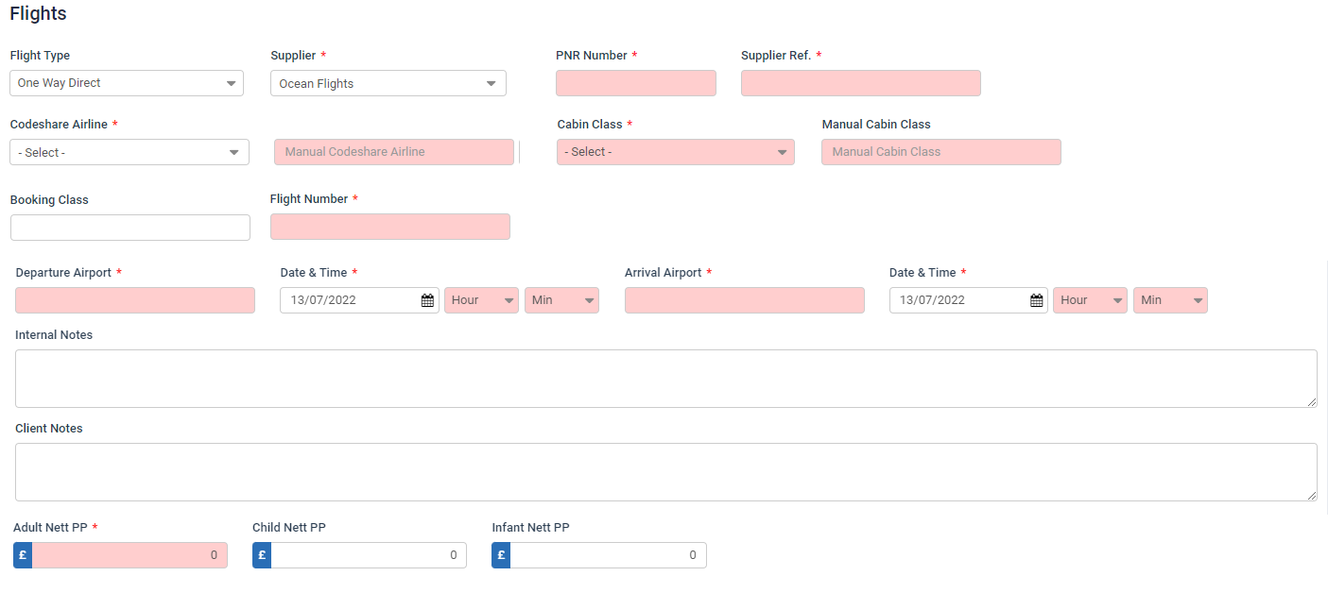
After the Flight type is selected, on the SPP quote the user will have to choose the Codeshare Airline from the drop-down and enter the Manual Codeshare Airline manually, along with the Cabin class (from the dropdown) and Manual cabin class (if applicable). The booking class will have to be added on the system, along with the flight number and seat number. The user will have to add details such as:
- Departure Airport
- Departure date and time
- Arrival Airport
- Arrival date and time
Internal and client notes will also be a part of the same.
Above details will be pulled from PNR if the user is using PNR functionality (will be binded automatically)
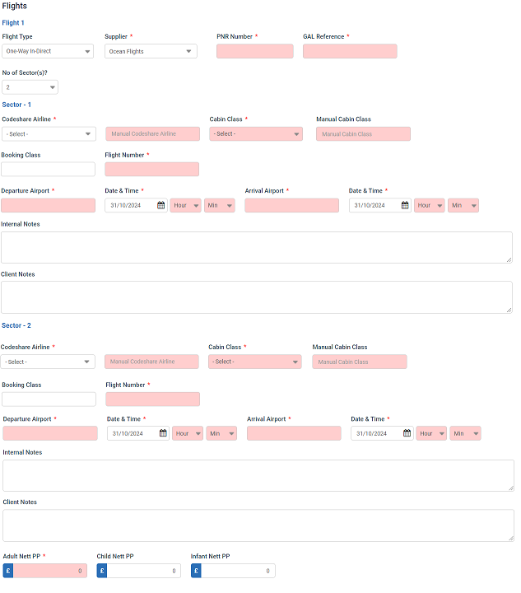
At the end of the SPP quote, the user will have to enter the price per pax and an external URL if needed (will function as it does at the moment).
If the flight type chosen is in-direct, the user will also have to choose the number of sectors and fill the information accordingly by choosing the number of sectors and setting up the flights accordingly.

Points to note:
- This is a major work and will require a good amount of development time and will necessitate relevant changes in the system
- When we copy the details from SPP quote to the G2B quote, the functionality of the same will also change
- The table structure of the SPP quote flights will also be altered for the same as it requires data migration of the all the historical quotes that were sent from the system
- If it is required, the design of the SPP quote email and preview will also be changed
- Query – As it has been stated that the G2B quote form is being replicated into the SPP quote, would it also be required to replicate the rules of the G2B quote on the SPP Quote?

