
CONFIDENTIAL
3rd July, 2024

Understanding Document

Change Requests for Placement Finder (CRM ID: 18700)

Version 1.0

This document outlines the general scope of your project based on our understanding of the requirements provided and discussions to date. |  | Prepared for: Sarah


Please don’t print me, it’s bad for the environment
DISCLAIMER
This document is submitted with the explicit understanding that the contents are confidential and would not be divulged to any third party without prior written consent from Dotsquares Ltd. Services are supplied according to our terms and conditions http://www.dotsquares.com/terms

Table of Contents
Purpose of the Document 4
Scope of Work 4
Development Process 10
CMMI 11
Why Dotsquares 12

---------------------------------------

Revision History
Version | Date | Description | Prepared by | Reviewed by
1.0 | 03-07-2024 | Initial analysis and estimate | Prakhar | -

Purpose of the Document

This document outlines the general scope of your project based on the requirements provided and discussions to date. The main objective at this stage is to ensure that all parties agree upon the general scope, budget and schedule of the project prior to commencing work on a time & materials basis.

Clients are urged to ensure that all details contained within this document are clear and fully meet their requirements before any work commences. Timescales mentioned only cover the scope listed, if this changes, costs and timings will change accordingly.

Once you are happy we will progress into the next stages. This may include further detailing requirements and functionality or it may go straight into design/development. This will depend on the nature of the project.

Scope of Work

- Chat + Group Chat + Twillio integration + Chat popup

The users will be able chat amongst them using the following functionality. To chat with a particular LAPT or CP, the users have the following ways to do it:

Care Providers:

From Referral search section:

- The care providers will be provided with a chat now button, so that the users will be able to click on that button and will have direct chat with the LAPT user who has posted the referral
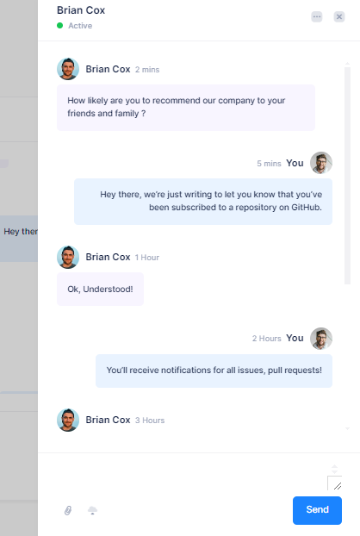

From Chat Section:

- Within Organization: The care providers will be able to search for the people working in the organization and chat to them one to one.
- With LAPTs: The users will be able to chat with the LAPTs one to one
  - In this section, the users will have a list of all their previous chat from which they can scroll and select any particular chat which they want to send message on
  - The users will be able to search for any LAPT user by the name
  - The users will be able to upload any document (word/PDF) and also upload images (.jpg, .png) from the chat section

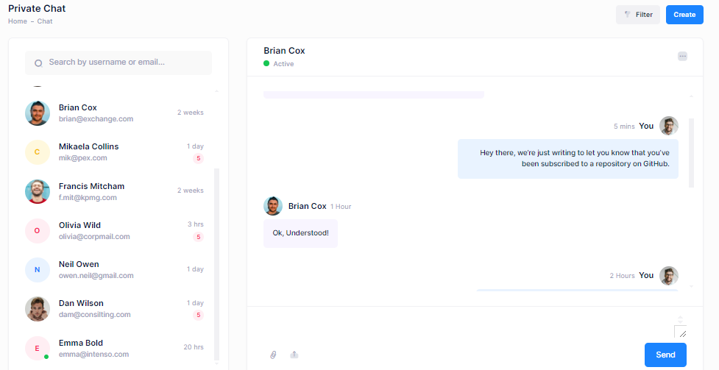

Twillio Integration

We will be integrating a 3rd party API called Twillio which will be used to send text messages to the users who are not logged in the system so they will be receiving the text messages on their registered mobile phones via Twillio so that they can check the messages and reply back to the message using our portal.

LAPT:

From Search and Live Placements section:

- The LAPT will be provided with a chat now button, so that the users will be able to click on that button and will have direct chat with the CP user who has added the accommodation

From providers section:

- The LAPT will have a list of all the providers and they can view profile of any provider and contact them via chat

From Chat Section:

- In this section, the users will have a list of all their previous chat from which they can scroll and select any particular chat which they want to send message on
- They can also chat to internal LAPTs internally with each other
- The users will be able to search for any CP user by the name
- The users will be able to upload any document (word/PDF) and also upload images (.jpg, .png) from the chat section
- The users will be able to select uploaded documents from “Forms library” and once that is done

Group Chat

The LAPTs will have the following groups:

- Global Group (Internal): The LAPTs will be added to a Global group where they can post any message and will be received organization wide and they can also see what all messages are getting posted by other users.
- Adult placements group: The LAPTs who have placement type as Adult will be added to this group and can chat to other LAPTs added to this group as well
- Children Group: The LAPTs who have placement type as Children will be added to this group and can chat to other LAPTs added to this group as well

Twillio Integration

We will be integrating a 3rd party API called Twillio which will be used to send text messages to the users who are not logged in the system so they will be receiving the text messages on their registered mobile phones via Twillio so that they can check the messages and reply back to the message using our portal.

- 2-factor authentication

The users will have 2-factor authentication to login to the system. The functionality will be as follows:

- Whenever the user login to the system, the users will have the OTP screen and the OTP will be received on their registered email ID so that they can see the OTP and enter it on the screen
- They will also have the option to resend the OTP in case they have not received it yet.
- The users will have an option in the settings section where they can enable/disable 2-factor authentication
- The 2 factor authorization will be set to “ON” by default

- FAQ manager

The admin will have a FAQ manager in the admin panel where they can manage the following:
- Add/Edit/delete any question
- Add/Edit/delete any answer
- Assign the question and answer to a particular user type (CP and LAPT type)

- Malicious activity alert to manager

We will provide the account administrator the ability to approve and reject the users request to end placement and close referral. (If any other case, please let us know.)
- They will receive email whenever a user is attempting to end placement or close a referral
- They will have the option to approve/reject these requests from the Placements and referral sections.
Could not find use of this functionality.

- Shortlist function

The LAPT will have shortlist function where they will be able to shortlist some of the providers in which they are interested and want them to contact later

- The users will have a button to shortlist these from the placements section

- Forms library for LAPT

The admin will be able to upload some forms from the back-end section which will be general templates
- The LAPT users will be able to go to the forms section
- They will be able to see a list of all the uploaded forms
- They can download any form from this section

- Create review alert

When a LAPT is booking a placement:

- The LAPTs will have to options:
  - Create review alert for a particular date
  - Create review alert according to week – 1w/2w/3w/1mo
- The users will also have the option to add “notes for alert” for the review which will be sent in the email as well so that they have the review notes before going for the inspection on their email.
- There will be another option to send the alert to the Account administrator as well

- Announcements Section

There will be a new section called announcements for both LAPT and Care providers.

For LAPT:
- The LAPT account admin will be able to post announcements from this section which will be received by the care providers.
- In order to add announcements, the LAPTs will have to enter the following details
  - Title of the announcement
  - Description of the announcements
  - Image related to the announcements
- Once, all these details are added they will have to select the following option:
  - Send announcements to all the care providers
  - Send announcements to the selected placement type and service type care providers
- The account admin will also have the option in their profile settings if they want to provide announcement section access to the users or not.

Timeline: 3 man days

- Hide/unhide referral

The users will have the option to hide/unhide a live referral and will have a separate section called hidden referrals where they can see the details and hide/unhide the referral and book placement for that referral.

Development Process
Project Management Tool  Dotsquares will provide free access to DS Projects our project management and collaboration platform for project planning, communication and tracking.  - Daily updates provided  - Keeps digital track of conversations  - Milestones and tasks for planning  - Maintain task list for deliverables  - E-mail notifications about updates & other activities | 

Testing
We provide unit testing services for your project as a standard package. Unit testing is completed by the developer during the development cycle. We ensure all the code blocks (paths) in the software are executed at least once and produce the desired results.
Environment  - Where possible, Dotsquares provides free of cost hosting during the project for you to test at your convenience.  - If the project dictates specific environment requirements, a separate estimate will be provided for these.  - When the project is finished and signed off, we ask you to choose a hosting provider and deploy the project to live environment. |  | Deployment  - Dotsquares will deploy the complete solution for the project. Code can also be supplied directly to you or any repository account held.  - Web based developments will normally be transferred to your own hosting account and put live as required.  - Mobile applications will be uploaded to the relevant AppStore under your developer account.

CMMI
CMMI Maturity Level Rating
Improved Quality
- Well-defined processes limit opportunities for error.
- Smart supplier management ensures quality results.
- Strategic people management enables team members to develop skills that will help the organization succeed.
Decreased Costs and Enhanced Productivity
- Streamlined processes allow teams to integrate and collaborate more efficiently.
- Standardized project management practices reduce redundancy and waste.
- Identifying skill gaps helps break down workflow bottlenecks.
Higher Customer Satisfaction
- Service delivery strategies strengthen weak customer touch points.
- Elective product development instills customer confidence.
- Project management practices help teams meet and manage customer expectations.
Improved On-Time Delivery
- Field-tested project management standards keep work on schedule.
- Clear development processes reduce scope creep and deadline extensions.
- Careful vendor management mitigates supplier delays.



Why Dotsquares
We thrive on seeing ideas grow. Since 2002, we have been working with individuals and global brands to embrace the evolving digital industry.

We are big on trust, reliability and mutual respect so we will take the time to understand you, your product and your business. We work closely with all our clients and are always looking to forge ongoing trusted relationships.

Taking your IT project offshore allows you to cut down on the costs whilst maintaining a quality that onshore companies struggle to match. We take the pain out of your IT projects and let you concentrate on the business you know best
Your own.

Dotsquares are an international creative digital design and development company striving to make your vision a reality.

Portfolio

What our clients say
Daniel Ox
Ocean Holidays Group
UK
Significant cost savings can be made working with an outsourced development company you can trust. Dotsquares have an exceptional team of quality engineers who work quickly and are always aware of deadlines.”

John Wussah
Education & Training Company
Australia
“You have been one of the best developers I have ever worked with. You have excellent technical and interpersonal skills and you got my website development and design project done to my amazement and satisfaction!”

Brian Riback
New York Daily News
USA
Dotsquares went beyond the requirements. The Team are amazing and working with them is a winning formula. I feel extremely lucky to have these gentlemen on my Team with their unyielding dedication to excellence.”


Affiliations


