Log in page
- Opening hours to read 9am to 6pm 7 days per week
- Change text to
Welcome to Manage My Booking. Here you can view/print your confirmation and travel documentation. Please enter you the booking reference number, lead passenger surname and date of birth used to confirm your on the booking.
- Change to just ‘booking reference’
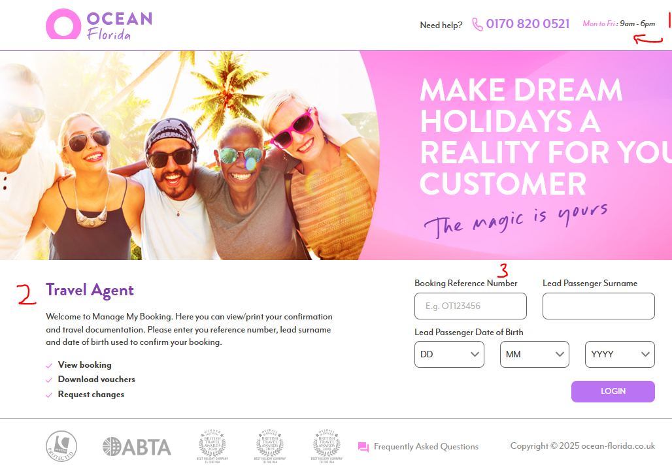

Main page
- Change to - ‘Complete travel documents will be uploaded 7 - 14 days prior to departure date

- Change to - Please take a moment to check that all passengers’ titles and names are spelt correctly and have been booked exactly as they appear on passports. Please also check all booking details carefully and advise us immediately of any errors, discrepancies or omissions, Ocean Florida will not accept any responsibility for any problems encountered or costs incurred if this policy is not adhered to.

- A. Should be ‘Welcome ##TRADE Agent##. In this example this would say

Welcome Seaside Travel Easington Colliery

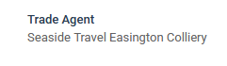

B. Please change booking reference shown below which is CRM reference to show the booking reference used in TD for the booking.

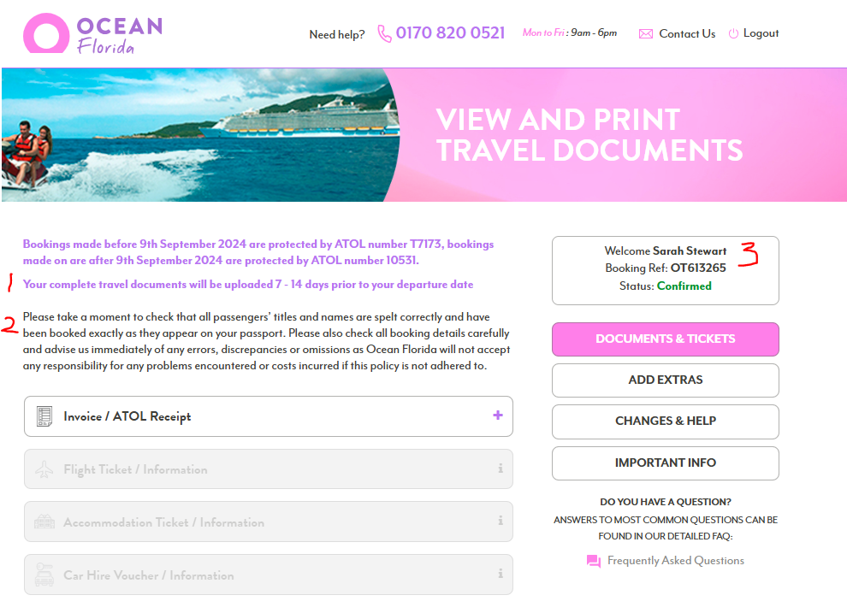

Add Extras
- Change to – Select an option below to request a price
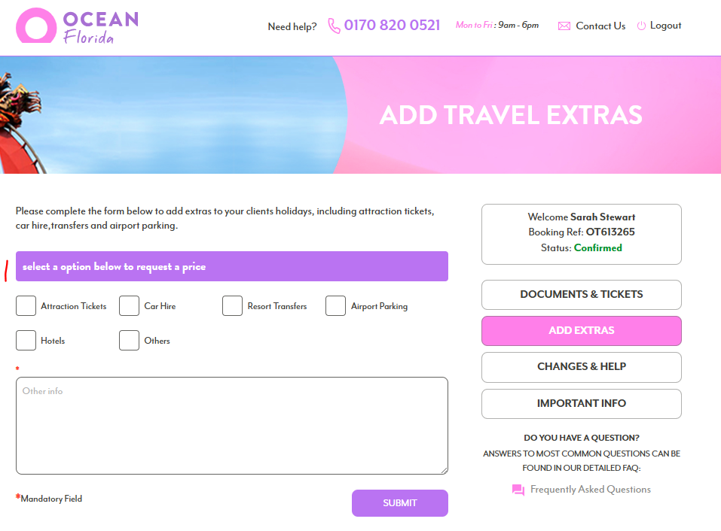

Changes and help
- This should populate the Trade agent/member name
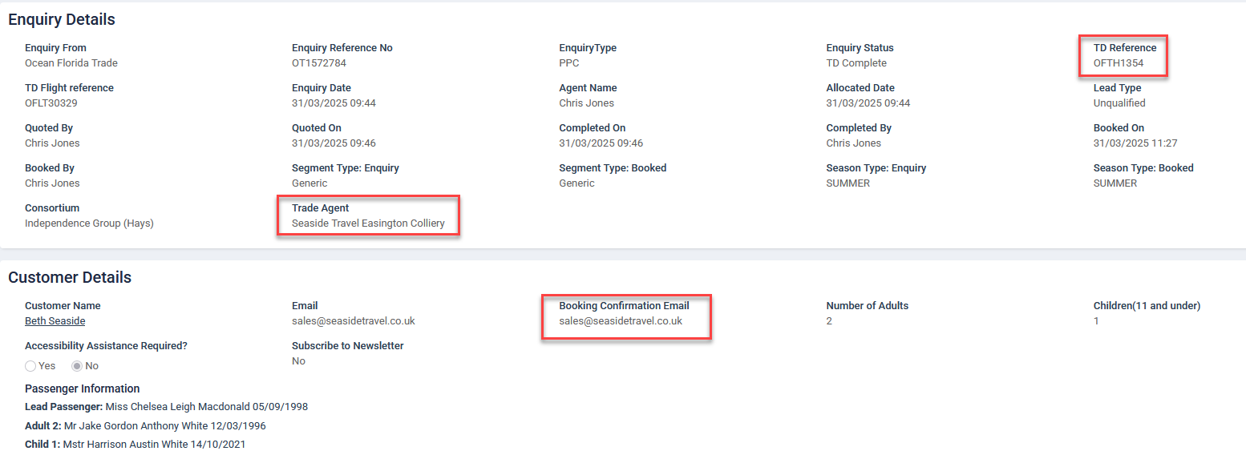
- Booking reference shown please show TD reference and not CRM reference. Please change in welcome box and main field below labelled point 2
- Just to confirm this should use BCE
- Remove phone number field completely
- Details box. Please add some placeholder text in this box:
(This place would be in grey and remove out as the user starts to text in this box)

Please put details we need to know in here, and if you need us to contact you on a different email address let us know in here

