- reference for task - Card SPP2-139 pe attach h... fir bhi missing h ya nhi kiya h toh there is no way to trace and track work
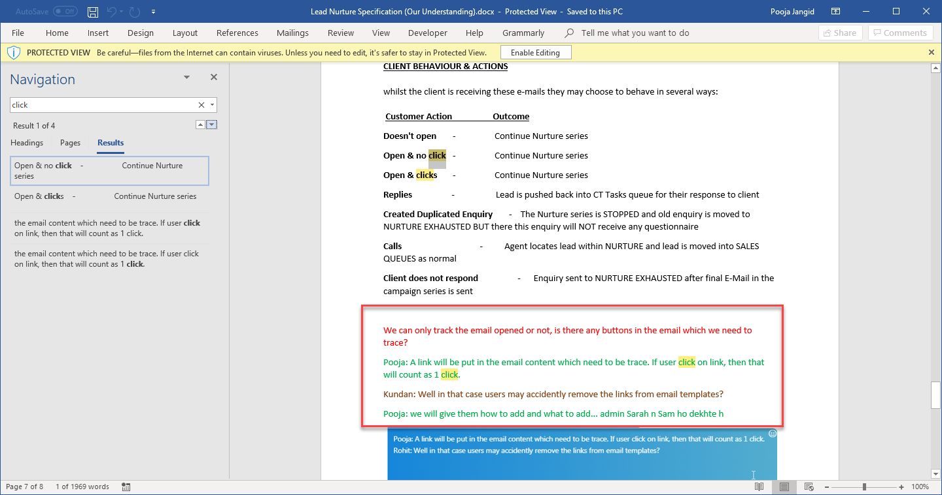

- sample report me Phone lead and Duplicate lead diff colour me show ki hue h - Need to discuss with Satypal.
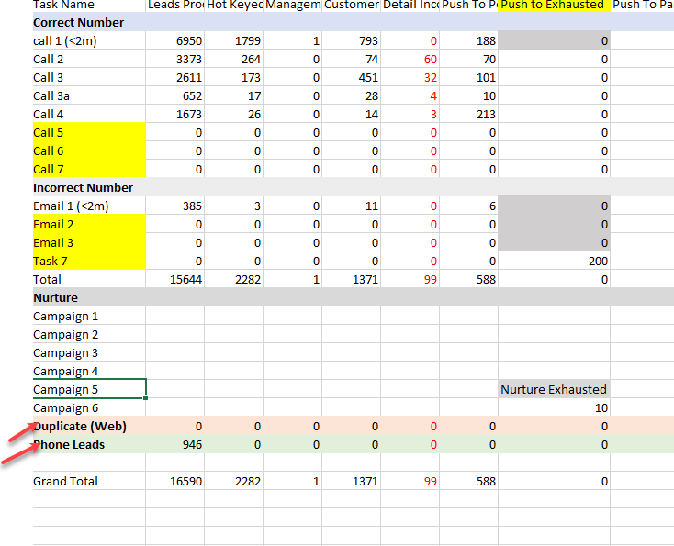

- isme maine 2 total ko red (#fb8888) kiya h.. kyoki ye total me add nhi hote h. so ye clear pata chal jaye user jo bhi dekhe tab.
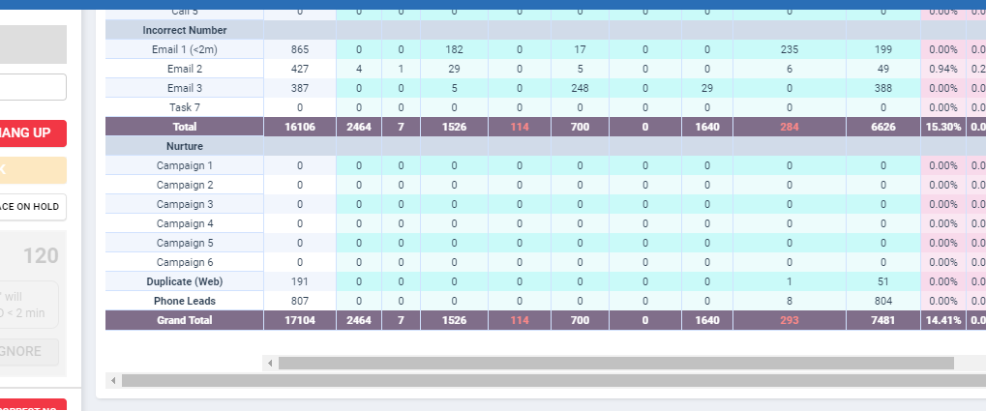

- https://ocean-holidays.leankit.com/card/828977558 - Issue on the card
- Stats may be right but its good to check for reason.
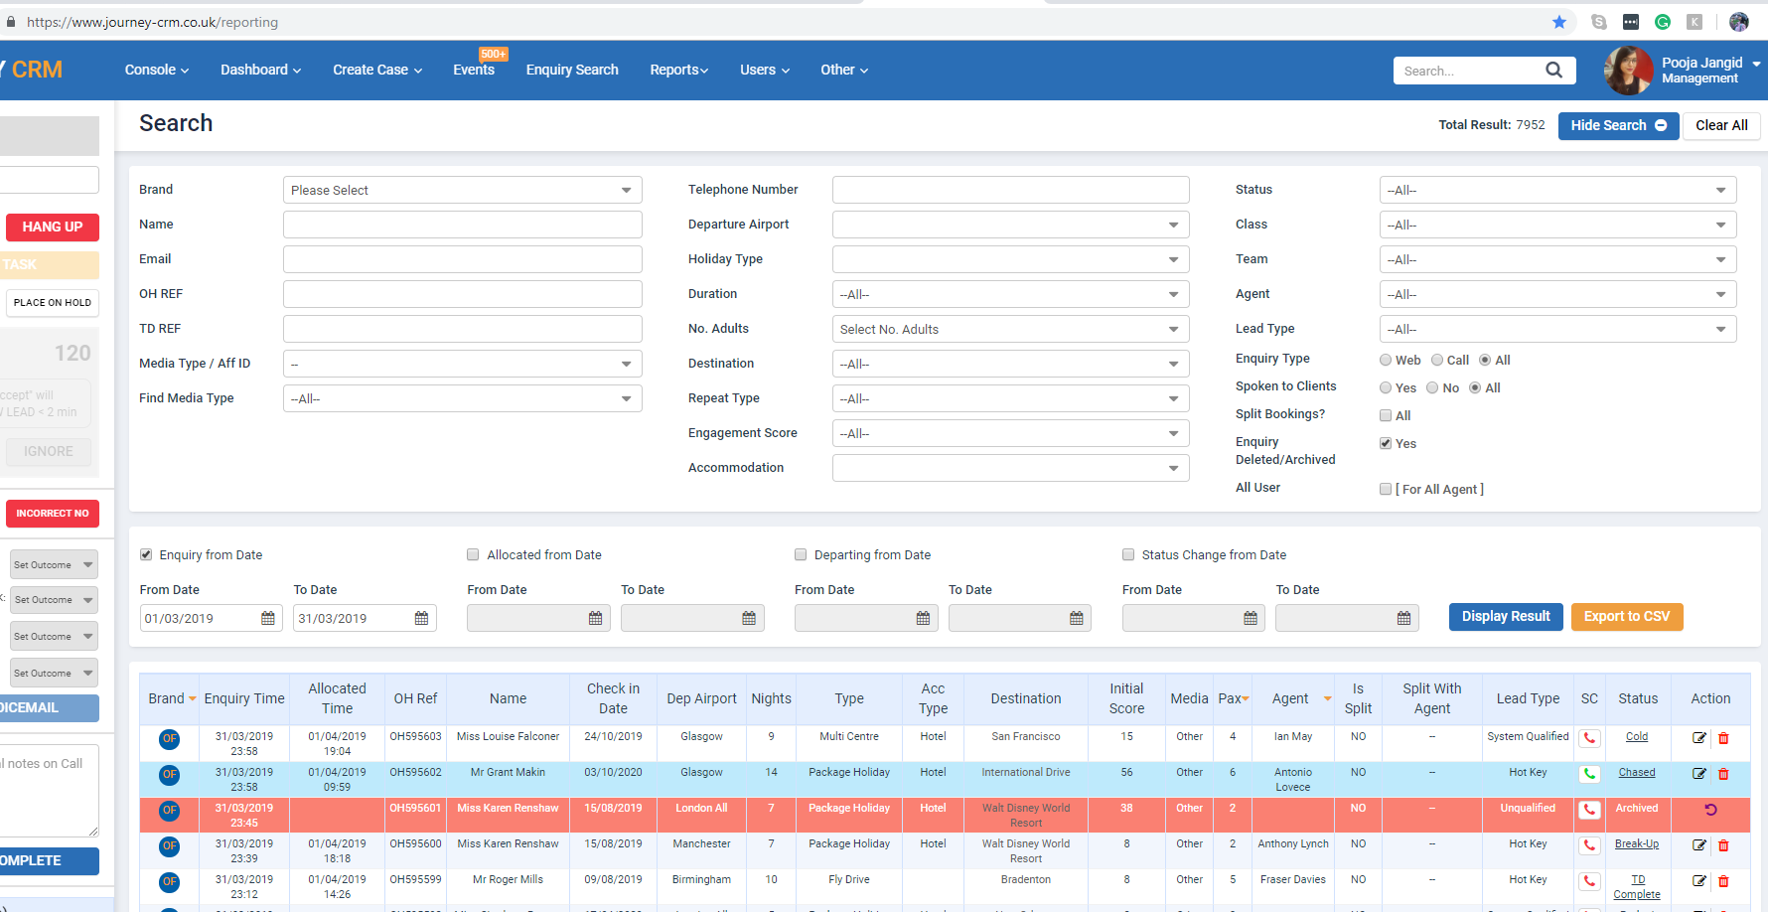
enquiry search - March me enquiry ka count 7952 h./. all phone web and deleted
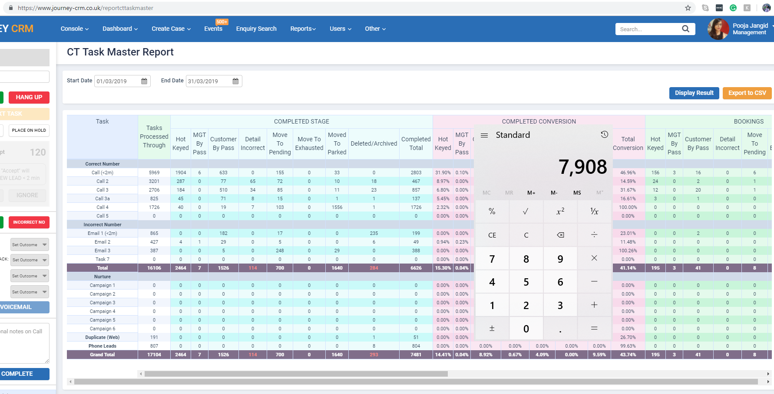
but CT task master me ye different h.. i believe ye same hona chahiye as per new concept.. toh isme kya miss hua h ye dekhna hoga..

- Nurture Scheduler pushing data to mailchimp on OFF subscription - Need to discuss with Satypal.
- March stats not showing anything in MOVE TO EXHUASTED column. I think it should show.

