Offers:

- The numbers do not update when update the filters. (WB-451)
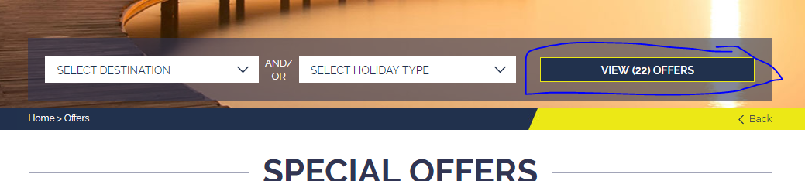

- Please remove the outline in all SORT BY (It was not there before, I think it’s some misunderstanding) Please remove from all property, Itineraries, offers, articles and things to do. (WB-452)
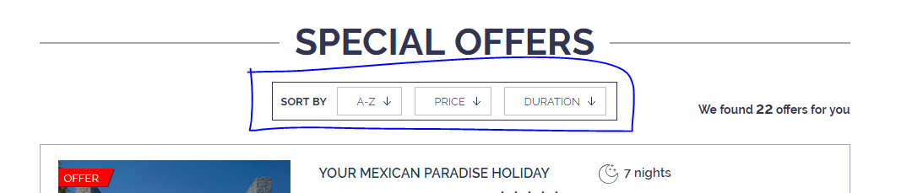

- Please try to flow the same padding all around (WB-455)
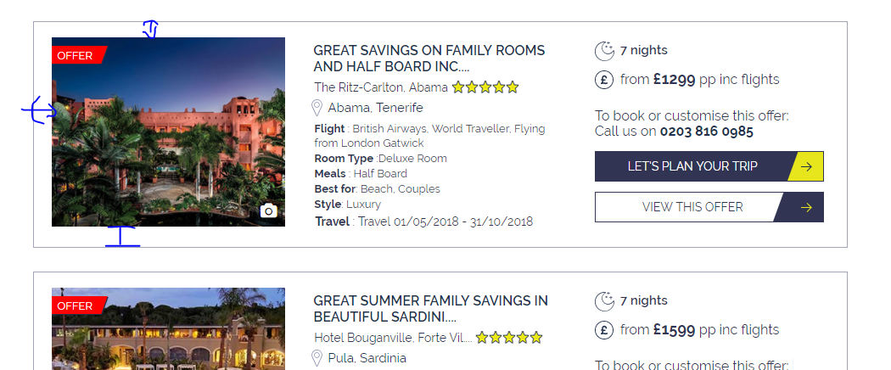

- Align the yellow button (Tab) (WB-453)
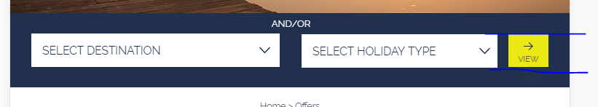

- Some error (Tab, Mobile) (WB-454)
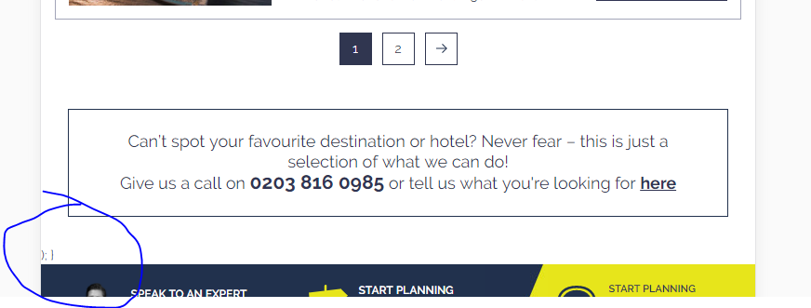

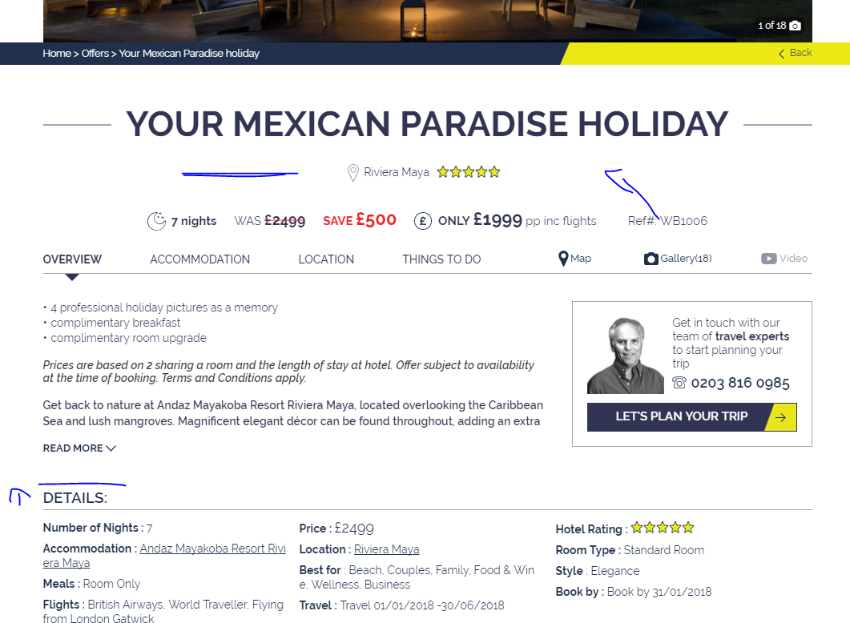

- Design update… Please flow the attached design (all devices) (WB-456)

- Wrong price + Please do not break words in to 2nd line (WB-458)
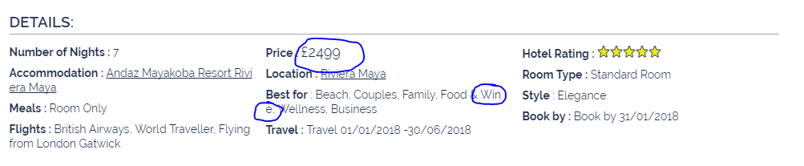

- Align – Dan requested that we made the load more buttons narrower on desktop
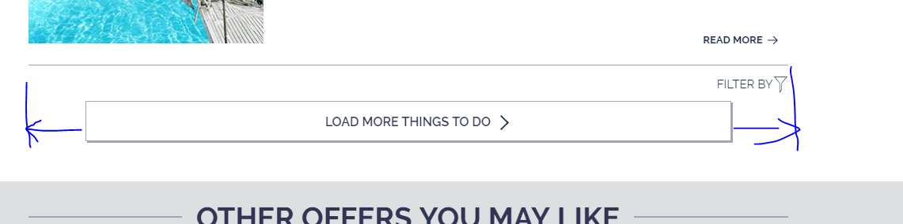

- Align – Dan requested that we made the load more buttons narrower on desktop

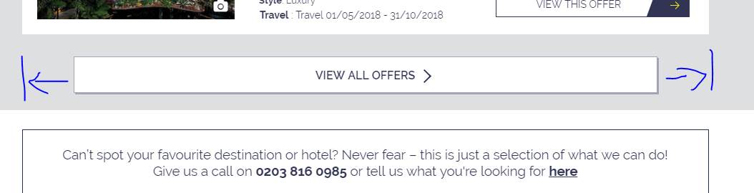

- Remove the extra space – This should be resolved with the design update (WB-459)
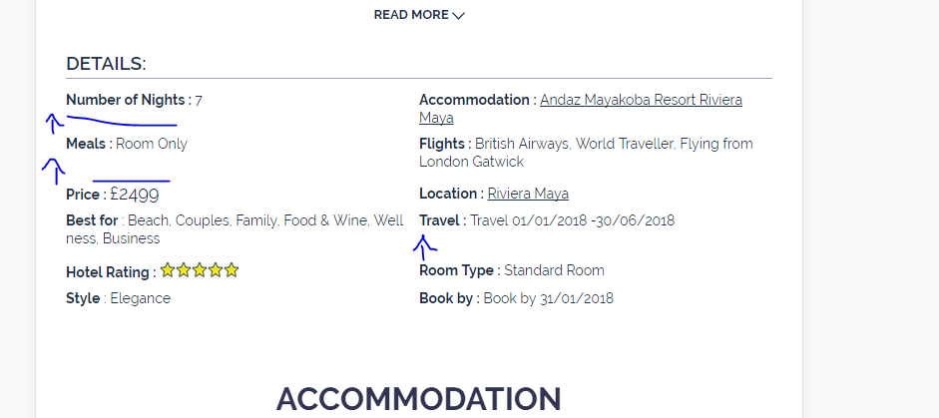

- Line break (WB-460)
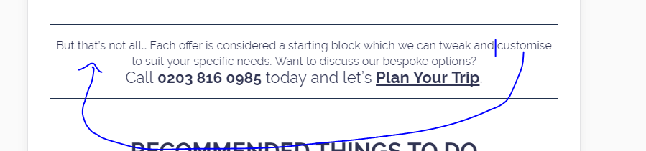

- Please remove the space ( Check the attached design) – should be resolved with updated PSD (WB-456)
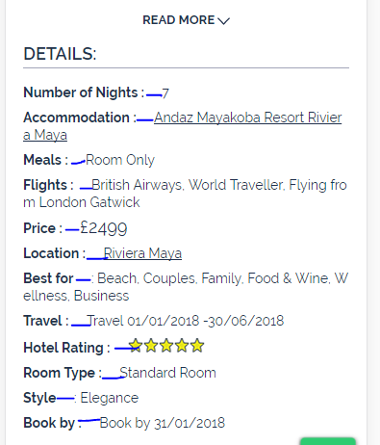

- Add call to action like in the accommodation pages (WB-462)
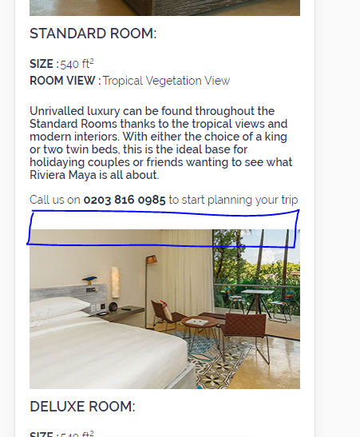

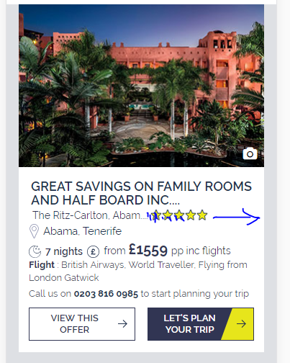
- Use the maximum space available for full hotel name (WB-461)

