ITINERARIES

- Remove outline (WB-452)
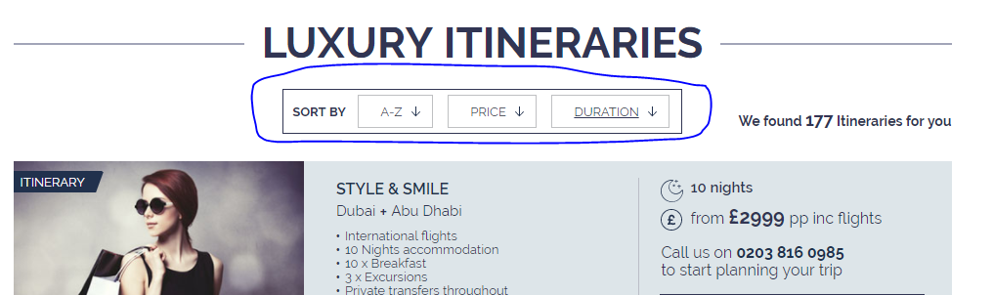

- Please use the same design as the Algolia search ( Do this for all listing, Things to to to property) (WB-463)
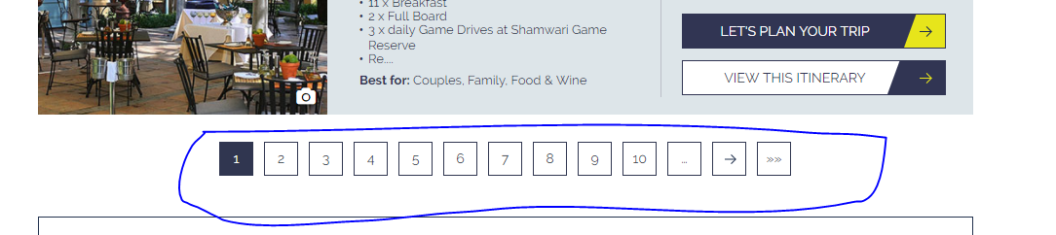



- Spacing (Tab) (WB-464)
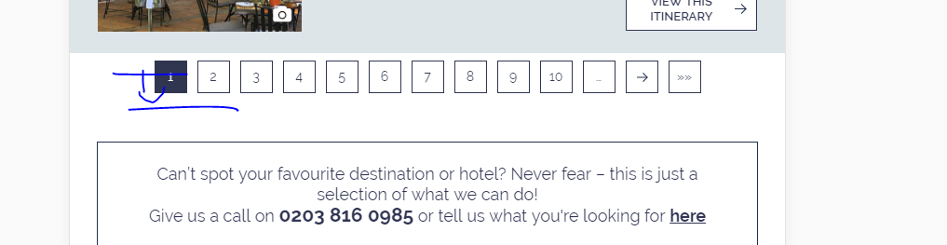

- Make “Best for: “ to 2nd line (WB-465)
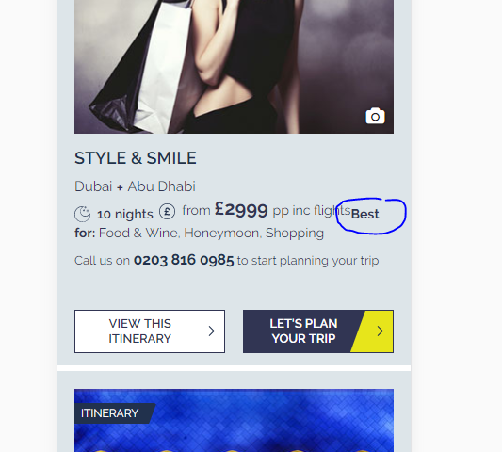

- Design update (Design attached) – I believe the current design works better
Also please talk to Anna about this design update I did some time back ( https://projects.invisionapp.com/d/main#/console/10725761/253740152/preview )

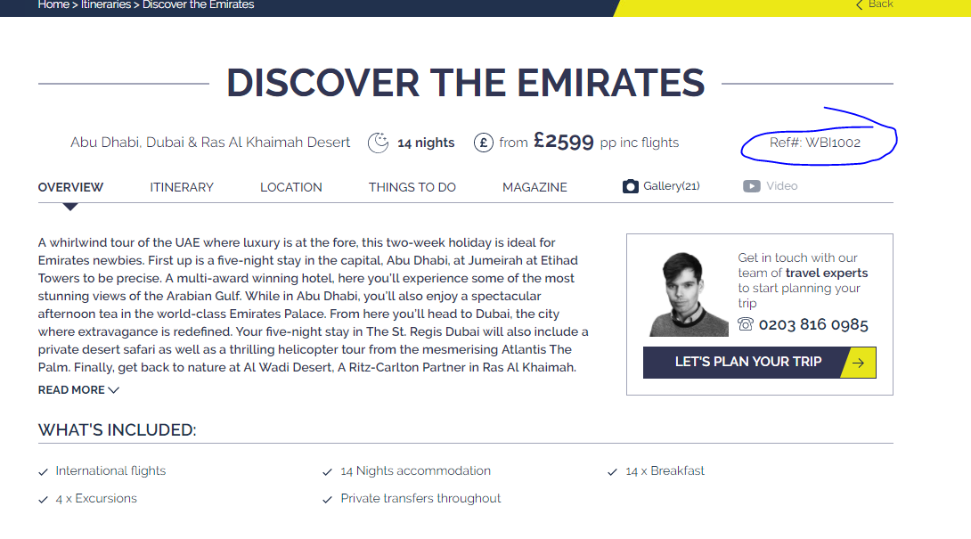

- Make this line bit darker (WB-466)
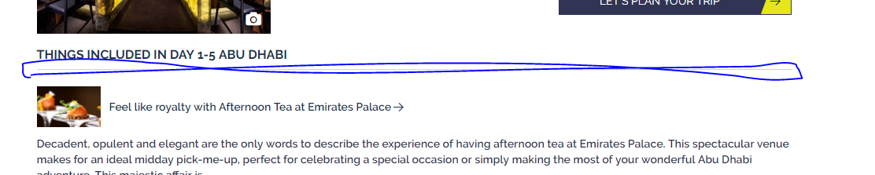

- Make the font 2 point bigger and bold to make it look like a title (WB-466)

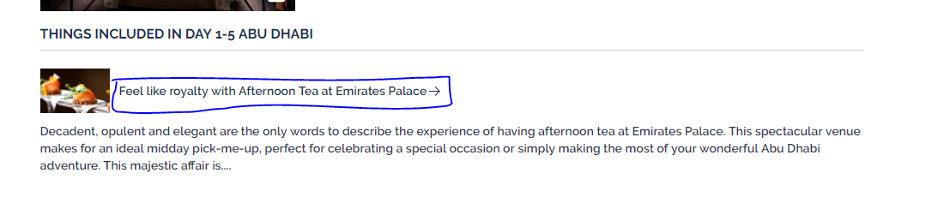

- Reduce margin (WB-467)
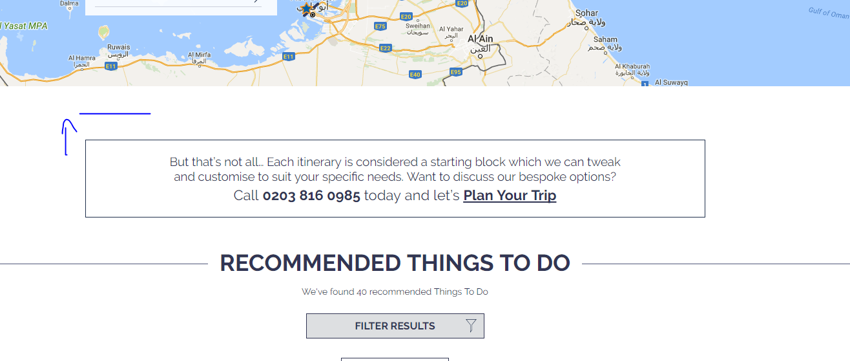

- Align – Dan advised to make this indented
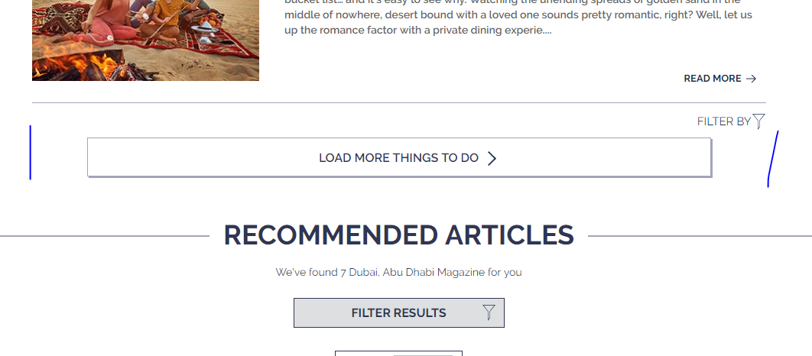

- Align + more margin - Dan advised to make this indented
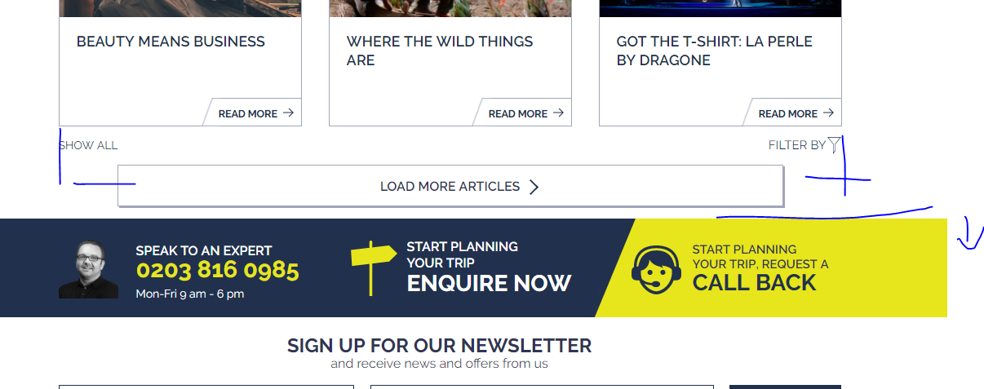

- Spacing (all devices) (WB-468)
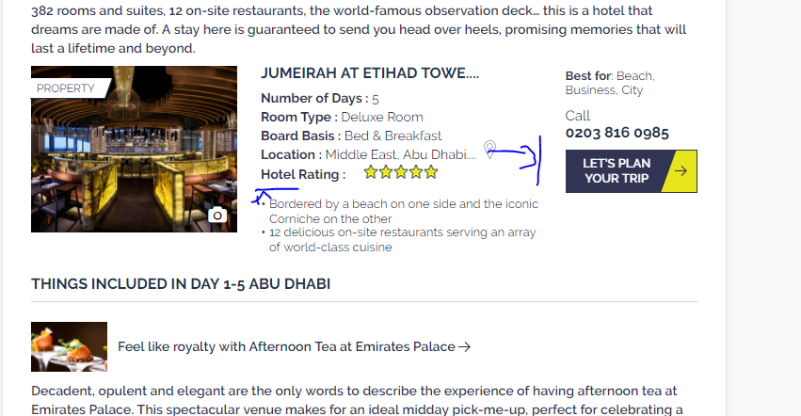

- One line call to action like accommodation listing (WB-468)
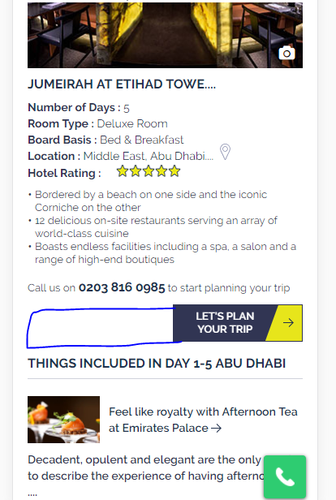

- Please add a break line. (WB-469)
