Ocean Florida Trade – CRM – Development
User Story/Goal
How this brand operates?
Ocean Florida Trade operates in quoting ‘Trade Member Agents’ holidays, who then pass on quotes to their customers. We don’t deal directly with a customer as will always quote and book via a Trade Member Agent.
Currently the Ocean Florida Trade team don’t work from a CRM. They work from an email inbox and do all quotes via there. When it comes to bookings, they add them directly onto TD via the Trade member profile.
We now need to automate their processes to allow for future growth, so we want to have them join the CRM under a new Brand.
Features within the CRM will try to be consistent with the other brands, but there will be some differences due to how we receive enquires/how we quote/book. All of this will be outlined below.
CRM Core Functions:
- New CRM Brand
- Create Trade Client
- Managing inbound emails to CRM
- Create Enquiry – Phone and Web Leads
- Create Quote
- Book Now
- Queues and rules/G2B Statement List
- Enquiry Search
- G2B Booking/Send to client to confirm
- TD Load
- Product cases (TBD)
- Flight cases
- CSB
- Amendments
- CMS Admin
- Reporting
- Big Query
- CMS – Add Consortium
- Domain

Tasks

1/. New CRM Brand/Module/User Role

A new Brand to be added to Journey CRM called – Ocean Florida Trade
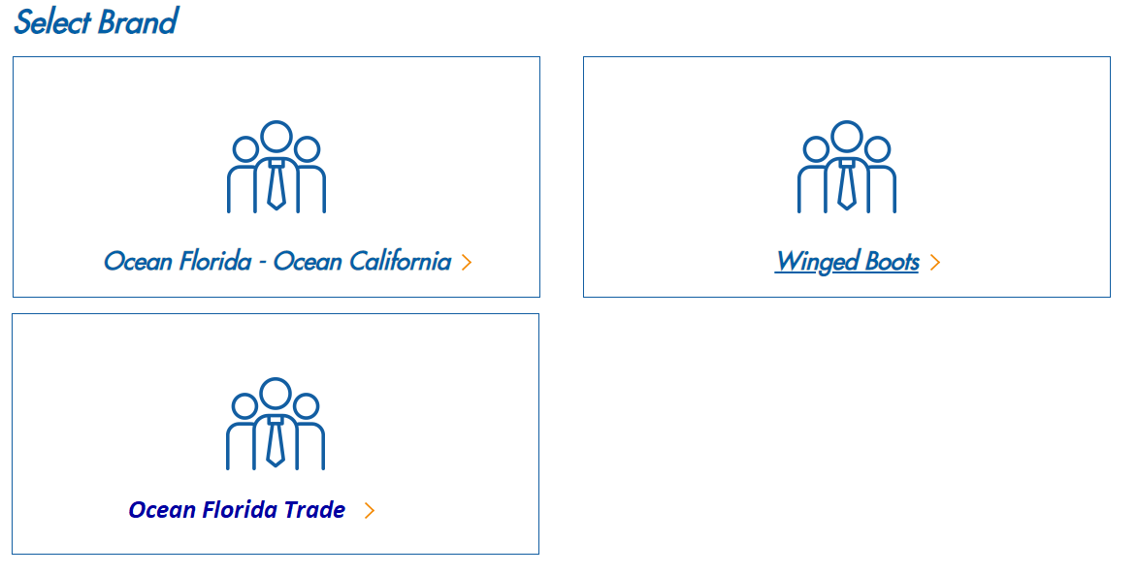
OFT brand will have 3 modules
- SPP Sales
- Customer Service
- Product System
- Flight System (part of OF/OC brand so it will not show to OFT users)
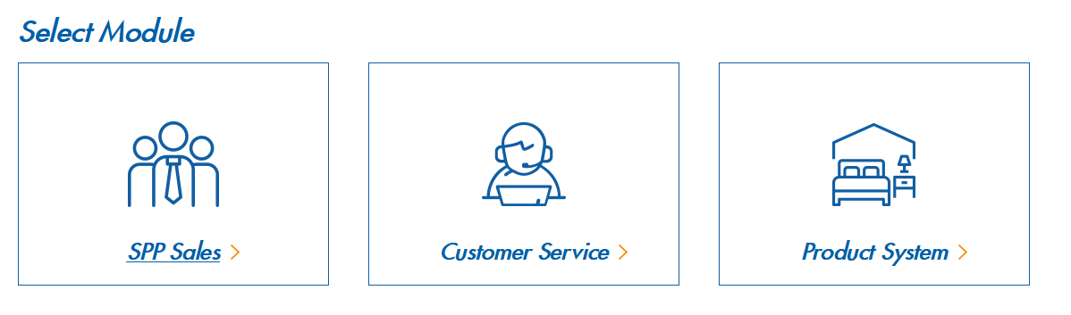
OFT brand will have 3 user roles
- Management
- Agent
- TD Load Team

OFT CSB will have two roles:
  - Management
  - Agent
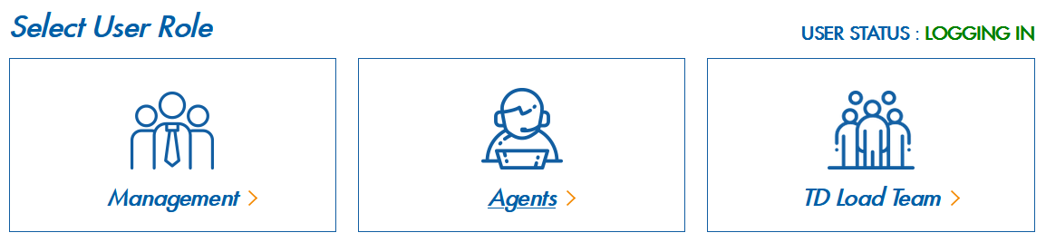
Brand identifier in CRM:
OT leads in the CRM will be shown as per below.
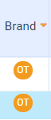
DS Reply - This will manage by Orange color or will manage by different color. Please suggest Orange it is
2/. Create Trade Member
Add a new menu option for Trade Member user.
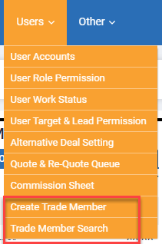
Create Trade Member:
This will have below fields:
TD Membership ID – This information will be put from Top Dog and will be used in the auto load booking process to load client profile. This will only accept number.
Association Code: This is free textbox which can accept both character and digits.
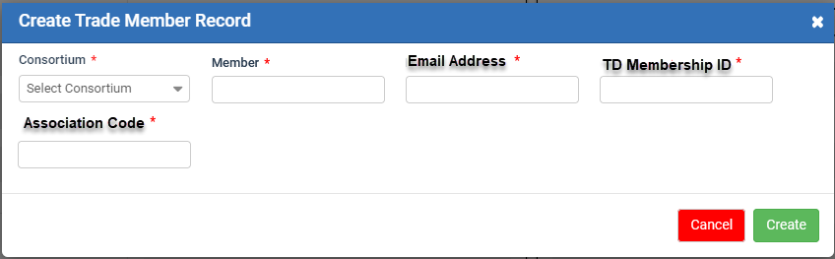
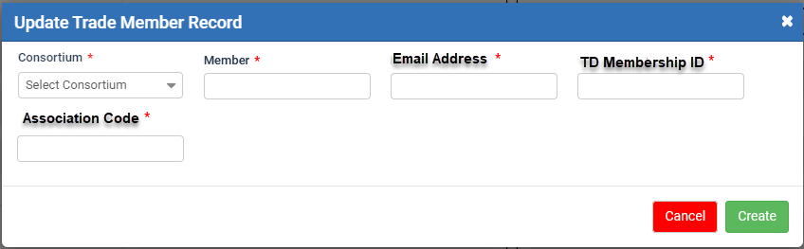
A user can search trade member from below form:
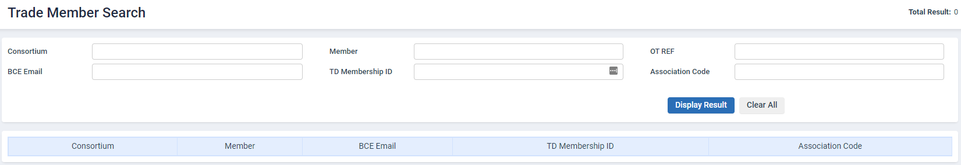

Trade Member record: This will be like ‘Corporate client’ record of WB brand but with limited information. All the enquiries will be connected to trade member record.
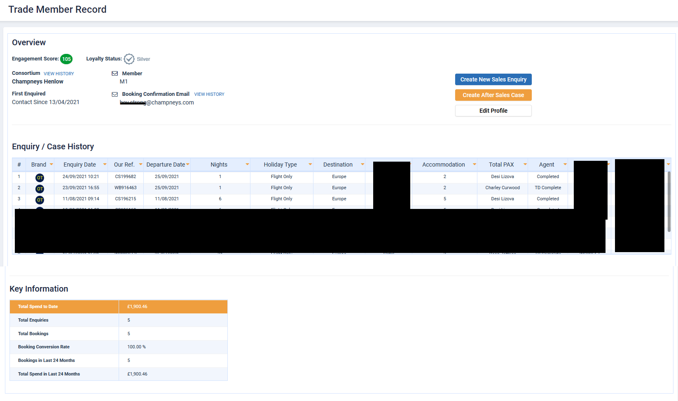
DS Query – we understand the Trade Member Record, but how will we manage the actual contact record which links to the enquiry. For instance, in WB it is termed as Leisure Contact Record
Below fields are mandatory on the enquiry form and making changes on DB for not making this mandatory will be a big change and will impact the CRM. So to get this done, can we get these basic details by putting some default values when a new enquiry is created. Once the contact is created, details can be pulled from there, but on the initial note, we will require these details.
- First Name - TBA
- Last Name - TBA
- Holiday Type – TBA (brand specific, will not be shown in any other brand and will not be shown in other segments)
- Departure Date - today
- Departure Airport – TBA (need to be added in CMS for this brand only)
- Destination - TBA (need to be added in CMS for this brand only)
- Duration – 1 night
- Accommodation type - None
Creating a contact is also required, so we will require atleast the ‘First Name’ and ‘Last Name’ for the trade agent
When we create a contact record, the name will be <first name TBA> <last name TBA> and email address is fetched from the trade client inbox.

3/. Managing inbound emails to CRM
We will be adding a new email inbox which will be having all the email copies of oceanfloridatrade@ocean-holidays.co.uk.
New email address: oceanfloridatrade@oceanholidaysmail.com
NEW Queue
- CRM will read the inbox and create enquiries in the CRM which will land in NEW queue.
DS Reply -
We assume if new lead is generated in the CRM against the existing contact, then duplicate lead rule will apply for the same contact? No, every time a lead comes from the same contact, it will go on the new queue
Email body text will be added in Sales Conversation section just like we have for PS trade client. It will show the subject line at the top. (use Sales module design here, below is just a mock-up)
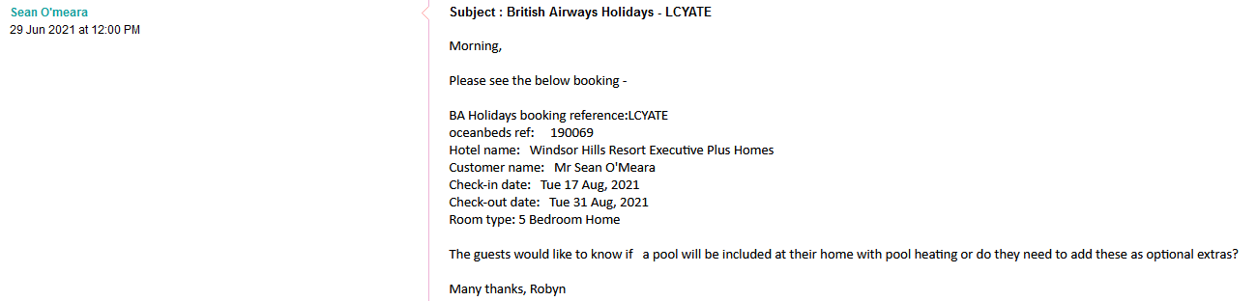

All the enquiries landed in the NEW queue will have different action next to it.
- Edit
- Link (this will open a pop-up)
- Delete
Link pop-up mock-up:
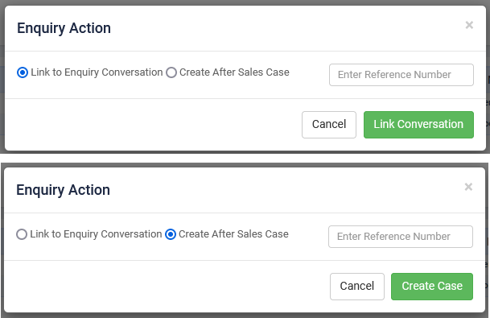
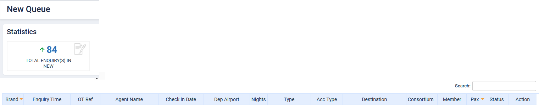
Link icon on NEW queue-
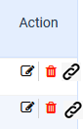

Edit New Enquiry:
When a user edits a new enquiry from NEW queue and save after completing all the mandatory fields then that enquiry will move into Pending queue. A record will be added in the timelines.
Action Enquiry:
- Link Conversion
If a user decided to link that enquiry information as a conversation for existing enquiry, then user will put OT reference (can’t be from NEW status – show an error message if its NEW enquiry ref) in the textbox and click on link conversation button. This action will add the conversation associated with current enquiry to OT reference which added by user.
If email address doesn’t match with OT ref enquiry’s email address, then on Enquiry Reference textbox change event, it will show below message to user
Both enquiries have different trade agent email addresses. The system will add new trade agent email address <current enquiry email address> under the conversation recipient list of <OT reference>. Please make the required changed on the enquiry <OT Ref> manually after linking conversation.

Example:
Original enquiry belong to Agent Sarah
New enquiry belong to Agent Matt
If trade agent Matt enquiry’s conversation will link to trade agent Sarah’s enquiry, then both will have different emails. Further communication should be sending to both trade agent Matt and Sarah.
A notification will send to owner (OT agent) of the enquiry (OT ref added by user) and auto forward concept will apply here as well just like we have in other brands.
Auto-forward team manager address: oceanfloridatrademanagers@ocean-holidays.co.uk
If email address doesn’t match with OT ref enquiry’s email address, then it will show on that enquiry as per below design under the conversation recipient list.
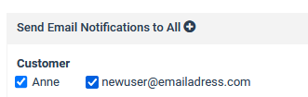

- Create Case
When a user decides to convert a NEW enquiry into a case then user will put OT reference for which he/she wants to create after sales case (can’t be from NEW status – show an error message if its NEW enquiry ref) and click on create case button.
When an agent clicks on link case then create case pop up will open with details of OT reference added by agent. Agent can complete the rest of the form and create a case.
OT brand will use same enquiry nature and type as OF/OC
Current enquiry’s conversation/email body text will be added into CS note section.
4/. Create Enquiry – Phone and Web Enquiries
Phone: Any enquiry which is created from the CRM (Create New Enquiry), will consider as phone lead if OT agents are adding it.
Web Leads: Any enquiry which are coming via email inbox, will be considered as web lead and if a MGT user creates an enquiry then that will be considered as web enquiry.
** Lead Type – All enquiries will be categories under Unqualified type
OFT enquiry form will look like below-
** Customer Quote section will not be required for OFT.
When a user will select Consortium then member will bind accordingly.
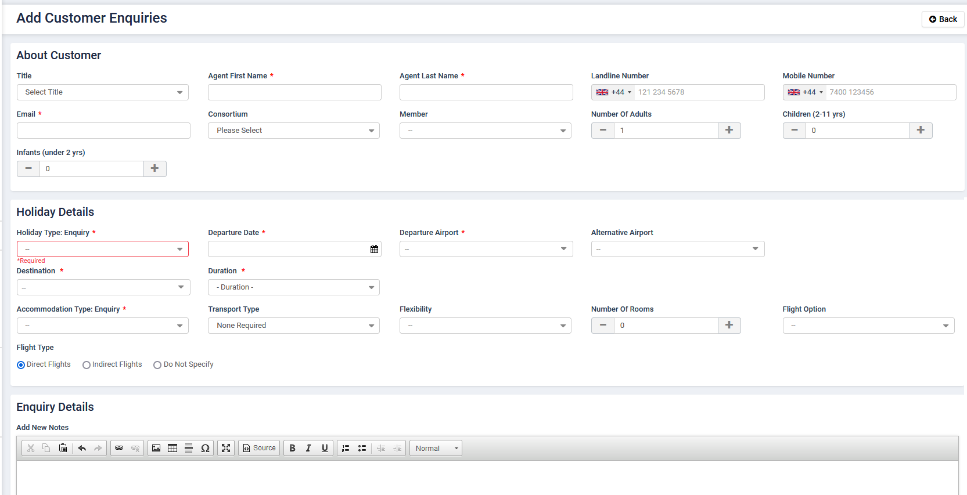
DS Reply -
If the same Trade member’s enquiry is assigned to another agent, a pop-up will show that the enquiry is already assigned to an X member and is in this queue. Will this be the same for OFT? Yes
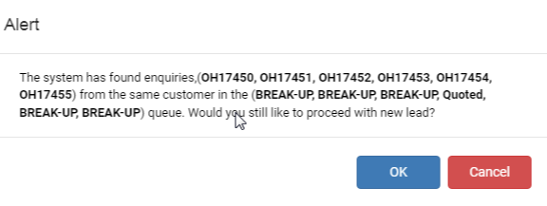
5/. Create Quote
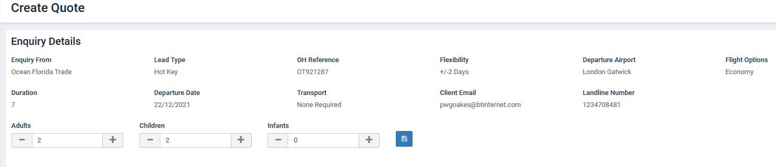
Template:
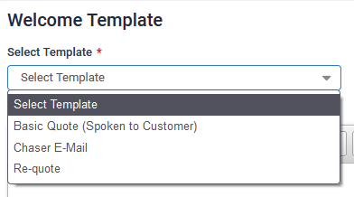
Manage from CMS (SPP Template section https://www.journey-crm.co.uk/Admin/ManageTemplate

SPP quote form will be same as OF/OC.
Hold Name will not be required for OFT brand.

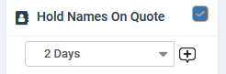

Email preview:
- No Links will be added with products
- Change the timing
- No quote footer
- No closing text in the footer section
- Added new section called BOOK NOW
- Added Quote Number below to Quote reference: This will be the number of that quote/requote, e.g when an agent sends his/her first quote then number will be #1 and on second #2 and so on.
- Remove below section:
- 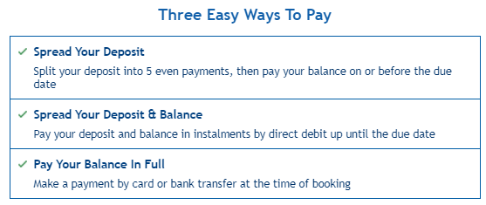

banner from the bottom

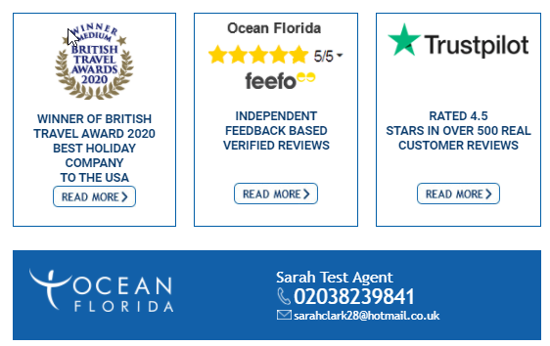

OFT Quote Template sample design:
‘Your Itinerary and Cost Overview’ section will changed as per below mock up and rest of the quote design will remain same.
Please make sure that when you copy the text within that box into word doc or outlook email then it should be pasted as normal text, not as table, which means, all the information of that box will be under 1 td tag for email design and responsive can be managed accordingly.
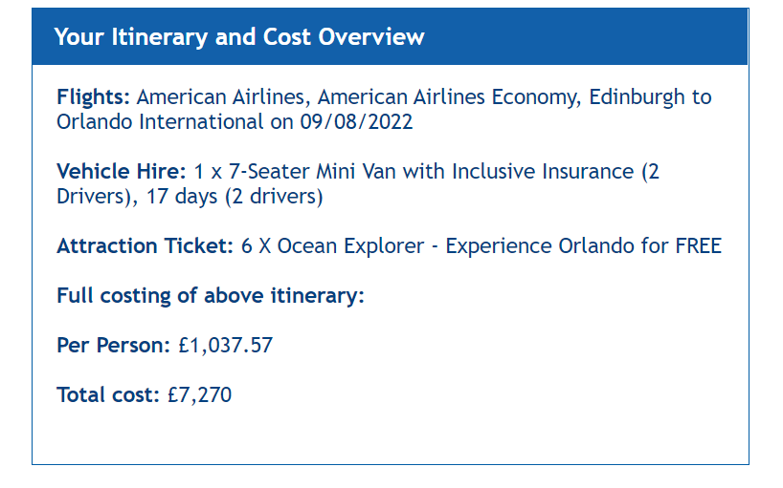

Sample quote design. Changed areas are highlight below.
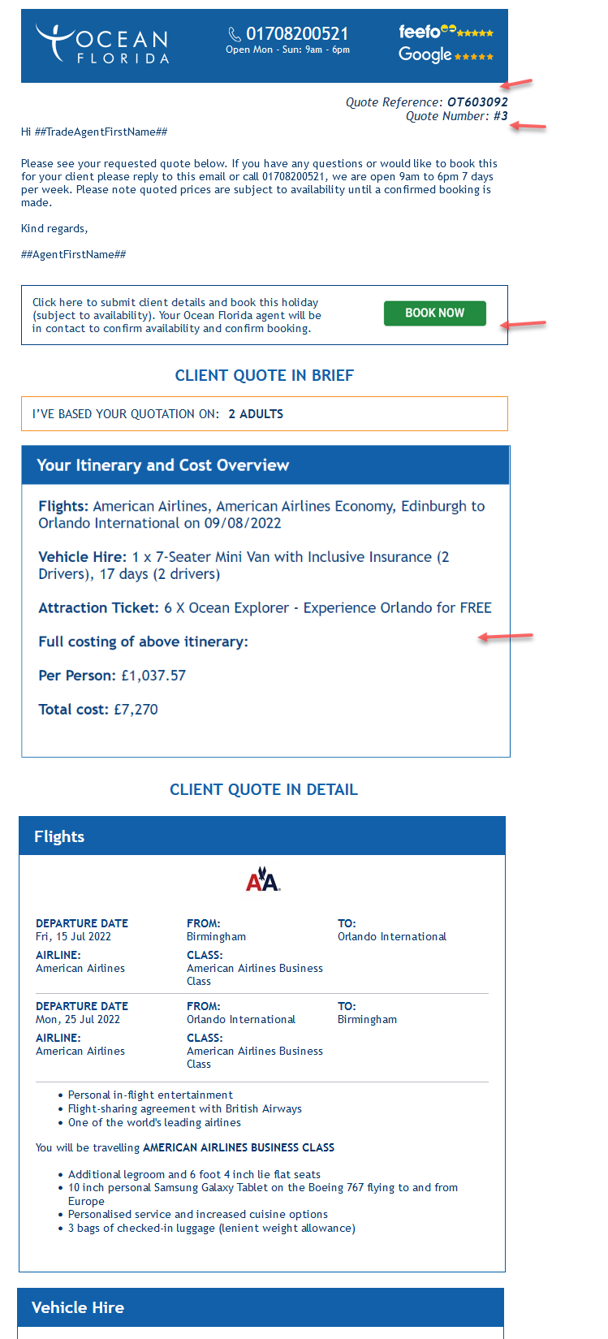
6/. Book Now
Please correct the spelling of ‘availability’ in the below content.
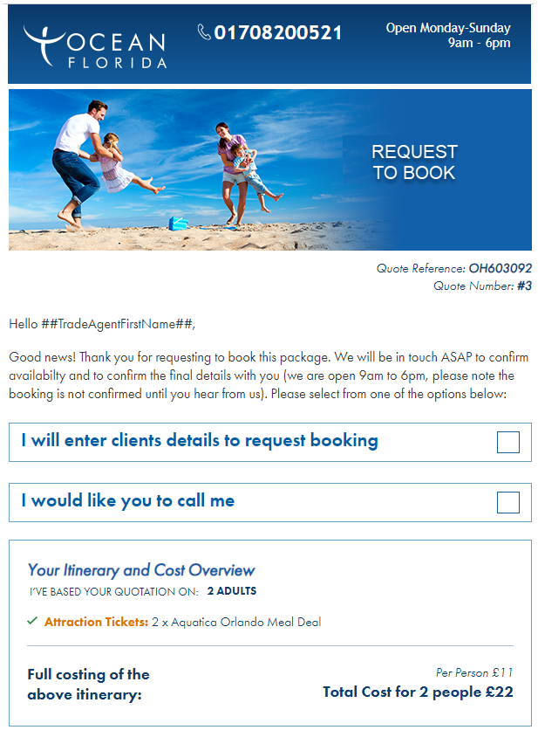
Customer Details section:
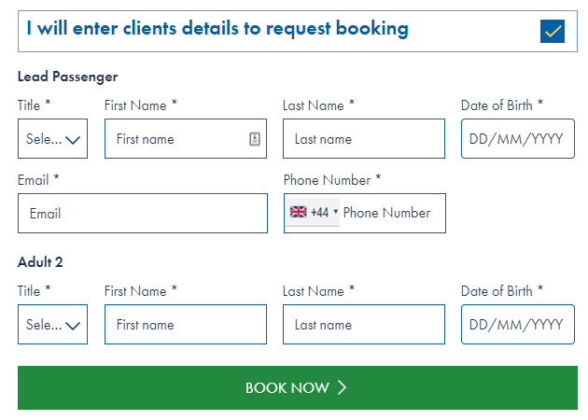
DS Reply – In the G2B quote form, it is mentioned that we do not need Twilio API formatting. So just to confirm the same here as well To be done as it is on G2B form
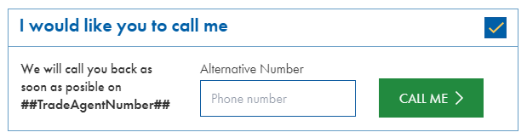
7/. Queues and rules:
- A sales agent can use auto allocated button feature only if Allocated queue is empty of that user. REMOVE
- A sales agent can only move a lead in to complete state (Quoted, Chased, HOT, COLD, Break-up, Parked) when a basic quote has been sent on it. REMOVE
- A sales agent can’t move a lead into Chased status until a chaser template is sent on it. REMOVE
- A sales agent can’t move a lead back to the allocated queue, only MGT users has these permission. REMOVE
- A sales agent can move lead into In progress and after 12 hours that lead will move back to allocated queue keep
DS Reply -
- Conflict points 2 and point 5. Need to discuss. Point 2 remains as is and Point 5 has been amended
B) Need to discuss on ATM process if we are removing conditions from the queue. No
- A sales agent can’t move a lead directly in booked state like (TD LOAD, TD COMPLETE, Awaiting Confirmation, Committed and TD Error). These states can only be managed through G2B quote. keep
- A sales agent needs to add some alternative on SPP quote but this will manage via CRM permission so we can manage this rule through CRM directly. REMOVE
- A sales agent can’t use bulk chase and break up with Email and SMS keep
- A sales agent can’t send a conversation/SMS/Quote to any customer/trade agent until lead is allocated to him/her. REMOVE
- A sales agent can search their own lead through Enquiry Search. But if they use Name, OH Reference, Email and Contact number field then system will look up in entire database and show the result to agent, irrespective of to whom that lead is allocated and what status of that lead is. Want any agent to see all results
- A sales agent can look up for any contact via contact search record section yes

Please compile a list for the user permissions as per this document

8/. Enquiry Search
Below search have few new fields and some are removed. This will work on same concept as OF brand.
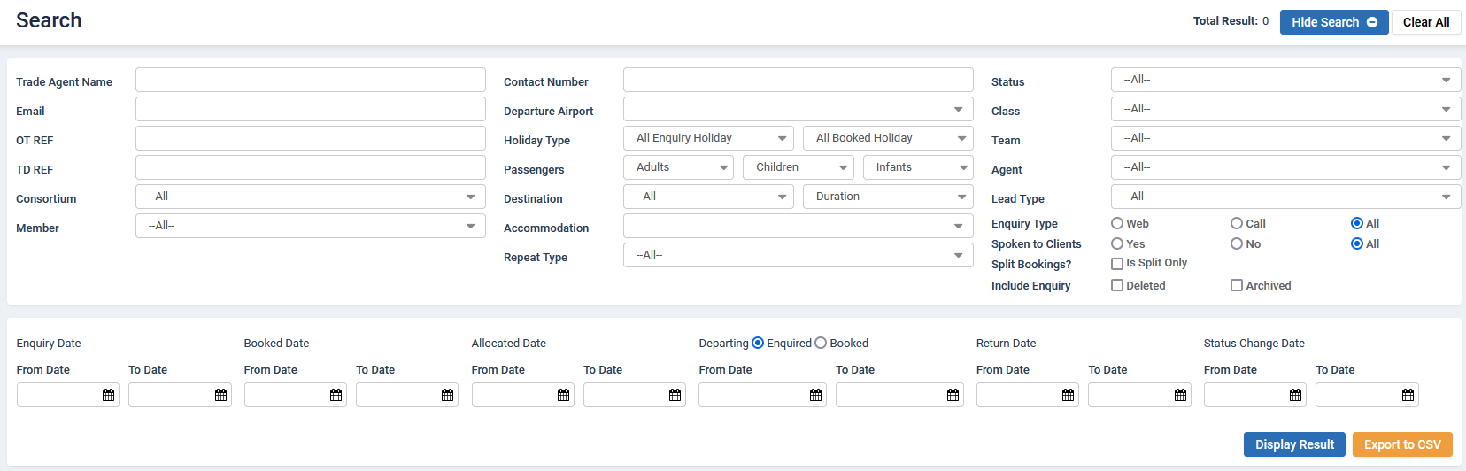

9/. G2B Booking/Send to client to confirm
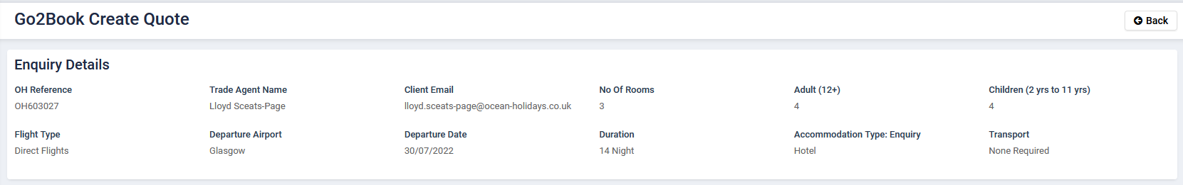
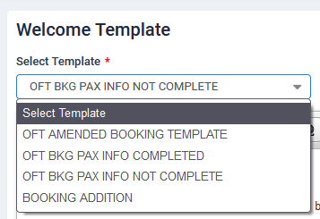
Passenger Details:
This form will also show trade member email address next to BCE email address.
When user select the Lead Pax then it will show 2 more field for that passenger. Lead Pax Email & Lead Pax Phone Number. Both will be optional.
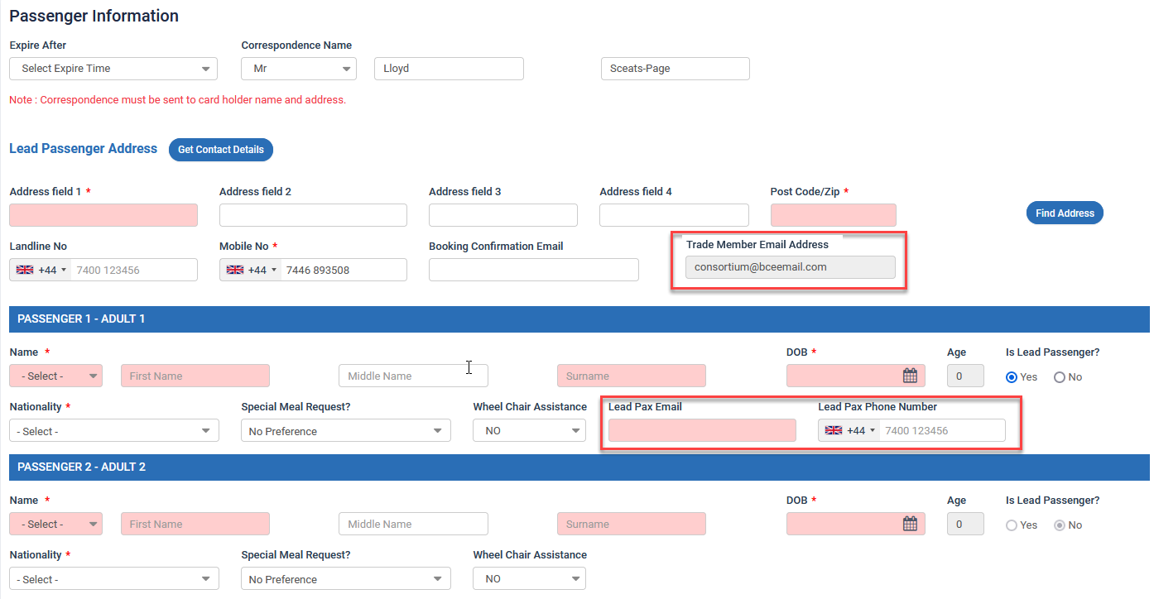
** Lead Pax Phone Number – this doesn’t require to use Twilio formatted text box. Please use normal textbox. Only allow numbers but doesn’t need to be validated.
Deposit:
Deposit/Rule will be managed in the CMS as same as OF brand.
Deposit option on G2B pricing tab will only show Invoice.
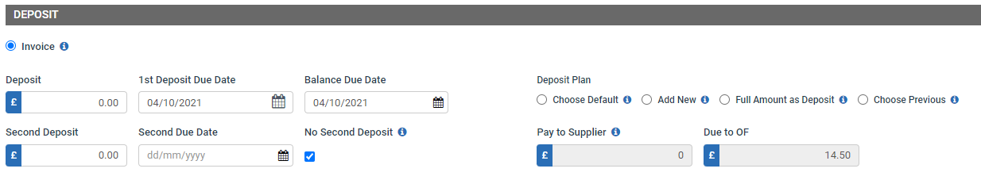

Send to Client to Confirm:
This button functionality will change for OFT brand.
When a sales agent sends G2B quote to Trade agent via Send to Client to Confirm button then booking will move into Awaiting confirmation and below steps will be followed –
- Trade agent will receive email in same format as OF.
Subject Line: ##OTReference## - Complete Your Booking
Content:
Hi ##TradeAgentFirstName##,
Your booking is almost completed, there are just a few simple steps to get this done.
1. Check through the passenger details and ensure they are correct. Once submitted they will be the exact details used to finalise your reservation.
2. Complete any missing passenger information
3. Tick the checkbox to confirm you have read the terms & conditions
4. Select ‘COMMIT BOOKING’ to secure your holiday
Please click the following link where you will be prompted to provide any missing data: Click Here
You will need the following reference to access your details: ##OTReference##.
Once your booking is confirmed, you will receive a confirmation e-mail, usually within 24 hours. If you have any queries whatsoever or if you prefer to complete your confirmation on the phone, please call us on ##OceanAgentTelephone##.
Kind regards,
Pooja Jangid
##OceanAgentTelephone##. (01708200521)
Note for developer: Token are used for give idea what value will bind here. Please use same token values which we use for other brand to keep the token name consistent. Number added in the signature is just for sample and will not be added in the actual email.
Trade agent will login into web portal to complete the information using email address and OT reference.
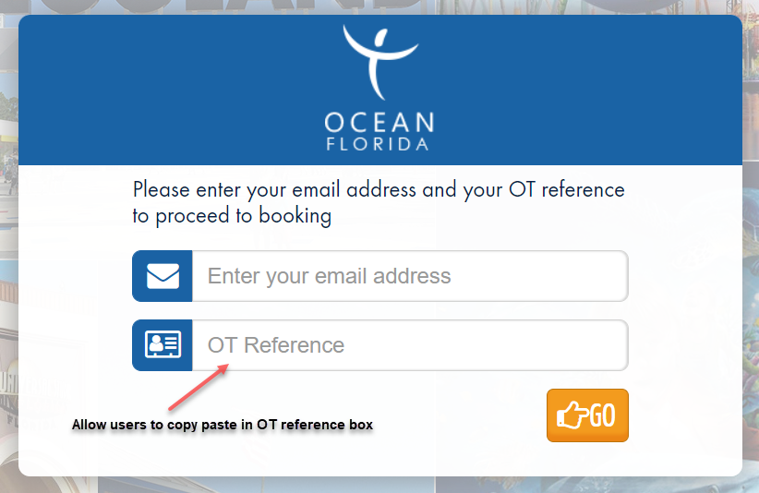
Welcome Portal screen after login:
Content:
Hi ##TradeAgentFirstName##,
Your booking is almost completed, there are just a few simple steps to get this done.
1. Check through the passenger details and ensure they are correct. Once submitted they will be the exact details used to finalise your reservation.
2. Complete any missing passenger information
3. Tick the checkbox to confirm you have read the terms & conditions
4. Select ‘COMMIT BOOKING’ to secure your holiday
Once your booking is confirmed, you will receive a confirmation e-mail, usually within 24 hours. If you have any queries whatsoever or if you prefer to complete your confirmation on the phone, please call us on
##OceanAgentTelephone##.
Kind regards,
Pooja Jangid
##OceanAgentTelephone##

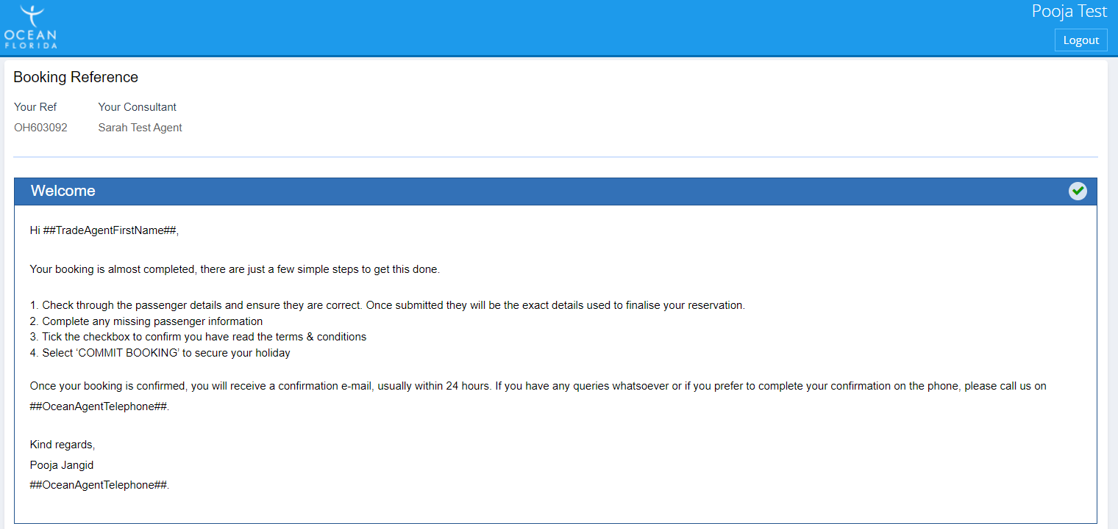
Passenger Section:

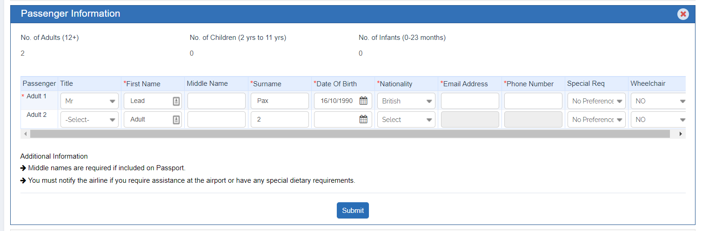

- Remove Address section
- Remove Lead Pax detail section
- Added Email Address and Phone number columns in the pax grid which will only be enabled for lead pax and will be read-only.
- In Additional Information, we change 1 statement (please be informed that if middle names are…) to ‘Middle names are required if included on Passport.’

Rest of product sections will show as same as OF brand along with the additional information statement.
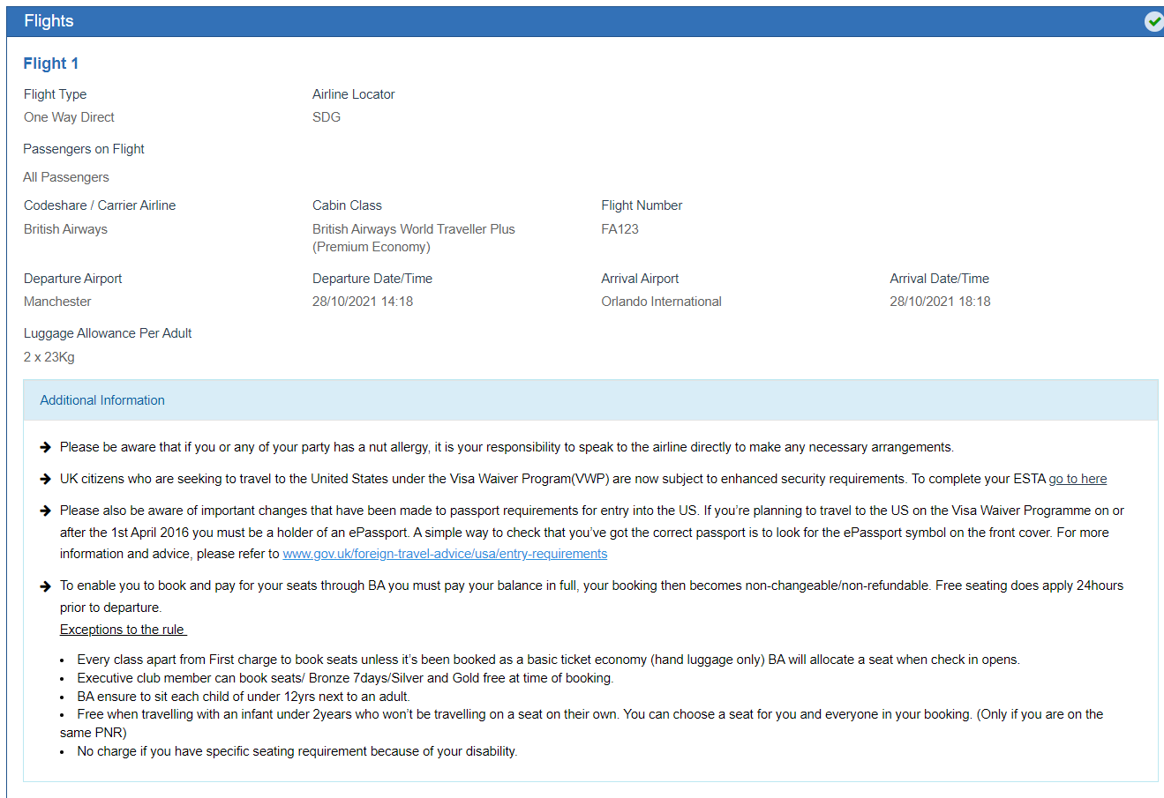
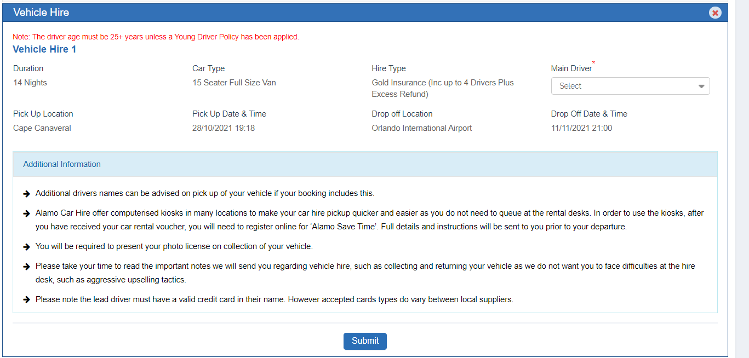
Pricing section:
- Added a new statement for the deposit. This is mandatory to tick before committing the booking.
- Today’s Deposit changed into Deposit Due

Pooja will discuss this with Steve if we can share T&C on public link without compromising on the security.
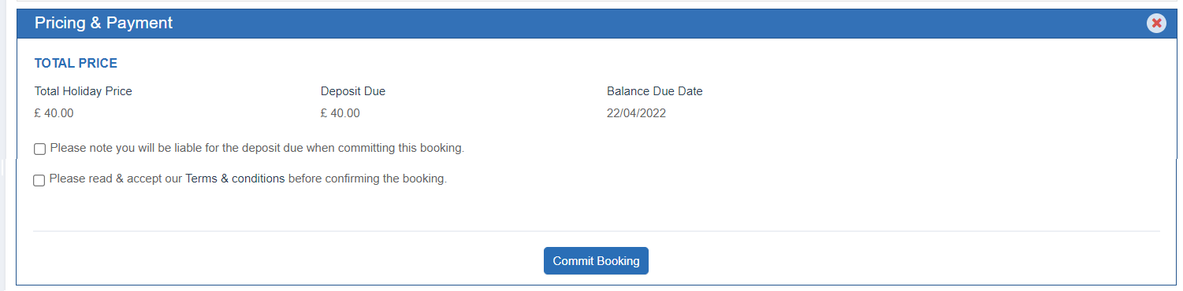
Thank You Page:
Content:
Thank you for providing passenger details
Your reservation is almost complete and we will be in touch once we have confirmation.
Thank you for choosing Ocean Florida
##OceanAgentFullName##
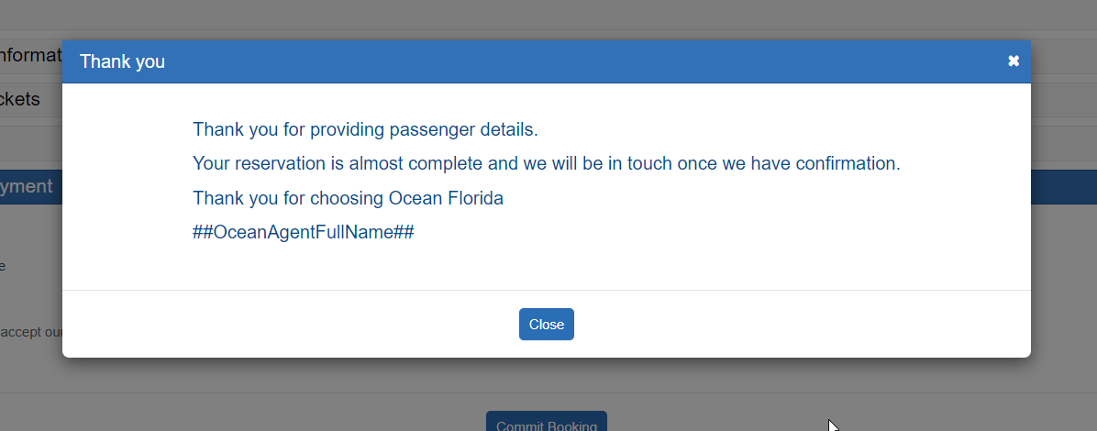

- Trade agent will commit the booking no email will send here.
- As soon as they commit that booking will move into TD LOAD state and no email will send at this stage as well.
- Booking will not pass-through Committed queue. No payment will be taken.

10/. TD Load
All the OFT bookings will be loaded on a new retailer (Ocean-Florida Trade).
TD reference prefix: TOF
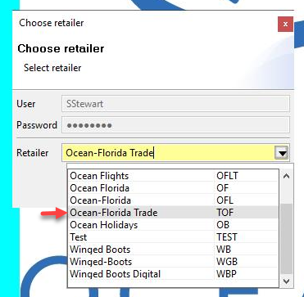

This retailer will work like corporate client of WB brand
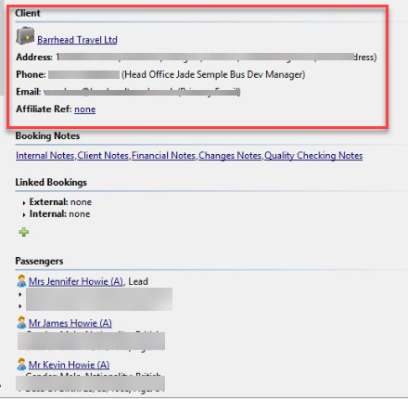

All the bookings will have consortium and each consortium will have a unique TD membership ID. So, whenever a TD Load user load a booking into TD then it will on Ocean-Florida Trade retailer and client profile will have the TD Membership ID. Trade Agent name and email or any other details relating to this, will not push into TD. Passenger which are added on the G2B form, will push under passenger section.

11/. Product cases
Implementation should be as per OF/OC
All the OFT PS cases will show under PS case and team need to login into OFT brand to access these cases.
DS Reply: As discussed with Pooja and Shubhang, the approach for the PS system still needs to be decided

It will function as the FS system. To be worked on it accordingly

These pointers can be reviewed for later, as it requires rebuild and will be done later

12/. Flight cases
Ocean Trade FS cases will manage in same way we manage WB FS cases.
All brand cases will be managed from OF Flight module.
Brand related changes will be covered here.
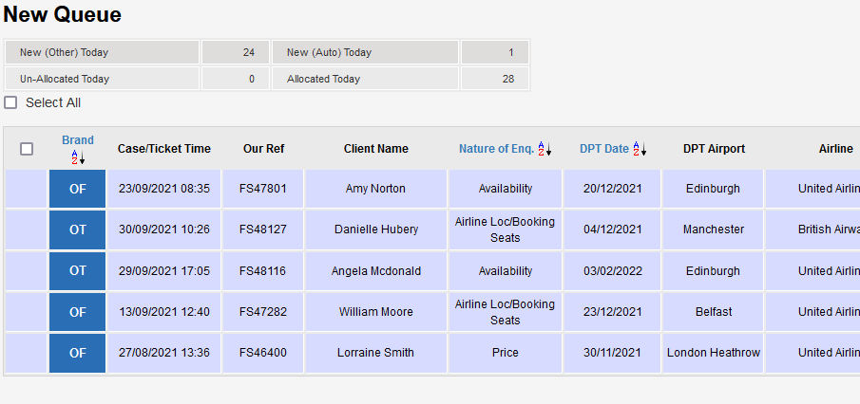
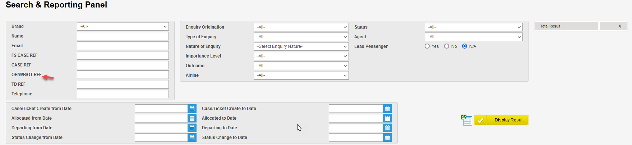
DS Reply - FS client and internal conversion rule (Read/Reply/Event) will apply for the OFT FS case?
Yes

13/. CSB
This will be exactly same as WB CSB module.
CSB module will show only OFT CS cases.
Amendment form will have different concept which will be covered in the next section.
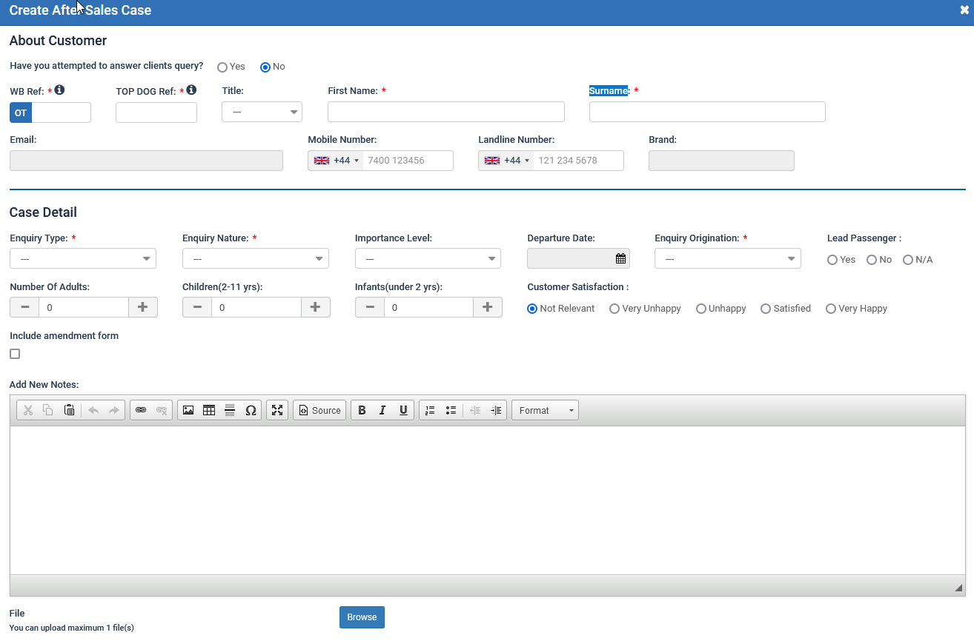

14/. Amendments
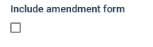
If an agent tick Include Amendment Form, then below pop up will show after saving the case as same as we have WB brand.

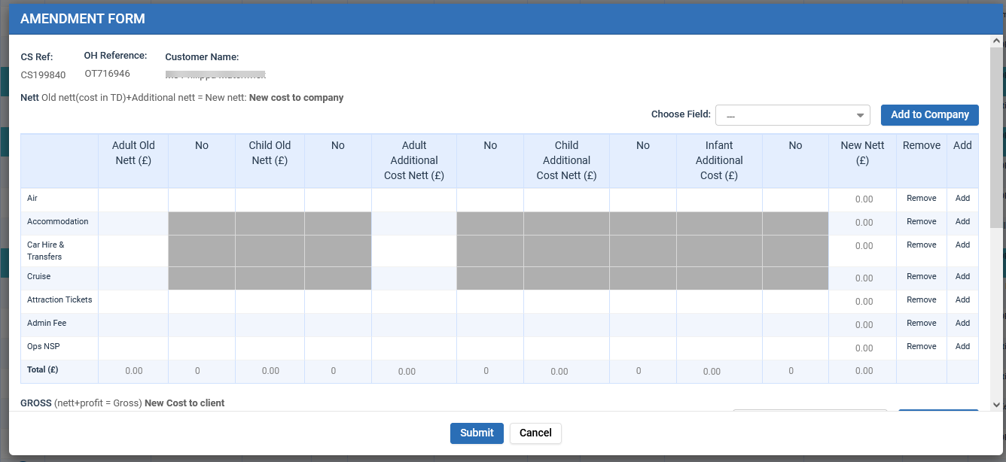
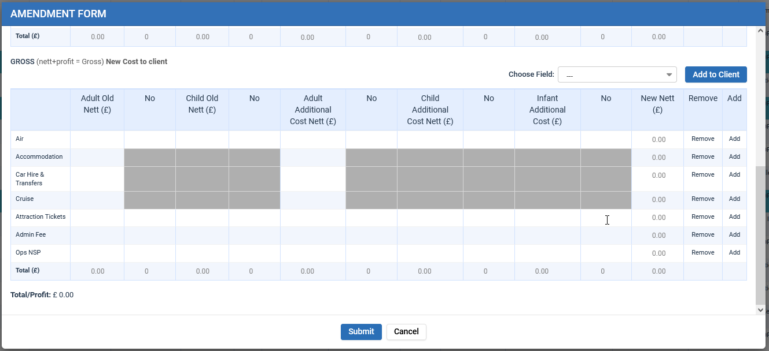

15/. CMS Admin

We will accommodate Ocean Florida Trade in CMS.
DS reply – We are reviewing the areas that needs addition of OFT in the CMS
Remains constant with current brands (OF/OC and WB)

16/. Reporting
This will build in Phase 2.

17/. Big Query
We will push Ocean Florida Trade brand data into BQ.

18/. Create Consortium
This will manage from CMS.
Menu will be added under Enquiry Master:
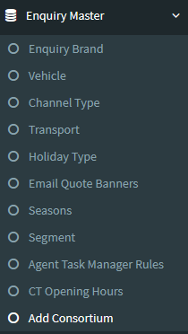
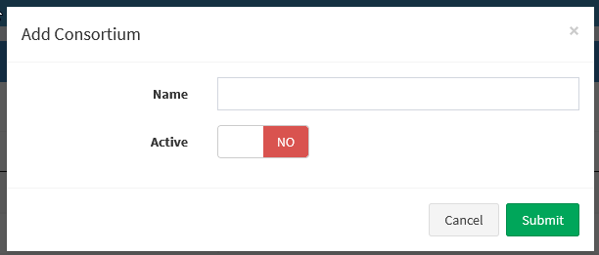
- New email domain

Require new email domain which will be used in all OFT brand email.
@oceanfloridatrademail.com

19/. User Roles and Permissions:
Under the Users tab on the notifications bar, the user will have to click on the ‘User Accounts tab’. The user will then have to make the choices as per the below screenshot

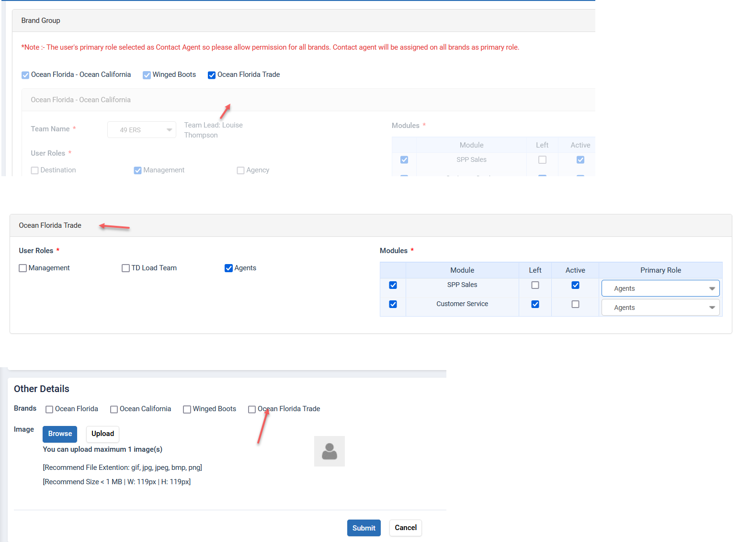
A new option will be added for the users called ‘Ocean Florida Trade’. Once that is chosen, the other brands (OF/OC and WB) will be disabled. The 3 user roles will be Management, TD Load team and Agents. There will also be a new signature for the agents who are a part of the Ocean Florida Trade brand.
20/. Ocean Florida Trade User Navigation Menu:

For the navigation bar on top of the screen, the user will have the following options
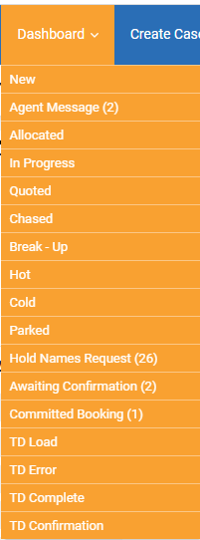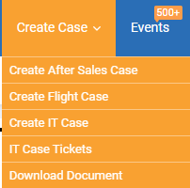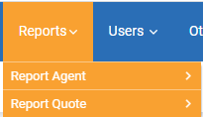
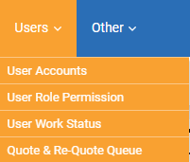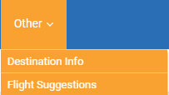
The permission for each user will be managed from role permissions.

DS Queries:
- We are adding all queues for this brand but some will not be active and relevant for the user Yes
2. Will manage the ATM process for the OFT leads? - No
3. Will have console pages for the OFT users? No consoles required for OFT
4. Will manage the ‘Agent Message’ menu for the OFT sales users? - Yes
5. Will enable the IT tickets menu for the OFT brand? Yes
6. What is difference between PS TRADE client and OCEAN FLORIDA TRADE role? – TBD
7. No auto-allocation required for the OFT brand (relevant to allocated queue)

