On the PS system, we have a section under case conversation where Agents can do communications within the organisation. We need a similar function on SPP/G2B

This is how it looks on PS:

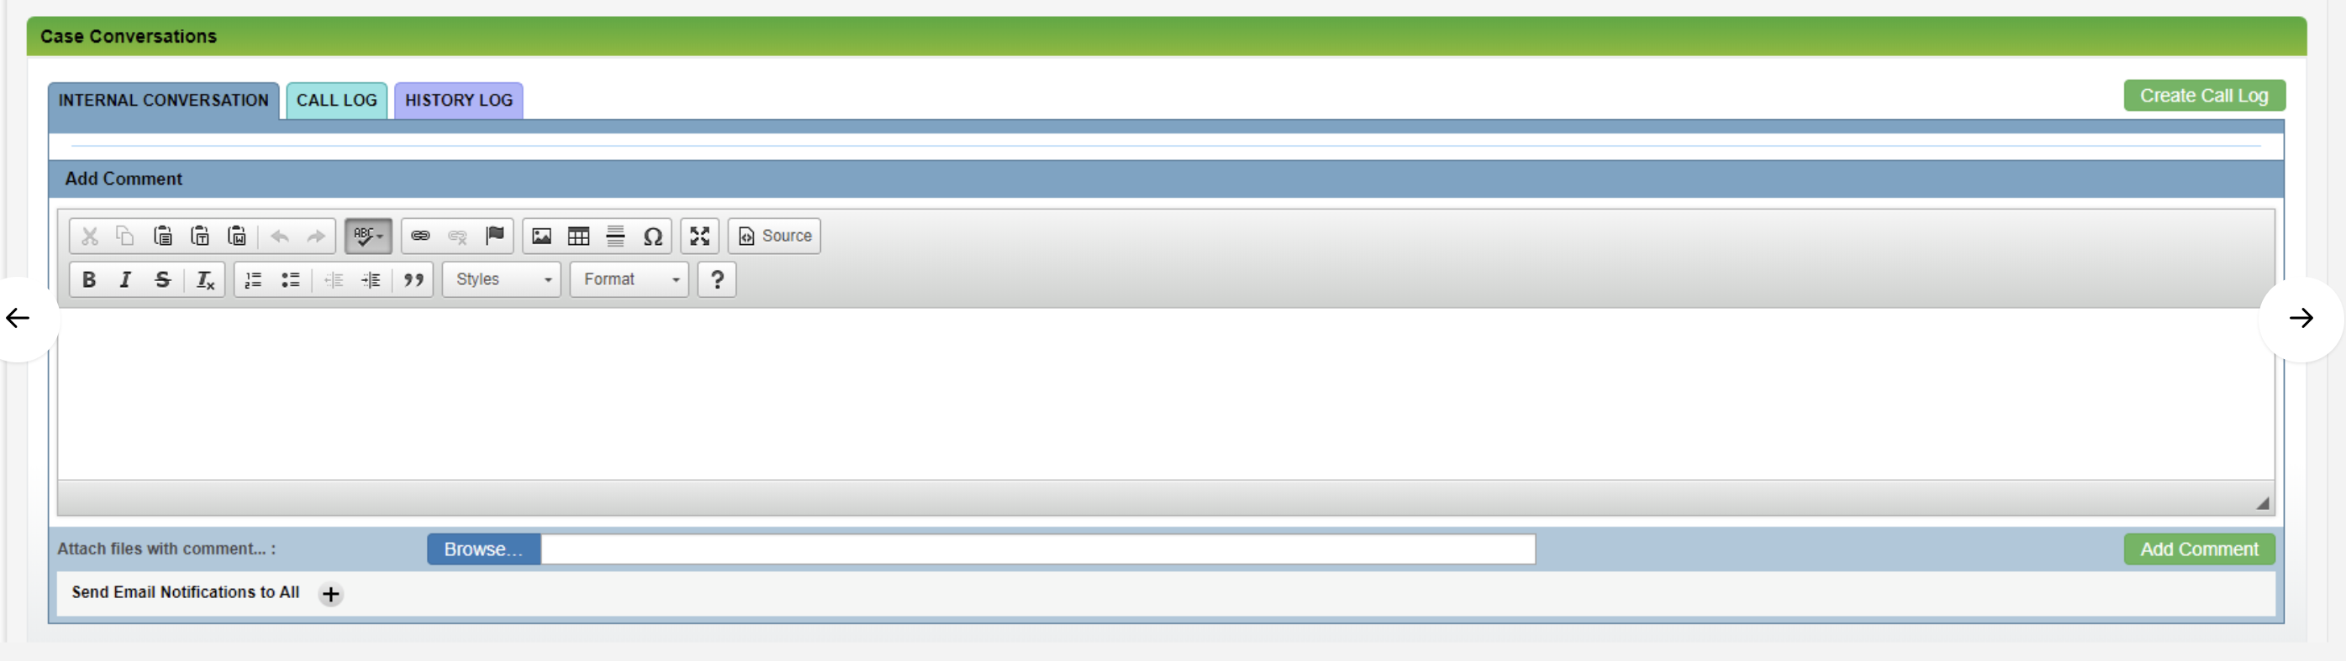

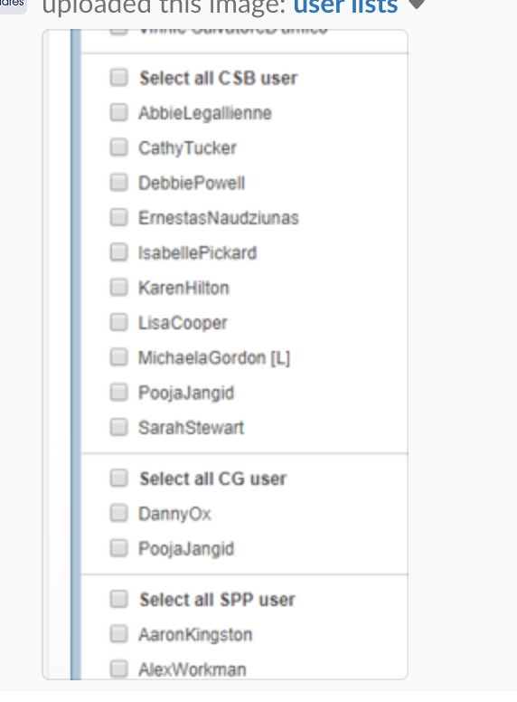

We require the same as above but with a new tab here titled ‘Internal Communication’

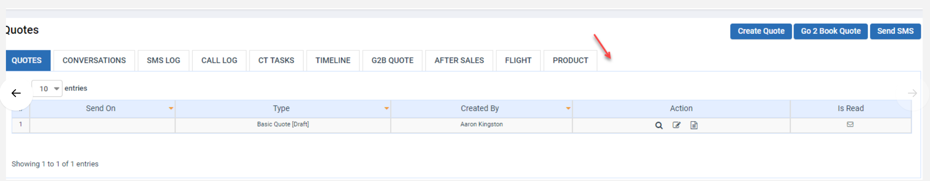

And make everything relevant to SPP instead of PS

