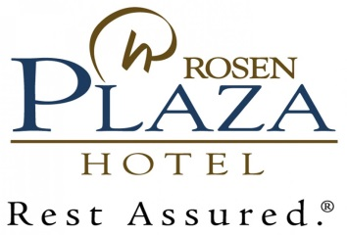

Addendum to 2017 Net Rate Agreement
Account/Company | Ocean Holidays
Special Offer | SPO 2017

The following is an Addendum to the FIT Net Rate Agreement between Ocean Holidays and Rosen Plaza Hotel.

- This Addendum will supersede the 2017 FIT Net Rate Agreement rate over the dates listed below.

- All other contractual terms and conditions as outlines in the 2017 FIT Net Rate Agreement remains as outlined and agreed to in the original FIT Net Rate Agreement.

Valued Added: | Complimentary Self- Parking, WIFI, Fitness Center Access &  25% Discount in select restaurants, excluding alcohol
Offer: | 15% OFF  (FREESELL/72 HOUR CUT-OFF)
Booking Window: | December 19, 2016 – February 19, 2017
Travel Window:

April 16, 2017 – October 12, 2017
November 01, 2017 – December 24, 2017

Offer not valid/applicable | Value Dates
Offer not valid/applicable | Compression Dates
Offer not valid/applicable | Close Out Dates

SPO 2017 Rate MUST be referenced on each reservation in order for special offer to be applied to reservation. Any reservation that is reported without this reference will be applied to standard contract rates. Rosen Plaza holds no responsibility to adjust room rates once a room night is consumed.

Please circle:
Offer will report on reservation Yes Room Rate will report on reservation No

- All Reservations must be reported as sell and report.

- A signed copy of this addendum MUST be returned by email to gexinor@rosenplaza.com or via fax to (407) 996 9111. Upon receipt we will countersign, return a copy to you for your records, and load into our reservation system. A signed addendum must be on file for special to be applied to reservation.

Thank you for your continued support and for including this offer in all available marketing opportunities.

Agreed to:
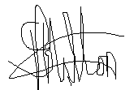
____ ____
By:Simon Hilton By: Gerdia Exinor
Account/Company: Rosen Plaza
Ocean Beds

23rd dec 2016 ____ ____
Date: Date:

