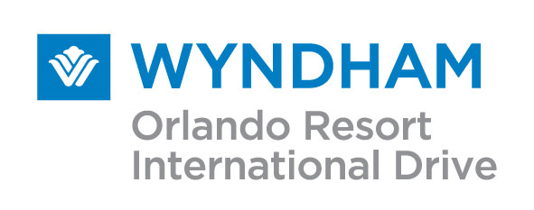

8001 International Drive

Orlando, Florida 32819

Phone: (407) 351-2420

Fax: (407) 248-9732

2018 Tour Operator Rate Agreement:

Company Name | Ocean Beds
Property Main Contact | Simon Hilton
Contact Title | Head of Product
Company Address | Equitable House
 | 88-100 South Street, Romford, Essex RM1 1RX
Company Phone | +44 0-2038239827 (UK) //407-390-6422 (Local)
Contact E-mail | Simon.hilton@ocean-holidays.co.uk
Close out notification email | Stopsales@ocean-holidays-co.uk
Above Information Verified: Mark “X”  Yes:__x_____ No:________ | Please Indicate any changes to above in particular the Stop Sale Email address:  3204 Rolling oaks Blvd, Kissimmee, FL 34747… everything else good

DATES  2018: | Net Rate:  Run of House | Cut-off  Run of House | Net Rate:  Family Suites | Cut-off  Family Suite | Allocation  ROH and Family Suite
2 January – 8 January | $71.00 | 10 Days | $96.00 | 14 Days | Free Sell
9 January-24 March | $80.00 | 10 Days | $105.00 | 14 Days | Free Sell
25 March- 7 April | $102.00 | 10 Days | $132.00 | 14 Days | Free Sell
8 April-30 June | $75.00 | 7 Days | $100.00 | 14 Days | Free Sell
01 July-11 August | $80.00 | 7 Days | $110.00 | 14 Days | Free Sell
12 August-24 December | $75.00 | 7 Days | $100.00 | 14 Days | Free Sell
25 December-01 Jan. 19 | $102.00 | 7 Days | $152.00 | 14 Days | Free Sell

Rates are per room, per night USD, based upon single-quad occupancy
Room Rates are subject to prevailing State and Local taxes at the time of room occupation, current tax rate is: 12.5%

Advance Purchase Buffet Breakfast Wholesale Price: $12.00 Per Person, inclusive of tax and gratuity Retail Price: $16.00 plus tax and gratuity.

Resort Benefits for our Ocean Holidays guests have been reduced to $15.00 per room, per night and include the following Resort Benefits:

- On-Site Parking
- Wireless in-room high speed internet
- Scheduled shuttles to Universal Studios ® Universal City Walk ® and SeaWorld ® Theme Parks
- Two (2) all-day ride passes on the I-Ride Trolley (Per Stay)
- Weekday Newspaper in Hotel Lobby and Fitness Center
- Daily Fitness Center Access, including use of equipment, sauna, steam room, lockers and shower facilities.
- Live Network Airline Kiosk with Boarding Pass Printer
- Up to first 30 minutes of Long Distance telephone calls (within the Continental 48 States only)

GUEST WILL PAY RESORT FEE UPON CHECK IN: _____x____YES __________NO

Initials: ____SPH__________

CHECK IN-CHECK OUT: Check in time is 4:00 PM; Check out time is 11:00 AM. All guests must present a photo ID and credit card for incidental charges upon check in.

Black out dates: The Hotel reserves the right to close out any future sales over a specified period. In all such instances, the Operator will be asked to provide names and dates for all rooms sold during the said period within 48 hours of notification (excluding weekends). Current 2018 Black Out Dates:

- January 9-10, 24-25, 2018
- February 12-13, 2018
- March 9-11, 2018
- April 12, 2018
- May 7-8, 2018
- June 4-5, 2018
- June 11-13, 2018
- June 24-25, 2018
- Sept. 24-25, 2018
- Oct 6-8, 2018
- October 18-19, 2018

RATE: The rates contained in this agreement are exclusively for International wholesale leisure programs are to be sold strictly B2B (Business to Business.) Forward distribution to U.S. or International websites who sell B2C (Business to Consumer) is strictly prohibited and will result in immediate contract termination.

Contracted F.I.T Rates do not apply to conventions or groups of 10 or more rooms; please contact your Wyndham Orlando Resort Sales Representative for convention or group room rates and availability.

TAXES: 12.5% Tour voucher must include current taxes. Should either State or Local taxes increase, you will be informed immediately and will be responsible for any and all increases.

Rollaways/Cribs: Rollaway beds may be added to certain room types are available at $15.95 per night, plus tax. Cribs are free of charge. Rollaway beds and cribs are limited and on a first-come; first served basis.

RESERVATIONS PROCEDURE: All reservations must be reported at the time of the booking. Reservations are automatically confirmed if the stay dates are outside the black-out dates listed above. Reservations over black -out dates and outside “Free Sell” cut-off date period must be authorized by the Reservations department.

Email Reservations to: lindaharvey@wyndham.com

CANCELLATIONS/CHANGES: Cancellations will be accepted with no charge up to 72 hours prior to the arrival date. Any cancellation after this time, or if the guest does not arrive on the reservation date, the Agency agrees to pay for one night’s room and tax. All cancelled reservations will be assigned a cancellation number, should a billing discrepancy occur, it is the Tour Operators responsibility to submit their cancellation number. Early departures will be charged one night room and tax. No-shows will be charged one night room and tax.

BILLING PROCEDURES: Ocean Holidays is on a prepay status, all reservations must be paid in their entirety within 7 days of the guests arrival date, prepayment for reservations made inside of the 7 day window, must be paid within 48 hours. If payment is not received by the date of the guest arrival, the guest will be responsible for all charges, to protect against this the Wyndham Orlando Resort is supplying a credit card authorization form to keep on file, this card will only be charged when payment has not arrived prior to guest check in. Please return the credit card authorization along with this agreement.
Hotel Key Contacts:

Deneen White: Sales Manager: Dwhite@wyndham.com
Pam Henderson: Reservation Mgr.: Phenderson@wyndham.com
Linda Harvey: Reservations: Lindaharvey@wyndham.com
Mary Sells: Credit Manager: Msells@wyndham.com
Hotel Main Phone Number: 407-351-2420
Reservation Fax Number: 407-248-9731

Initials: ___SPH__________

BROCHURES AND WEBSITES: Any printed or on-line material used as a tool to sell the Wyndham Orlando Resort must have current and accurate information on the Resort’s facilities and its available services. New images and descriptions; including attractions and restaurants within walking distance have been provided with this contract. Refunds will not be issued for Guests who have been provided inaccurate information by the Tour Operator. For additional photos or descriptions please contact your Hotel Sales Representative.

FORCE MAJEURE: shall be excused for the period with respect to the performance of any of the terms, covenants and conditions of this agreement when prevented from doing so by Force Majeure which shall include, without limitation, all labor disputes, government regulations or controls, fire or other casualty, inability to obtain any materials or services or any Acts of God.

THE WYNDHAM ORLANDO RESORT reserves the right to review production and renegotiate terms of the rate agreement after a period of 90 days from date of contract execution. Either party, with 30 day notice can terminate this agreement with written notification of cancellation intent.
This Agreement must be signed by an authorized agent of your company and returned on or before June 30th, 2017 acknowledging your companies full acceptance of all the terms and conditions contained herein. A counter signed copy will be returned to you for your records.

Authorized Signature:

Ocean Holidays / ocean Beds Wyndham Orlando Resort:

____21st June 2017___________________ ____________________________________
Date Date

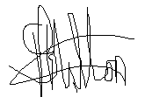
____________________________________ ____________________________________
Signature Signature

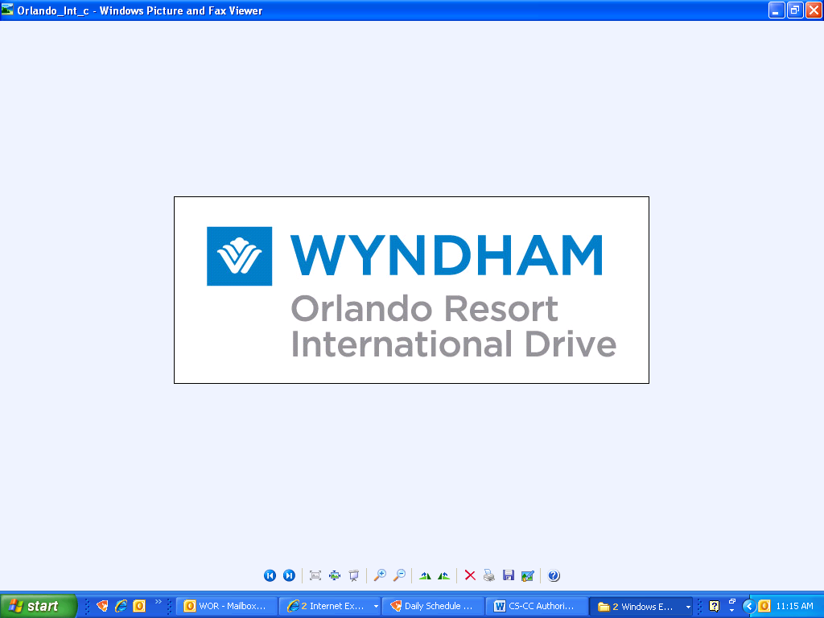

CREDIT CARD AUTHORIZATION FORM

I am authorizing the Wyndham Orlando Resort, International Drive to charge the credit card account below for payment on reserved guest rooms and applicable taxes in which pre-payment has not been received

Company Name: Abreu Tours

By signing below I am authorizing the Wyndham Orlando International Drive to charge this credit card for the above charges listed, under the terms specified on this form.

AMEX/VISA/MC/DC/DISC/CB Card # ___________________________ Exp. _________

Print Name ____________________________ Signature ____________________

As It Appears on Card

Billing Address: __________________________________________________________

City: ___________________________ State: __________________ Zip: _________

**Please attach a copy of the front and back of the credit card listed above
and driver’s license with matching signature**
Without this information we are unable to process the charges.

PLACE DRIVER’S LICENSE OF CREDIT CARD HOLDER HERE
PLACE FRONT OF CREDIT CARD HERE

Thank you for choosing the Wyndham Orlando International Drive
8001 International Drive • Orlando, FL 32819
Telephone 407.351.2420 • Fax 407-351-4306 •

