5 bedroom, 4.5 bathroom home with private pool

- 5 bedroom home
- 4.5 bathrooms
- Luxury Hampton Lakes Home
- 15 minutes from Walt Disney World
- Solar heated pool

This spacious and luxurious five-bedroom home provides the ultimate in quality holiday accommodation, spanning over two storeys, it provides a great backdrop for families or groups. Natural stone travertine and hardwood floors, granite counter tops, stainless steel appliances and chic furnishings add to the feeling of contemporary elegance.

Information

Queen-size 2
Twin 6
Sofa Bed N
Private Pool Y
Spa N
Internet Y
Games Room Y

Description
The open-plan ground floor begins with the formal dining space at the front of the home. The dark wood, rectangular table seats eight in comfort and is located next to the new designer kitchen. Granite counter tops, stainless steel appliances and all the pots, pans, glassware needed to cater for guests are provided.

At the rear of the ground floor the elegant, contemporary family room is the ideal place to kick back and relax after a busy day at the parks or on the golf course. This area is equipped with a large flat-screen TV and DVD player. Sliding glass doors lead directly from the family room to the pool deck. For casual dining there is a breakfast bar in addition to outside patio dining.

Bedroom accommodation begins with a queen-bed master suite at the rear of the ground floor. Light wooden floors, a leather accented bed and dark wood cabinets and flat-screen TV with DVD complete the space. The spacious private bathroom has a corner bath, walk-in shower plus twin vanity basins with granite surround and dark wood cabinets.

A second queen-size master suite is located near the front of the home. This room is finished in similar style and also enjoys a flat-screen TV. Upstairs the bedrooms are all twin bedded for maximum flexibility.

A Toy Story room is decorated with themed linens and soft toys of Buzz Lightyear and his friends, plus there’s a princess-themed room featuring images of Disney's favourite fairy tale characters. The third twin bedded room is finished in autumn tones with leather bed heads and dark wood cabinets. All bedrooms have a flat-screen TV with cable channels.

Everyone in the group will love the games room, equipped with a full-size table tennis table and foosball.

Florida is all about outdoor living. The large pool and deck provide the opportunity to have a relaxing swim, soak up the sun or enjoy an al fresco meal at the patio dining table. A new solar pool heating system has been installed so there are no extra charges for pool heating.

Location

Hampton Lakes offers luxury villas to rent in Davenport, built around two central lakes. The amenities in the community include its large swimming pool, gym and exercise room, sand volleyball courts, tennis courts, children's playground and a picnic/barbecue area.

Hampton Lakes is conveniently located off Highway 27, just off the US 192 approximately 15 minutes from Walt Disney World and close to a variety of shops, bars, restaurants and some great golf courses. This exclusive development of luxury homes is a prestigious, private community set amongst the gently rolling hills and orange groves of Northeast Polk County. The Resort offers easy access to Interstate 4, which leads to the beautiful white sandy beaches of the Gulf Coast or westwards to Daytona Beach, Cocoa Beach and the Kennedy Space Center.

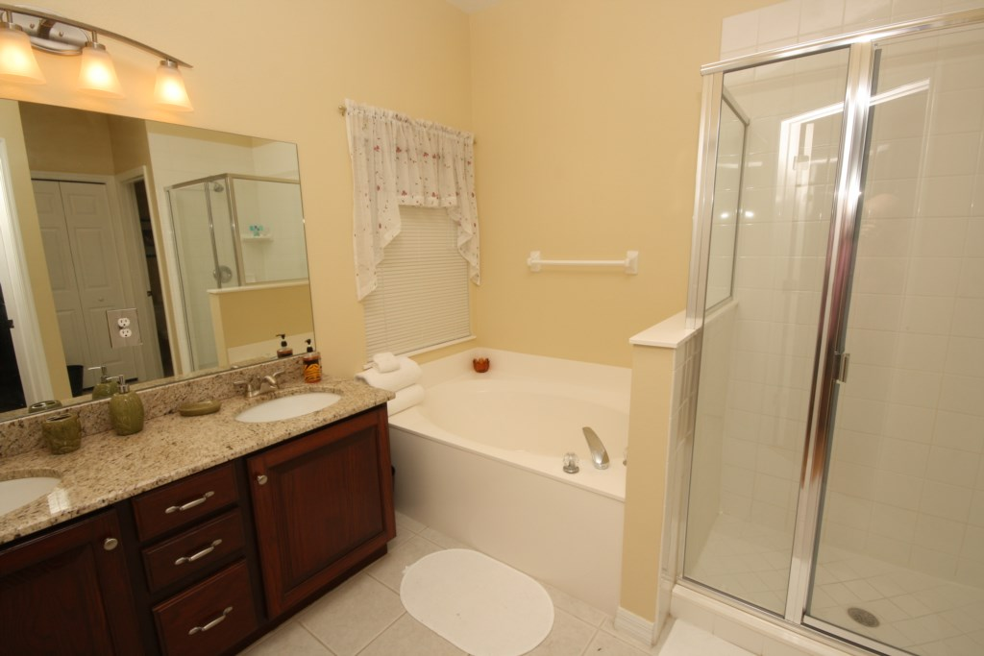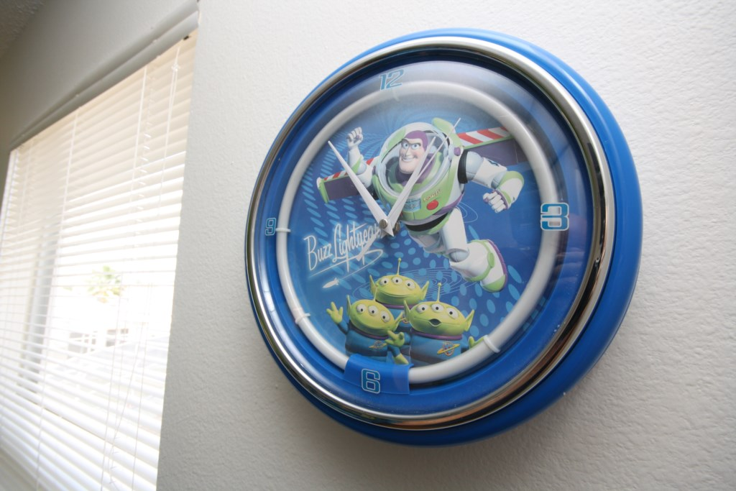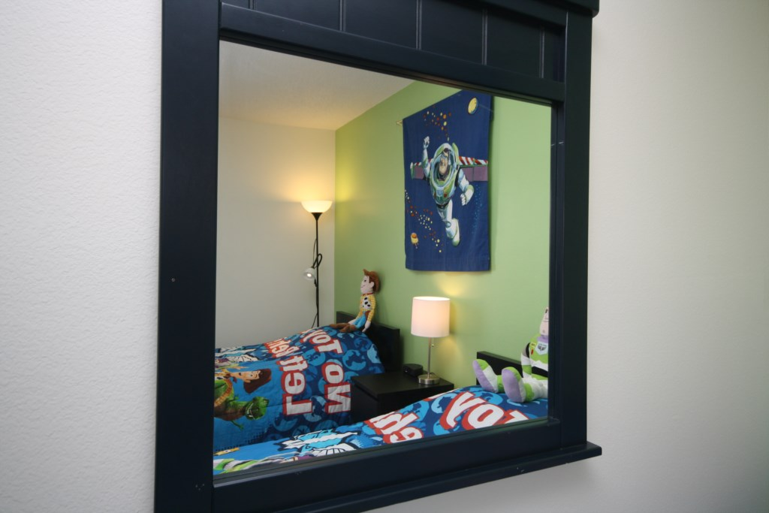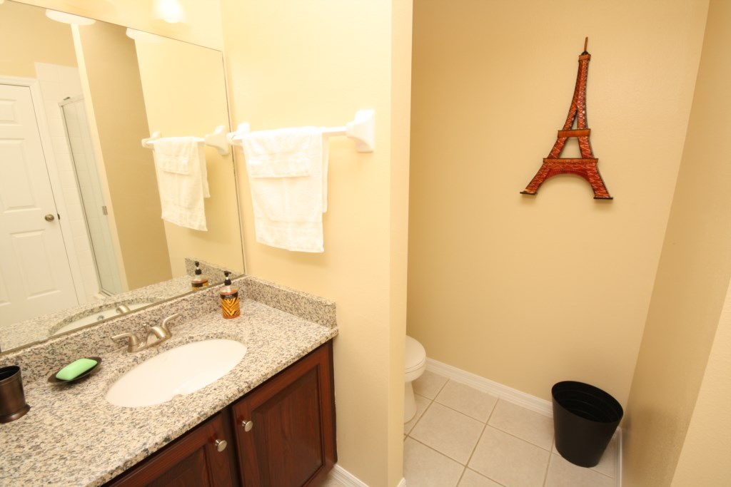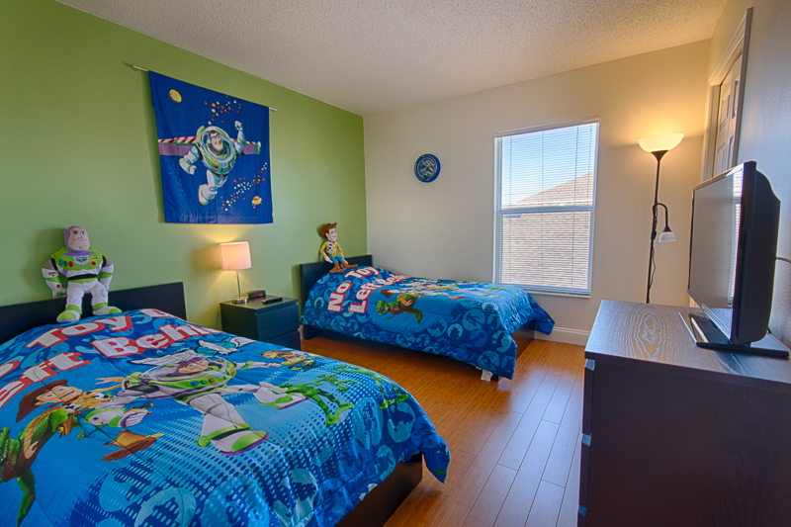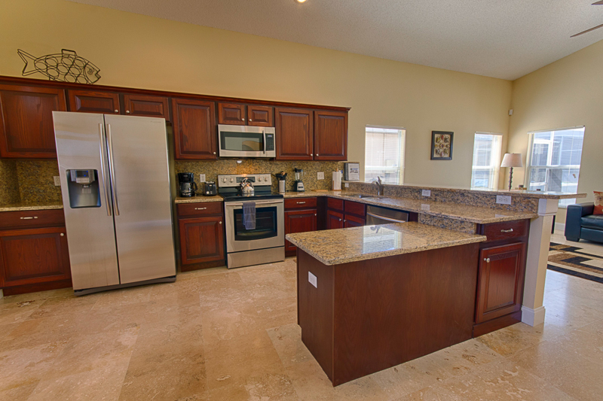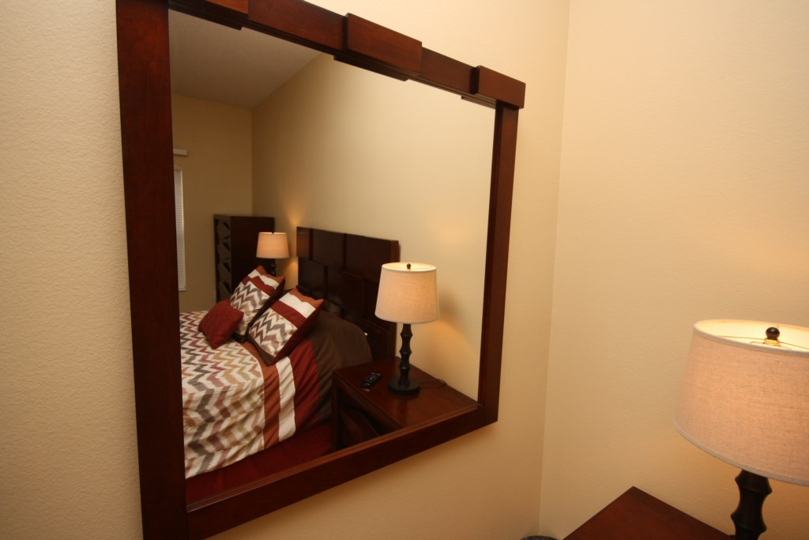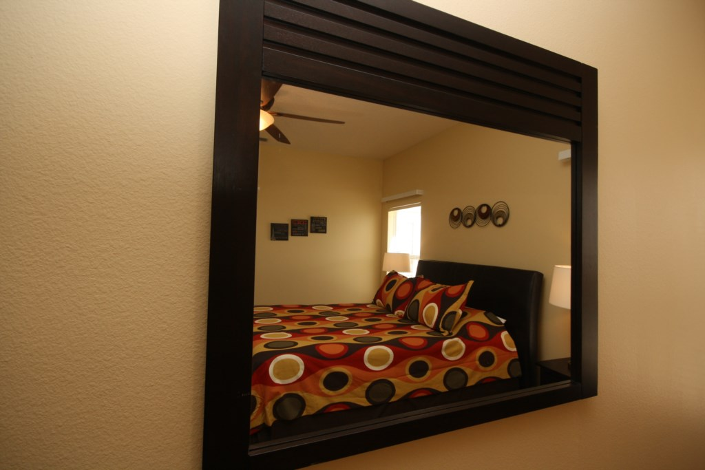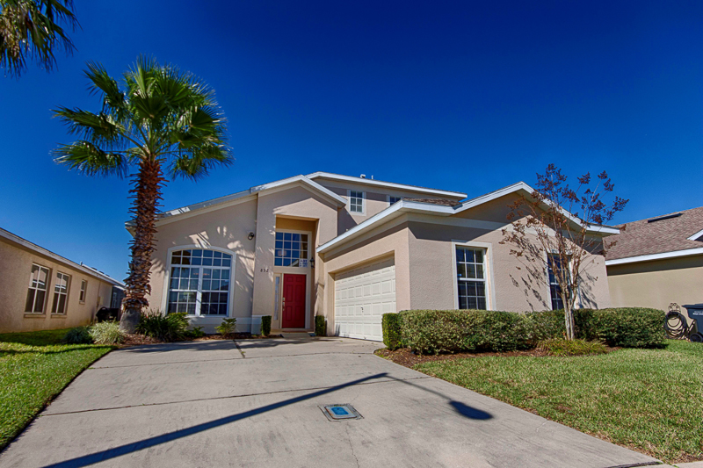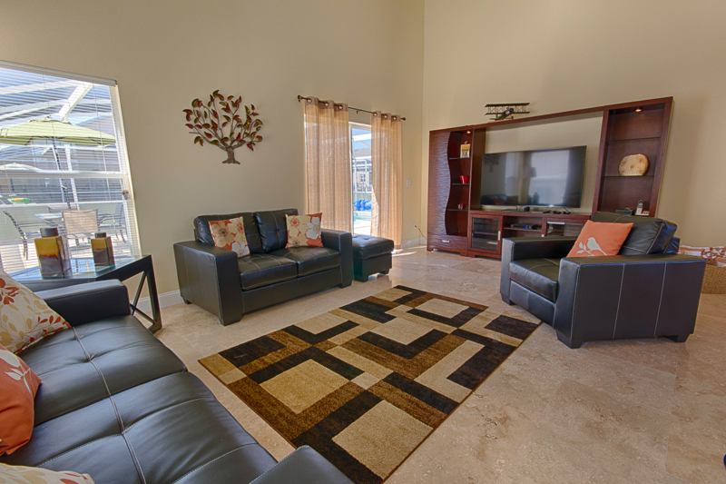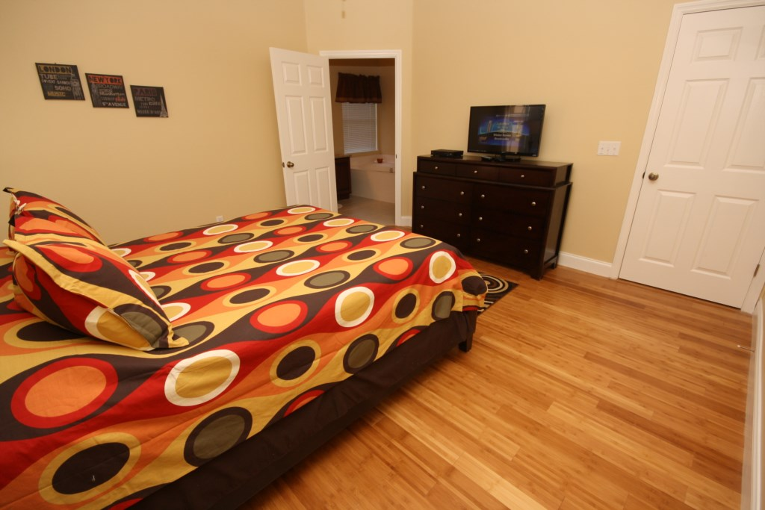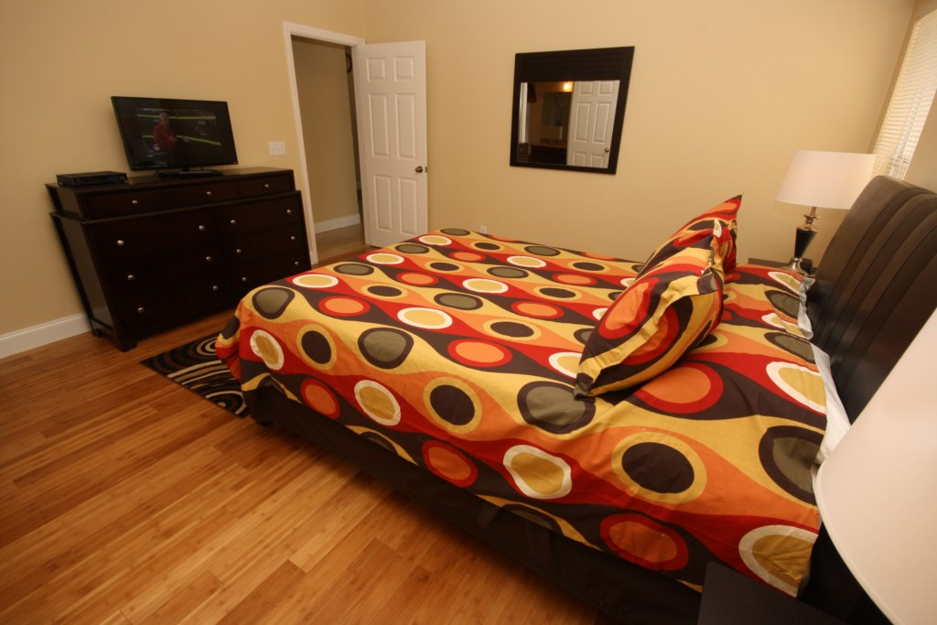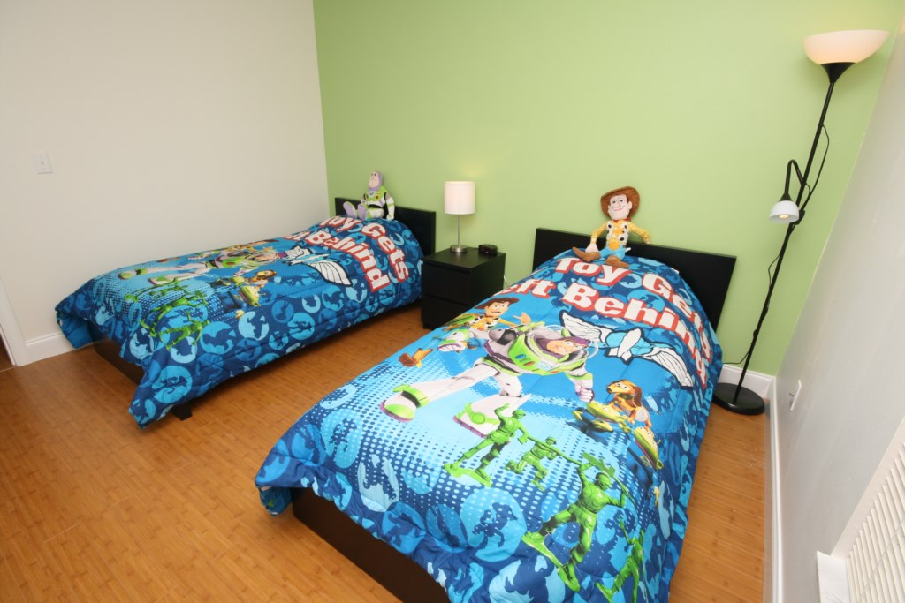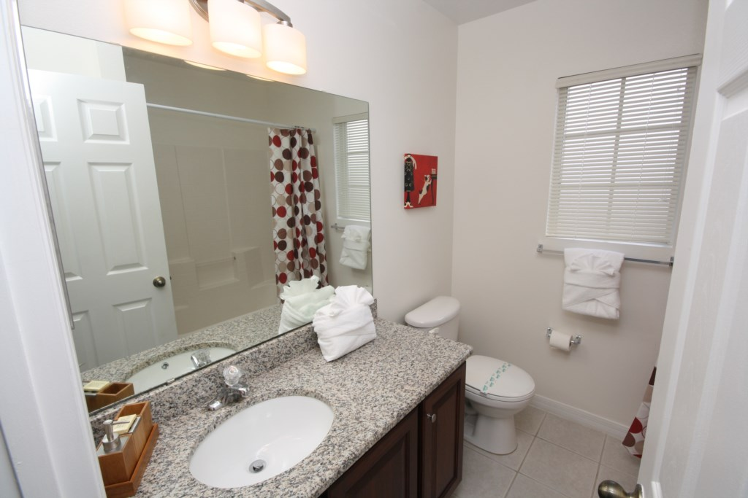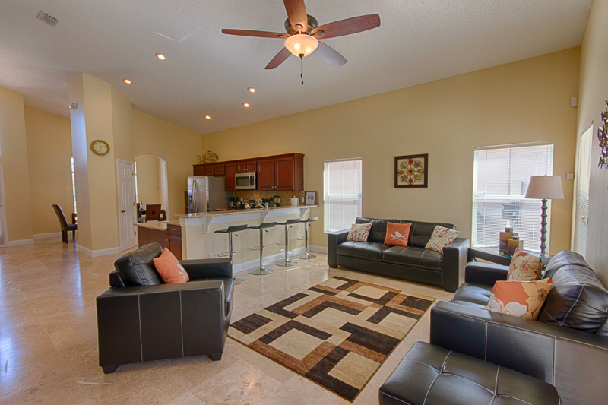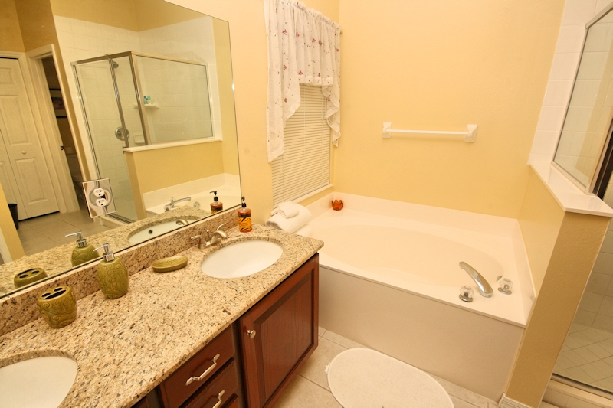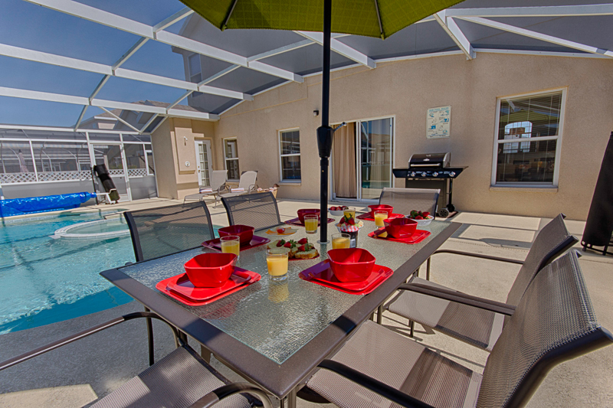b