- 3 bedroom home
- Highlands Reserve
- 15 minutes from Disney
- Backs onto the golf course

3 bedroom, 2 bathroom home with private pool

This is a gorgeous one-storey home situated in the prestigious golf community of Highlands Reserve. With bright, neutral tones throughout, it provides a welcoming and comfortable space for a Florida family holiday.

Description
Beautifully decorated with modern furnishings, this home is sure to be the perfect place for guests to unwind after long days out and about.

The home features two large living areas, a great master bedroom with a king bed, a second room with a queen bed and a third with twin beds - there is plenty of room for a couple or a family of up to six people. All bedrooms have flat-panel TVs and there is complimentary Wi-Fi in the home too.

The outdoor patio features a covered Lanai with a dining set for al fresco meals, plus a couple of sun loungers for guests to really make the most of the Sunshine State. The sunny pool deck overlooks the water on the 10th hole – the only hole in Highlands Reserve with water – so it is a lovely place to sip one’s morning coffee or have a pre-dinner aperitif in the balmy Florida weather!

Location
Highlands Reserve is a prestigious holiday and residential golfing community in Davenport offering excellent on-site facilities including a communal swimming pool, tennis courts, 18-hole golf course, practice range, putting green and cafe bar, which is open seven days a week.

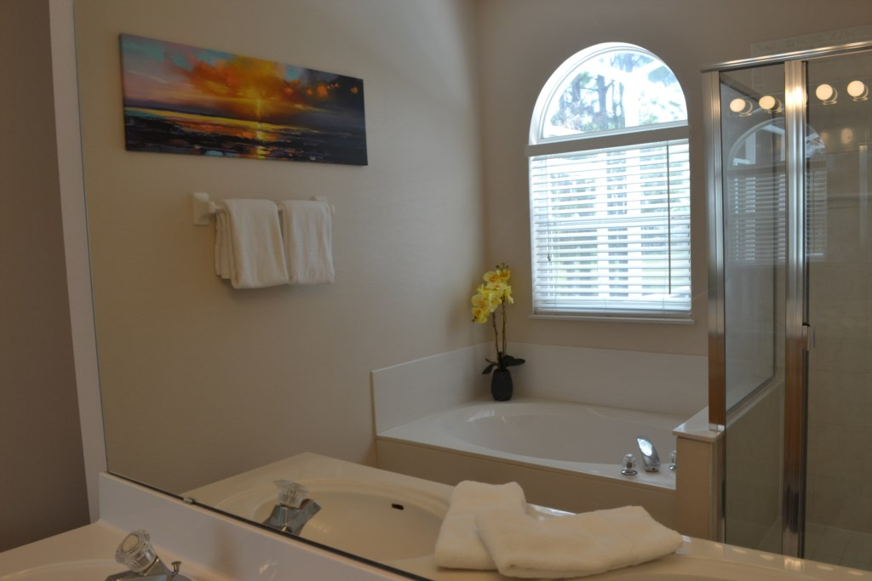
The resort is situated just off US highway 27 in a peaceful location, set amongst beautiful rolling countryside with an abundance of orange groves. It is ideally located for easy access to all major attractions, with shops, supermarkets and restaurants all close by.
