Testing Plan – Sprint 37
Thursday 14th September
- Sarah/Matt
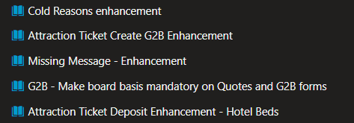
Notes:
Missing email there was small glitch on linking with object bug so have added to VSTS card.

Tuesday 19th September
- Sarah/Matt/Tessa and Pooja
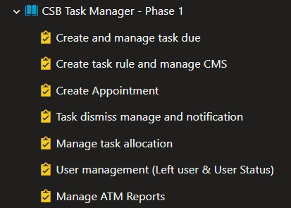

Accessibility Phase 3
- Sarah/Pooja/Anna/Sam
