DATE: June 10, 2016

FROM: John A. Goodman, Director of Sales and Marketing
Wyndham Orlando Resort International Drive

SUBJECT: 2017 EARLY BOOKING BONUS

cc: L. Eddekkaki, M. Sells, L. Harvey, P. Henderson, L. Garnier, D. White

PROMOTION OVERVIEW

Wyndham Orlando Resort International Drive is pleased to offer the following promotional program for 2017:

Promotion Name: 2017 EARLY BOOKING BONUS

Voucher Verbiage: Please ensure that vouchers and manifests reflect “WHIEBB” to identify appropriate promotion

Booking Window: June 15, 2016 – September 29, 2016. Must report all bookings by Friday, September 30, 2016

Travel Dates: January 2, 2017 – December 31, 2017

Black-out Dates: Blackout dates for 2017 include:
- Jan 9-11 - Feb 07-09, Feb 20-23
- Mar 13-16, Mar 30 -Apr 02 - Apr 14-15, Apr 27-29
- May 15-18, Jul 18-21 - Sept 25-27
- Dec 04-06
Additional close-out dates may apply and will be communicated accordingly

Offer Details: - VALID FOR NEW BOOKINGS ONLY
- Reduced net room rates for as specified below

Minimum Stay: 1 Night

2017 EARLY BOOKING SALE: Continued

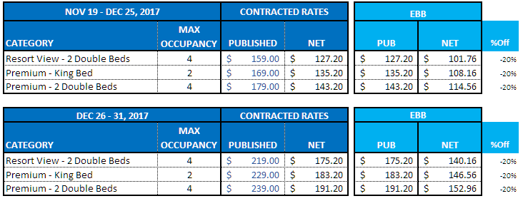

Above net rates are EP (room only), per room, per night, based on above stated occupancy. All rates are subject to 12.5% Government Tax and a $22.44 Resort Fee (per day) not included above. Resort fee paid locally by guest

Terms & Conditions

Booking Guidelines: All bookings must be sent to the Resort’s Reservations Department via email at lindaharvey@wyndham.com or via fax 407-248-9732.

Billing Procedure: The hotel will invoice bookings based on the rate information listed on the original manifest, reservation, or above allotment request received.

This promotion is valid for new bookings effective June 15, 2016 and may not be combined with any other offer or promotion unless otherwise specified in writing. All reservations in conjunction with this offer must be reported directly to the property and are not applicable to group bookings. All other terms and condition apply as per original contracted agreement.

All vouchers/manifests must state the applicable promotion(s) verbiage. Any vouchers or manifests submitted to the resort that does not denote the applicable promotion codes will be billed at originally contracted net rates. No exceptions will be allowed. Program to be merchandised and marketed heavily by Wholesaler/Tour Operator. Please submit a Marketing Plan to define promotional program to be instituted against these special net rates.

