

Software Requirements Specifications (SRS)

Treeboard
CRM ID: 15613

CONFIDENTIAL

This document outlines the general scope of your project-based
on our understanding of the requirements provided
and discussions to date.



DISCLAIMER
This document is submitted with the explicit understanding that the contents are confidential
and would not be divulged to any third party without prior written consent from Dotsquares Ltd.
Services are supplied according to our terms and conditions

http://www.dotsquares.com/terms

Contents
1. Document Ownership 3
2. Document Version Control 3
3. Scope 3
4. Functional Requirements 3
A. Header (Same in All web pages – All clickable) 3
B. First Banner 4
C. About Us 4
D. Search Map 4
E. How it works 4
F. Contact US 4
G. Footer 4
3. SignUp 5
4. Items Summary Page 5
5. Payment gateway Screen 5
A. About Us 5
B. Terms & condition 6
C. Privacy Policy 6
D. FAQ’s 6
E. Help & Support 6
F. Career Pages 6
Forgot Password 6
A. Left Side Menu Details : 7
B. Top right corner 7
C. Notification Bell for the messages before top right corner 8
D. Search box before notification bell 8
E. Main Dashboard Fields and Feature 8
1. Manage Logo and FavIcon 12
2. Manage General Setting 12
Forgot Password 13
1. Manage Logo and FavIcon 14
2. Manage General Setting 14
5. Non Functional Requirement 16
6. Target Platform 16
7. Deliverables 16
9. Project Management 16
11. Unit Testing 17
12. Development Environment 17
13. Staging Environment 17
14. Deployment Environment 17
15. Testing Environment 17
16. Technology 18

1. Document Ownership

 | Author/ owner | Reviewed by
Name | Arnav | Abhi
Designation | Tech Lead | PM

2. Document Version Control

Release  Date | Version  No. | Section / Page #  Changes | Change  detail | Done  by | Reviewed  By
21/10/2021 | 1.0 | Scope Define | N/A | Arnav | Abhi

3. Scope
The project objective is to integrate and populate the data to the client existing theme for Front end and backend. We are assuming the all the designs will be provided by client and our role is to integrate the entire system (backend) to populate the dynamic data. We will be working on requested changes and alteration in both platforms.
As per the client discussion, we also need to implement real time chat feature, where two users can interact with each other, which shows the time and date of message sent.

Functional Requirements
1.Home Page/Landing Page

A. Header (Same in All web pages – All clickable)
      - Logo:-Liked to Home page. On-cick action user will be redierct to home page
      - Home:- Liked to Home page. On-cick action user will be redierct to home page
      - About Us :Liked to Abut us page. On-cick action user will be redierct to About Us page.
      - Subscription Plan: Liked to Subscription Plan section appearing on the home page. On-click action user will be move to Subscription Plan section on the home page.
      - Contact Us: Liked to Contact Us section appearing on the home page. On-click action user will be move to Contact Us section the home page.
      - Login:-Liked to Login page. On-cick action user will be redierct to Login page
      - Sing-up Liked to sing-uppage. On-cick action user will be redierct to sing-uppage

C. About Us
      - Backgroud Image
      - Text
      - Read More Action button which will redirect them to about us page

E. How it works
      - Image
      - text

F. Contact US
      - Name-Required, Text input field, VALIDATION ON FIELDS
      - Email – Required, Text input field, Allow only valid e-mail address
      - Message - Required, Text Area, Max 450 Chars. should allowed.
      - Send button:- On-click action save the data in the DB and send E-mail notification to Admin and the Proivded E-mail address. Email to admin with what fields.

G. Footer
      - Social Account Links of client – Instagram, Linkedin, Twitter
      - Quick Links (Register, About Us, Contact Us, Login)
      - Privacy Policy
      - Terms & Conditions
      - FAQ’s
      - Help & Support
      - Career Pages
2. Subscription Plan
      - Company/Recruiter will be able to click on header option to go through the subscription plan and their benefits.
      - Manageble from backend
      - Image/badge icon
      - Text
      - Validity
      - Terms and Condition
      - Register now action button.
      - Mobile

SignUp
      - Enter you full name:- Required, Text input field LAST NAME REQUIRED.
      - Enter You company name:-Required, Text input field
      - Your email:- Required, Text input field, Allow only valid e-mail address
      - Mobile Number- Required, Text input field
      - Add orginazational Social account (FB and twitter):Text input field, Keep it optional
      - Company size
      - Your password – Add validation + message
      - Confirm password – Add validation + message
      - Checkbox for T&C
      - Register Button: On click action sent E-mail verification link and a Notificatioin E-mail to admin. Save details in the DB.
      - Have an account ? login in link: On Click action redirect user to login page.
      - Once completed user will be redirect to User page.:- After completeting the E-mail verification user will be able to login and will be redierct to Dashboard page.

Items Summary Page
      - This page will appear when user select any plan.
      - User will be able to see the details for final review of selected plan.
      - If user has alredy signed-in then Need to show the Sign up details as mentioned below :
      - Full name (Edit)
      - Company name(Edit)
      - Email (Edit)
      - Mobile Number (Edit)
      - Socila accounts (Edit)
      - Subscription plan the opt for.
      - Next subscription renewed date
      - Submit button , which will take the user to payment gateway screen.

Payment gateway Screen
      - Using Stripe
      - Image
      - Add Card details
      - Saved Card details
      - Payment buttom
- Content Pages

A. About Us
      - Image
      - Content
      - Contact Us button
      - Managebale from backend

B. Terms & condition
      - Text Only
      - Managebale from backend

C. Privacy Policy
      - Text Only
      - Managebale from backend

D. FAQ’s
      - Category based
      - When clicked on category, the respective questions will come up.
      - Now once clicked on the questions, answer will come up.

E. Help & Support
      - Text Only
      - Managebale from backend

Company/Recruiter/Hiring manager web panel
- Sign in
      - Setup the company/recruiter/hiring manager page where user can login into the dashobard panel by using their registered email address and password
      - Fields are Email Address & Password along with Login Button.
      - Apply validation on email address & password both will be required.
      - After successfully login into the system, user will redirect to the dashboard page
      - Remember Me checkbox: save the login credientials in browser
      - Website Logo display at top of the box.
      - Once A company/recruiter/hiring manager will register then a Compy Adimin user will be created.
      - This user will be able to add other sub admins.

Forgot Password
- On the forgot password screen user needs to provide his registered email address.
- On forgot password screen there will be a required text input filed labeled as E-mail and a submit button.
- User will provide email address value in the required text input filed and then click on the submit button.
- Then the provided email address will submit to the system and will be check in the system database if the email address exists or not. If the email address doesn’t exist then an error notification message “Invalid E-mail address” will be displayed.
- If the email address exists but the user is inactive then an error notification message. “Your account has been deceived. Please contact the website administrator.” Will be display.
- If the email address exists but not verified then an error notification message “Your email is not verified yet. Please verify your email address and then try again later” will be display.
- If the email address is found in the system with verified status and the user is also active in the system then generate a reset password verification token.
- The token will be alive in the system for a certain period of time it may be for 1-2 hours after that duration the token will be expired.
- Then generate a reset password notification email containing the reset password page link.
- This reset password page link will contain that access token in encoded format.
- And then send this Reset password notification email to the user on his provided email address.

Reset Password
- On the reset password screen there will be two password input fields and a submit button will appear.
    - New Password (Required, Password input field)
    - Confirm Password (Required, Password input field)
    - A submit button

- Confirm password must match with the new password
- Enforce users to follow the common password policy rule here while creating a new password.
- When the user clicks on the submit button then a new password and the reset password access token will be submitted to the system
- This token will be match and verified in the system.The system will check if the token exists and it is alive in the system.
- If the token exists and it is alive then the new password will be updated and a success message will prompt to the user saying “Your password has been updated successfully” and the user will be redirected to the login page.
- Otherwise, if the token has expired then the system will throw a message something like “Your reset password session has expired. Please try again later by submitting a new reset password request.” and then redirect the user to forget password screen again.
- If the token doesn’t match in the system then “Your rest password request is invalid!”
- Dashboard

Left Side Menu Details :
      - Manage Jobs:-
        - 1. Create Job; Linked to Create Job Section. On click action user will be redierct to Create Job Section
        - 2. Current Job:- Linked to currently active job listing. On click action user will be redierct to urrently active job listing.
        - 3. Archived Job:- Linked to Archived Job listing. On click action user will be redierct to Archived Job listing.
        - 4. Draft Job:- Linked to Draft Job listing. On click action user will be redierct to Draft Job listing.
        - 2. Closed jobs:- Linked to Closed jobs listing. On click action user will be redierct to Closed jobs listing.
        - 4. Trash Jobs:- Linked to Trash Jobs listing. On click action user will be redierct to Trash Jobs listing.

      - Manage Interview:-
- Upcoming Interview:
- Past Interview
      - Manage Staff:-
- View All Staff
- Add New Staff
      - Manage Candidates/CV
        - -Manage Hired Candidates
-All application CV will be stored here.
        - - Manage Application Status
      - Settings
        - 1. Dark/Light Mode
        - 2. Others Settings
      - Sign Out – user must be logged out from the web to login page again.

Top right corner
      - Orginazation profile Picture, if not avaibale then put a default one.
      - Once clicked, a menu will appear with the below information :
      - My Profile
- Business Logo
- Business Name
- Category
- Phone Number
- Street Address
- City
- Pin Code
- Change password
- Submit button to update.

Notification Bell for the messages before top right corner
      - Admin will receive the notification on the below events.
- Can see the count of number on notification bell.
- Once read the notification will be vanished.
- There will be a View all link then user will be redirect notification listing page.

Search box before notification bell
      - User need to filter out as “Find Job”, “Find Candidate”, Past and current job title, City specific jobs.
      - Once ticked the above, user will search for any keywords and all the respective words will appear and user can redirect to the same.
      - User can search for multiple option from the above.

Main Dashboard Fields and Feature
1. View Active Job List : will be shown the 5 active jobs as per the subscription plan
- Fields for the above are :
- Job title
- Job role
- Location
- Total Applications Received
- Total Interview Schedule
- Opetion must be their to view app job details and user will be redirect to manage active jobs application.

2. View Applicant List : will be shown the 5 applicant list who recently applied on any job.
- Fields for the above are :
- Name
- Profile Picture
- Gender
- Applicant location
- Applied to job title name
- Rating given by recruiter
- Once clicked user will be redirect to the Job application page.

3. Graph : We will show the graph for weekly/monthly behaviour of the application received (only Counts)
Fields for the above are :
- Admin can select as Weekly/Monthly
- Once hover, user will be shown the count of number of application received for the particular date (Montly) or Day (Weekly)
- If clicked user will be redirect to that particular date received application for all the jobs.

3. Manage Staff : User can see the data based on the staff added by the admin itself.
Fields for the above are :
- Staff Name
- Staff Type
- Job Assigned name
- Application received against that job by that particular staff.

- Create Profile (Add Organisation details)
Please refer to point 8,B for the same.
- Create/Post Jobs

1. Enter Job Details
- Job Title – Auto Complete Search Text Field, Required [Options will appears various Job Titles added by Suber Admin in Job title Masters]
- Job Role – Drop Down options [ Various Roles added by Super Admin in Roles Manster], Required
- Employment Type: Part Time/ Full Time, Either Full Time or Part Time

- What contract type is it?: Contract type will appear as following :-
- 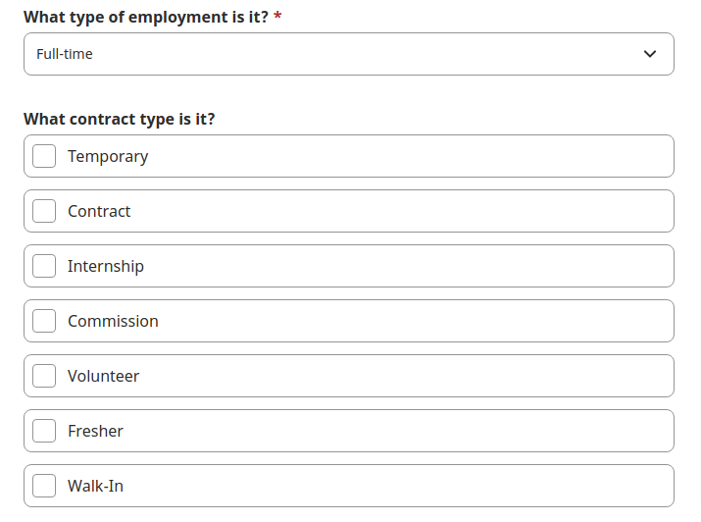
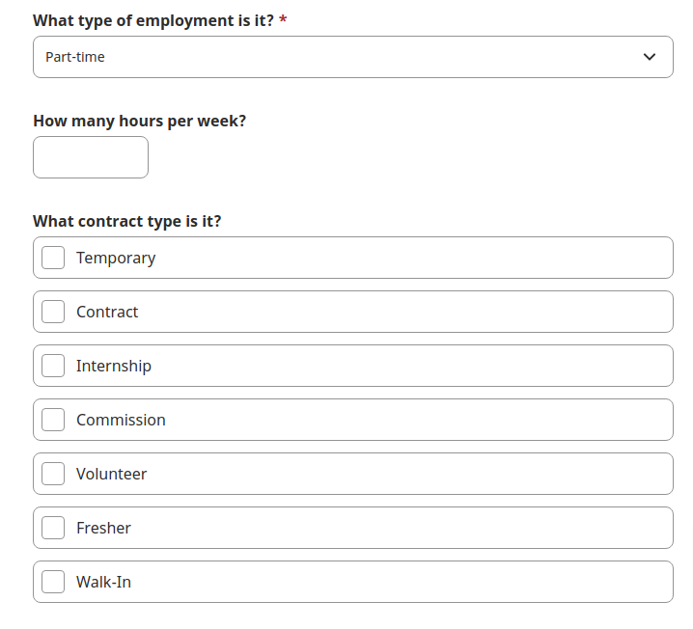
- 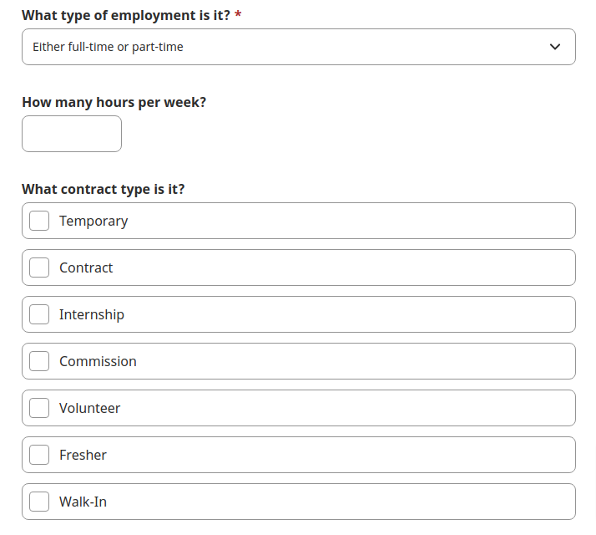
- Location – Populate from Multi select, Auto complet Location dorop Down.[ Requried]
- Qualifications:- Multi select, Auto complete search drop down options added by Super Admin in Qualifications Manster [Required]
Required Skills:- Multi select, Auto complete search drop down options added by Super Admin in SkillsMansters [Required]
- Joining Date - Calender Date Picker
- hiring budget:-
- Joining Location - Populate from Multi select, Auto complet Location dorop Down.[ Requried]

2. Create Schedule :
      - Required shifts – No/Yes Bullet:
- Morning shift
- Day shift
- Evening shift
- Night shift
- Flexible shift
- Rotational shift
- Fixed shift
- Monday to Friday
- Weekend availability
- UK shift
- US shift
- Other
      - Seasonal jobs – No/Yes Bullet
      - Weekly hours
        - 1. 1-10 Hours
        - 2. 11-20 Hours
        - 3. 21-30 Hours
        - 4. 31- 40 Hours
        - 5. 40+ Hours

3. Compensation:
Conpensation Type:- Range, Starting AT, Up to, Exact Rate
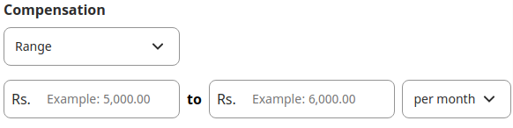
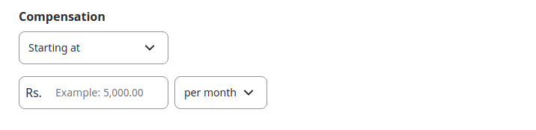
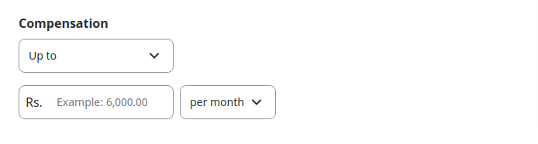
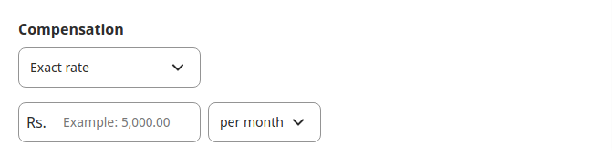
(Per hour/Per day/ Per week/ Per Month/ Per Year will be the drop-down options)
Supplimental Payment offers:-
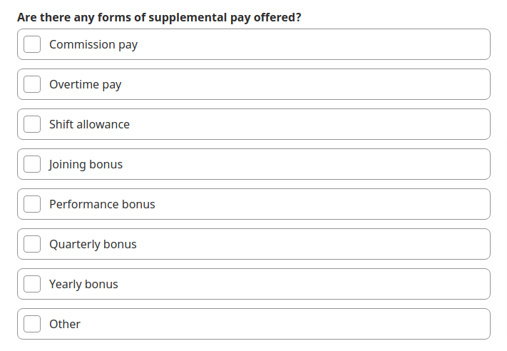
- Benefits
        - 1. Free meals
        - 2. Discounted Meals
        - 3. Health insurance
        - 4. Paid Time off
        - 5. Other, Here admin will write down the benefits.
        - Hit Save as Draft or Publish button or Cancel.
        - Save as Draft:- Job will be save as Draft later user will be Edit the Job and Will be able to publish job.
        - Publish Button:- The job will be posted on Indeed and save as published in the System DB.
        - Cancel:- The Wizard will be closed nothing will be save and form will be cleared.

4. View Details:
      - Here user will be able see Complete Job Details.
      - Add Interviewer : Can add interviewer name, email address
      - The above field is not visible to candidate.
      - An email will be sent out to that interviewer will all the details.

5. Select Plateform
      - This option will appear when user will click on the Publish Button
      - Here company can select the plateform where thye wanted to post, At this time we only have indeed.
      - Add a button to create the link with all the information.
      - Add options to share on Facebook and Twitter
      - Once user click on the shared link, they will be redirected to the indeed site.

6. Review Job Post
      - Here user can review each and every fields from the above and can edit before posting the job.

- Manage Interview
1. Schedule Interview:
      - When ever any user apply to a job on the Indeed Job Plateform, the admin will receive E-mail notification from Indeed (This notification will be sent from Indeed out of the System) admin will review the application and if all good proceed to the schedule interview as below.
- Schedule Interview
- Date of interview
- Start time
- End time
- Add notes
- Submit.
      - Admin needs to generate a manual (Zoom/MS Team/Meet) link and add it over the final email to the applicant.
      - Once submit, an email will be shoot to the respective applicant with the interview details and link to join the interview.

2. View Interview
      - Here’s admin can see the details of the upcoming interview and past interview as well.
      - Once interview is done, admin can provide the feedback over the text field and start rating as below .
      - 1 - Needs improvement
      - 2- Meets only few role expectations
      - 3 - Partially meets role expectations
      - 4 - Meets all role expectations
      - 5 - Exceeds all role expectations
      - Admin can move the interview to archived if needed.
      - Admin can change the status from here to move to next round or to send the offer letter.

3. Generate Offer Letter
      - Here’s admin can see the list of applicant whose interview has been done and they are moved to the next level to send the offer letter.
      - Admin need to only add the below values for the particular applicant and all the other information (content) will be manage from the template manager.
      - Date of Joining
      - Salary
      - Issue date
      - Submit button, which will share the email to [the selected candidate.

NOTE : Once offer letter has been sent, the selected candidate will do the signature (e-sign) using the DocuSign 3rd Party API on the portal, where we will received the confirmation via email and notification and selected candidate profile will moved to hired candidates.

- Hiring Dashboard (Same as the admin dashboard)
      - Current
      - Upcoming interviews
      - Open interviews
      - Add new jobs
      - View and edit job details
      - Filter jobs by locations
      - Archived
      - Manage Interview
      - Manage CV

- Search (Same as 8.D)
      - User need to filter out as “Find Job”, “Find Candidate”, Past and current job title, City specific jobs.
      - Once ticked the above, user will search for any keywords and all the respective words will appear and user can redirect to the same.
      - User can search for multiple option from the above.

- View Applicant Details
      - Company can view the applicant detail as below
      - Name
      - Profile Picture
      - Gender
      - Profile description
      - Location
      - Portfolio
      - Skills
      - View previous work history
      - Contact Details
      - Rating and Reviews given by the recruiters
      - They can review the previous history of applied jobs and review rating.
      - Option to send email, where admin can write.

- Add staff members
      - Admin/Recruiter can add 3 types of user to the system as below :
      - A. Recruiter (Admin) - Can post/advertise jobs, can view any open position, view full details of all candidates, can operate wide changes to the user-settings of the product, can remove/add Hiring Managers and Collaborators.
      - Hiring Manager (Mid level access) - Cannot advertise jobs, can view assigned positions and can be restricted to view only selected positions, can view either all or have restricted view to a select few, can be withheld from having access to certain information about candidates (salary, notice, right to work). Can view all stages of the interview process with the exception of the first stage application made by candidates (where Recruiter can decide if they want to grant that access or not).
      - C. External Collaborator (Low level access) - can upload candidates on a specific open vacancy that is pre-assigned by Recruiter beforehand. Cannot view other candidates or jobs or see the stages where the candidates are at.
      - Admin needs to enter the name of the user
      - User type
      - Email Address
      - Contact No.
      - Select the modules that needs to be provide access
      - On submission, the invitation has been sent to staff via email. When staff member will click on the link theri E-mail address will be verified and they will be logged in as per their assinged role.

- Settings

1. Manage Logo and FavIcon

The company will be able to manage the account details.

They can change the password and other profile details.

They can also change and update the business/organisation details.Manage General Setting.

- Template management
We will list the email templates which shoot on a particular event/ activity by the user. Admin can add generic static email template and view / edit other pre defined email templates. Admin will have option to manage the status of each email template. Each template will be linked to a particular event such as “Sending Interview Notification”, “Selction of Candiate For particuar Job”, “Sending a Offer letter to a candiates” and so on.
- Notification
      - Admin will receive the notification on the below events.
- Can see the count of number on notification bell.
- Once read the notification will be vanished.
- There will be a View all link then user will be redirect notification listing page.
Super Admin
- Login
      - Setup the admin login page where admin can login into the admin panel by using their registered email address and password
      - Fields are Email Address & Password along with Login Button
      - Apply validation on email address & password
      - After successfully login into the system, admin will redirect to the admin dashboard page
      - Forgot Password Link
      - Remember Me checkbox
      - Website Logo display at top of the box

Forgot Password
      - Setup the forgot password page where admin can reset their account password by using their registered email address
      - Field is only email address
      - Apply validation on email address
      - Send Reset Password email to entered email address
      - Reset Password page
      - Admin can reset account password by using this page
      - Password length should be a minimum of 8 characters only, this is used everywhere on site where passwords need to be set.

- Dashboard Panel
      - It would be the first screen where the admin will be redirected after they are logged into the panel. This section will display the statistics like:
      - Total Recruiter
      - Total Jobs
      - Total Subscription
      - Total Revenue
      - Total Consumers
      - Total Contact Enquiries
- Masters Manager
  - From this section admin will be able to manage various master fields values which are being used in the system. Currently there three masters will appear in this section which are as following:-
- Job Categories:- Ex - Software Development Occupations, Back End Developer, Front End Developer, Mobile Developer, Software Quatlity Assurance
- Employment Type:- Ex -Temporary, Contract,Internship, Commission, Volunteer, Fresher,Walk-In
- Qualifictions:- Ex:- B.Tech, B.Sc., M.Sc. etc.
- Skills:- PHP, Javascript, Megento etc.

Admin will be able to manage for all above master as below;-
Lisiting:- It will cotains following columns:-
  - Key,
  - value
  - created at,
  - status: (Active/Inactive),
  - Actions:- Edit /Delete links will apear in this column with each listing. On click edit link Edit value form will open. On click delete link User will be able to delete the selected listing.
  - Add New Value button: This button will appear above the listing. When user clicks on Add New value button then a Add new value form will be open.

Key | Value | Created at | Status | Actions
key | val | Oct 23rd, 2021 | Active | [Edit][Delete]

Add/Edit Form:-
      - Value/Lable (Text input, Required),
      - Key (Text input,Unquie Key value will be accecpted, Not required, If not prvoided then system will auto genrate a unique key like we genrate unique cateogry slugs). The key is reuired while posting a job on Indeed
      - All fields will be pre filled on the Edit Value form.
      - Submit button : On click action details will be saved/update.
      - Cancel Button: Form will be close when user click on Cancel button.

  - 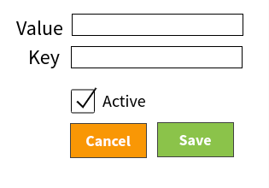

  - For above all three masters same functionality will be followed.

- Job Title Manager
From this section admin will be able to add various Job titles Such as Software Enginer, Software Developer, Seniour Software Enginner etc. There will be Listing/Add/Edit sections in the Job Titles Manager module.
- Listing:- Job Title listing will appear with the following information
    - Title,
    - Created at,
    - Status (Active/In-active),
    - Actions (Edit/Delete)
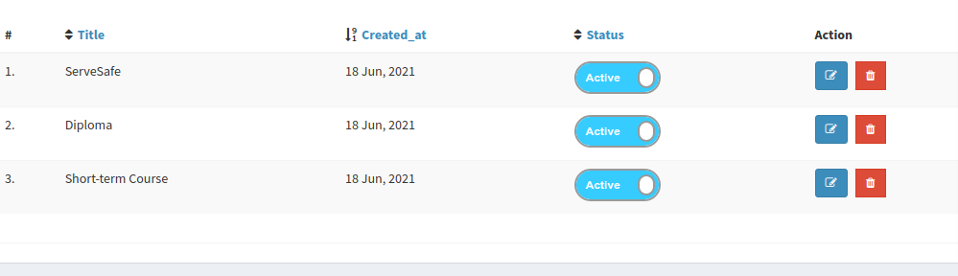

- Add/Edit Job Titles:- There will a Add/Edit form with the following fields:-
    - Title [Text inputbox, Required]
    - Active [Checkbox, Required, Default will be checked]
    - Job Categores [Auto complete Search, multi select , Required] Various Job Categories Will appaer as Tag options in this section.

Job Title
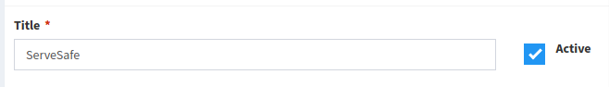
Job Categories:-
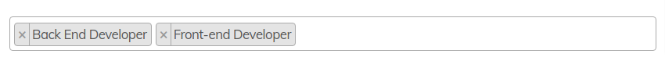
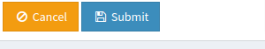
Multiple Job Categories can be selected for a single Job Title.
- On the Job Title Edit Form all fields will be as similar to Add Job Title Form and All fields will be pre filled and required.

- Manage Company/Recruiter
      - List view of app company/recruiter
      - Search option
      - Sort option
      - Can view company profile
      - Total jobs posted
      - Total applicant responded
      - Total staff added (with roles)
      - Total jobs awarded
      - Edit/delete/active/deactive the company
      - Filter by location.

- Manage Subscription
      - Add subscription
      - Edit subscription
      - -Plan Title
      - -Services included
      - -Validity (Monthly, Annually)
      - -Subscription Amount
      - Delete subscription
      - Search option
      - Sort
      - Filter
      - Submit button
      - A. Free plan - 1 Recruiter user, 1 Hiring Manager users, no external collaborator, 1 active jobs, limited number of applicants/candidates to 20 CV's per plan
      - B. Start-up plan - 3 Recruiter users, Unlimited Hiring Manager users, 1 external collaborator, 10 active jobs
      - C. Business plan - Unlimited Recruiter users, Unlimited HM users, unlimited external collaborator, unlimited jobs

They will be in the area of monthly or annual subscription basis, can be cancelled anytime and can be upgraded/downgraded anytime by the user.

      - Sort option
      - Can view company profile
      - Total jobs posted
      - Total applicant responded
      - Total staff added (with roles)
      - Total jobs awarded
      - Edit/delete/active/deactive the company
      - Filter by location.

- Payment Management
      - Admin will be able to view all the payment received through the subscription
      - Filter out as daily, weekly, monthly, yearly
      - Search option

- Reporting Manager
      - Admin will be able to download the reports in csv and excel format for the revenue received in weekly, monthly, yearly basis.
      - Filter out as daily, weekly, monthly, yearly
      - Search option

- Admin Settings

1. Manage Logo and FavIcon
      - Setup the managed logo and favicon for the landing page.
      - Manage the website and admin logo.
      - Manage the website and admin favicon.

Manage General Setting
      - Setup the manage general setting page for the admin
      - Display general setting listing
      - Setup add new general setting form
      - Fields will be Title, Constant/Slug, Type and Config Value
      - Apply proper form validation on all required fields
      - Store new general setting into the database
      - Edit General Setting Details
      - View General Setting Details

- Account Settings
      - View Profile
      - Edit Profile
      - Change Password
      - Manage Website Logo
      - Manage Favicon
      - Manage Social Media Icons
      - Logout

- Manage Email template
      - The admin can manage ‘’by default’’ email templates from this section.
- Manage Content Pages
      - Can edit/delet content pages as below
      - T&C
      - Privacy Policy
      - FAQs
      - - Category wise
      - Help & Support
      - Career Page
      - About us

- Manage Contact Enquires
      - Privacy Policy
      - FAQs
      - - Category wise
      - Help & Support
      - Career Page
      - About us

- Manage Notification
      - Admin can send email to user (Company) from here.
      - Can select the user type
      - Add new email option
      - Send button
      - On clicking on send button, email will be sent to all users.

- Third-Party job feeds Integration
      - Indeed
      - DocuSign
      - Payment Gateway - Stripe

- GDPR Compliant
      - We will follow the GDPR compliant as per the law

5. Non Functional Requirement
      - Website will be mobile responsive i.e. Latest Samsung and iPhone Mobile Devices
      - Website will work in all browsers i.e. Mozilla, Chrome, Safari, Internet Explorer 8+
      - Website will be compatible with all devices and work in all resolutions i.e. Small Screen, Wider Screen, iPad (Latest Mobile Devices)

6. Target Platform
      - Desktop Users
      - Tab Users
      - Mobile Users

7. Deliverables

S. No. | Deliverable Name | Platform | Assigned to
1 | Website Front Panel (Source Code) | Web | Project Manager
2 | Test cases | Excel format | QA
4 | Technical Documents | Pdf Format | Tech Lead

9. Project Management
Dotsquares will provide access to DSP (Dotsquares Projects) / PMS (Project Management) which is a project management and collaboration platform for planning, communication and tracking. It helps developers, managers and clients to stay on top of what’s happening define and manage a project across teams and organizations, keeping up-to-date with the schedule, work visibility and progress.

- Daily updates served through message posts
- A central place to upload and share project wiki
- Keeps digital track of conversation
- Milestones and tasks for planning
- Maintain task list for deliverables
- A Simple bug reporting system
- Notebook section to record important notes
- E-mail notifications about updates & other activities
- Mobile app available for clients

11. Unit Testing
Unit testing will be done by the team during development. We ensure all the code blocks (paths) in the software are executed at least once and produce the desired results.

12. Development Environment
Development Hardware | Linux/Unix, Apache
Networking | LAN, Internet
Programming Language | PHP, Laravel, jQuery, JavaScript
Code structure pattern | MVC Pattern

13. Staging Environment

Hosting will be provided during the development of your mobile application/web application.
We upload the solution on our own web and database servers for you to test.
When the project is finished and signed off (production-ready), we ask you to choose a hosting provider and deploy the project to the live environment.

14. Deployment Environment
Dotsquares will deploy the complete solution for the project.
- Website code and database will be uploaded to the testing/staging server.
- Website and database will be check by the client.
- After client approval, website code and database uploaded to client live server.

15. Testing Environment

Hardware | Linux/Unix, Apache
Networking | LAN, Internet, Wi-Fi, mobile network
Equipment under test (EUT) | Desktop
System Software | PHP, MySQL, PHP 7+

16. Technology

 | Component | Web
1. | Operating System | Linux/Unix
2. | Server | Apache
3. | Database | MySQL Server
4. | Web framework | Laravel
5. | Design Pattern | Web and Mobile Responsive
6. | Programming Language | PHP
7. | Front End | NetBeans
8. | Editor/IDE | Linux/Unix

