- Some succession for login panel
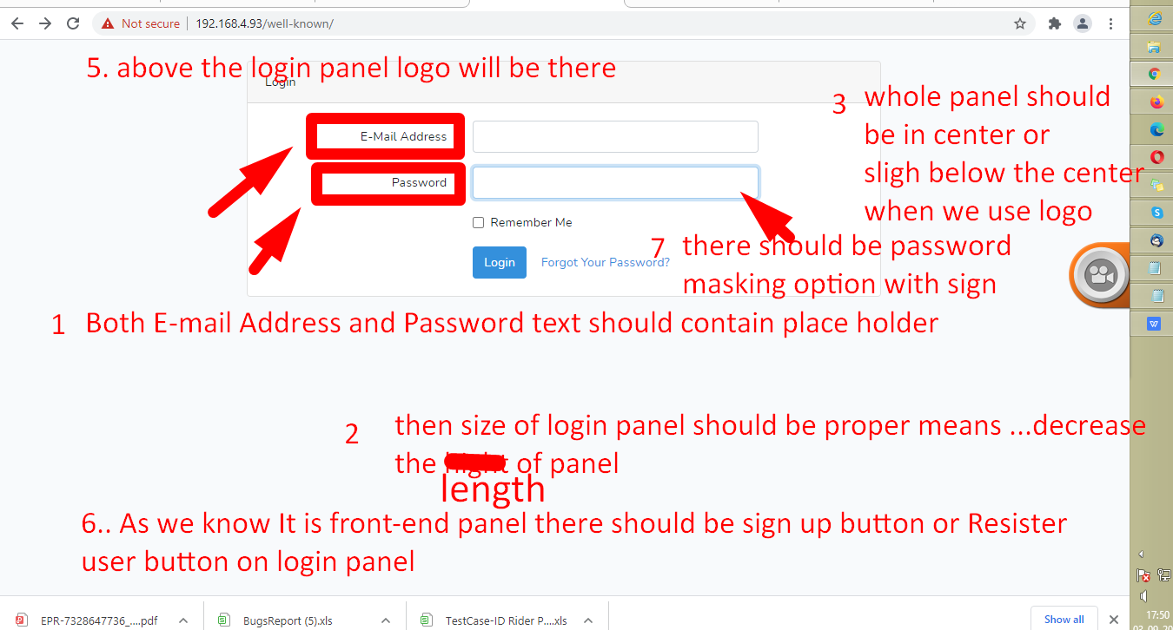
- Remember me is not working>>>> email and password should be autofill when we try to login next time after selecting remember me check box.
http://srecorder.com/s/hib5 http://srecorder.com/uploads/2021-09-03_11.13.17.mp4
- In mail response “Laravel” should be replace with Project identity
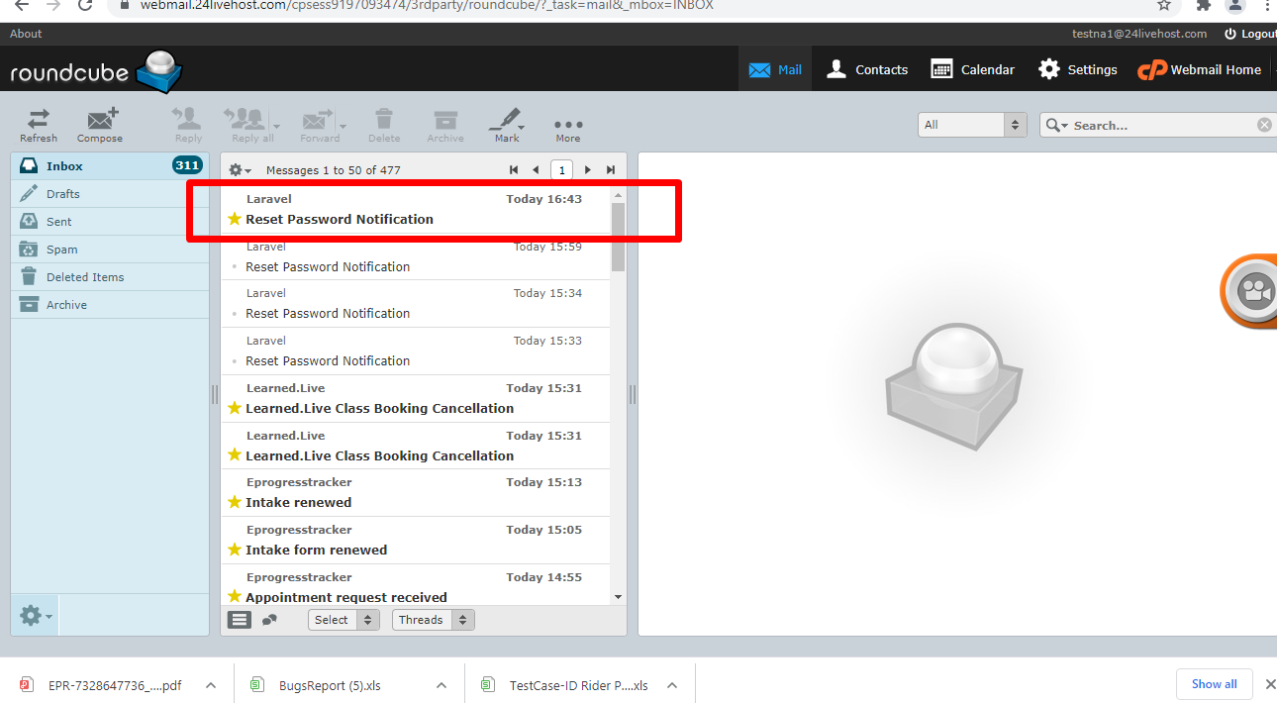

There should be proper email template for password reset link
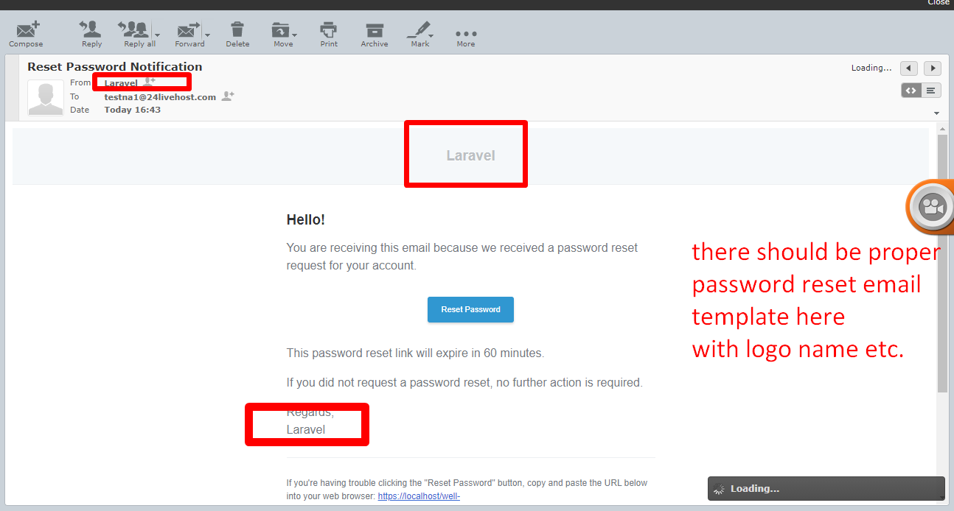

- Paasword resetting link is not working

http://srecorder.com/s/hibf
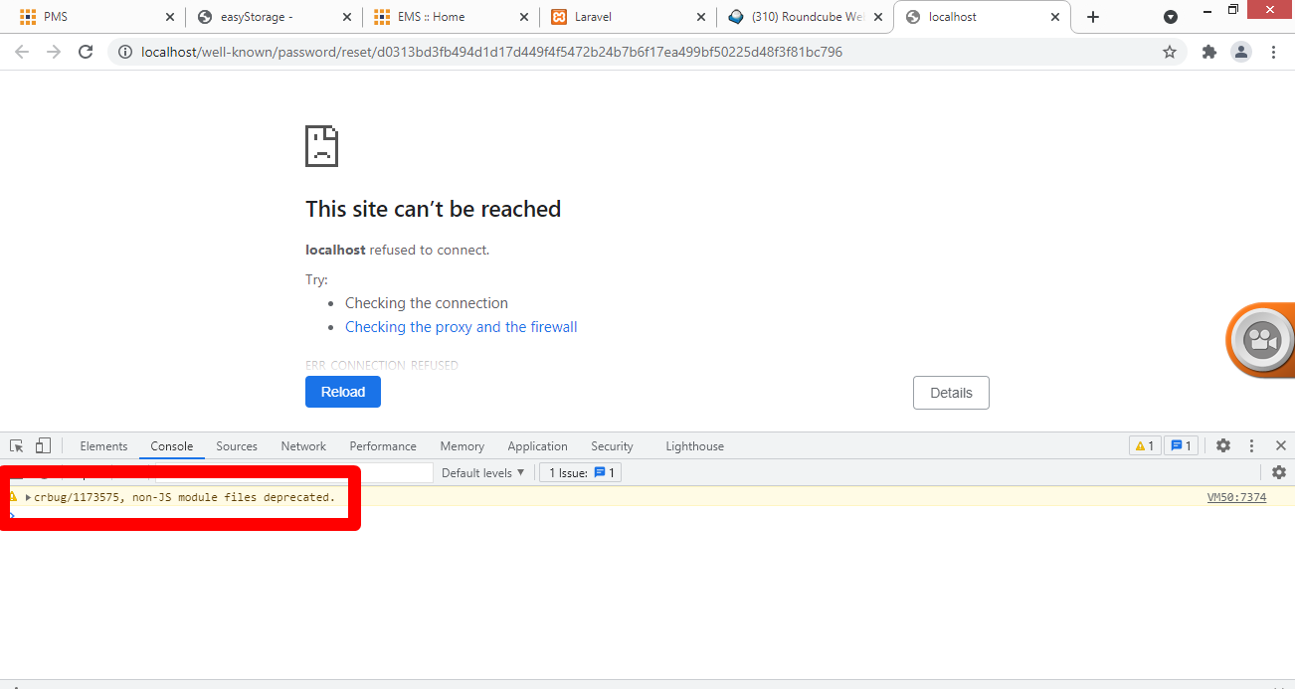
- No message is displaying
email and password is incorrect
http://srecorder.com/s/hily
http://srecorder.com/s/hibh
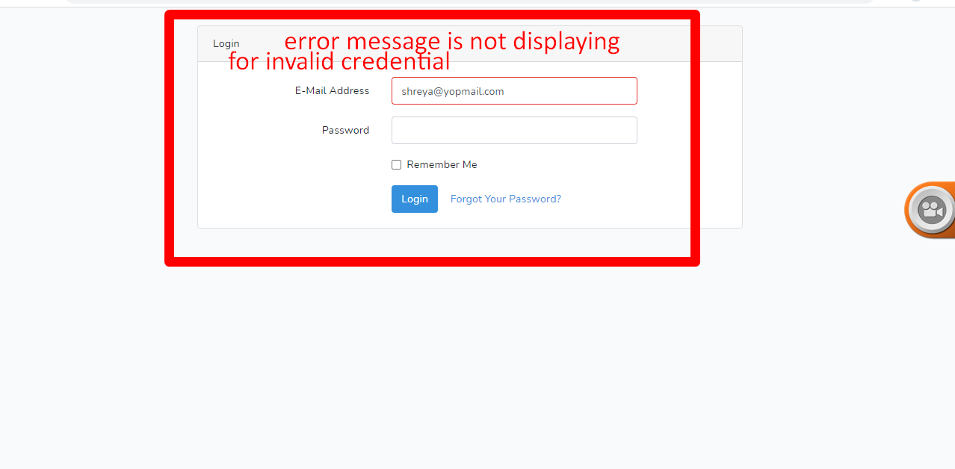
- No message is displaying
email correct and password is incorrect
Result- Proper messaging is not showing this case also
http://srecorder.com/s/him1
http://srecorder.com/s/hibs
- No message is displaying
email incorrect and password is correct
Reslult -Error messaging is not managed
http://srecorder.com/s/him2
- When we click on submitt button with out filling email Id and password
“This field is required”.error message should be in Red colour
http://srecorder.com/s/him3
- There should be asterisk(*) symbol with email and password text to show compulsion before login.
VALIDATIONS:--

FOR EMAIL ID
- a) 1) Character length should be there it may be from 20 to 30 may be or any range but should be
restricted.
b) there should
- Validation is not handled here for
a. incorrect email format like we are not using @ Symbol and domain name or character length
suggestions
2) for password it should min 8 to 20 or other highest range may change . and there should be compulsion for minimum one Capital character , one small character, one special character one numeric digit

