
CONFIDENTIAL
Feb 23rd 2021

Understanding Document

World Pole App Development
Version 1.0

This document outlines the general scope of your project based on our understanding of the requirements provided and discussions to date. |  | Prepared for:  Nathan Spiteri


Please don’t print me, it’s bad for the environment
DISCLAIMER
This document is submitted with the explicit understanding that the contents are confidential and would not be divulged to any third party without prior written consent from Dotsquares Ltd. Services are supplied according to our terms and conditions http://www.dotsquares.com/terms

Table of Contents
Purpose of the Document 4
Project Objective 4
Scope of Work 4
Technology Specifications 14
Ballpark Estimates 15
Exclusions 18
Payment Schedule 18
Hosting Plans 19
CMMI 21
Why Dotsquares 22

---------------------------------------

Revision History
Version | Date | Description | Prepared by | Reviewed by
1.0 | 23-02-2021 | Initial analysis and estimation | Nikhil | Ankit

Purpose of the Document

This document outlines the general scope of your project based on the requirements provided and discussions to date. The main objective at this stage is to ensure that all parties agree upon the general scope, budget and schedule of the project prior to commencing work on subsequent stages.

Clients are urged to ensure that all the details contained within this document are clear and fully meet their requirements before any work commences. Timescales mentioned only cover the scope listed, if this changes, costs and timings will change accordingly.

Once you are happy contact us and we will progress into the next stages. This may include further detailing requirements and functionality or it may go straight into design/development. This will depend on the nature of the project.

Project Objective
The project objective is to design and develop a mobile application for World Pole which will give a platform to students to view their assigned levels & tasks by the teacher. Students can access these task & can move to the next level after getting approval from the teacher.
Teacher can create their profile over the application, can see students & their respective courses along with the level. Teacher can decide the level of the student & can promote the student to the next level. Teacher can see the scheduled classes with the respective students along with the class statistics.
On the web side, admin can manage Students, Techers, categories & subcategories of courses, curriculam & other aspects of the mobile application.

Scope of Work
The scope of work includes the features and deliverables with the project development process. Here, we have explained the approach, features and deliverables and workflow to make it easy for you to understand in a better way. Please go through with scoped features carefully and feel free to ask for a change in case of any questions or amendments into the scope of work.

Users and Platforms

App Design
- Mobile Application Designing
Design will be done as per market standards and consists of steps:
- PSD Designing and Slicing of mobile application.
Designing points:
- The design should be very clean and clear for users to be able to read and browse through it easily.
- Designs, fonts will be high resolution with better look and feel.

Student App
On the basis of shared requirement, we have listed out below features which needs to be implemented into the proposed site-

Splash Screen
It is the student welcome screen which appears for few seconds and display the logo & name of app when user launches the app.



Signup
Student can register over the application by entering following details shown in the image below:

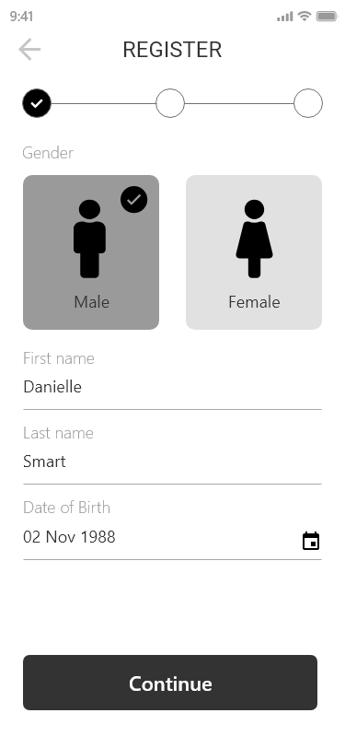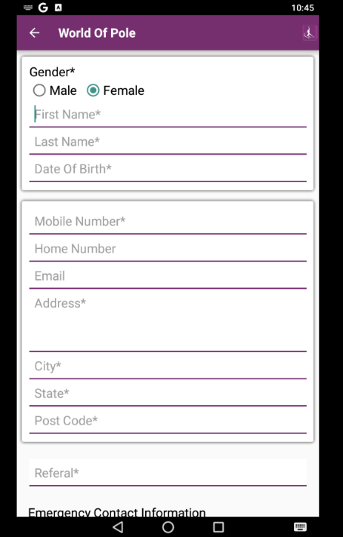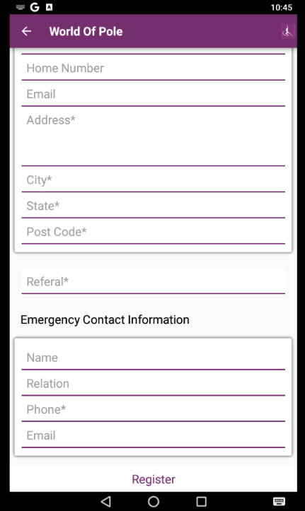

After submitting the above details, user will get a confirmation mail with verification code to activate their account.
*Note: The image is just for reference and the field mentioned in there, would be the ones we will be using in the application for the student who will be registering.

Login
- Student can login by using their E-mail ID and password. In case user forgets their password then they can recover their password from ‘Forgot password’ which will ask their E-mail ID.
- By logging inside the application, user will have access to manage their profile.
- Students can also enter the application as a guest, in that case there is no need to login the application. But to place any order they need to login the application so that they will be able to view their previous orders.

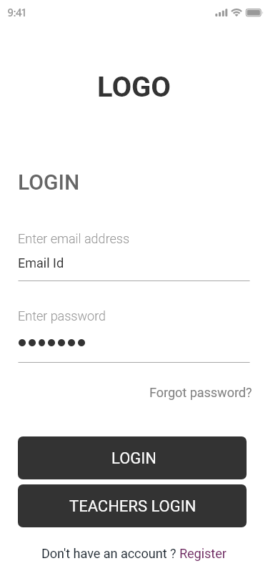

Dashboard
- Students will be able to view the classes schedule under which they can view timings,class name, maximum student who can join, number of students enrolled, teacher name. Upon clicking on a particular class, Student can view class detail and attend button. Once student tabs on it, he/she will be enrolled if the maximum capacity of student who can enrolled hasn’t exhausted.
- Student can also view their classes, they need to or they have opted to attend under this tab.
- Curriculam, this section will help student to identify the several categories of curricularm (beginner, intermediate, advanced) they need to complete. Under these categories there will be various types of tasks under several levels that a student has to complete in to order to traverse from one level to another and later completing all level under one category, student will be moved to next one. For instance, student completes all levels of beginner and then he/she moves to intermediate one.
- The Teacher will mark the students after they complete the task correctly and then allow the student to go to next move.
- Student can complete the task by looking at the app for movement instructions, and videos.

Profile
- The Student can view/edit their necessary details from this my profile section.
- Details entered while registeration by the student can be edit from this sections apart from student email, first name, last name.

Teacher App

Login
- Teacher can login by using their E-mail ID and password. In case user forgets their password then they can recover their password from ‘Forgot password’ which will ask their E-mail ID.
- By logging inside the application, user will have access to manage their profile.
- Teachers can either be added from admin backend panel or CRM.

Dashboard
- Teacher can view their schedule classes(Name,Date,Time,Class picture, total signed in for call,total count,capacity, no show), they have to take on daily basis. They can view the information of their class and the number student who has enrolled for it.
- Teacher will mark the attendence manually through the application. He/She has to mark the check box next to the name of student who have come to attend the session if in case any student doesn’t show but he/she has signed in for it, then teacher can mark it as no show.
- Manage student curriculam via marking the level when the student completes the task under that. He/she can also add some notes which will be visible to the student.

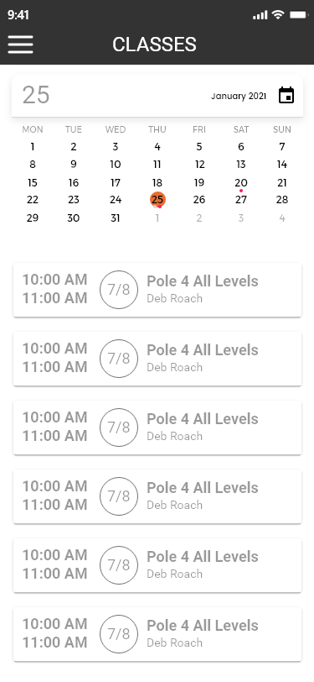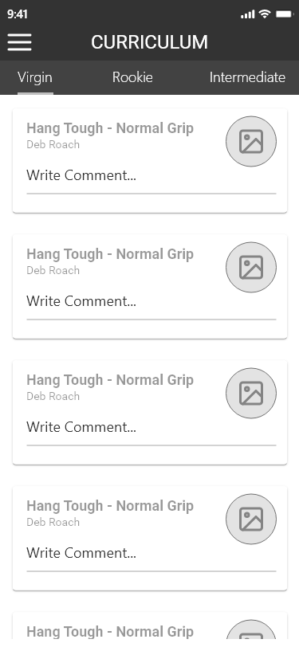

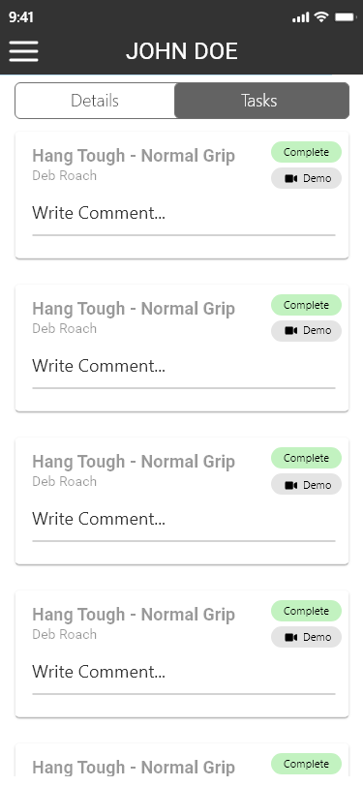

Student Listing
- Teachers can view the list of several students who are being assigned to them via admin backend panel or CRM. Teacher can also perform the search by typing their names.

View Student Details
- By tapping on any of the students from the list, the teacher can view details of tasks he/she has completed along with the level they have reached in their respective curriculam.

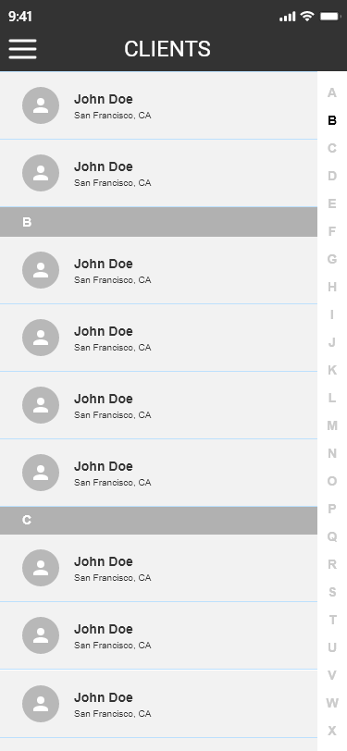

Profile
Teachers will be able to make changes or view the profile. Below will be the details available in the profile sections –
- Username
- Email ID
- First & Last name
- Mobile Number
- Upload profile image
- All other necessary details.

Super Admin Panel (Web)
- Login
Admin will login with credentials and access the panel.

- Dashboard
Admin can view various stats here like
- Students
- Teachers

- Teacher Manager
Admin will be able to manage teachers from this section.
- They can add / edit / delete / view teachers.
- Admin will send a notification email with the login credentials to the teacher.
- We will be fetching old teachers data from the CRM.
- The details required to add a teacher would be same as the given in the CRM APIs.

- Student Manager
Admin will be able to manage students from this section.
- They can add / edit / delete / view students.
- We will be fetching old student data from the CRM.
- The details required to add a student would be same as the given in the CRM APIs.

- Categories & Subcategories Manager
Admin can manage categories & subcategories of the levels. These levels can be:
Beginner
Interediate
Expert
Admin can add/edit/remove categories from the admin panel.
With each level there will be further tasks. These tasks will be linked with each level. There can be multiple task with a single level.

- Manage Curriculums (Master data)
Admin can manage the curriculums on this section. They can add/edit/disable the curriculum by the following options:
• Name : text box
• Status: dropdown with Active / Inactive value
They can also create task which will have:
- Task Instruction
- Task Image
- Video

- User Role Manager
- View admin users listing with pagination and search option
- Create option to assign roles.
- Show list of permissions against a role which can be marked as
- List
- Add
- Edit
- Delete
- Full Access
- Once any of the role has marked certain permission then they should view their dashboard options accordingly when they are logged in.
- Teacher can also access this area with limited permission where he/she can add student, assign curriculam to student along with the level.

- Email Templates
Admin will be able to manage email templates for the system emails.

- Content Screens
Admin will be able to manage content pages through this section i.e. FAQ, About Us etc.
Note:
We are working on some suggestions for the mobile application which will enhance business value of the application. We can schedule our call to discuss it further and can discuss these suggestions in our call.
Queries & Assumptions
- After looking at the API’s you shared, we are assuming that we won’t be utilising all the API’s from that list. We will only be using those API’s which will be required as per the features listed above.
- We are assuming that there will not be any memebership or subscription based module for now.
- There will not be any online classes or chat in this phase.
- There will not be any online booking for classes.
- There are some APIs related to member ships as well. Could you please let us know that how member ship is associated with this app.
- The estimates which we are sharing based on the details of API that we were able to access. If any complexity we find at the time of development then estimates may be revised. We will inform this in the starting of the project development.

Details Required
- Existing CRM access
- Existing Mobile Application details: Android or Iphone existing apps links with login credentails for both teacher and student.

Technology Specifications

Mobile Application and Backend
Component | Mobile Application | Admin Panel
Operating system | React Native | Linux
Server | - | Linux
Database | SQLite | MySQL
Web Framework | - | MVC
Programming Language | React Native TS | Laravel
Editor/IDE | Android – Android Studio  iPhone – XCode  Visual Studio Code | NetBeans

Deliverables
 | Deliverables |  | Deliverables
1 | App Designs | 5 | Project Plan, Sprint Planning, Team Meeting by BA / PM
2 | Mobile App Development | 6 | SRS by BA /PM
3 | Admin Panel and API Development | 7 | Delivery Schedule
4 | Test Cases Creation, Execution, System Testing by QA

Receivables
 | Item | User
1 | Hosting details | Client
2 | Android and iOS developer Account to upload the app | Client

Important Points

Third-party API/Tools
Please note that any delays or complications that may occur during or after the development that are a result of any 3rd party tools, scripts and hardware, are not included in the estimated timeframe. These will be assessed separately and may affect the development time required.

Assumptions
- All the API’s that needs to be integrated within the system will be provided by the client related to CRM.
- We tried to cover major features of the shared requirement. Please share your thoughts if we missed anything to specify or need to be removed so we can do needful and send you the revised estimated proposal.
- The images we have included in the proposal are only for imagery purpose only. The designs of the app will be different.
- Google play store and apple store developer account to make applications live.
- We expect that content to be added in the application will be provided by the client.
- The application will be built in portrait mode only.
- Web Hosting will be provided by client only.

Ballpark Estimates
Option 1: Offshore team and Project Manager with 1 resource
Estimated Timeframe of deliver (Man Weeks)  - (One Developer x 7 weeks) | 7
Estimated Cost | AU $12,600.00

Above Estimate(s) are valid for 30 days from date of issue

Resource Utilization
 | Profile | Nature of engagement
1 | Mobile Developer  Backend Developer  API Developer | Full Time
2 | Designer | Partial
3 | Quality Analyst | Partial
4 | Technical Lead | Partial
5 | Offshore team and Project Manager | Partial
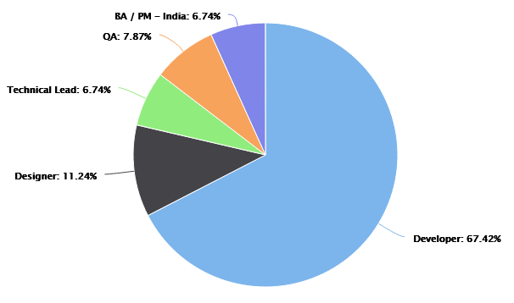

Option 2: Offshore team and AU based Project Manager with 1 resource
Estimated Timeframe of deliver (Man Weeks)  - (One Developer x 7 weeks) | 7
Estimated Cost | AU $13,510.00

Above Estimate(s) are valid for 30 days from date of issue

Resource Utilization
 | Profile | Nature of engagement
1 | Mobile Developer  Web Developer | Full Time
2 | Designer | Partial
3 | Quality Analyst | Partial
4 | Technical Lead | Partial
5 | Offshore team and AU based Project Manager | Partial
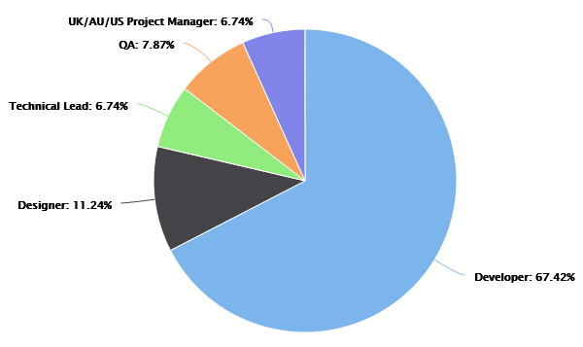

Option 3: Offshore team and Project Manager with 2 resources
Estimated Timeframe of deliver (Weeks)  - (One Developer x 4 weeks) | 4
Estimated Cost | AU $14,400.00

Above Estimate(s) are valid for 30 days from date of issue

Resource Utilization
 | Profile | Nature of engagement
1 | Mobile Developer  Backend Developer  API Developer | Full Time
2 | Designer | Partial
3 | Quality Analyst | Partial
4 | Technical Lead | Partial
5 | Offshore team and Project Manager | Partial

Option 2: Offshore team and AU based Project Manager with 2 resources
Estimated Timeframe of deliver (Weeks)  - (One Developer x 4 weeks) | 7
Estimated Cost | AU $15,440.00

Above Estimate(s) are valid for 30 days from date of issue

Resource Utilization
 | Profile | Nature of engagement
1 | Mobile Developer  Web Developer | Full Time
2 | Designer | Partial
3 | Quality Analyst | Partial
4 | Technical Lead | Partial
5 | Offshore team and AU based Project Manager | Partial

Exclusions
- Application is not multi-lingual
- No offline mode is possible for this business type.
- There is no front-end website for the business included into scope.
- No Landscape mode
- Android Tablet app and iPad apps

Payment Schedule
 | Weekly Invoices | Payment Method | Amount | Total Amount
With 1 Resource
1 | From Week 1 to - Option 7 | Pay in our Australian account | AU $1,800 + 10% GST per week | AU $12,600 + 10% GST
1 | From Week 1 to - Option 7 | Pay in our India account | AU $1,800 per week | AU $12,600
2 | From Week 1 to - Option 7 | Pay in our Australian account | AU $1,930 + 10% GST per week | AU $13,510 + 10% GST
2 | From Week 1 to - Option 7 | Pay in our India account | AU $1,930 per week | AU $13,510
With 2 Resources
1 | From Week 1 to - Option 4 | Pay in our Australian account | AU $3,600 + 10% GST per week | AU $14,400 + 10% GST
1 | From Week 1 to - Option 4 | Pay in our India account | AU $3,600 per week | AU $14,400
2 | From Week 1 to - Option 4 | Pay in our Australian account | AU $3,860 + 10% GST per week | AU $15,440 + 10% GST
2 | From Week 1 to - Option 4 | Pay in our India account | AU $3,860 per week | AU $15,440

Estimate Notes
The exact speed of design & development will be affected by client turnaround times, i.e. responding to queries and providing feedback. All services are supplied according to our T&Cs http://www.dotsquares.com/terms

The above estimate is based only on the features which we have listed in this document. If you need any other feature (not listed in this doc) then the estimate is likely to change. It may also vary after sharing your response on any queries being asked in this document.
Note: Your project will be managed & developed by your Dotsquares Team. Other than Developers indicated in a full time capacity, all team members will be involved partially as required for specific hours in a week.

Hosting Plans
We can provide a range of hosting packages to suit your requirements – please enquire for more details.
Based on the known requirements our network team would recommend the follow
Fully Managed Cloud Server  1. CPU : 2 Core  2. RAM : 4 GB  3. HDD : 80GB SSD Storage  4. Dedicated IP : 1 IP  5. Bandwidth : 4TB  6. OS : Linux Centos  7. Control panel : cPanel/WHM  8. Server Backups  9. 24 hours emergency support  10. Fully managed account services  The cost of the above package will be AU$190 per month  Server Setup Charges : AU$50 One Time  SSL Certificate : Included  Fully Managed Cloud Server  1. CPU : 6 Core  2. RAM : 16 GB  3. HDD : 320GB SSD Storage  4. Dedicated IP : 1 IP  5. Bandwidth : 8TB  6. OS : Linux Centos  7. Control panel : cPanel/WHM  8. Server Backups  9. 24 hours emergency support  10. Fully managed account services.  The cost of the above package will be AU$490 per month  Server Setup Charges : AU$50 One Time  SSL Certificate : Included | Fully Managed Cloud Server  1. CPU : 4 Core  2. RAM : 8 GB  3. HDD : 160GB SSD Storage  4. Dedicated IP : 1 IP  5. Bandwidth : 5TB  6. OS : Linux Centos  7. Control panel : cPanel/WHM  8. Server Backups  9. 24 hours emergency support  10. Fully managed account services.  The cost of the above package will be AU$350 per month  Server Setup Charges : AU$50 One Time  SSL Certificate : Included

Development Process
Project Management Tool  Dotsquares will provide free access to DSProjects our project management and collaboration platform for project planning, communication and tracking.  - Daily updates provided  - Keeps digital track of conversations  - Milestones and tasks for planning  - Maintain task list for deliverables  - E-mail notifications about updates & other activities | 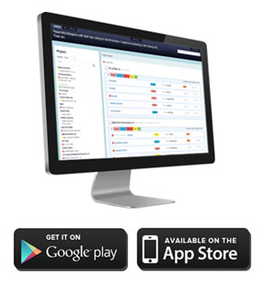

Testing
We provide unit testing services for your project as a standard package. Unit testing is completed by the developer during the development cycle. We ensure all the code blocks (paths) in the software are executed at least once and produce the desired results.

Environment  Where possible, Dotsquares provides free of cost hosting during the project for you to test at your convenience. If the project dictates specific environment requirements, a separate estimate will be provided for these.  When the project is finished and signed off, we ask you to choose a hosting provider and deploy the project to live environment. |  | Deployment  Dotsquares will deploy the complete solution for the project. Code can also be supplied directly to you or any repository account held.  Web based developments will normally be transferred to your own hosting account and put live as required. Mobile applications will be uploaded to the relevant App Store under your developer account.
Warranty  Your software is delivered with a free warranty of 30 days. You must notify the team during the 30 day warranty period if you identify an error in the code / system / program. Once it has been agreed Dotsquares will correct any errors made in the construction of the code / system program no cost. Dotsquares reserves the right to define a bug / error. |  | Intellectual Property Rights  All the Intellectual Property created, written, developed, furnished or produced by us during the term of the agreement / project, that are within the scope of the agreement or any applicable Statement of Work shall be the exclusive property of the client.  All the code base, assets, documentation (if any) will be provided to you after development.

CMMI
What our CMMI Maturity level rating actually means for you.
Improved Quality
- Well-defined processes limit opportunities for error.
- Smart supplier management ensures quality results.
- Strategic people management enables team members to develop skills that will help the
organisation succeed.

Decreased Costs and Enhanced Productivity
- Streamlined processes allow teams to integrate and collaborate more efficiently.
- Standardised project management practices reduce redundancy and waste.
- Identifying skill gaps helps break down workflow bottlenecks.

Higher Customer Satisfaction
- Service delivery strategies strengthen weak customer touch points.
- Elective product development instills customer confidence.
- Project management practices help teams meet and manage customer expectations.

Improved On-Time Delivery
- Field-tested project management standards keep work on schedule.
- Clear development processes reduce scope creep and deadline extensions.
- Careful vendor management mitigates supplier delays.



Why Dotsquares
We thrive on seeing ideas grow. Since 2002, we have been working with individuals and global brands to embrace the evolving digital industry.

We are big on trust, reliability and mutual respect so we will take the time to understand you, your product and your business. We work closely with all our clients and are always looking to forge ongoing trusted relationships.

Taking your IT project offshore allows you to cut down on the costs whilst maintaining a quality that onshore companies struggle to match.

We take the pain out of your IT projects and let you concentrate on the business you know best:
Your own.

Dotsquares are an international creative digital design and development company striving to make your vision a reality.

What we do…

WEB   | GAMES   | APPS  
Our web development professionals bring years of experience to meet both the business and technical requirements of a project. | Our game developers use platforms such as Unity, Maya, Cocos2D, Unreal, ARKit, Maya, Max and more to create the best gaming experience. | We provide cutting-edge mobile app development that can efficiently and creatively meet current business demands.
CRM   | DIGITAL MARKETING   | IT SUPPORT  
Each company is different and we can create bespoke CRM systems to manage your client relationships in the most efficient way. | The industry is becoming saturated. Using methods like SEO, SMM, PPC and Google Ads, our marketing experts can give your brand a voice. | Server support, network troubleshooting, remote installation, our hosting experts are on hand 24/7 to keep your business alive.

Portfolio

What our clients say
Daniel Ox
Ocean Holidays Group
UK
Significant cost savings can be made working with an outsourced development company you can trust. Dotsquares have an exceptional team of quality engineers who work quickly and are always aware of deadlines.”

John Wussah
Education & Training Company
Australia
“You have been one of the best developers I have ever worked with. You have excellent technical and interpersonal skills and you got my website development and design project done to my amazement and satisfaction!”

Brian Riback
New York Daily News
USA
Dotsquares went beyond the requirements. The Team are amazing and working with them is a winning formula. I feel extremely lucky to have these gentlemen on my Team with their unyielding dedication to excellence.”


Affiliations


